Maths Year 6
w/c 22.6.2020
The objectives we are working on in this week are:
- To use simple formulae
§ To generate and describe linear number sequences
§ To express missing number problems algebraically
This week’s learning is a simple introduction to algebra. On Monday, you will start by learning how to find the rule for a sequence of numbers; then on Tuesday, you will learn how to form expressions using algebra; on Wednesday, you will learn about substitution; on Thursday, you will solve some simple one step equations and finally, on Friday, there is an emoji challenge for you to try and solve!

Using the link below, click on Summer Term – Week 7 and each day (Monday – Thursday) watch the video and complete the accompanying task (these are printed in your pack). Lesson 1 – Monday, Lesson 2 – Tuesday, Lesson 3 – Wednesday, Lesson 4 – Thursday.

https://whiterosemaths.com/homelearning/year-6/

Monday (Part 1)
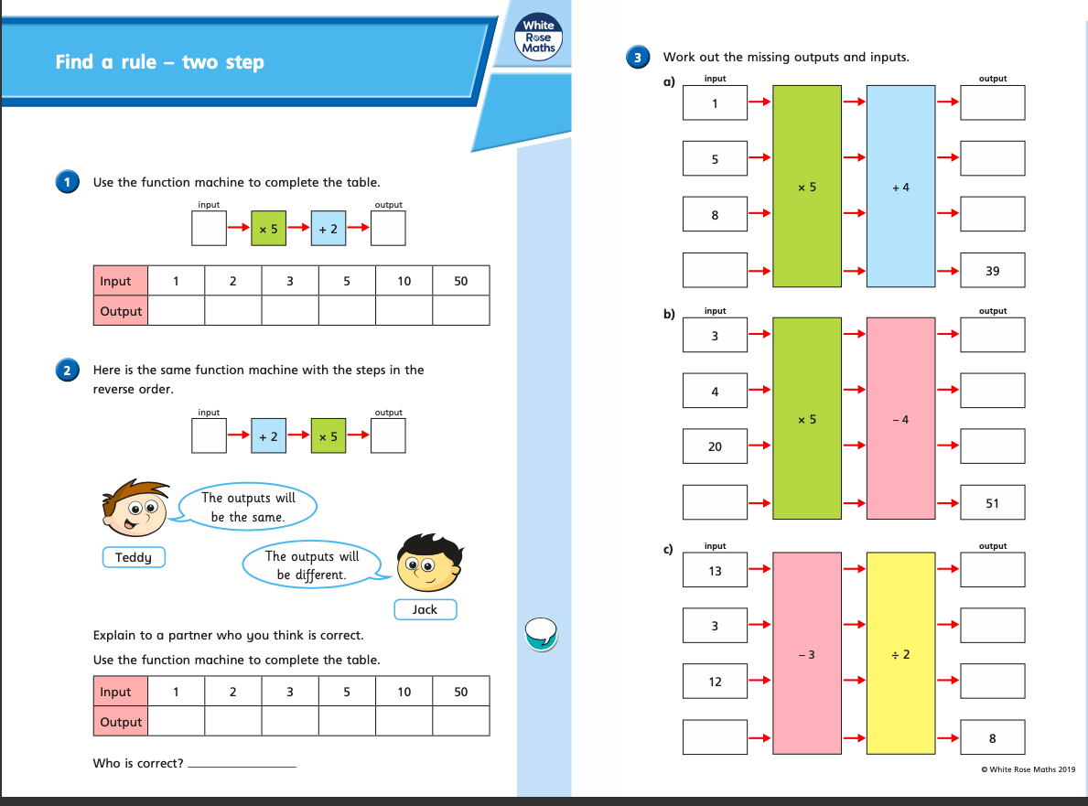

Monday (part 2)
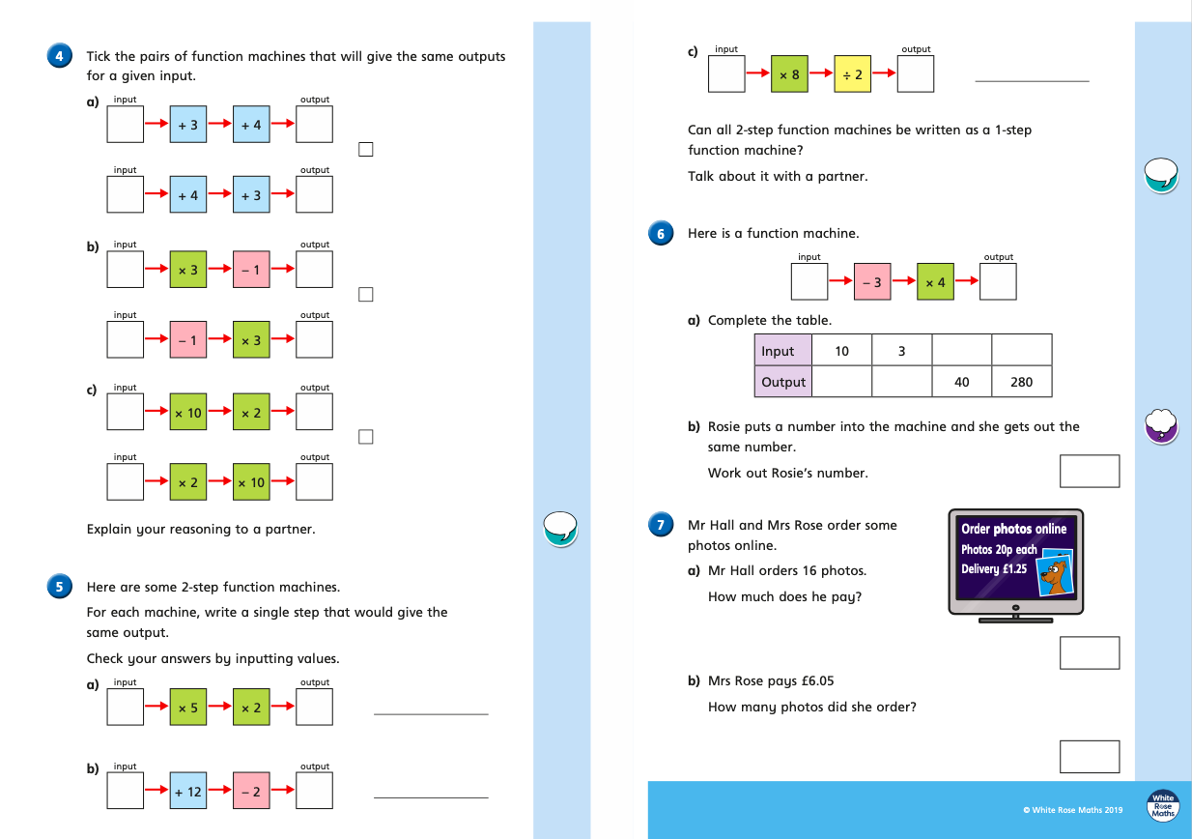

Tuesday (part 1)
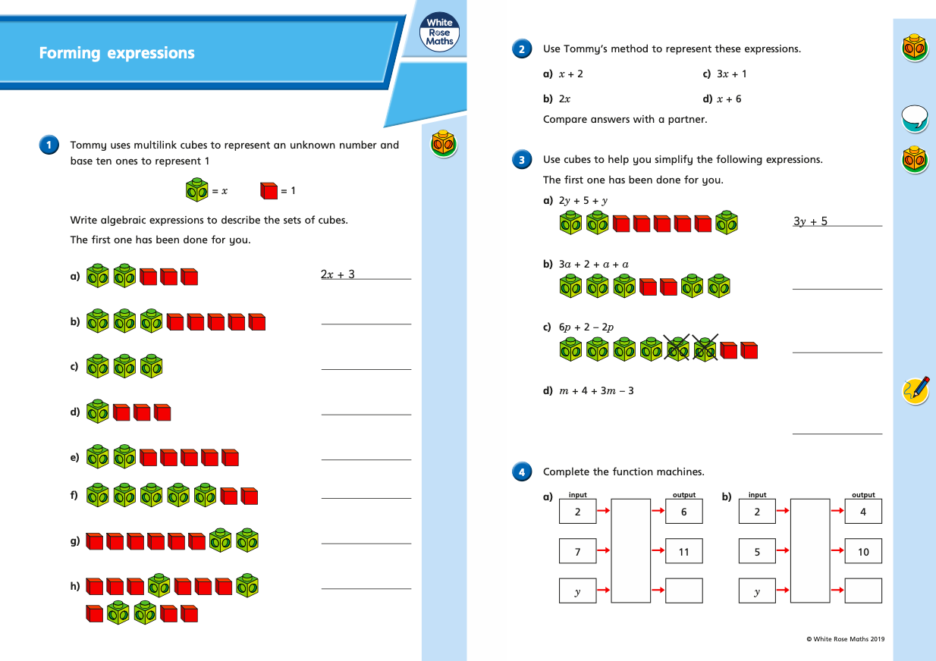

Tuesday (part 2)
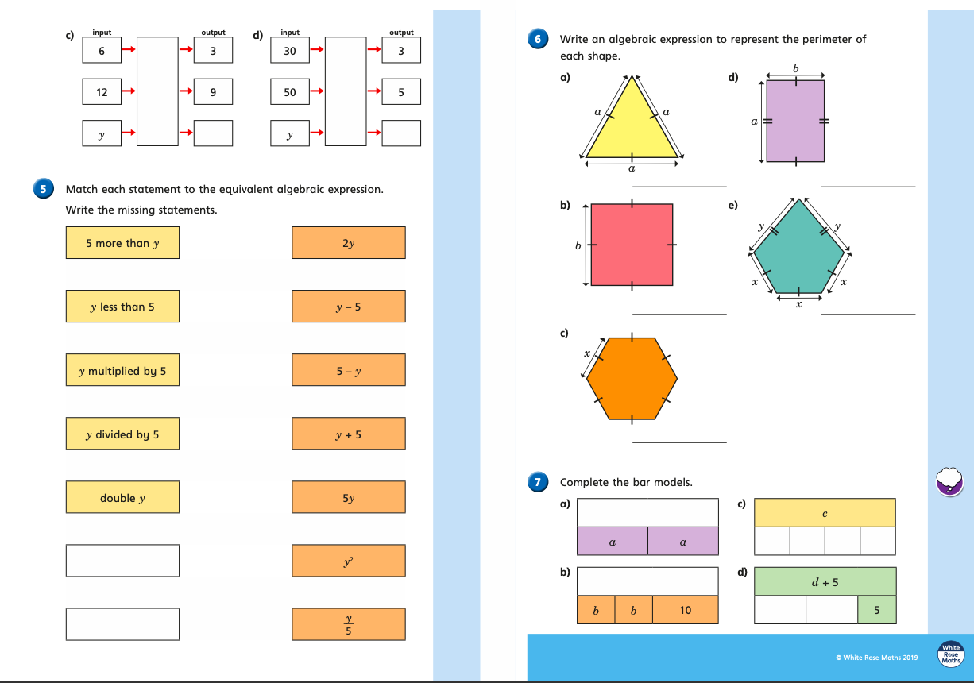

Wednesday (part 1)
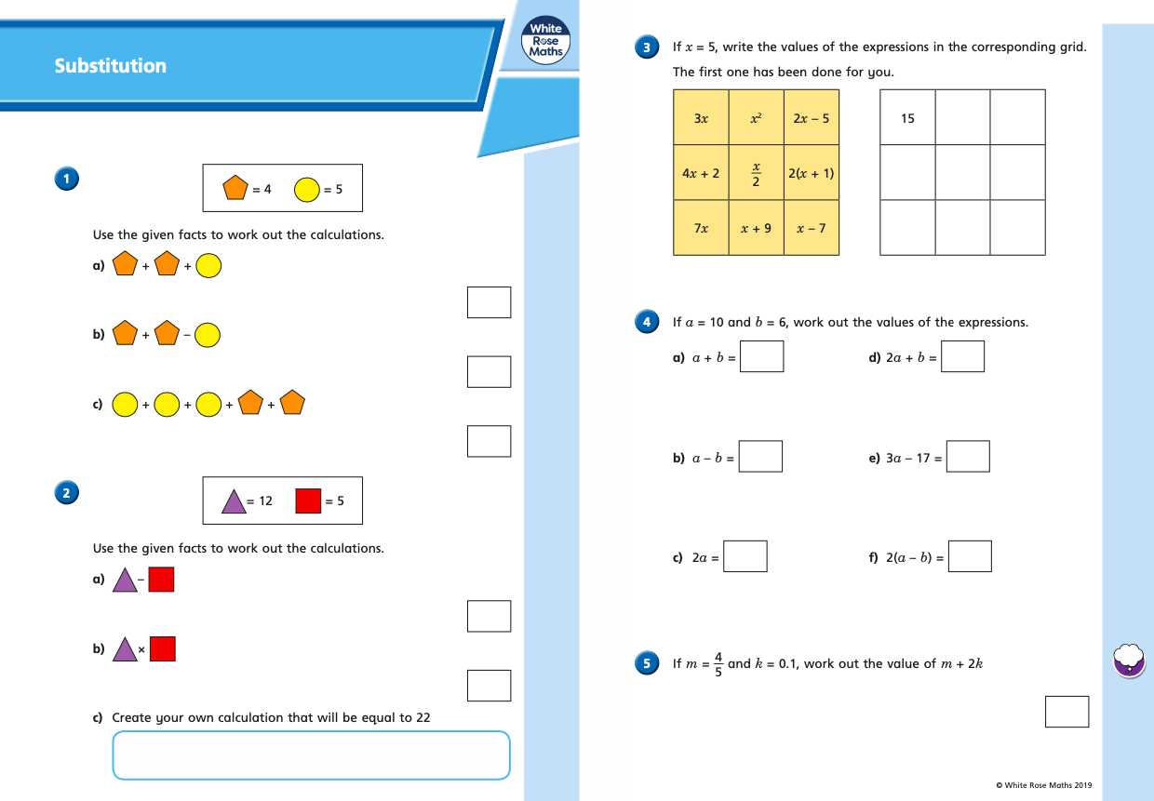

Wednesday (part 2)
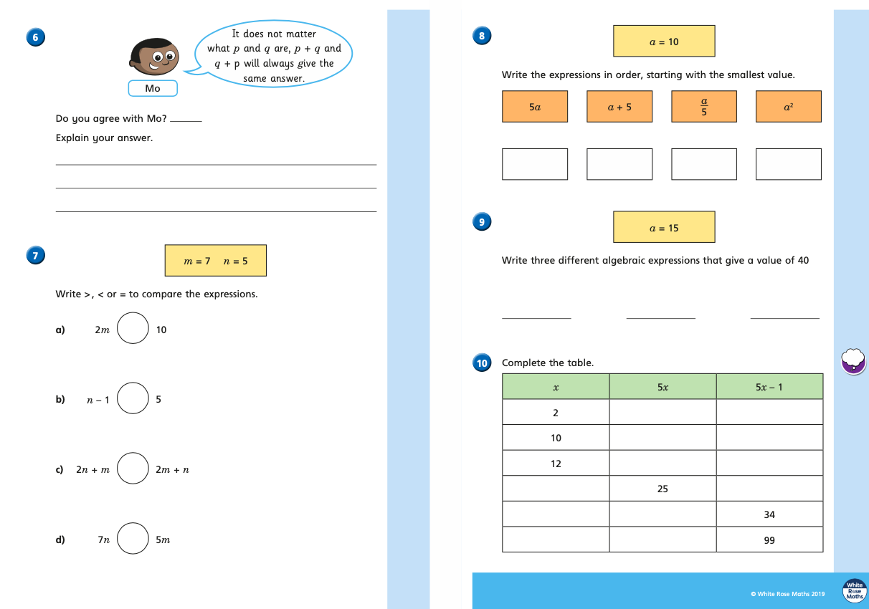

Thursday (part 1)
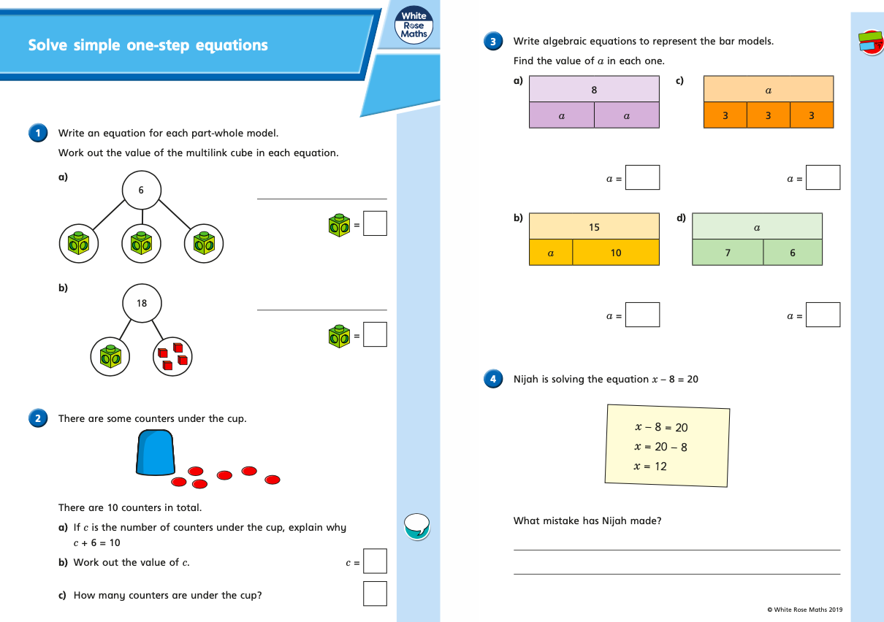

Thursday (part 2)
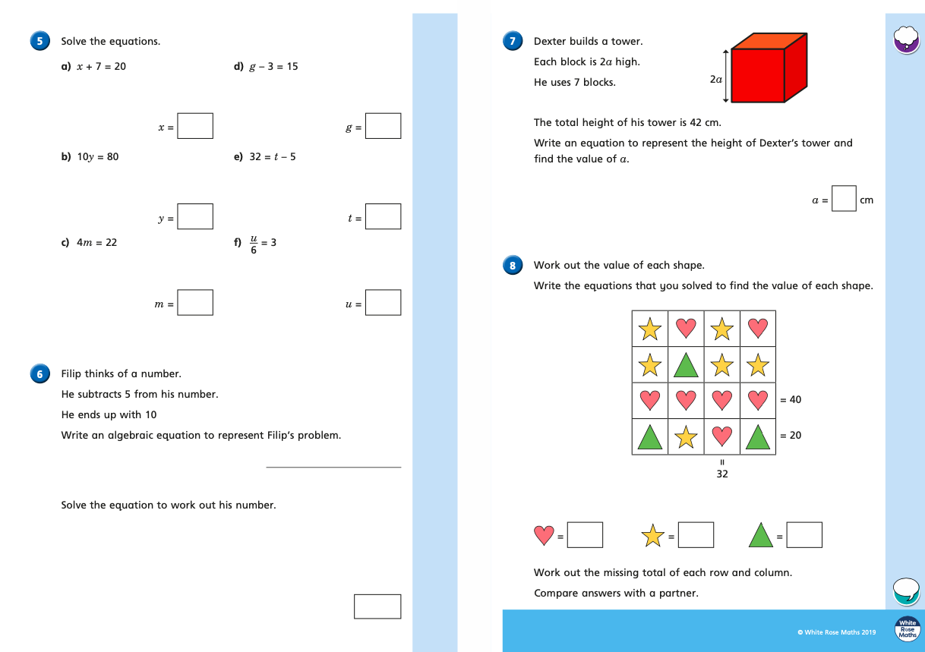
Friday
