Maths Year 6
w/c 1.6.2020
The objectives we are working on in this week are:
- To multiply fractions by whole numbers
- To multiply simple pairs of proper fractions, writing the answer in its simplest form.
- To divide proper fractions by whole numbers
- To find fractions of amounts
This week’s learning will be a recap of more learning we carried out in school during the Spring term. On Monday, you will start by revisiting how to multiply fractions by whole numbers; then on Tuesday, you will revisit multiplying simple pairs of proper fractions; on Wednesday, you will be revisiting how to divide proper fractions by whole numbers; on Thursday, you will be revisiting finding fractions of amounts; and finally, on Friday, you can practise what you have learnt this week using activities on Classroom Secrets Kids.
Using the link below, click on Summer Term – Week 4 and each day (Monday – Thursday) watch the video and complete the accompanying task (these are printed in your pack). Lesson 1 – Monday, Lesson 2 – Tuesday, Lesson 3 – Wednesday, Lesson 4 – Thursday.
https://whiterosemaths.com/homelearning/year-6/
On Friday, use the following links to continue practising what you have learnt this week:

https://kids.classroomsecrets.co.uk/resource/fractions-of-an-amount-video-tutorial-2/
https://kids.classroomsecrets.co.uk/resource/multiply-fractions-by-fractions-video-tutorial/
https://kids.classroomsecrets.co.uk/resource/year-6-multiply-fractions-by-integers-game/
https://kids.classroomsecrets.co.uk/resource/year-6-divide-fractions-by-integers-game-2/

Monday (part 1)
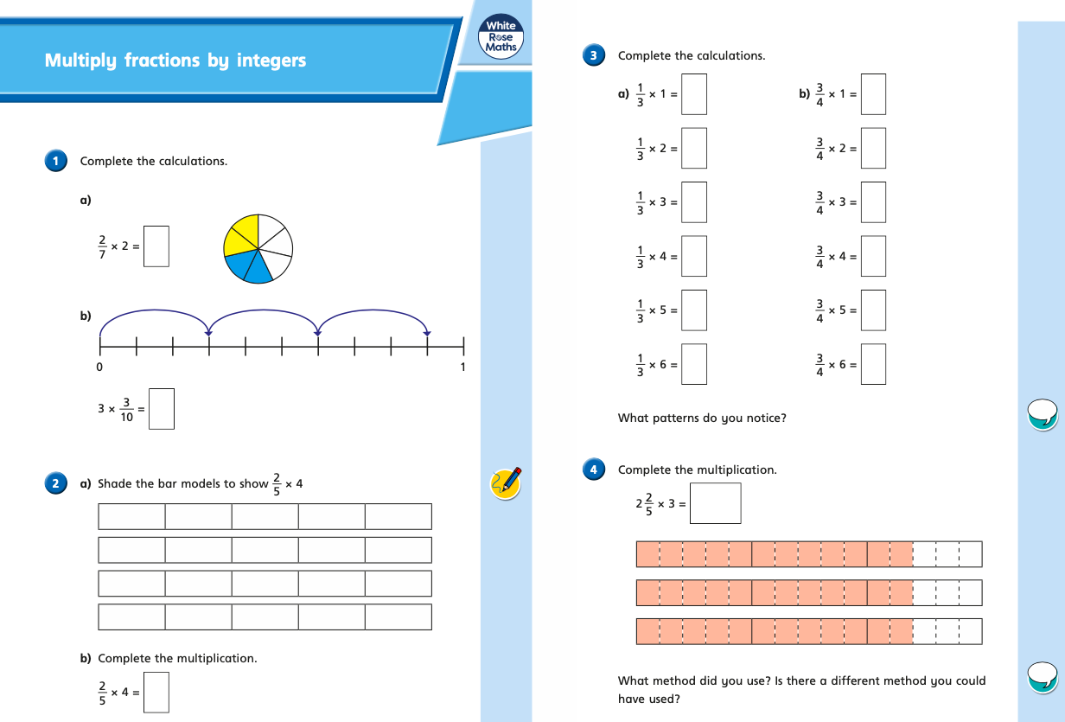
Monday (part 2)
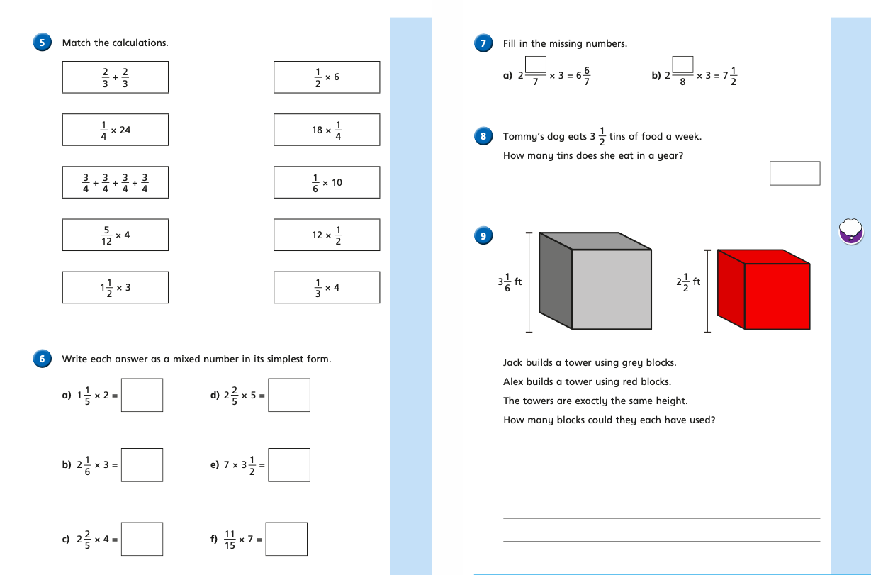
Tuesday (part 1)
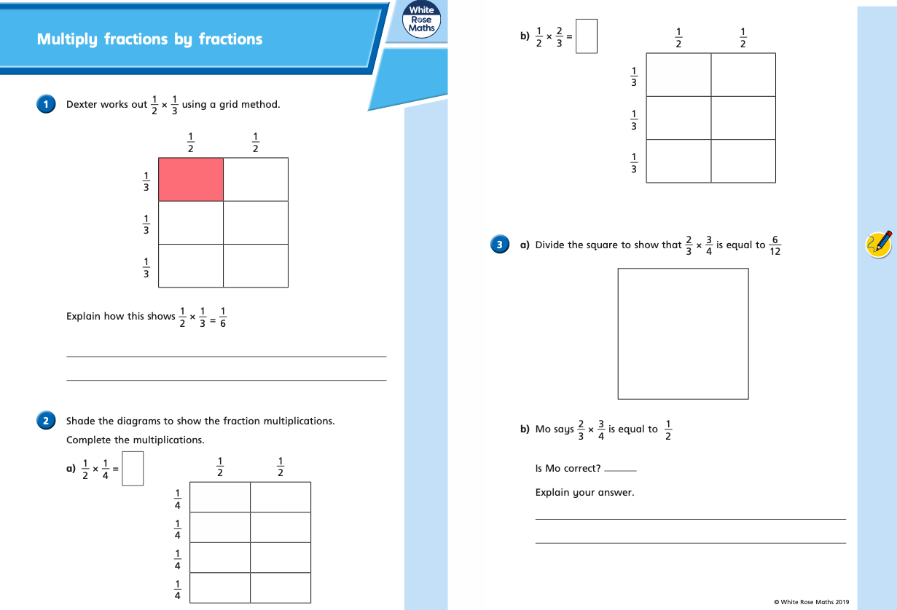
Tuesday (part 2)
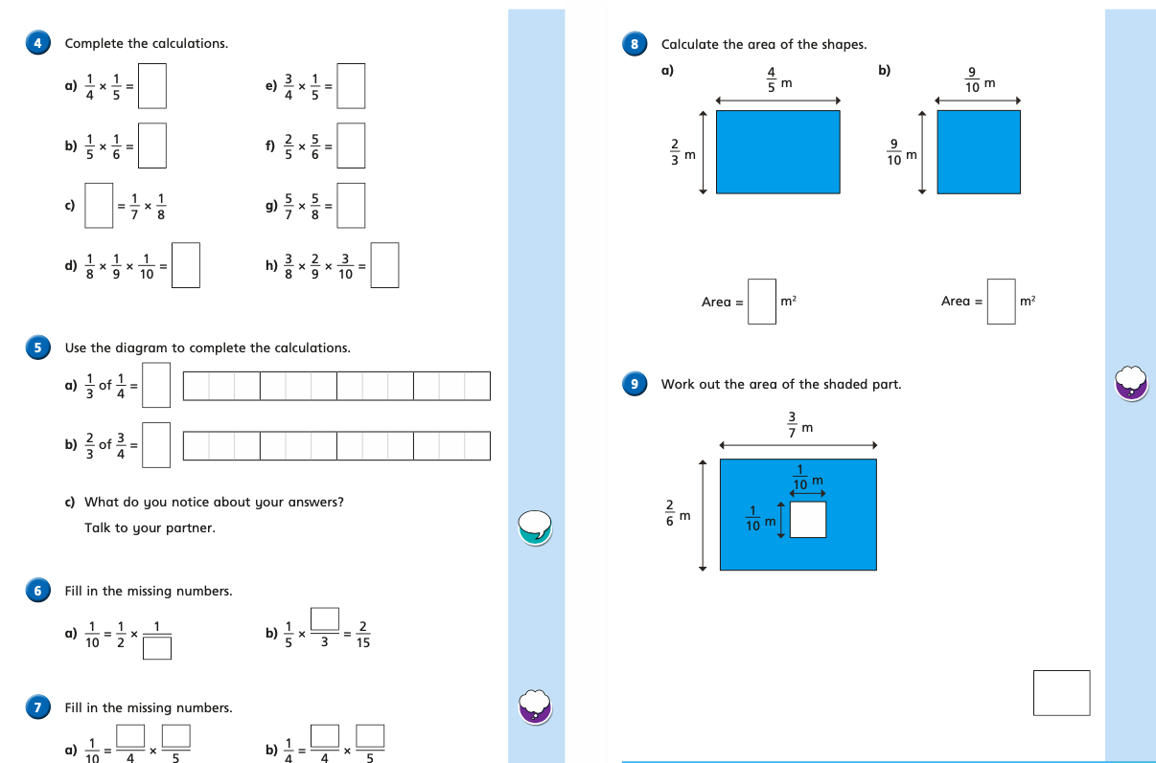

Wednesday (part 1)
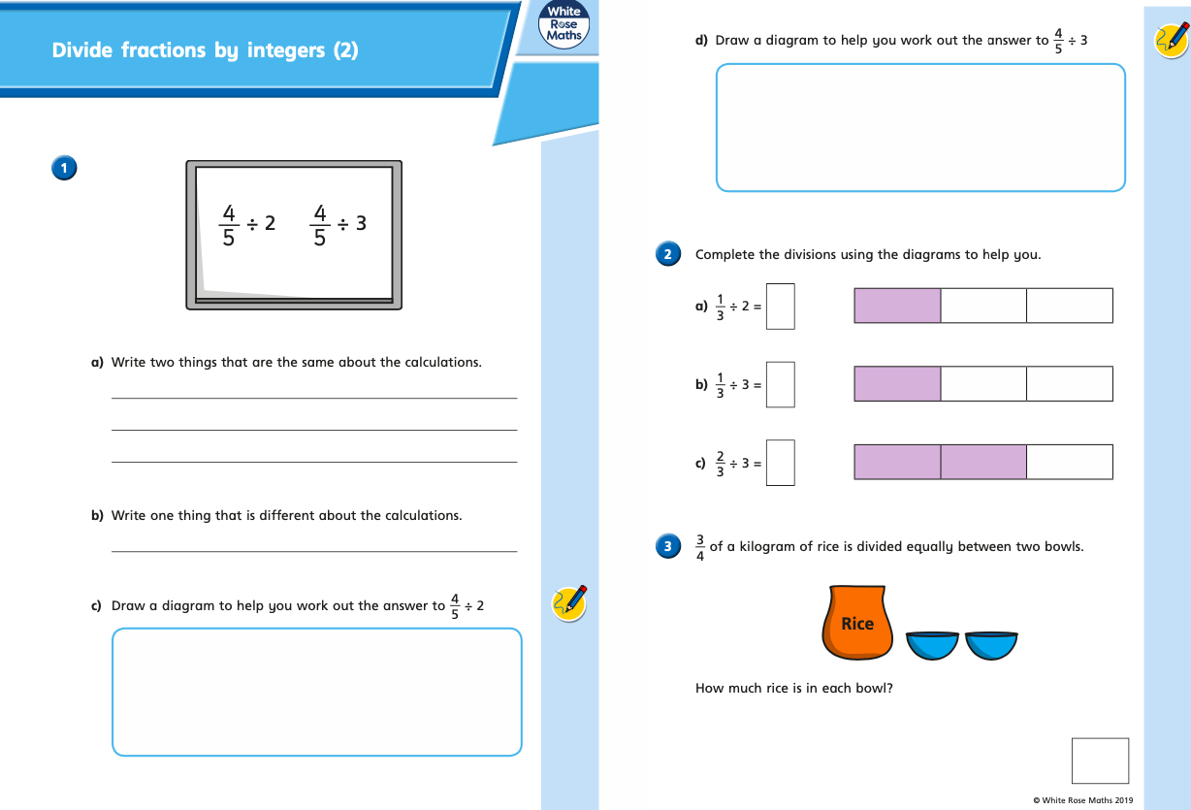
Wednesday (part 2)
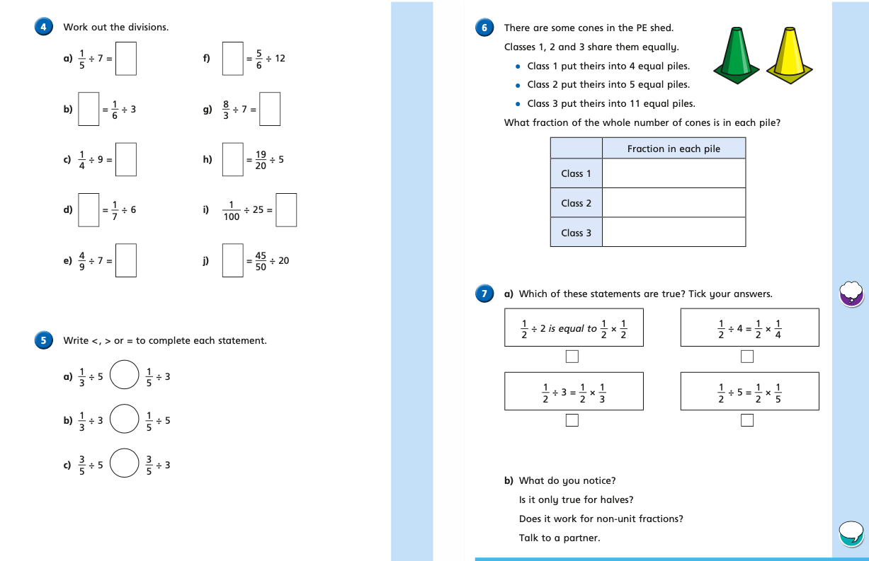
Thursday (part 1)
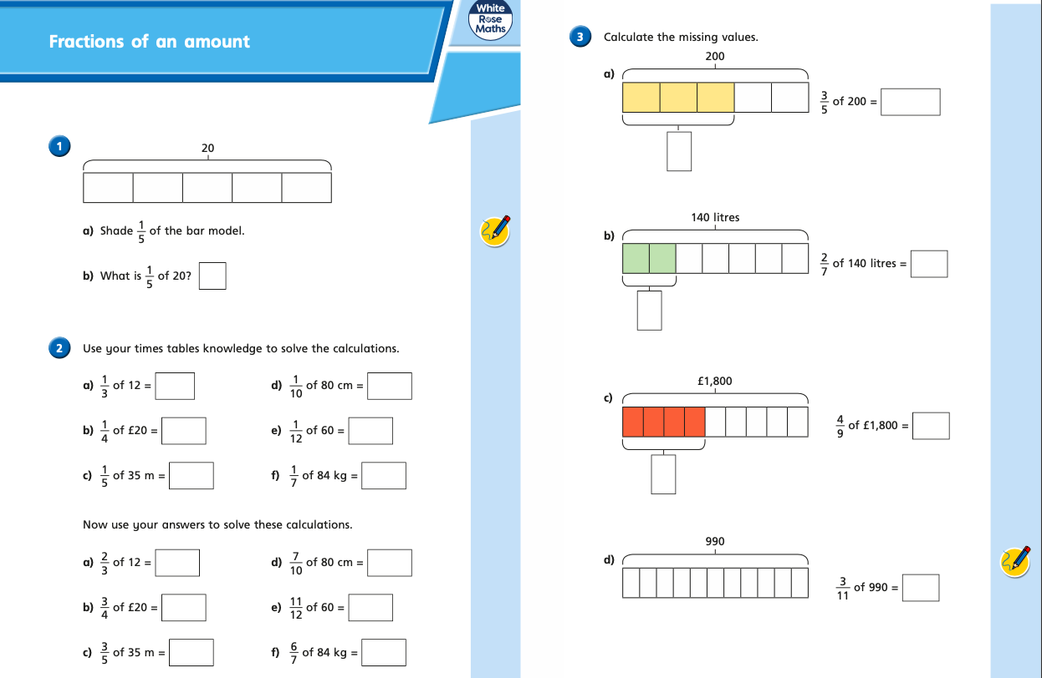
Thursday (part 2)
