Year 3 Maths
The objectives we are working on are...
- To count up and down in tenths; recognise that tenths arise from dividing an object into 10 equal parts and in dividing one-digit numbers or quantities by 10.
- To recognise, find and write fractions of a discrete set of objects: unit fractions and non-unit fractions with small denominators.
- To recognise and use fractions as numbers: unit fractions and non-unit fractions with small denominators

This week is another Fractions week. You can use what we did in school to help but also the work you did a few weeks will help too.

All the lessons can be found on https://whiterosemaths.com/homelearning/year-3/
This week’s learning is dated 1st June..
Monday: Tenths as decimals.

Monday Task 1 . Watch this video first to help you.
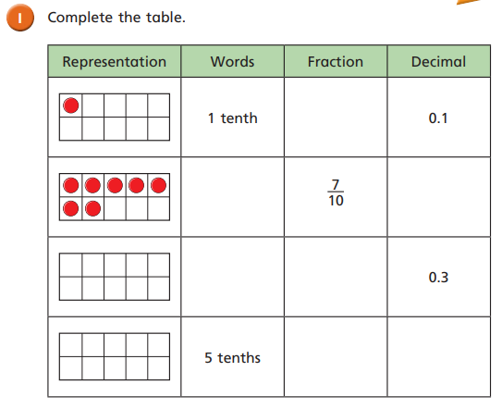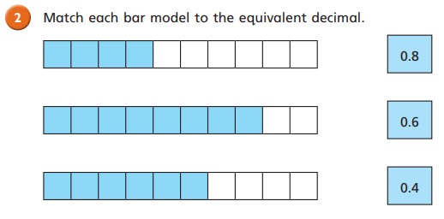

Monday Task 2
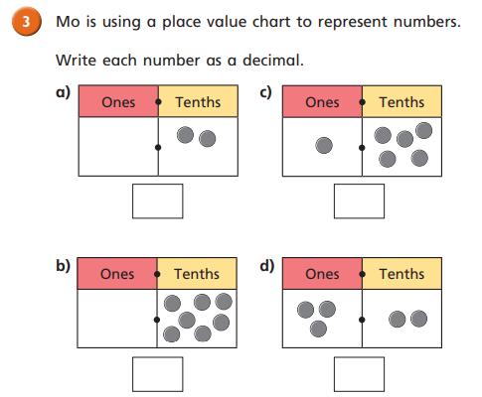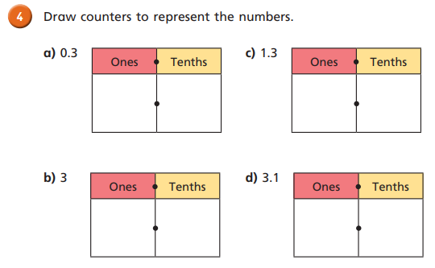

Monday Task 3
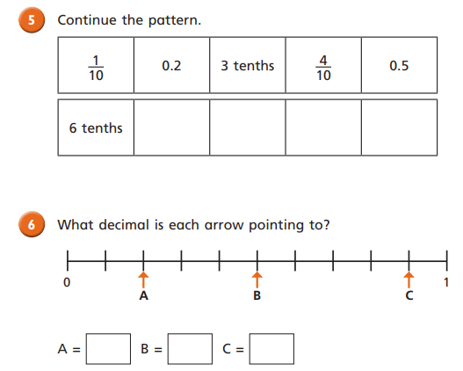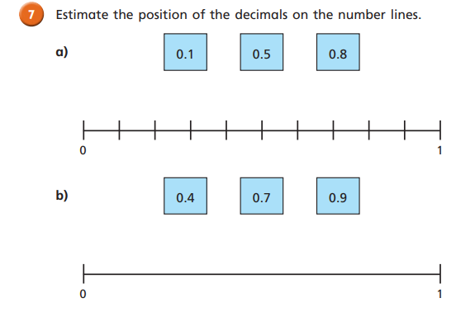

Monday Task 4
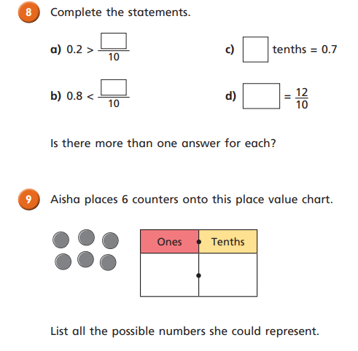
Tuesday Task 1. Fractions on a number line. Watch this video first.
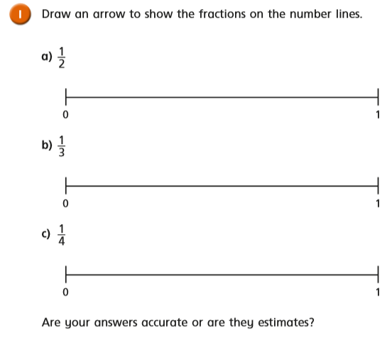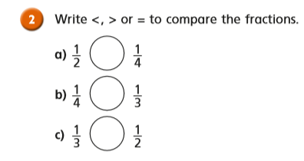

Tuesday Task 2.
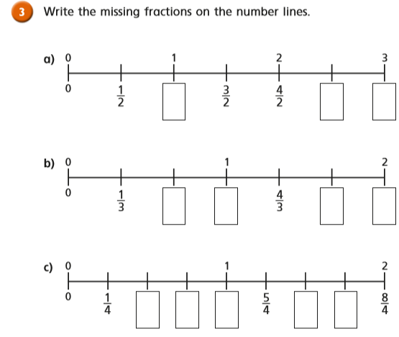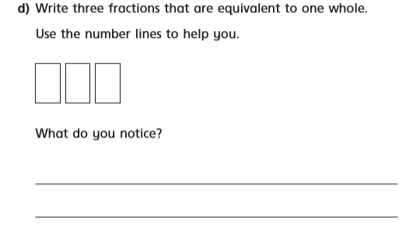

Tuesday Task 3.
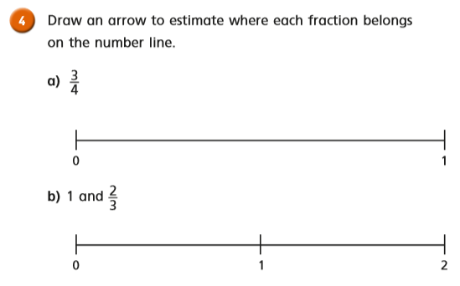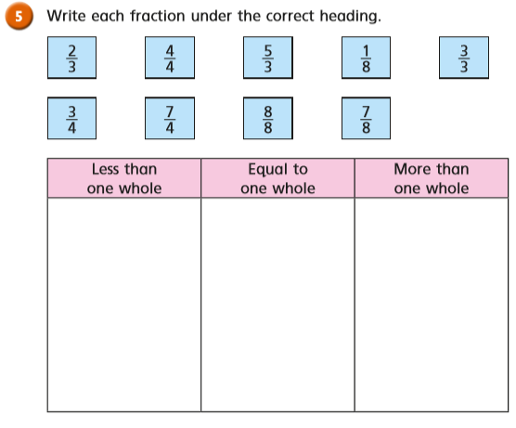

Tuesday Task 4.
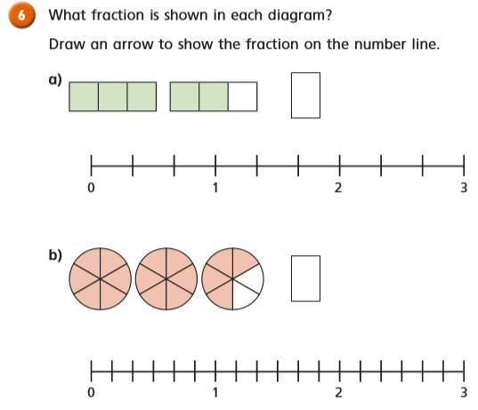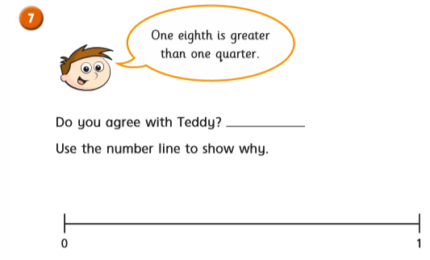

Wednesday Task 1. Fractions of a set of objects.
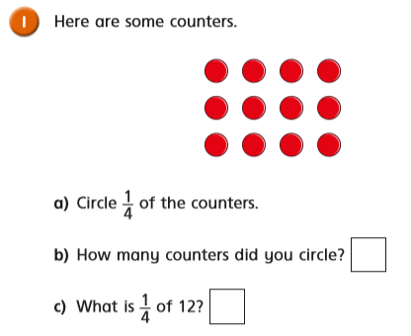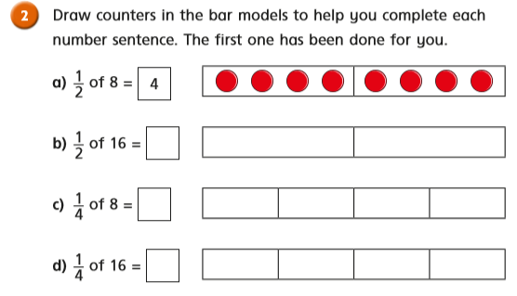

Wednesday Task 2.
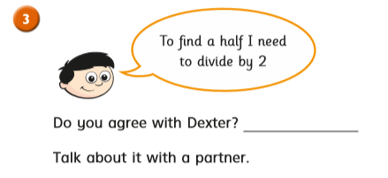

Wednesday Task 3.
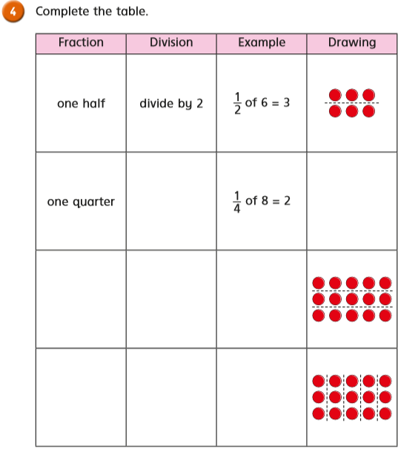
Wednesday Task 4.
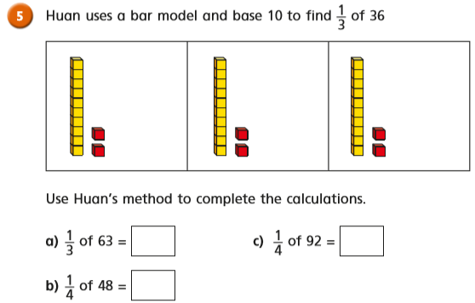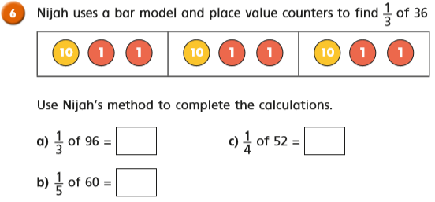
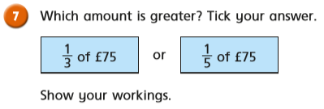

Wednesday Task 5.
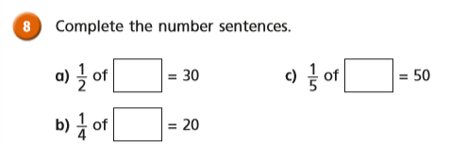
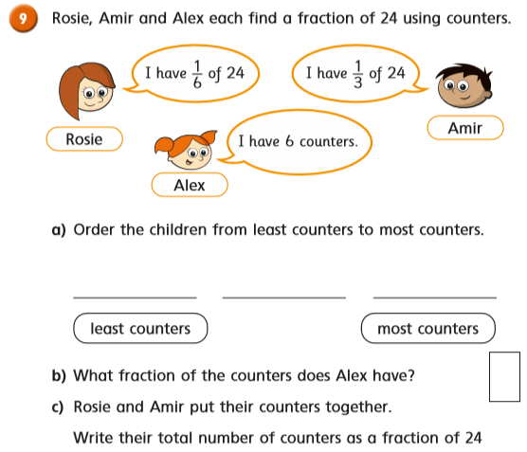
Thursday Task 1. Fractions of a set of objects. Watch this video first:
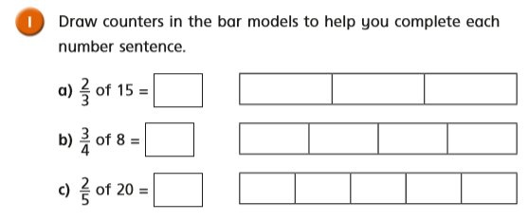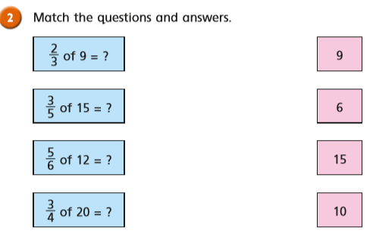
Thursday Task 2.

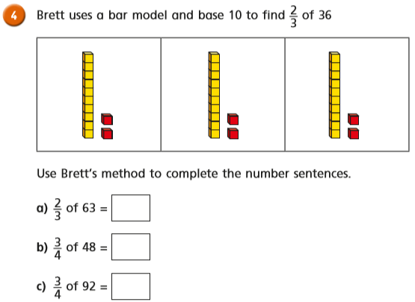
Thursday Task 3.
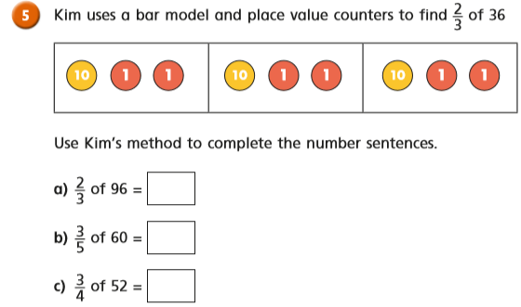

Friday Task 1.
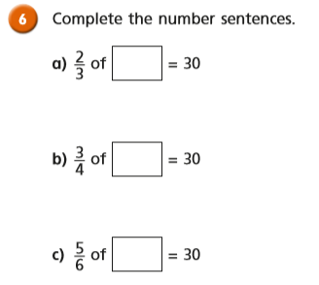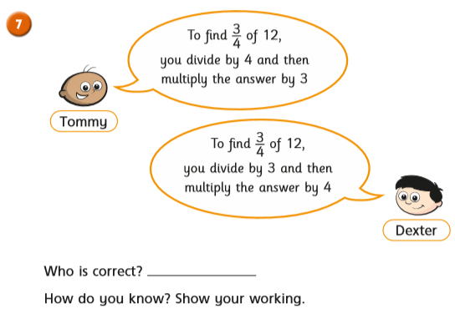

Friday Task 2.
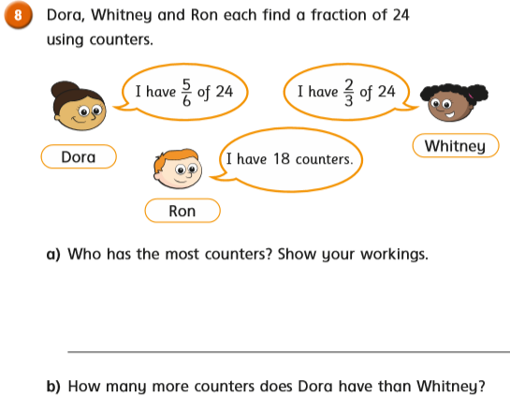
Friday Task 3.
