Maths Year 6
w/c 15.6.2020
The objectives we are working on in this week are:
- To recall and use equivalences between simple fractions, decimals and percentages, including in different contexts
- To solve problems involving the calculation of percentages [for example, of measures and such as 15% of 360] and the use of percentages for comparison

This week’s learning will be a recap of learning we carried out in school during the Spring term. On Monday, you will start by revisiting how to convert fractions to percentages; then on Tuesday, you will revisit finding equivalents between fractions, decimals and percentages; on Wednesday, you will then order fractions, decimals and percentages; on Thursday, you will be finding percentages of amounts and finally, on Friday, you can practise what you have learnt this week using activities on Classroom Secrets Kids.
Using the link below, click on Summer Term – Week 6 and each day (Monday – Thursday) watch the video and complete the accompanying task (these are printed in your pack). Lesson 1 – Monday, Lesson 2 – Tuesday, Lesson 3 – Wednesday, Lesson 4 – Thursday.
https://whiterosemaths.com/homelearning/year-6/
On Friday, use the following links to continue practising what you have learnt this week:

https://kids.classroomsecrets.co.uk/resource/percentages-of-an-amount-video-tutorial-1/

https://kids.classroomsecrets.co.uk/resource/order-fdp-video-tutorial/

https://kids.classroomsecrets.co.uk/resource/year-6-decimals-as-fractions-game/

https://kids.classroomsecrets.co.uk/resource/year-6-percentage-of-an-amount-game-2/

Monday (Part 1)
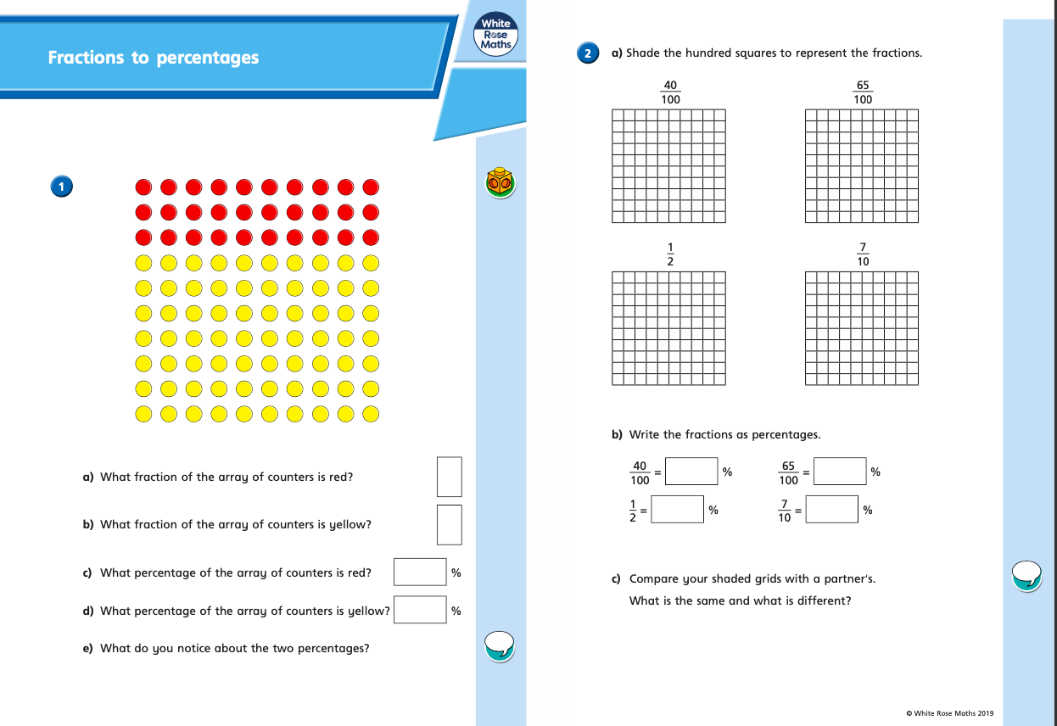
Monday (part 2)
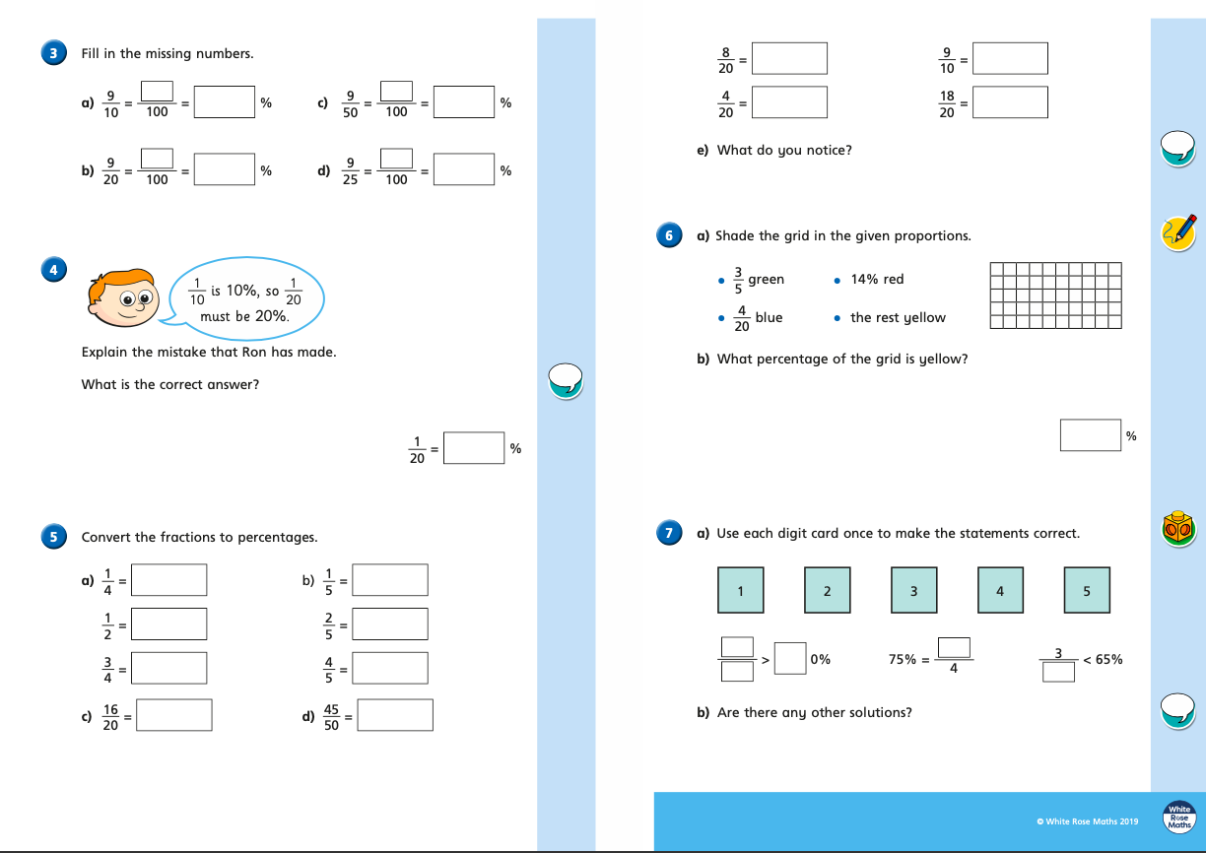
Tuesday (part 1)
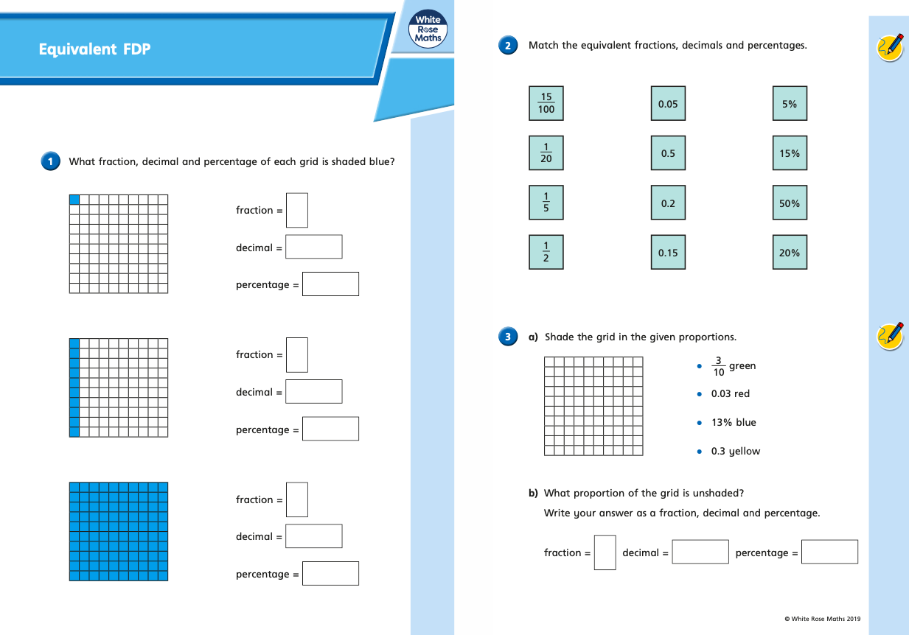
Tuesday (part 2)
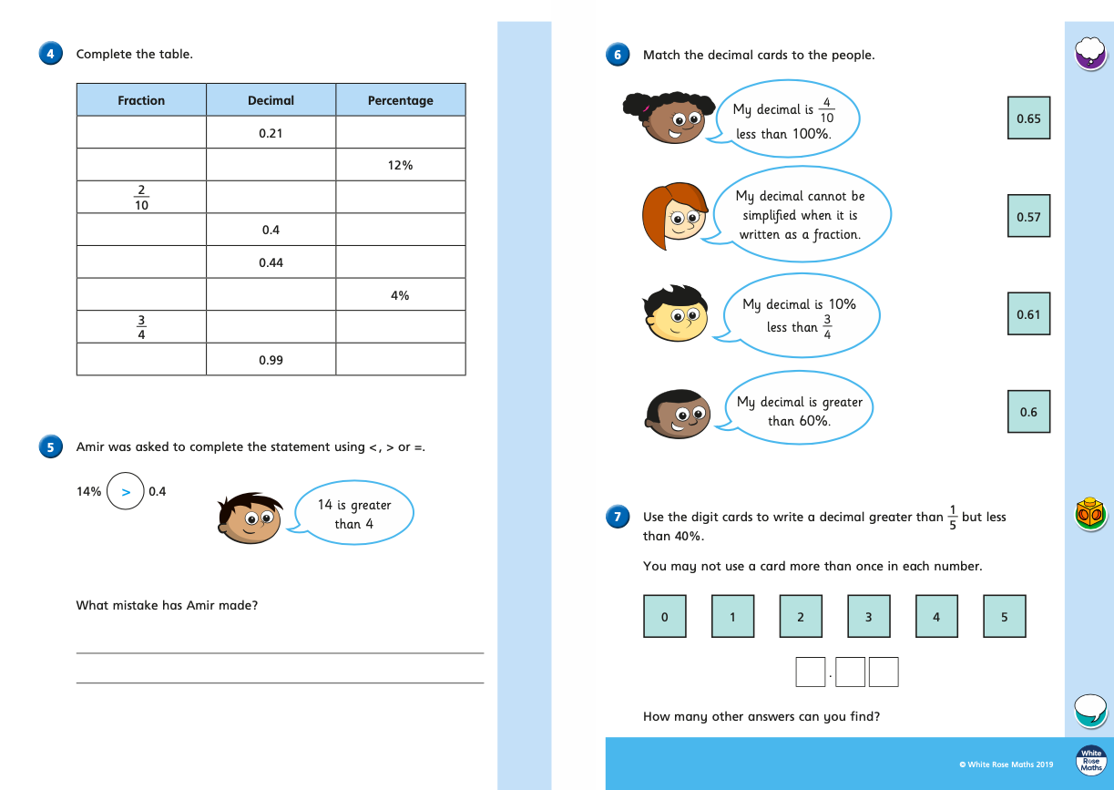
Wednesday (part 1)
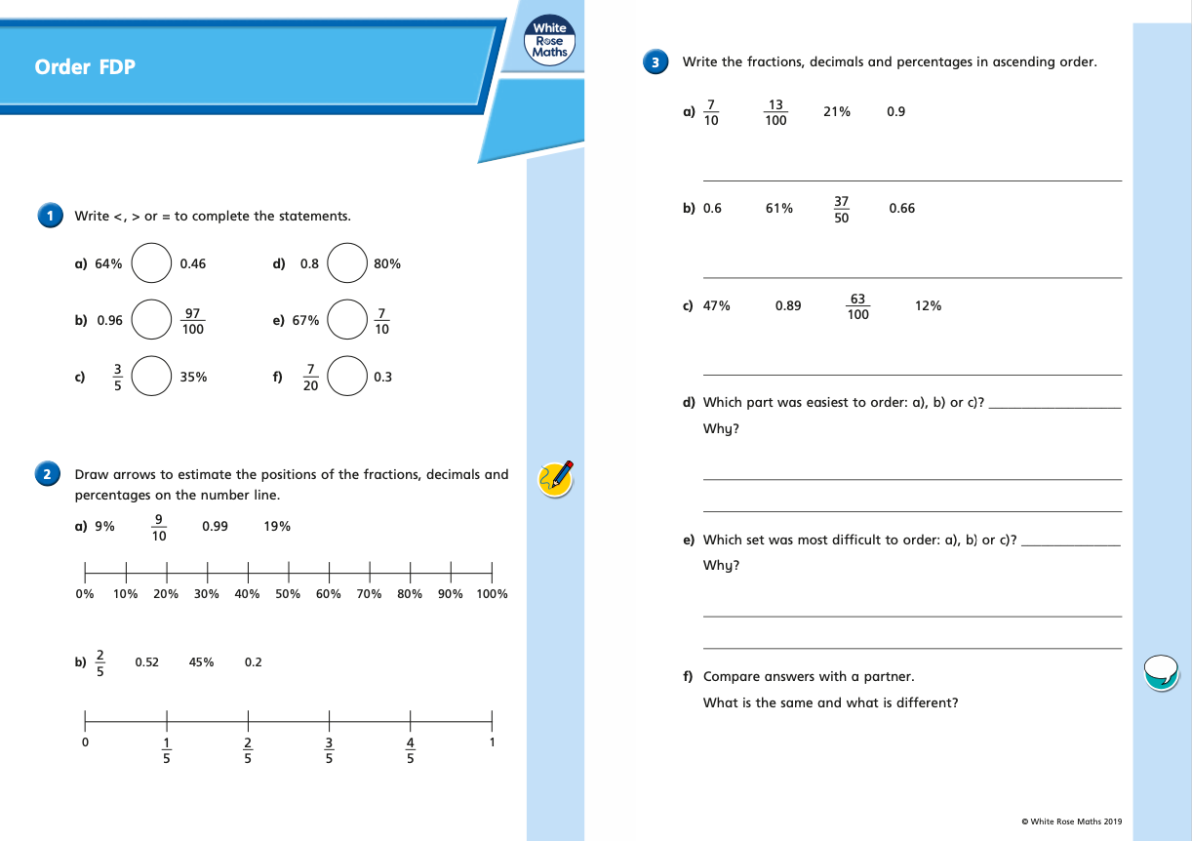
Wednesday (part 2)
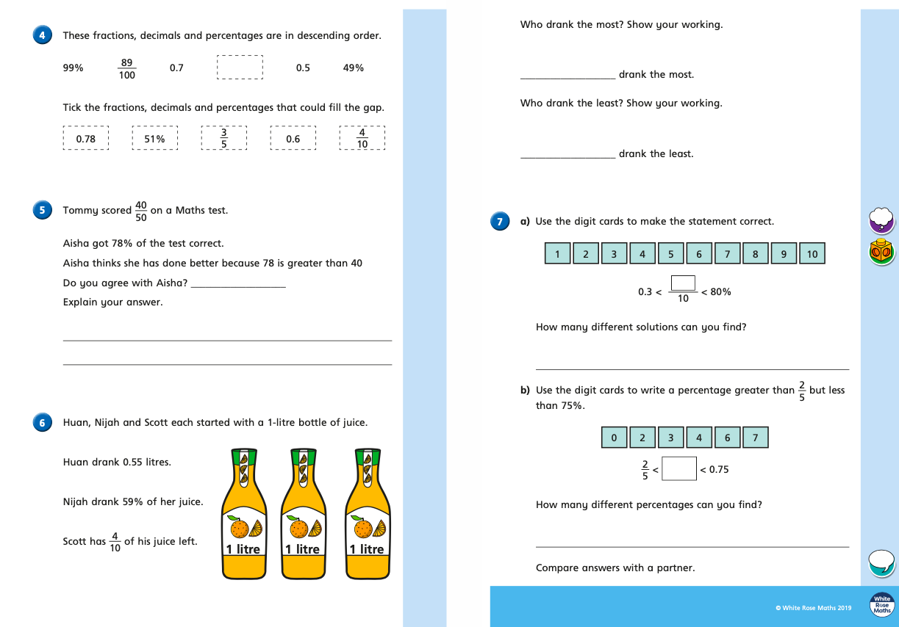
Thursday (part 1)
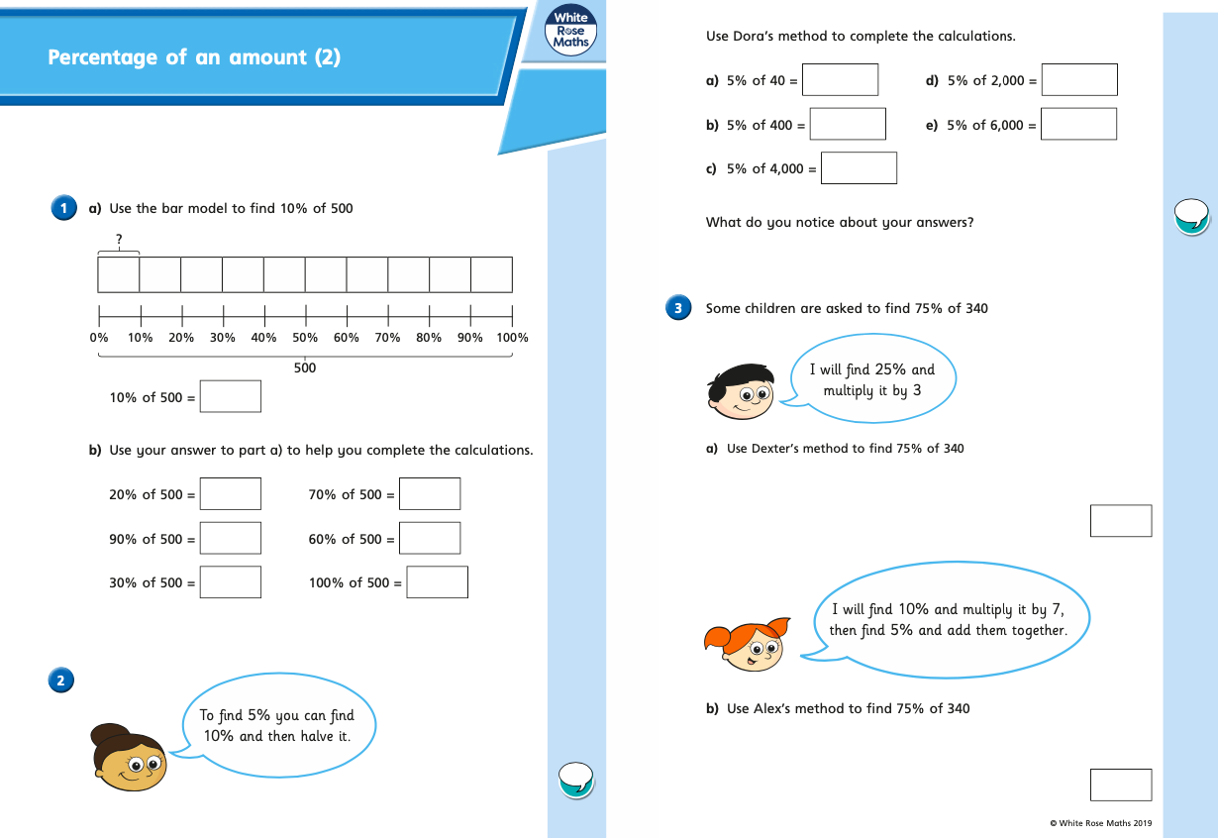
Thursday (part 2)
