Year 3 Maths
The objectives we are working on are:

- To recall and use multiplication and division facts for the 3, 4 and 8 multiplication tables.
This week is Times Tables week. Just a reminder, that by the end of Year 4, you should know all your time tables! No pressure! We’ve covered this in class, so this should be a great way to show what you can recall and how quickly and accurately you can do this.

All the lessons can be found on https://whiterosemaths.com/homelearning/year-3/
This week’s learning is dated 11th May.

Monday Task 1. Multiplying by 4 and 8. Watch this first https://vimeo.com/415086682
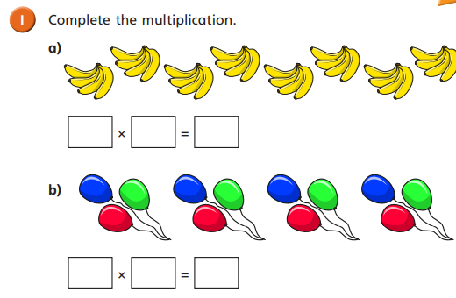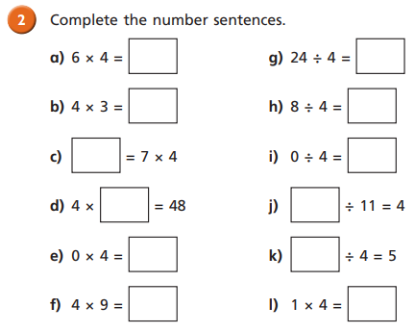

Monday Task 2
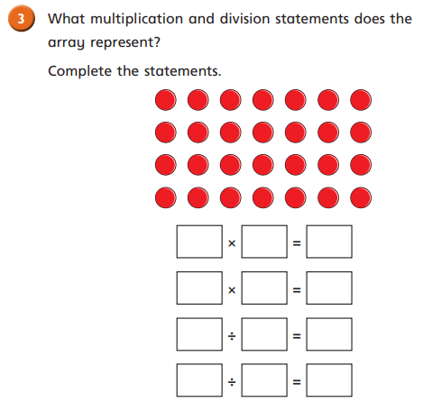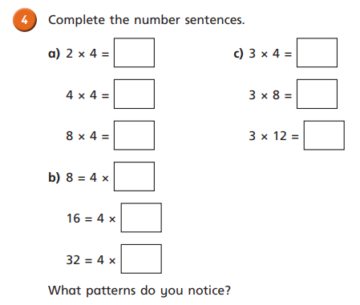

Monday Task 3
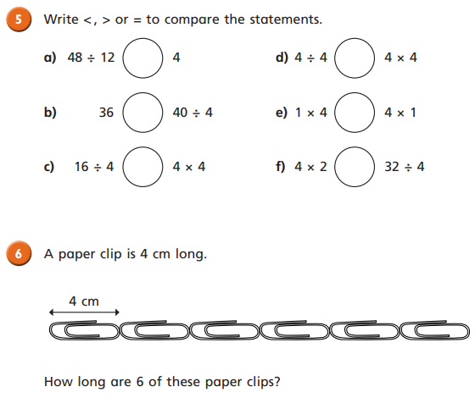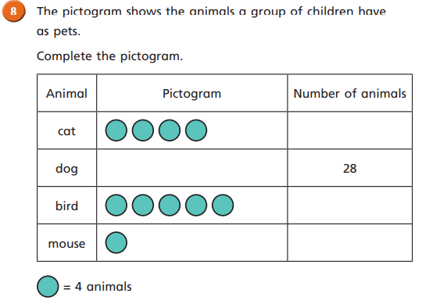
Monday Task 4.
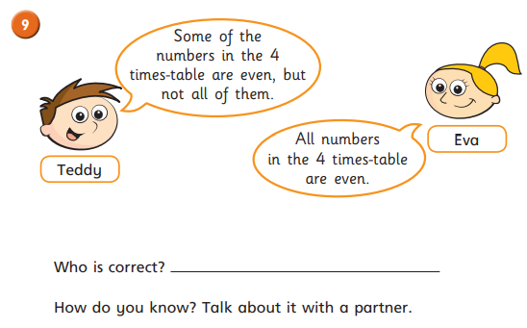

Monday Task 5.Multiplying by 8.
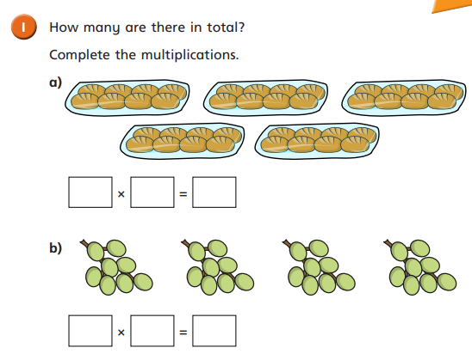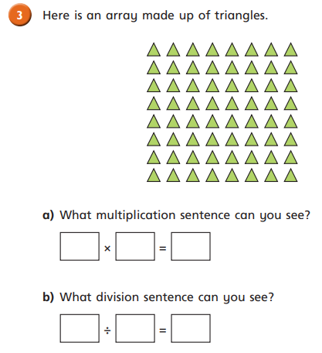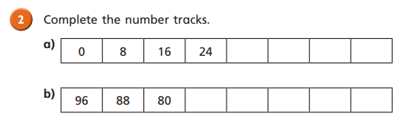
Monday Task 6. Multiplying by 8.
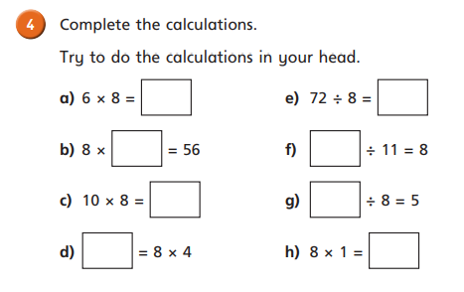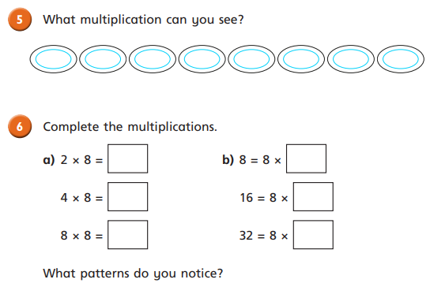

Monday Task 7 Multiplying by 8.
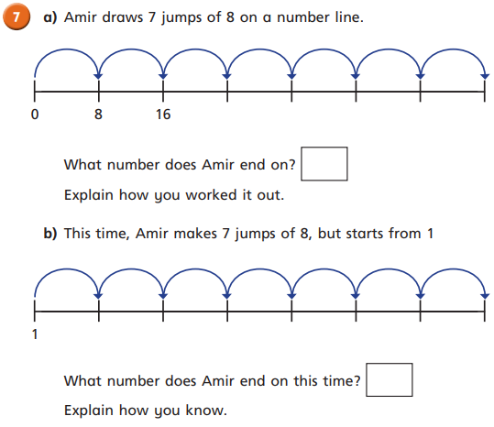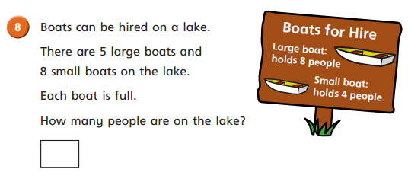

Monday Task 8. Multiplying by 8
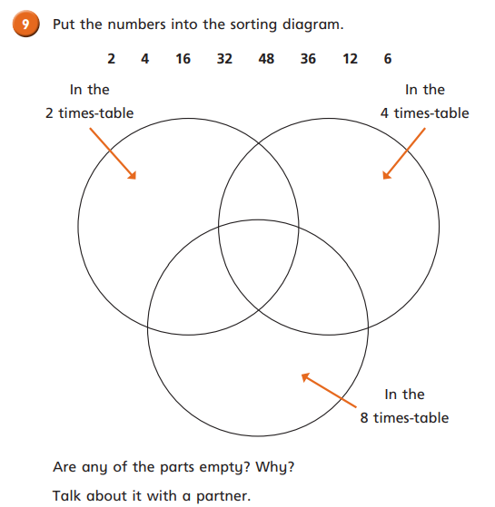

Tuesday Task 1.Multiply 2 digits by 1 digit. Watch this: https://vimeo.com/415086842
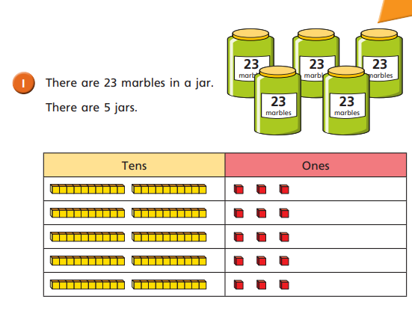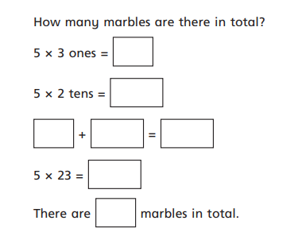

Tuesday Task 2. Multiply 2 digits by 1 digit.
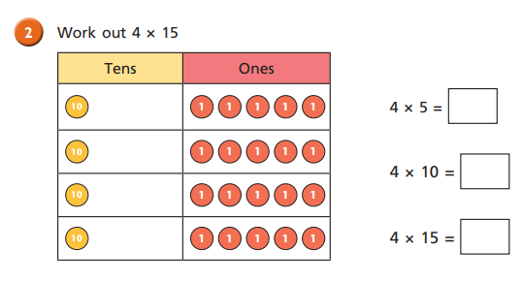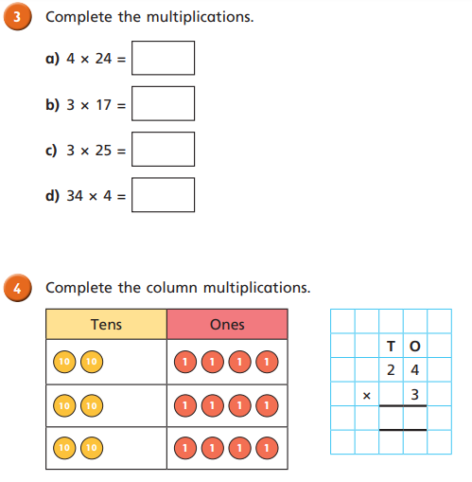

Tuesday Task 3. Multiply 2 digits by 1 digit.
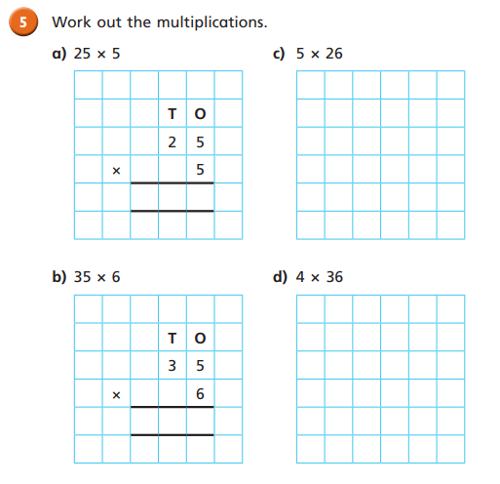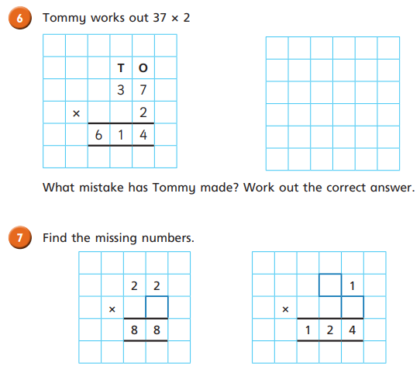

Tuesday Task 4. Multiply 2 digits by 1 digit.
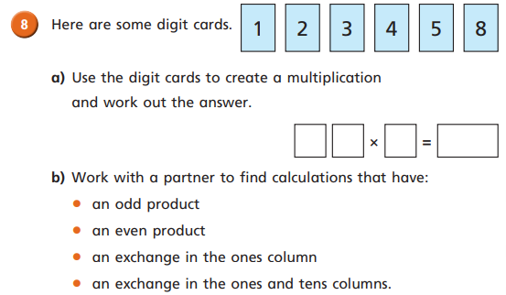

Wednesday Task 1. Divide 2-digits by 1-digit. Watch this: https://vimeo.com/415087020
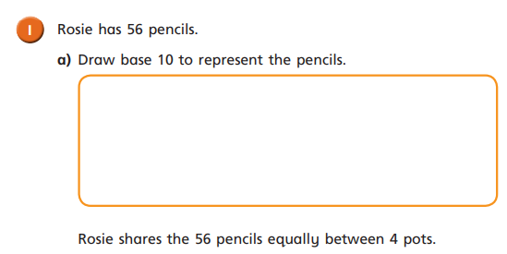
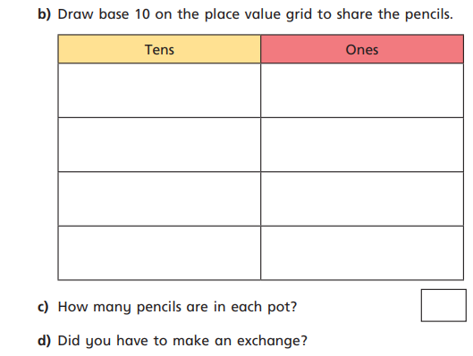
Wednesday Task 2.
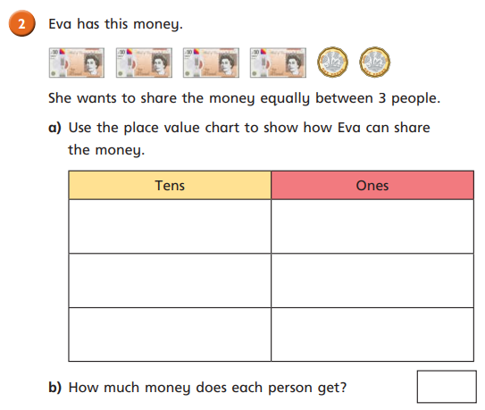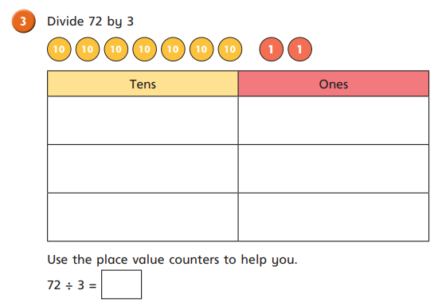

Wednesday Task 3.
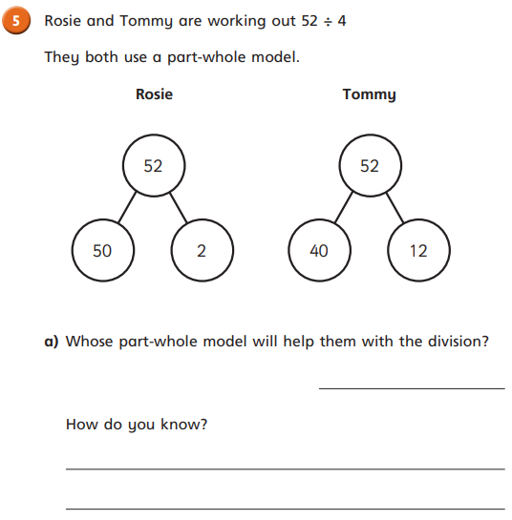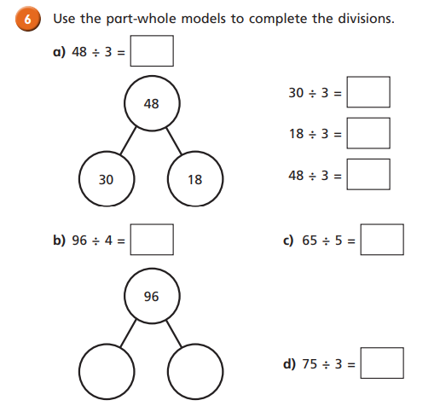
Thursday: Task 1. Word Problems. Watch the video first: https://vimeo.com/415087218
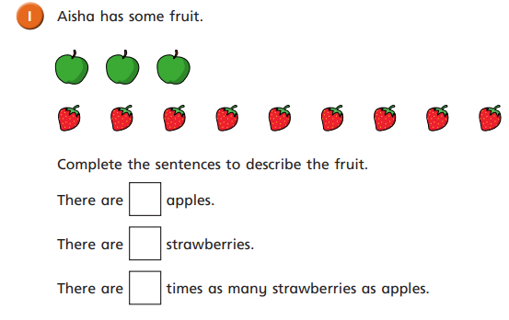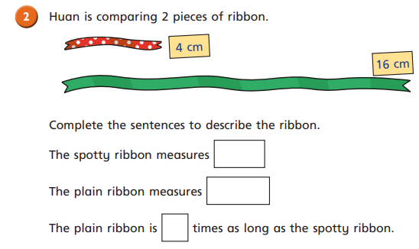

Thursday Task 2. Word Problems 2.
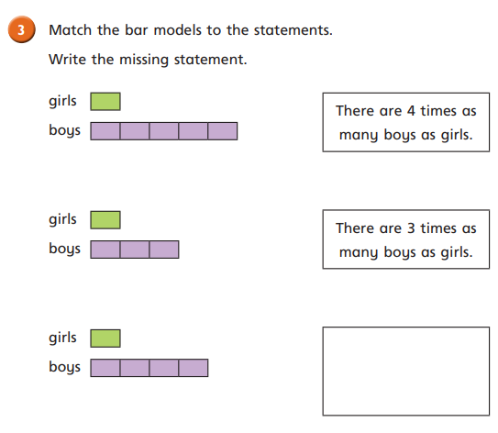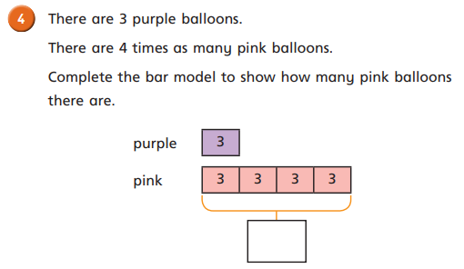

Friday Task 1.
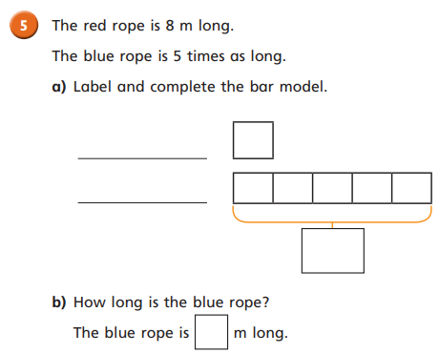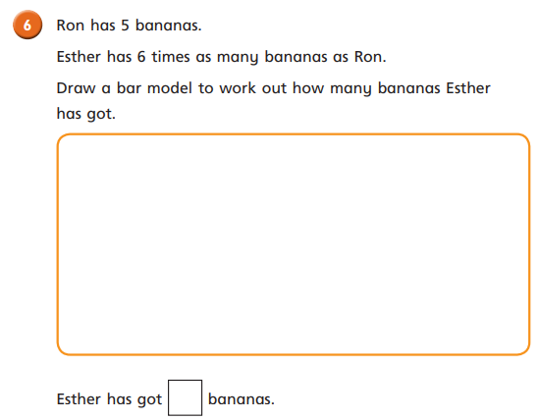

Friday Task 2.
