Year 1 Literacy Home Learning WC 29-6-20

Reading
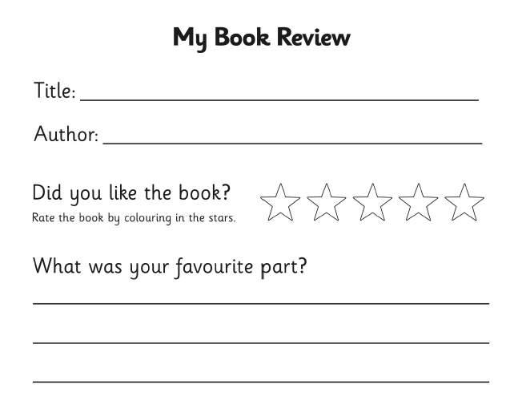
Monday - Read some books at home or online and share your thoughts. Complete a book review for one of the books that you have read.

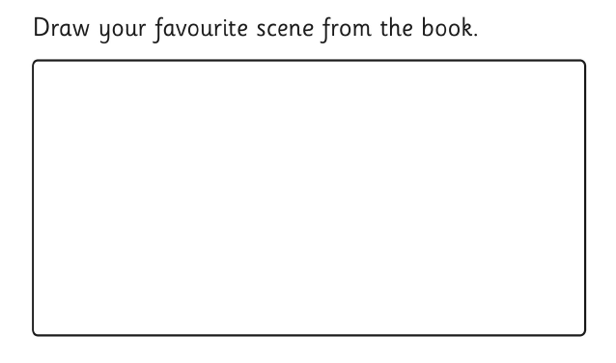

Tuesday
Complete Reading Eggs tasks.

Wednesday
Complete the Year reading comprehension ‘The Forest Sports Day’ on Classroom Secrets.
https://kids.classroomsecrets.co.uk/resource/animals-year-1-reading-comprehension-the-forest-sports-day/

Thursday
Complete Reading Eggs tasks.

Friday
Complete ‘Layers of the Ocean’ comprehension – page 3.

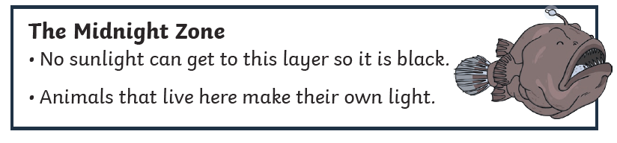
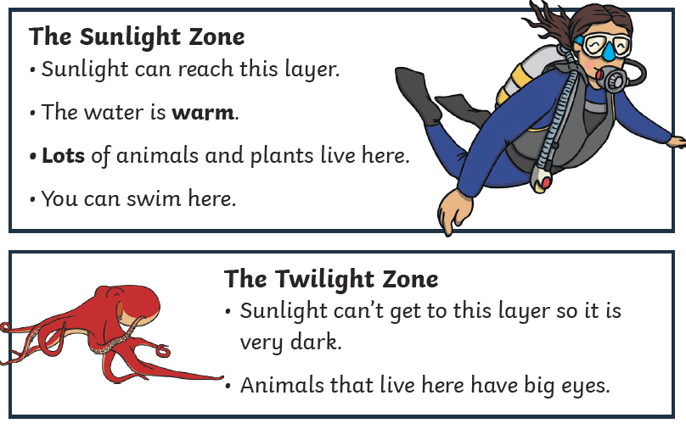
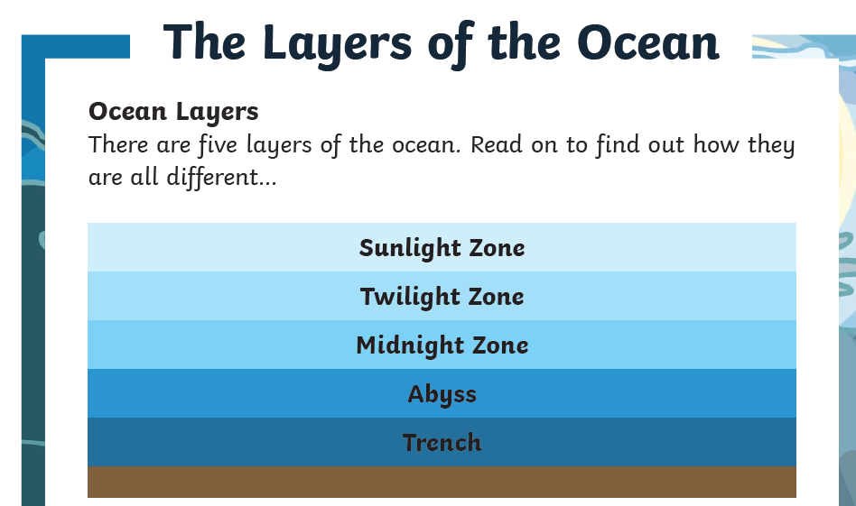
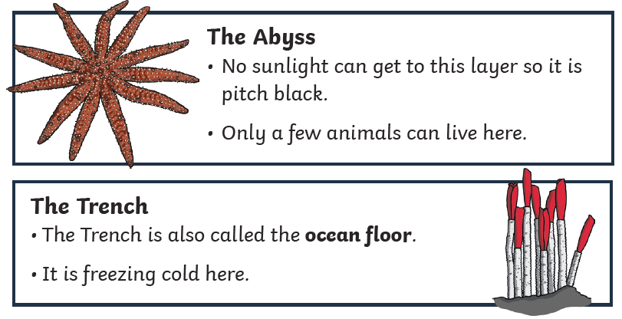
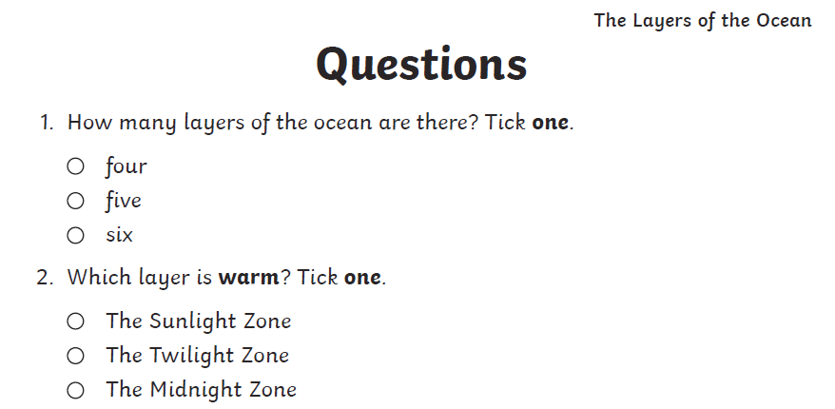
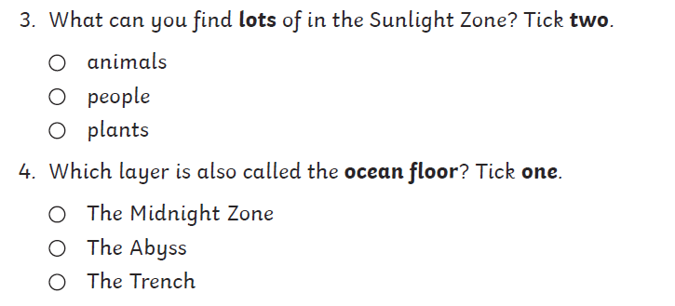
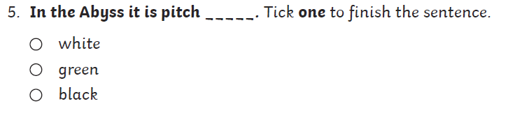

Writing - This week our focus story is ‘Jack and the Beanstalk’.
Monday Read or watch the story then order the pictures in your work book and write what is happening in each part of the story.
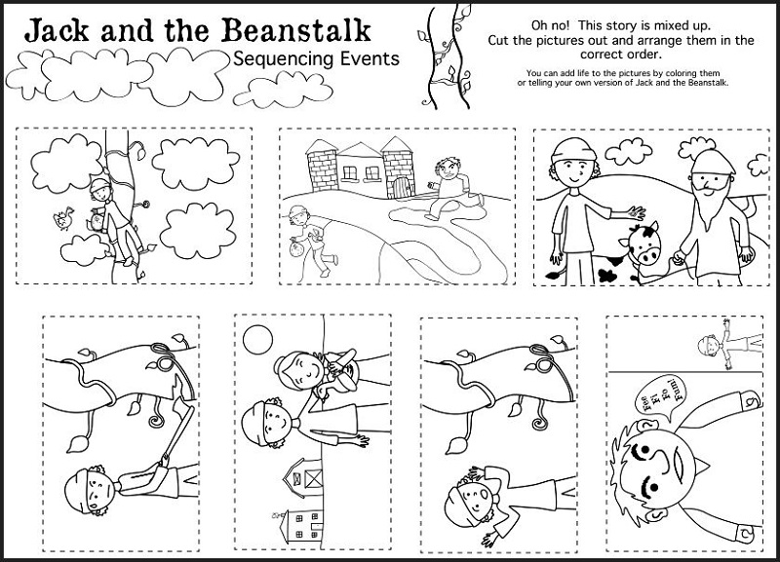

Tuesday
Write some words / phrases to describe the Jack, the egg and the hen (remember to use adjectives). Think about his personality as well as describing how he looked eg ‘Jack was clever because he was able to trick the giant.’ or ‘Jack was brave to climb the beanstalk because it was very high and he didn’t know what was at the top.’.

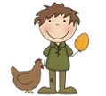

Jack was ______________________________________________________________

__________________________________________________________________________

___________________________________________________________________________

___________________________________________________________________________
Wednesday
It was dangerous for Jack to climb up the beanstalk.
Create a poster warning other children about the dangers of climbing up the beanstalk.

BEWARE!
Do not climb up the beanstalk

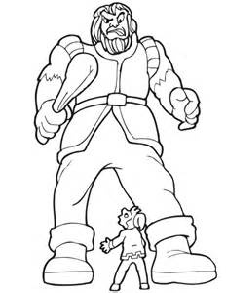

___________________________________________________________________________

___________________________________________________________________________

___________________________________________________________________________

___________________________________________________________________________

Thursday
When Jack was being chased, what might Jack and the Giant be saying?

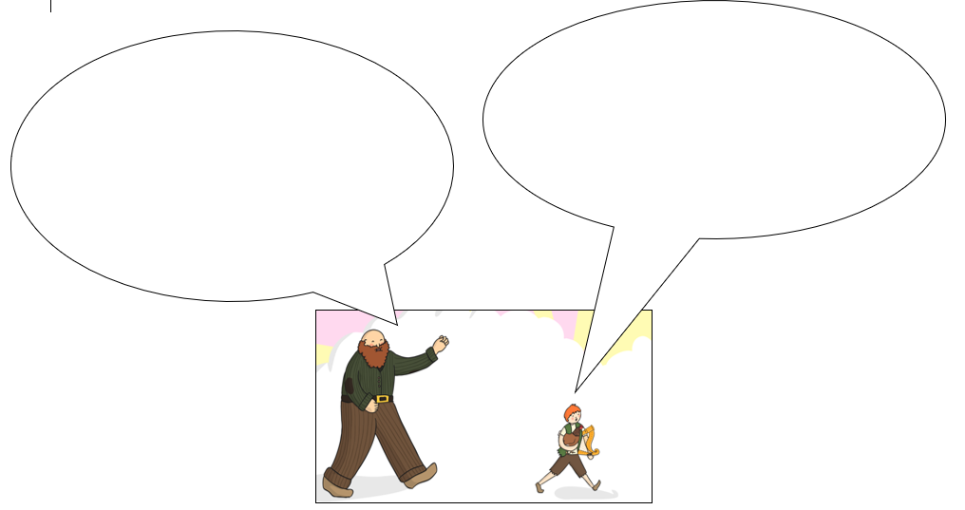

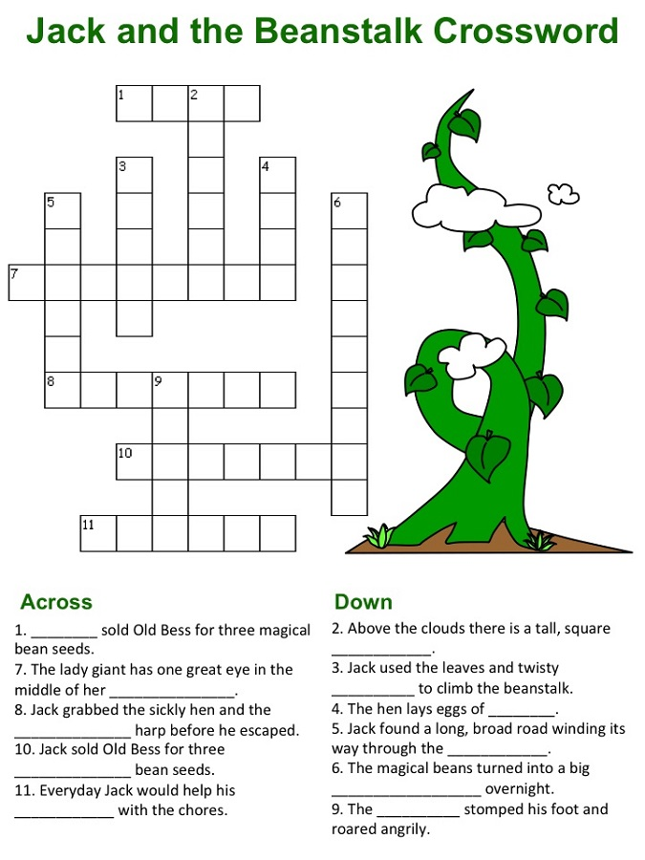
Friday – Task 1 - Use the clues to complete the crossword.

Crossword words

mother singing castle
vines Jack

forehead gold beanstalk

giant clouds magical

Friday – Task 2 – Adjectives
Adjectives describe nouns. Write 2 adjectives to describe each picture.

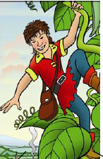

___________________________________________________

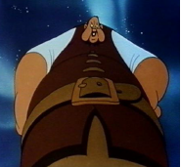

__________________________________________________

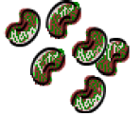
__________________________________________________

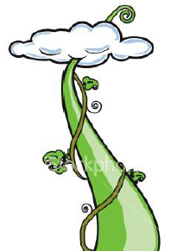

__________________________________________________

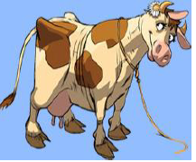
__________________________________________________

Phonics Monday – alternative spellings for /ew/
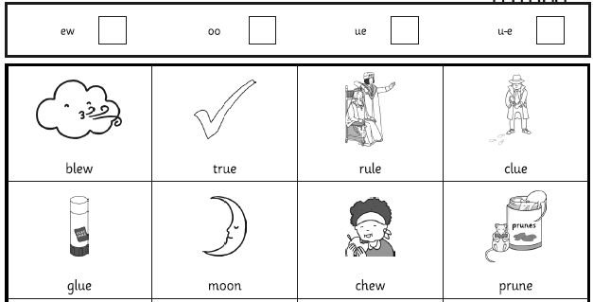

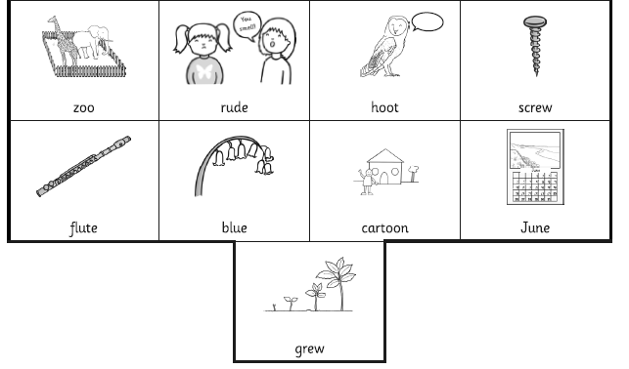

Phonics Tuesday – Split digraph o-e revision
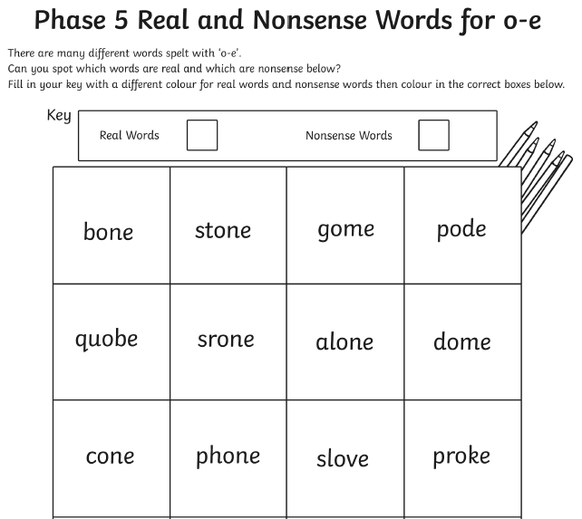

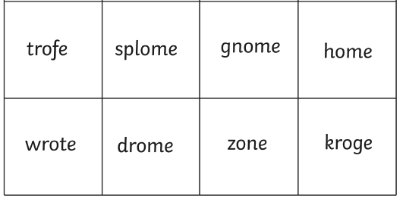

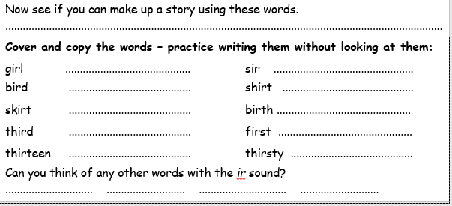
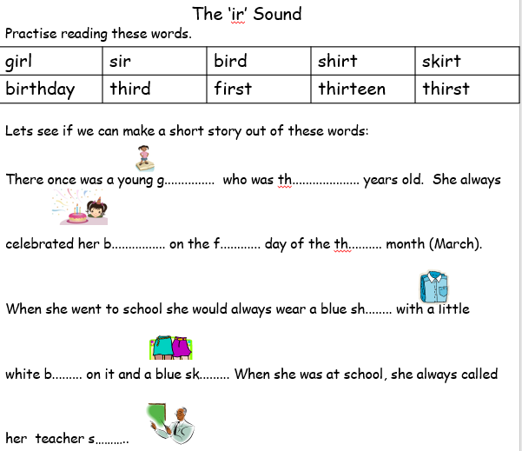
Phonics Wednesday – The /ir/ sound

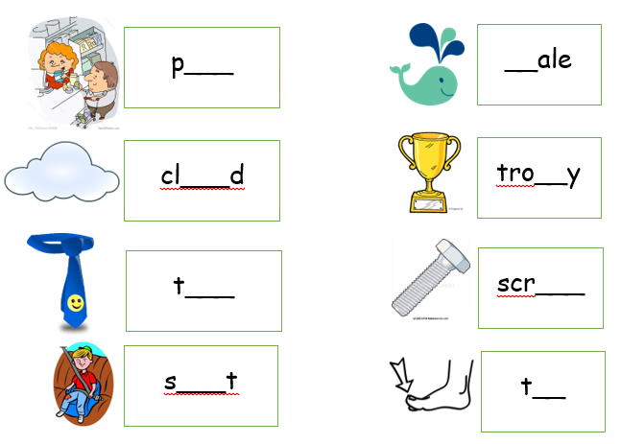
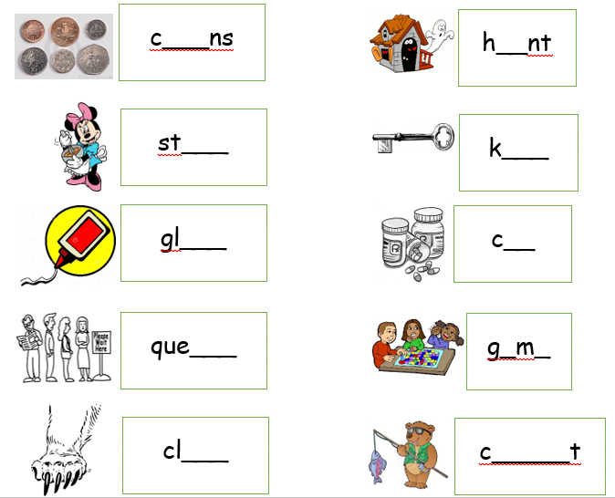
Phonics Thursday – Phase 5 revision
Friday – SPAG

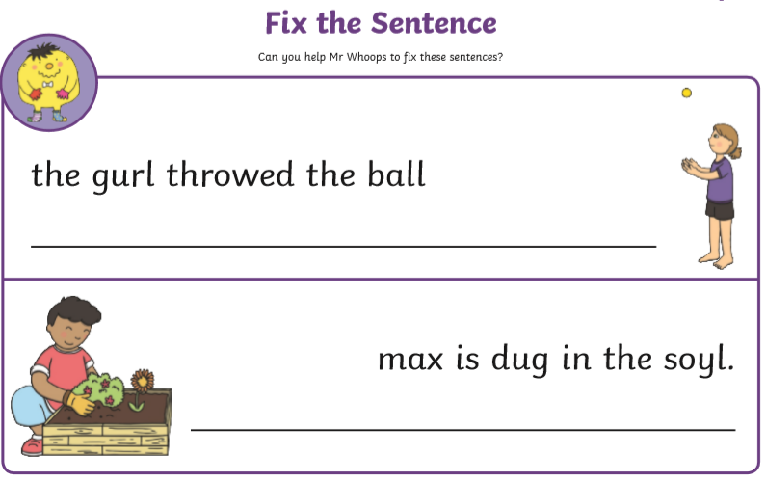

Friday – high frequency words handwriting

