Year 1 Literacy Home Learning WC 1-6-20

Reading
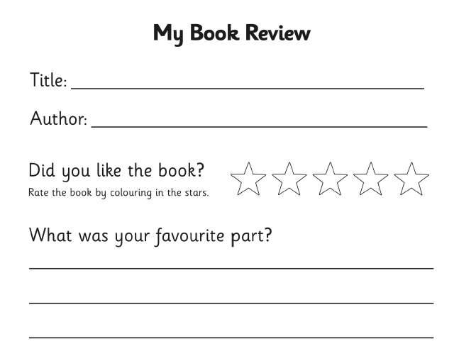
Monday - Read some books at home or online and share your thoughts. Complete a book review for one of the books that you have read.

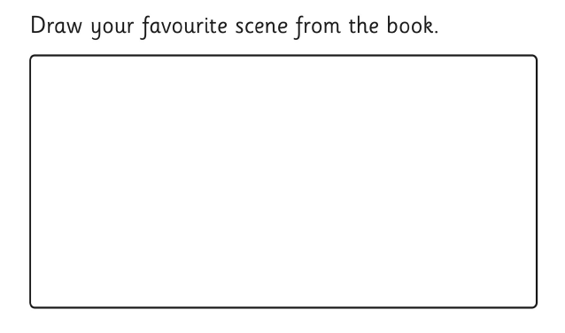

Tuesday
Complete Reading Eggs tasks.

Wednesday
Complete the Year 1 reading comprehension ‘Odd Socks’’ on Classroom Secrets.
https://kids.classroomsecrets.co.uk/resource/year-1-reading-comprehension-fiction-odd-socks/

Thursday
Complete Reading Eggs tasks.

Friday
Complete ‘Taking Care of a Dog’ comprehension – pages 3 & 4.

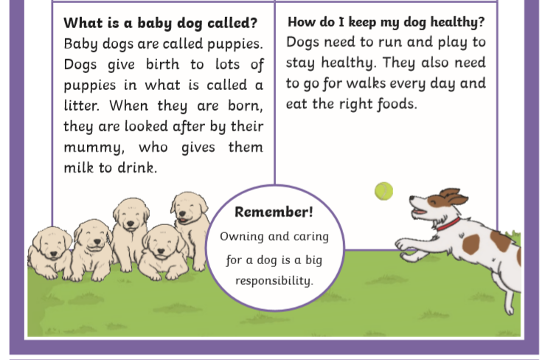
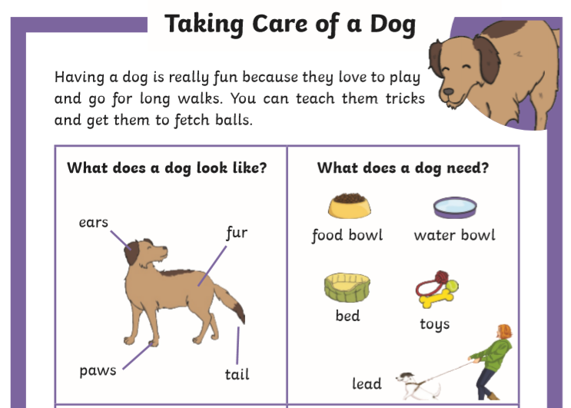

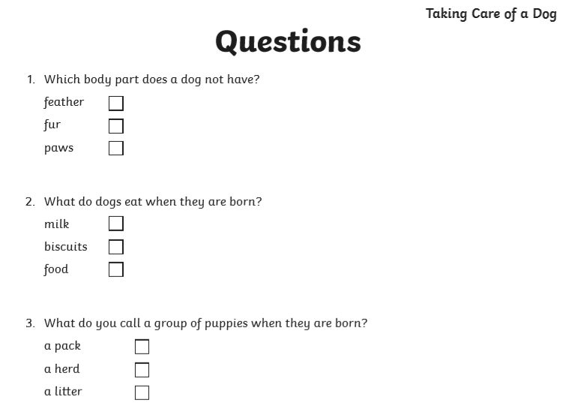
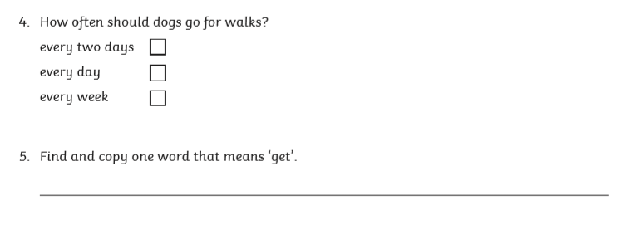

Writing
This week, we are using a film clip as a stimulus for our writing – it is all about a caterpillar and his shoes!
Watch the story of Caterpillar Shoes.
https://www.literacyshed.com/caterpillar-shoes.html

Monday
Think of some adjectives to describe the caterpillar and use page 7 to record your ideas.

Tuesday
Use your adjectives from yesterday to write a description of the caterpillar (write in your home learning book).
For example:
The long green caterpillar had a bumpy yellow back. He had curly blue antenna and large bulging eyes. As he crawled through the thick green grass is tiny feet walked in a wave. On each of his miniature feet he wore different styles of shoe.

Wednesday
Imagine that you were the beetle. What would you say to the caterpillar when he gave you one of his shoes?
Complete the speech bubble on page 8.

Thursday
The beetle was so pleased with her new shoes that she decided to write a thank you letter to the caterpillar. Use the template on page 9 to write your letter.
For example:
Dear Mr Caterpillar,
Thank you for giving me your old shoes, I love them! I have always wanted some shiny black shoes so that I can go dancing in them.
When I tried them on, they fit perfectly. They made me feel happy and proud. Now I wear them all the time because they are my favourite. All of my friends are jealous of me because I have the shiniest shoes!
I hope that your feet don’t get cold without your shoes! I think that you are the kindest caterpillar that I have ever met.
I hope that someday, I can return the favour and do something kind and generous for you.
From
Miss Beetle

Friday
When the caterpillar had given away all of his shoes, I wonder how he felt and what he was thinking.
Complete the thought bubble on page 10 to record your ideas.

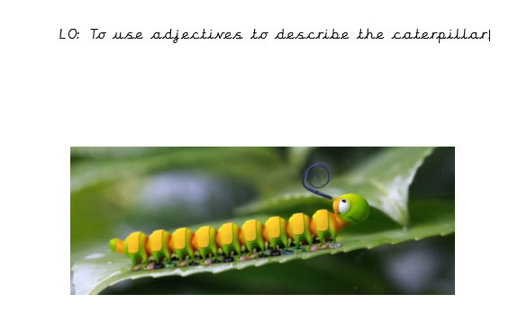

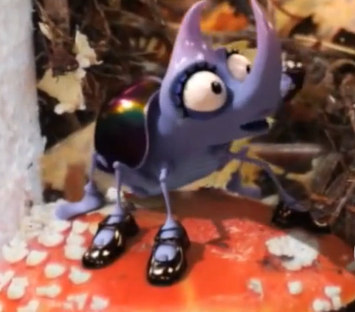

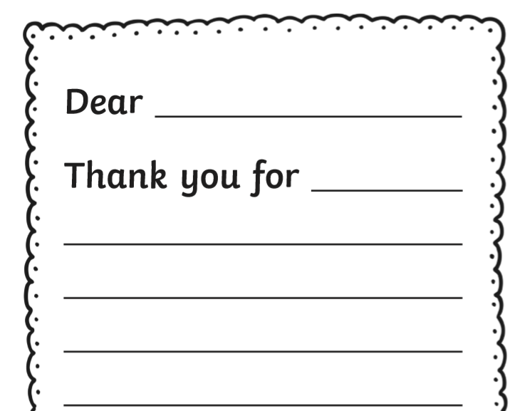
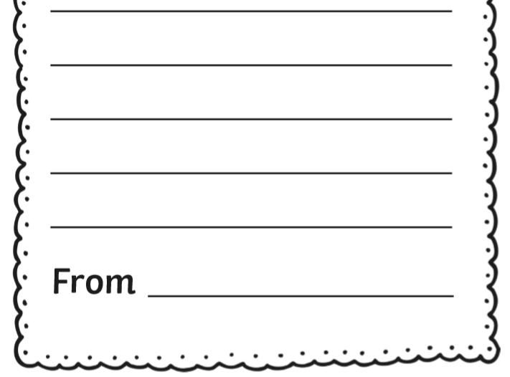

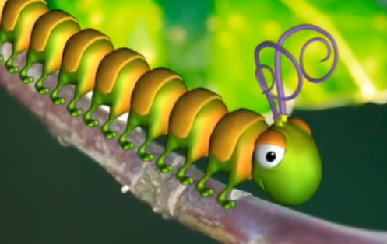
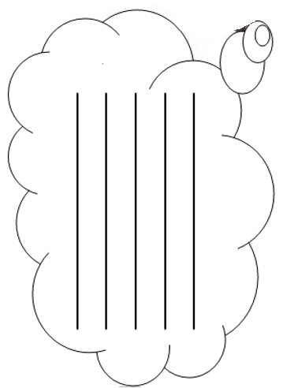

SPAG (Spelling, Punctuation And Grammar)
Verbs
Verbs tell us the actions that things do. Write a verb to say how each insect might move.

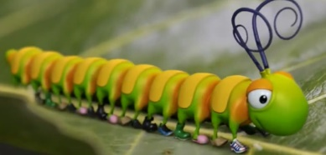
__________________________________

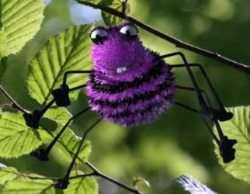

___________________________________

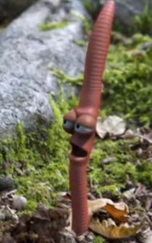

_____________________________________

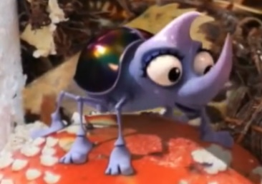
____________________________________

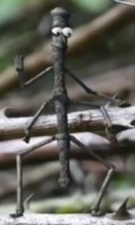

____________________________________

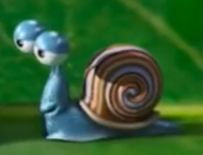
_____________________________________

Classroom Secrets – GPS section – Play the Capital Letters for Places game.
https://kids.classroomsecrets.co.uk/resource/capitals-game-year-1-capital-letters-for-places/

Phonics
Monday – ie spelling
Watch Geraldine Giraffe learns ie then complete the ie spelling sheet on page 13.
https://www.youtube.com/watch?v=DoPUHeA0CHA

Tuesday – split digraph i-e
Watch Geraldine Giraffe learns i-e then complete the i-e spelling sheet on page 14.
https://www.youtube.com/watch?v=o9JSTYL7vyc

Wednesday – alternative spellings igh, ie, i-e, y
Complete the alternative spelling tasks on page 15.

Thursday – alternative spellings igh, ie, i-e, y
Complete the grapheme word sort on page 16.

Friday – Reading phase 5 words
Play Classroom Secrets game ‘Phonics word match ay who u ie’ game.
https://kids.classroomsecrets.co.uk/resource/phonics-word-match-ay-wh-oy-ou-ie-game-phase-5/

Happy Learning!
Miss Ryder

