

**Year 2 Writing  for 1.6.20**

**Monday**

**Phonics** – How many words can you make using the alternative pronunciation for ‘**ey’**? Can you create some silly sentences or stories using the words below? Read the following comic linking to the sound we are looking at. <http://www.phonicsplaycomics.co.uk/comics.html>

Cut out the following ‘ey’ words. Can you sort them into two piles depending on how you pronounce ‘ey’?

Play the spelling game on <https://kids.classroomsecrets.co.uk/resource/year-2-spelling-game-3/>

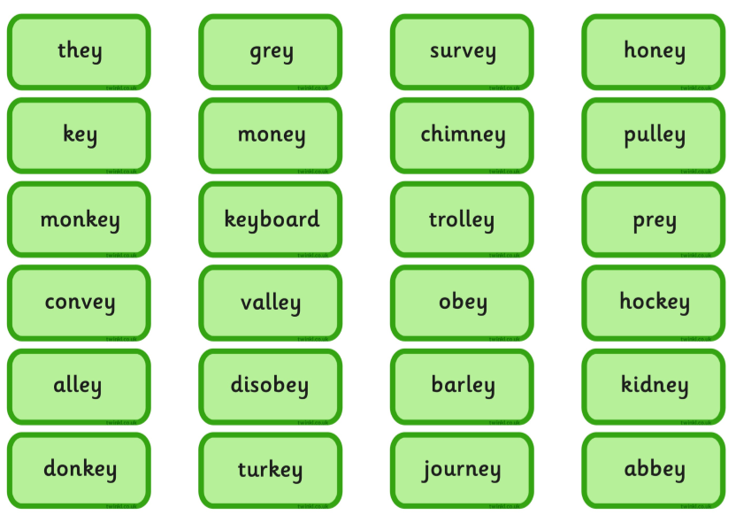

**Reading** – Complete a Reading Eggs lesson. Read your reading book to someone at home and share your thoughts. Complete a book review for one of the books you have read.

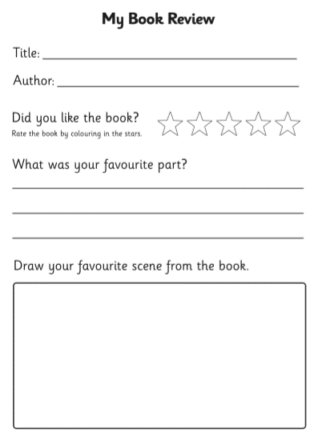

**Tuesday**

Complete the following comprehension about ‘Orangutans’

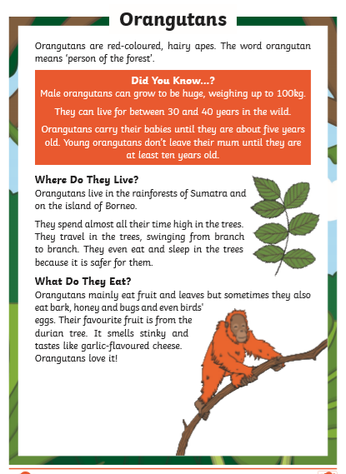

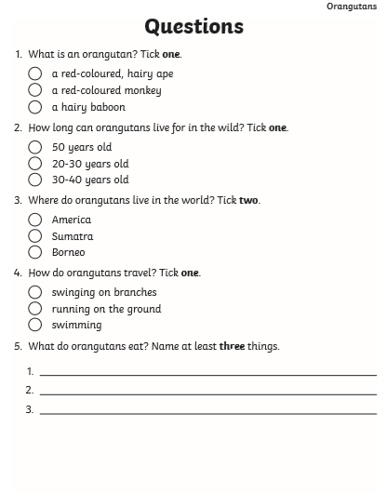

**Complete the word search**

Complete the word search

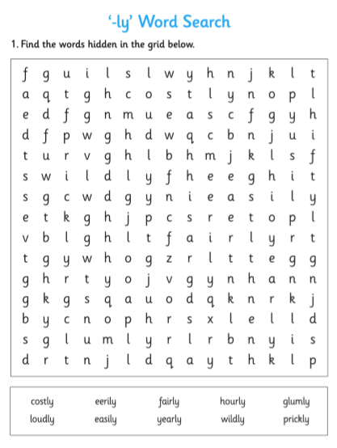

**Wednesday - SPAG – speech marks**

Watch the following to remind yourself about speech marks. <https://www.bbc.co.uk/bitesize/topics/zvwwxnb/articles/ztcp97h> In this video they call them inverted commas. They are exactly the same as when we looked at them in class. Do you remember when we said they looked like the numbers 66 and 99?

Play this game on Classroom Secrets Kids:

<https://kids.classroomsecrets.co.uk/resource/year-2-speech-punctuation-game-activity/>

Now look in your reading book, can you spot any speech marks?

This week we are going to look at the story ‘Monkey Puzzle’ by Julia Donaldson. On the next page I have put some pictures of the animals in the story with a speech bubble next to their head. What do you think the animals might be saying? Write what you think in the bubble (you do not need to look at the story yet). Then on the lines at the side, write out what the animals say using speech marks “ “

Remember, the speech marks only go around the words the animals have spoken!

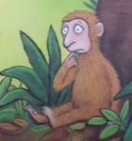

­­­­­­­­­­­­­­­­­­________________________________________________________________________________________________________________________________________

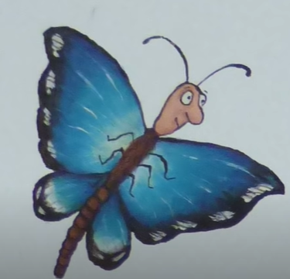

­­­­­­­­­­­­­­­­­­________________________________________________________________________________________________________________________________________

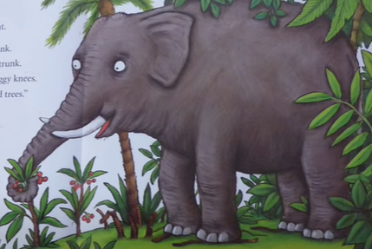

­­­­­­­­­­­­­­­­­­________________________________________________________________________________________________________________________________________

**Thursday**

Watch the story of Monkey Puzzle on You Tube:

<https://www.youtube.com/watch?v=JxpJnk3QO-8>

The poor monkey is lost and can’t find his mum so a butterfly takes the monkey to lots of different animals in the jungle to try and help.

Look at the pictures of the animals, how might they speak to the monkey? What sounds might they make? Write a list of words to help you but don’t use the word SAID! You might want to include words such as :

Grumbled, yelled, squawked, croaked, growled…….. Can you think of some more?

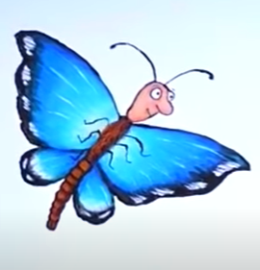

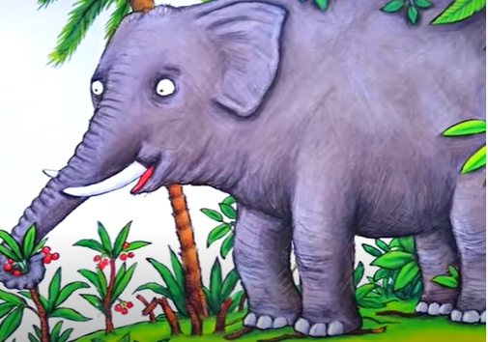

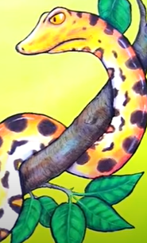

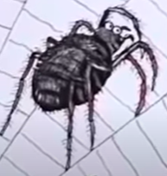

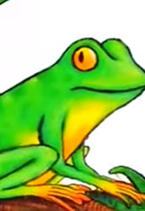

**My Puzzle Story**

We are going to think about creating our own Puzzle story!

Think of another animal which has lost its mum?

What is your animal?_____________________

Think of another animal which is going to try and help – like the butterfly in our story.

What is your helpful animal?____________________

Name 3 other animals they meet along the way

1.

2.

3.

On the next page is a story plan. Use it to draw pictures of what is going to happen in your story. You can write your clues on the lines underneath.

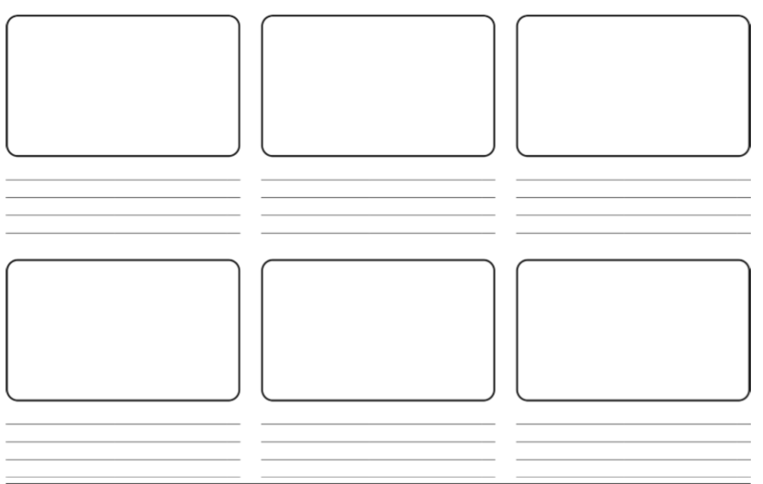**Friday**

Look at your plan from yesterday. You are now going to bring your story to life!

You can act your story out or write it on the sheets on the next page.

If you choose to act your story out, you might want to make some stick puppets of the animals to help. Remember to video your story and send it to school. I can’t wait to see it!

To help you with this it might be worth watching how the author Julia Donaldson acted the story out in this You Tube clip:

<https://www.youtube.com/watch?time_continue=443&v=QVyeBgzi7Qc&feature=emb_logo>

If you choose to write your story out, I have included some animal paper. This is a chance to practise your gorgeous handwriting too!

Don’t forget to send a photo of your story to school, I can’t wait to read them!!

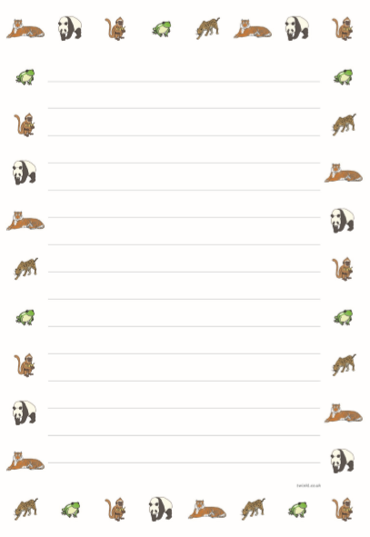



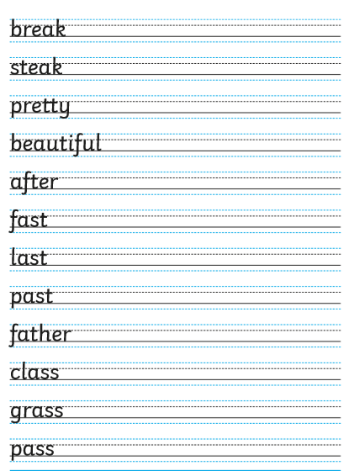

I’ve also included a handwriting sheet with the common exception words on to help you work towards a pen license!

I can’t wait to hear all about your new monkey puzzle story!

Happy Learning,

Mrs Burland