Year 1 Home Learning for WC 8-6-20

Maths – White Rose Maths Home Learning – Summer term week 6 tasks
https://whiterosemaths.com/homelearning/year-1/
Monday - Lesson 1 – Measure Mass
Watch the video and answer these questions

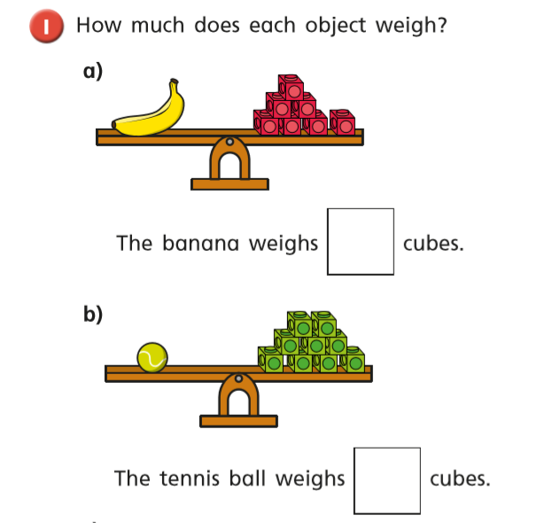

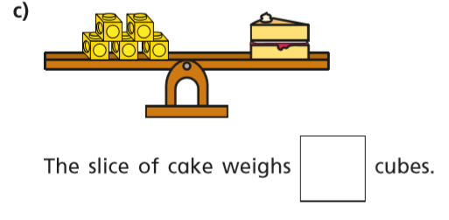

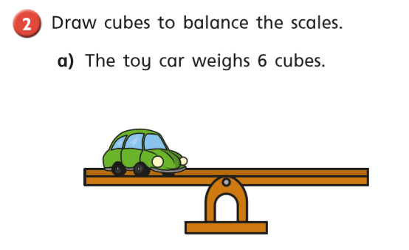
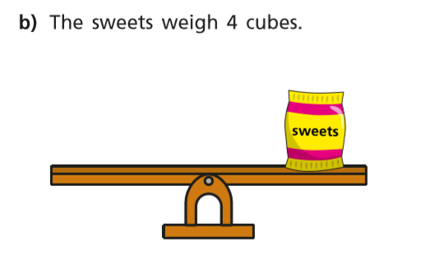
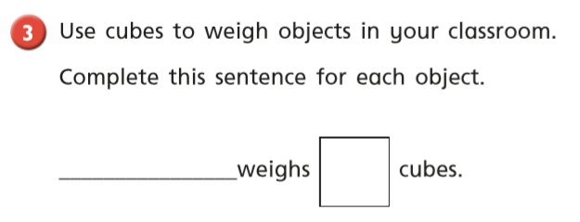
Tuesday
Warm up – Play ‘Introduce Weight and Mass Reasoning Game’ on Classroom Secrets
https://kids.classroomsecrets.co.uk/resource/year-1-introduce-weight-and-mass-reasoning-game/
White Rose Lesson 2 – Compare Mass Watch the video and then answer these questions

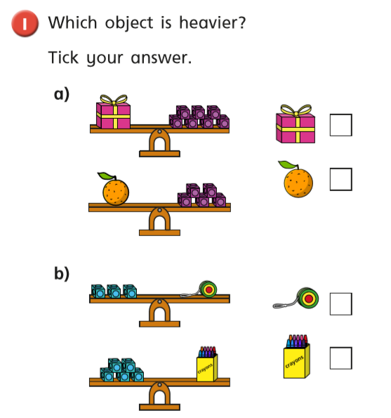

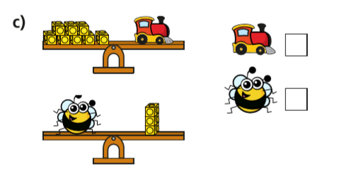
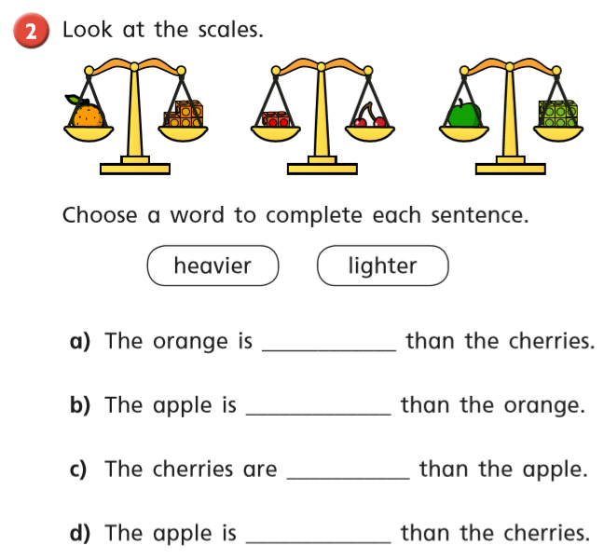

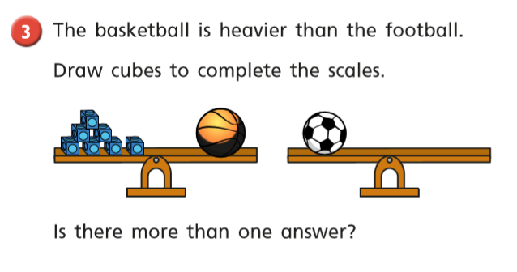
Wednesday
Warm up – Play x5 on Top Marks – Hit the Button
https://www.topmarks.co.uk/maths-games/hit-the-button
White Rose Lesson 3 – Introduce Capacity and Volume
Watch the video and then answer these questions
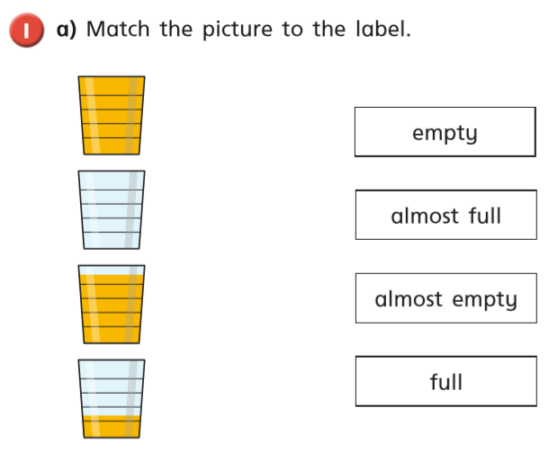

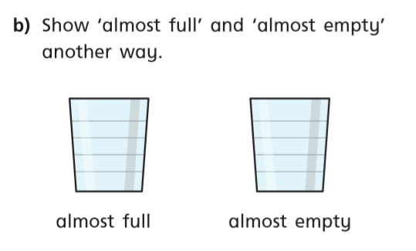
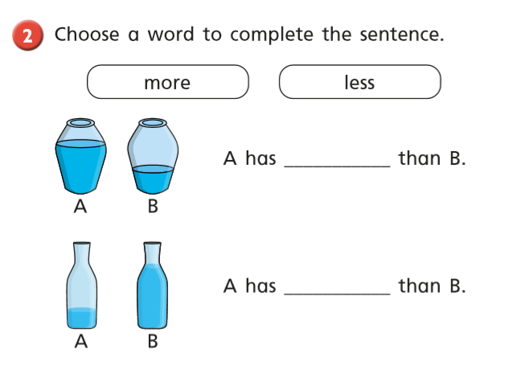
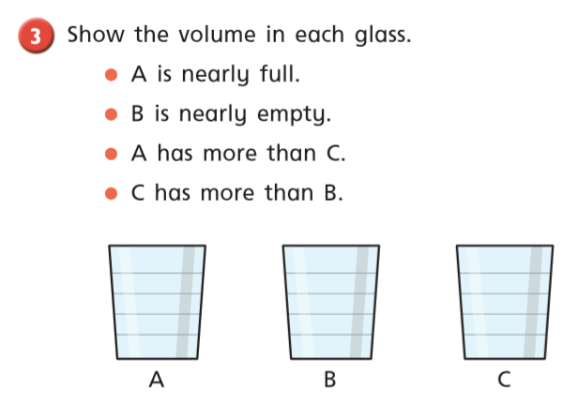

Thursday Warm up – Play ‘Sea-Shack Smash’ on Abacus
White Rose Lesson 4 – Measure Capacity
Watch the video and then answer these questions
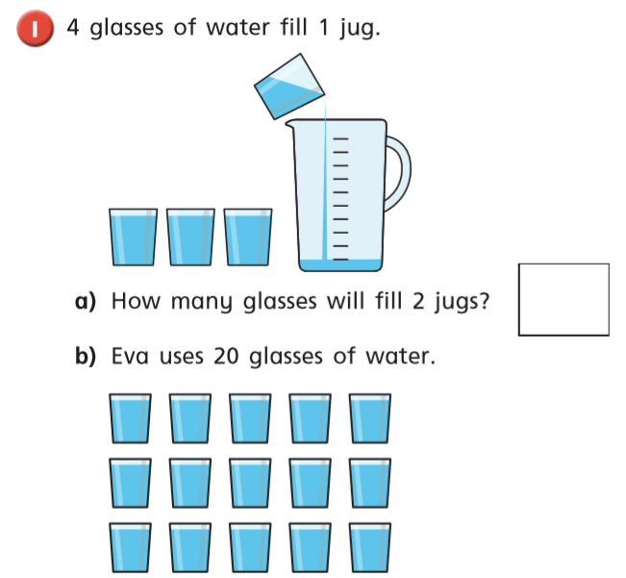
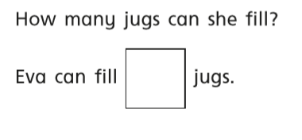
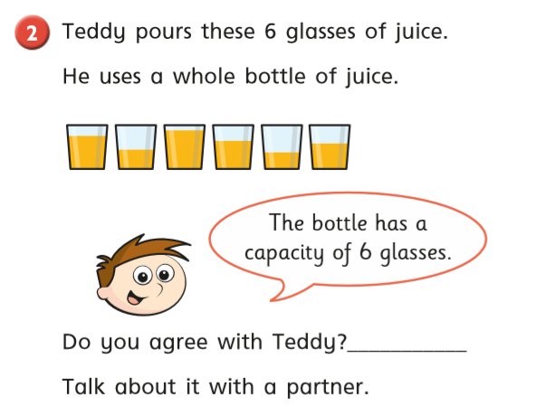
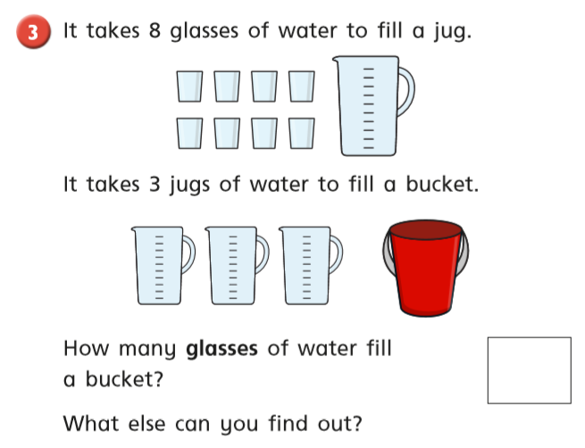
Friday – Warm up – play ‘Number Bonds to 20’ on Topmarks
https://www.topmarks.co.uk/maths-games/hit-the-button

Play Classroom Secrets Maths Game - ‘Number Bonds Reasoning Games’
https://kids.classroomsecrets.co.uk/resource/year-1-find-and-make-number-bonds-reasoning-game/

Complete the maths activity mat on page 11 and the 2D shape task on page 12.

Happy Learning!
Miss Ryder

