Year 1 Home Learning for WC 29-6-20

Maths – White Rose Maths Home Learning – Summer term week 9 tasks
https://whiterosemaths.com/homelearning/year-1/
Monday - Lesson 1 – Counting to 100
Watch the video and answer these questions
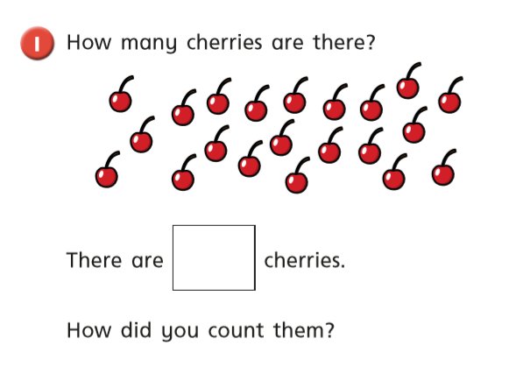
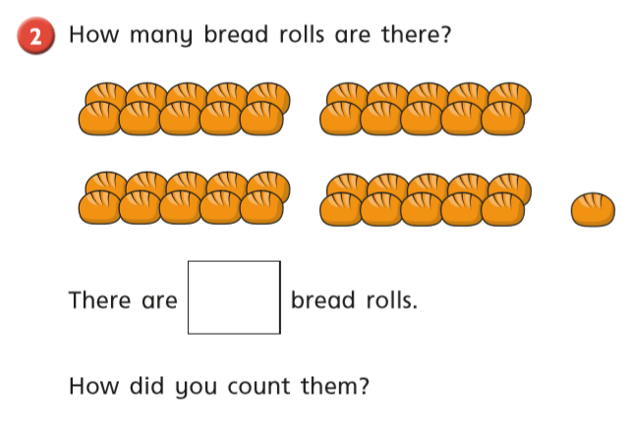
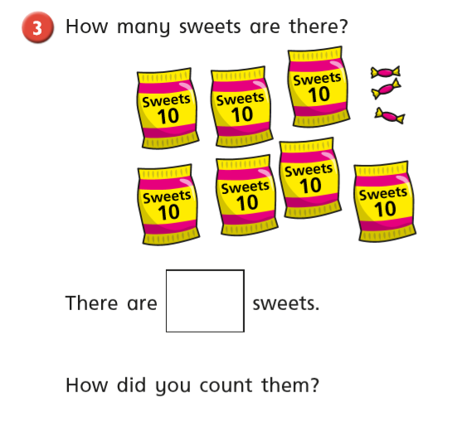
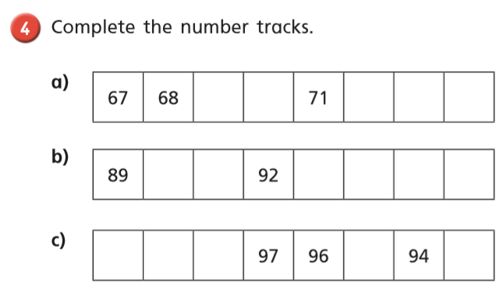

Tuesday
Warm up – Play ‘Count to 100’ game on Classroom Secrets
https://kids.classroomsecrets.co.uk/resource/year-1-count-to-100-game/
White Rose Lesson 2 – Partitioning Numbers Watch the video and then answer these questions
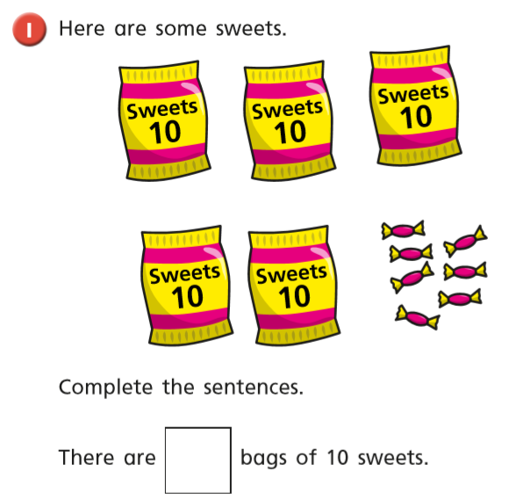
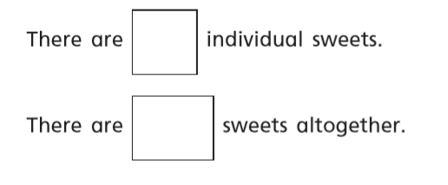

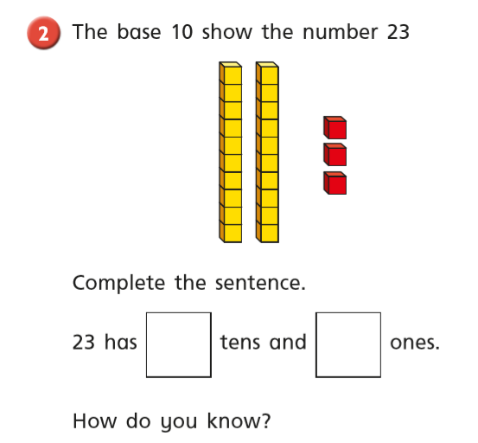
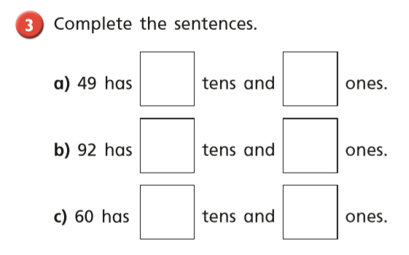
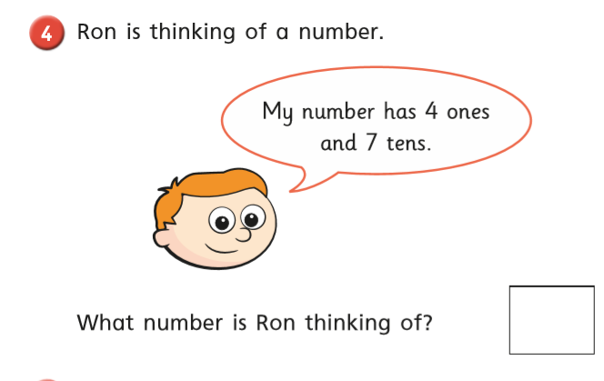
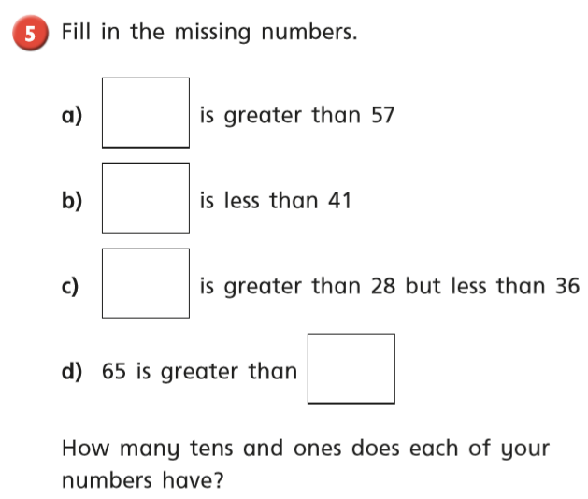
Wednesday
Warm up – Sequencing Caterpillar on Top Marks
https://www.topmarks.co.uk/ordering-and-sequencing/caterpillar-ordering

White Rose Lesson 3 – Comparing Numbers
Watch the video and then answer these questions
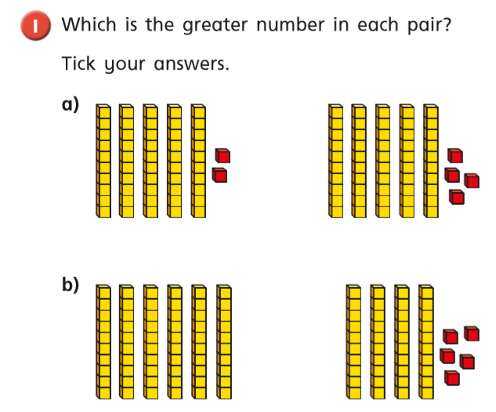
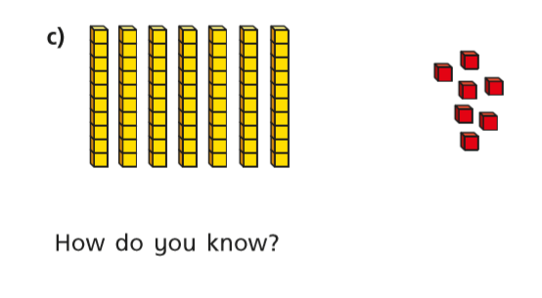
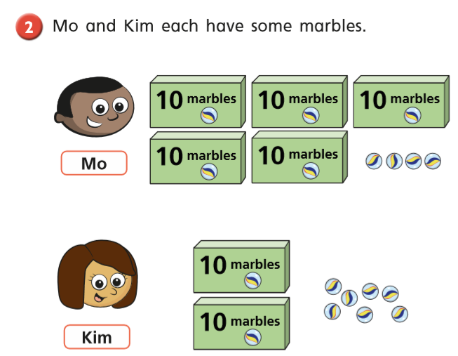
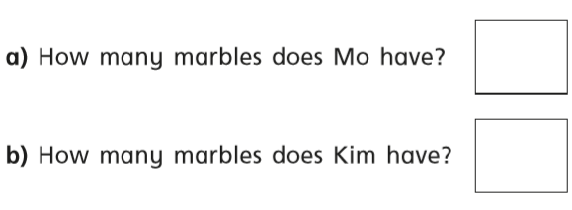
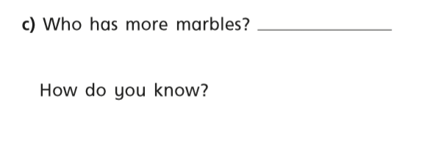
Use items around the house to make these numbers – cubes, lego and pasta are all great for this.
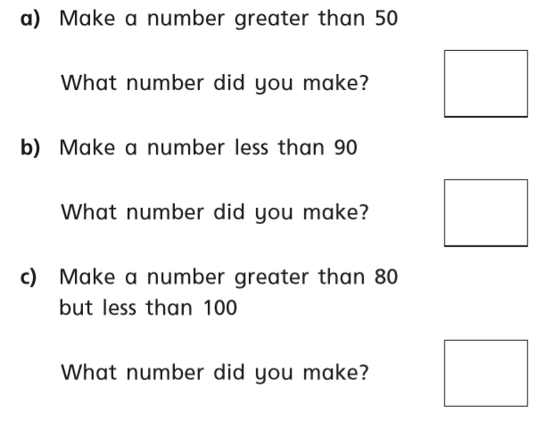
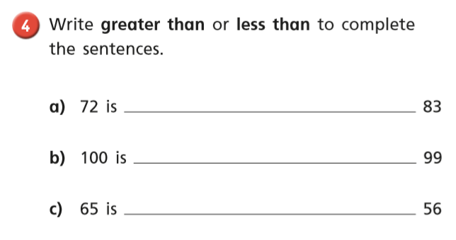

Thursday Warm up – Play ‘Marching Madness’ on Abacus
White Rose Lesson 4 – Comparing Numbers 2
Watch the video and then answer these questions

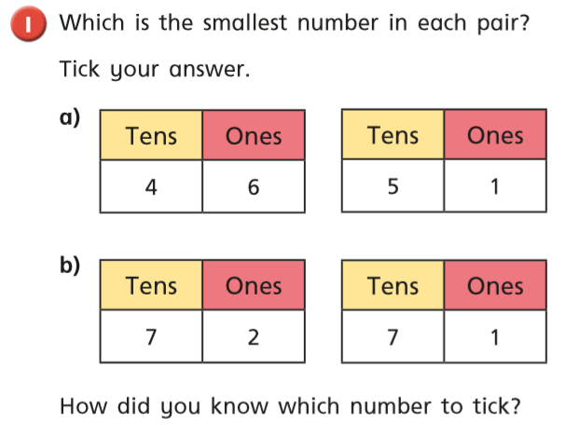
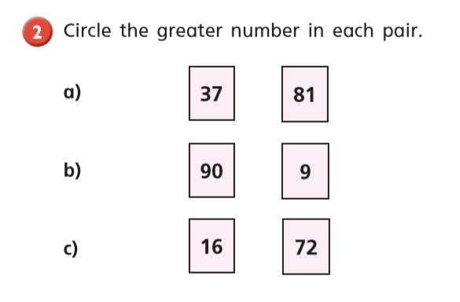
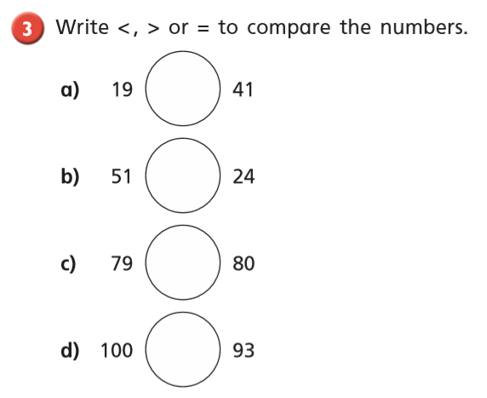

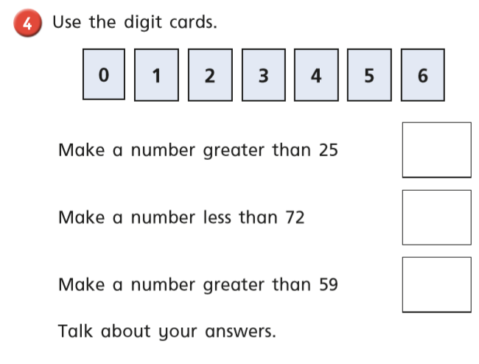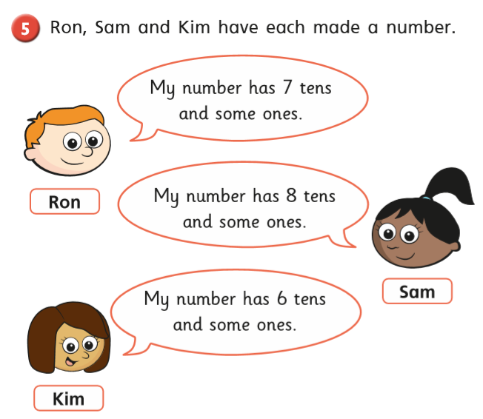
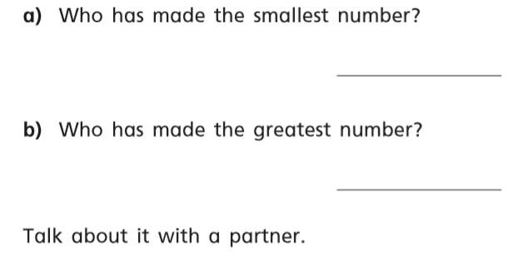

Friday – Warm up – play ‘Coconut Odd or Even’ on Topmarks
https://www.topmarks.co.uk/learning-to-count/coconut-odd-or-even

Complete the ‘Crossword Numbers to 20’ activity on page 15 and ’10 more and 10 less’ on page 16.

Happy Learning!
Miss Ryder

