Year 1 Home Learning for WC 22-6-20

Maths – White Rose Maths Home Learning – Summer term week 8 tasks
https://whiterosemaths.com/homelearning/year-1/
Monday - Lesson 1 – Make arrays
Watch the video and answer these questions

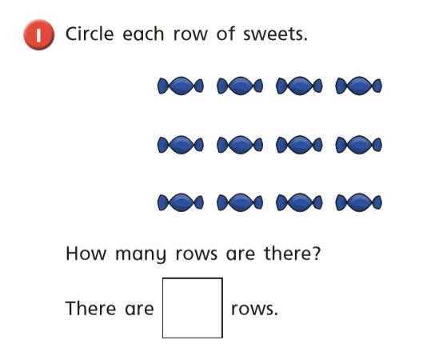

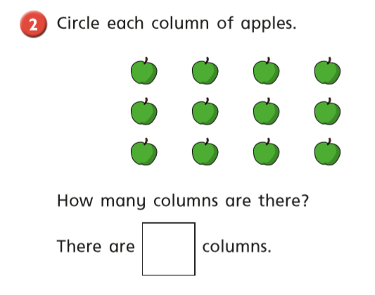
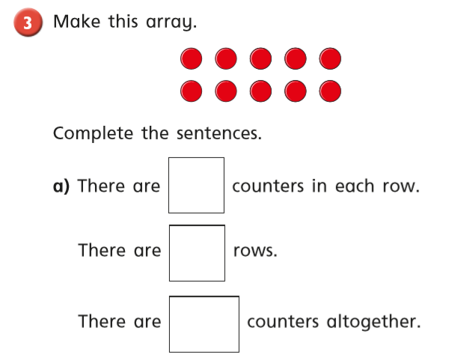

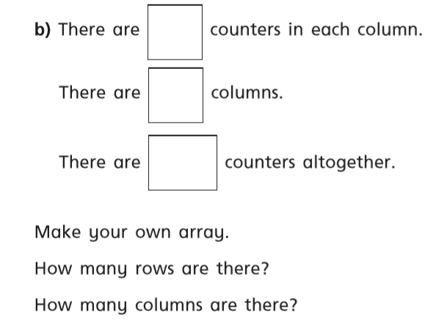

Tuesday
Warm up – Play ‘Making Doubles’ game on Classroom Secrets
White Rose Lesson 2 – Make Doubles Watch the video and then answer these questions
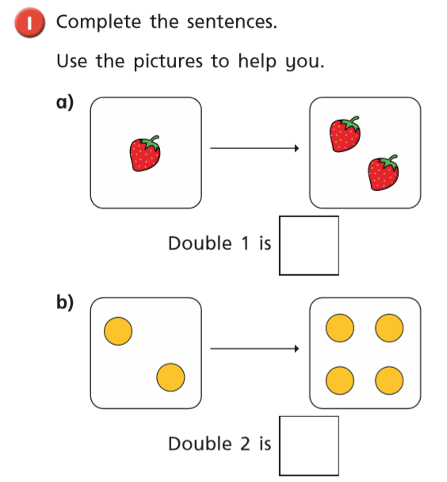

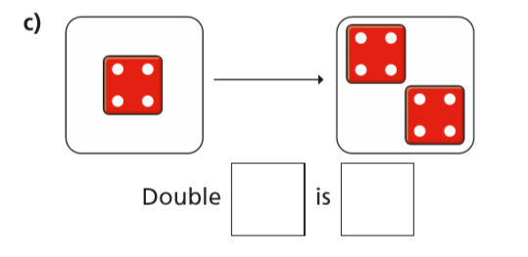

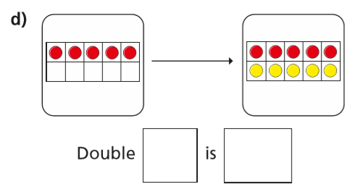
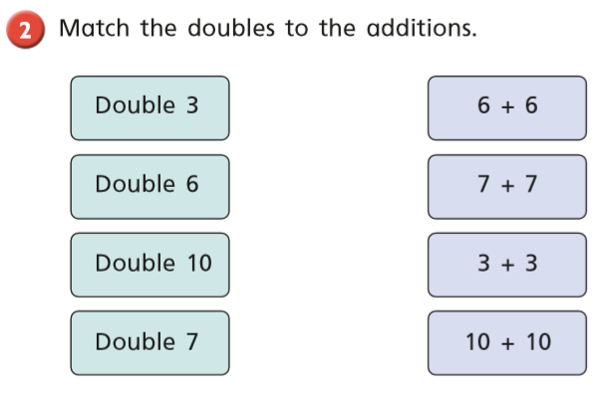
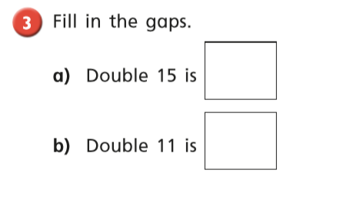
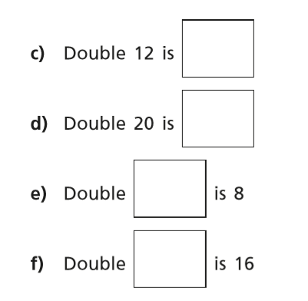

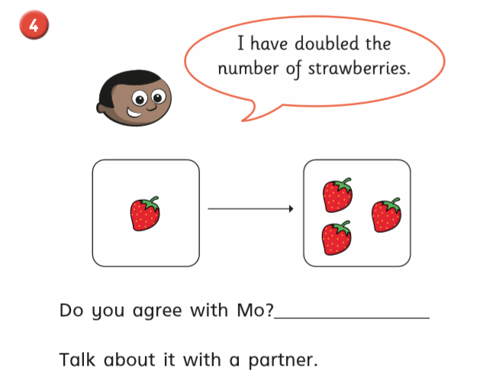

Wednesday
Warm up – Sequencing Caterpillar on Top Marks
https://www.topmarks.co.uk/ordering-and-sequencing/caterpillar-ordering

White Rose Lesson 3 – Making equal groups (sharing)
Watch the video and then answer these questions

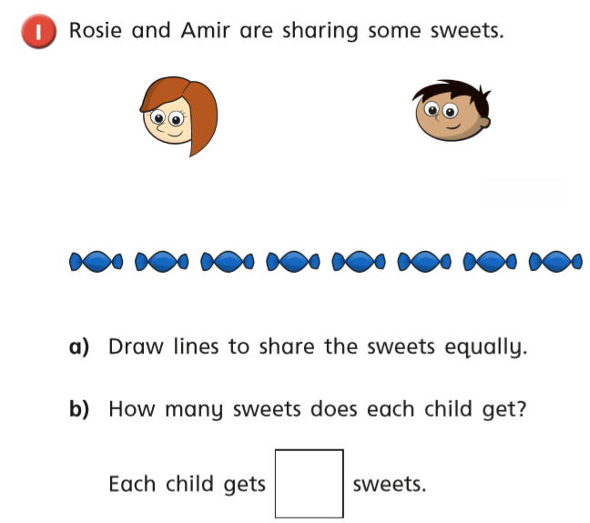

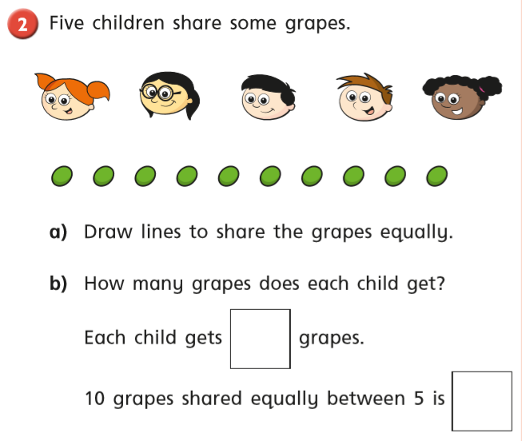
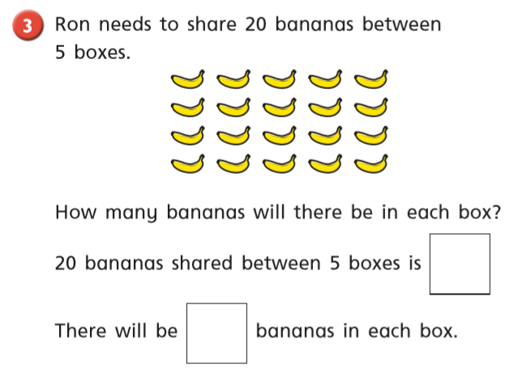
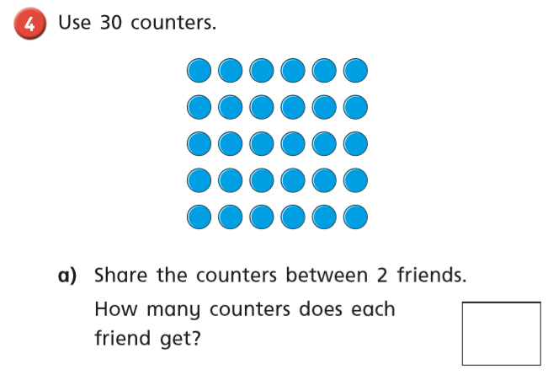
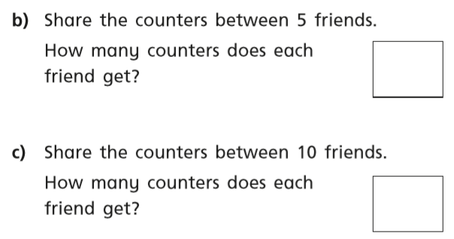
Thursday Warm up – Play ‘Balloon Pop’ on Abacus
White Rose Lesson 4 – Making equal groups (grouping)
Watch the video and then answer these questions
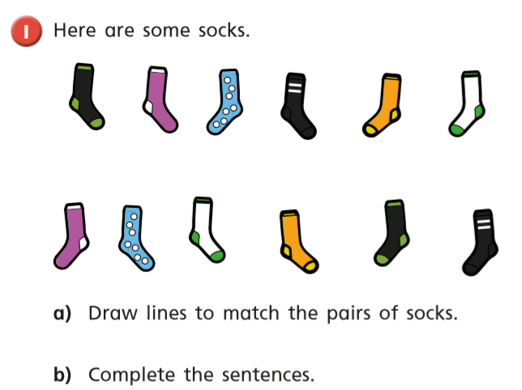
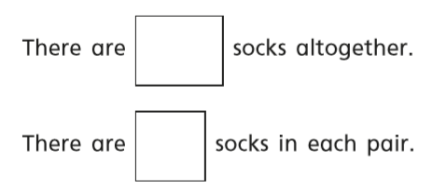
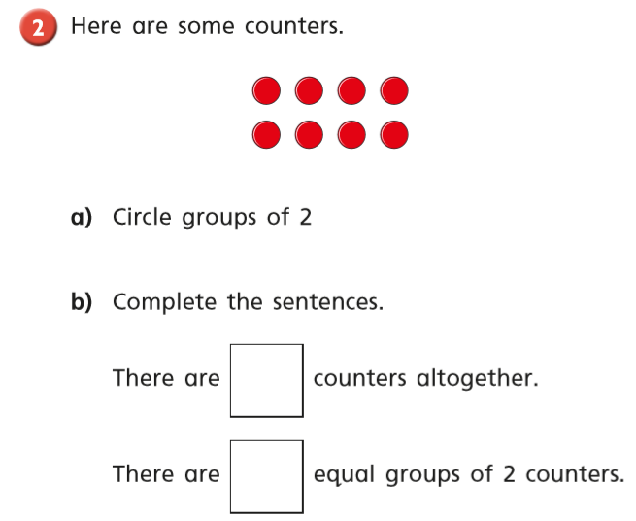
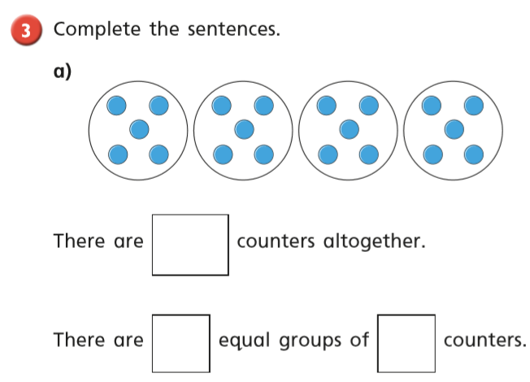
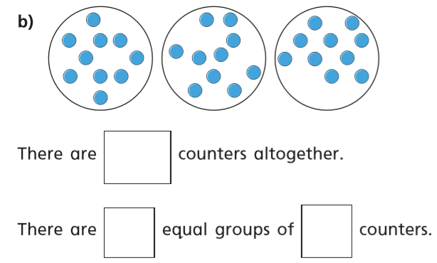
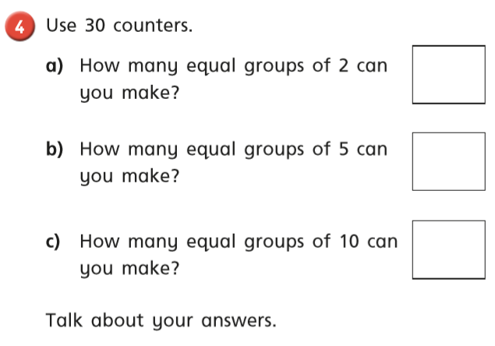

Friday – Warm up – play ‘Coconut Odd or Even’ on Topmarks
https://www.topmarks.co.uk/learning-to-count/coconut-odd-or-even

Complete the ‘Telling the time’ activity on page 14 and ‘Subtraction from 15 using a number line’ on page 15.

Happy Learning!
Miss Ryder
