Year 1 Home Learning for WC 15-6-20

Maths – White Rose Maths Home Learning – Summer term week 7 tasks
https://whiterosemaths.com/homelearning/year-1/
Monday - Lesson 1 – Count in 2s
Watch the video and answer these questions

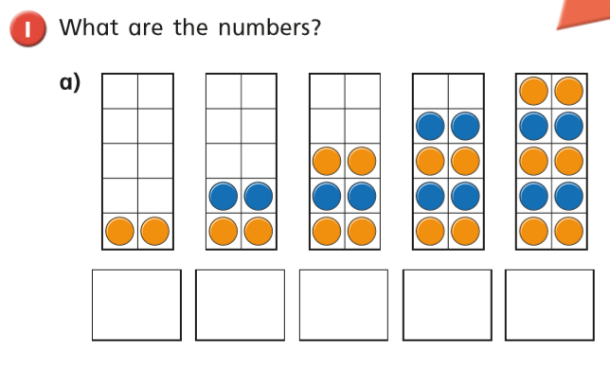
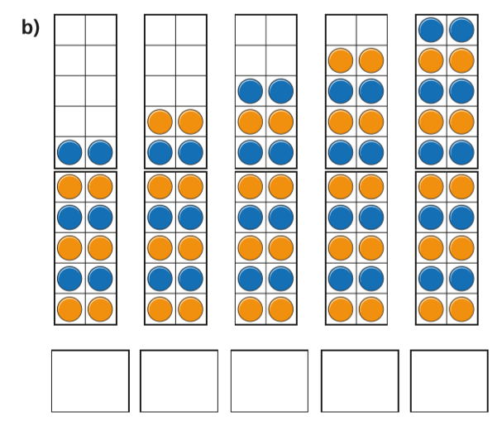

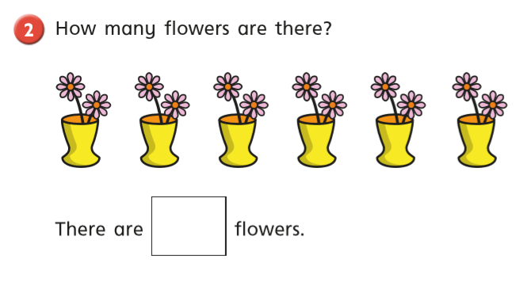

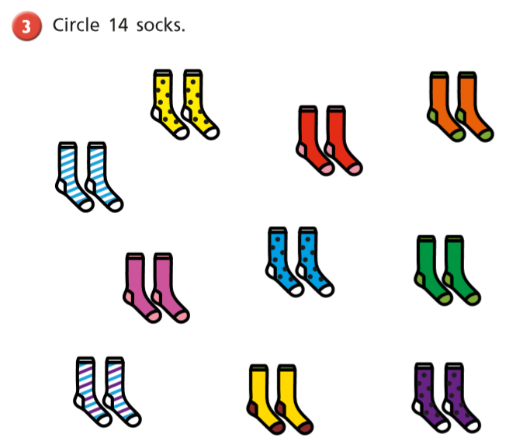

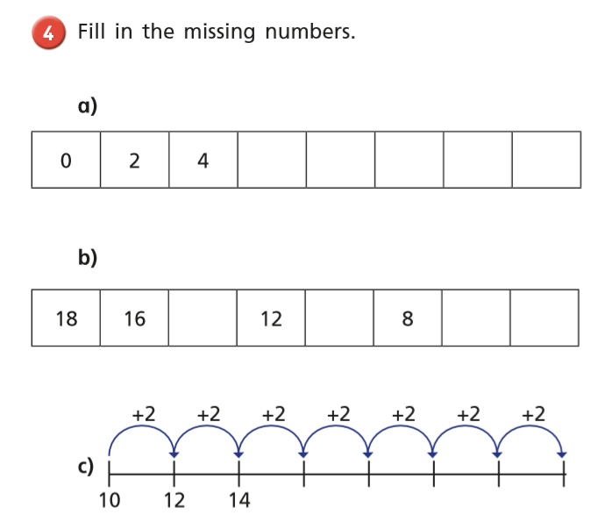
EXTENSION
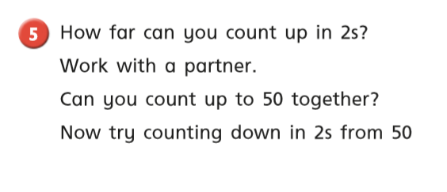

Tuesday
Warm up – Play ‘Count in 5s’ on Classroom Secrets
https://kids.classroomsecrets.co.uk/resource/year-1-count-in-5s/

White Rose Lesson 2 – Count in 5s Watch the video and then answer these questions
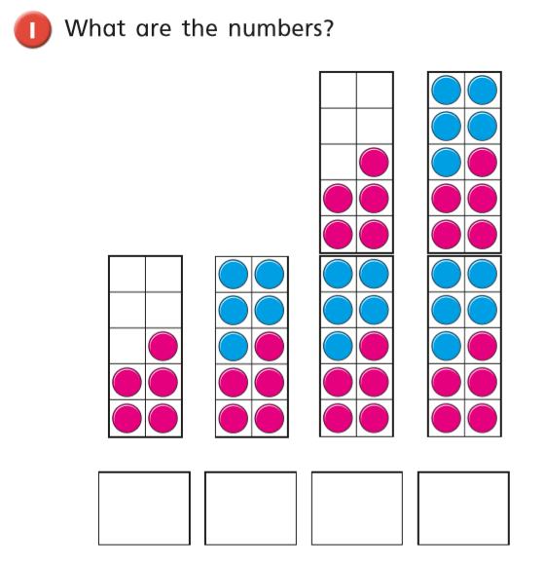
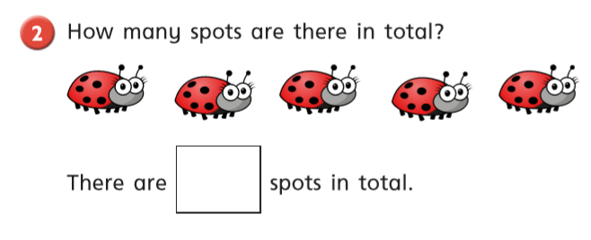
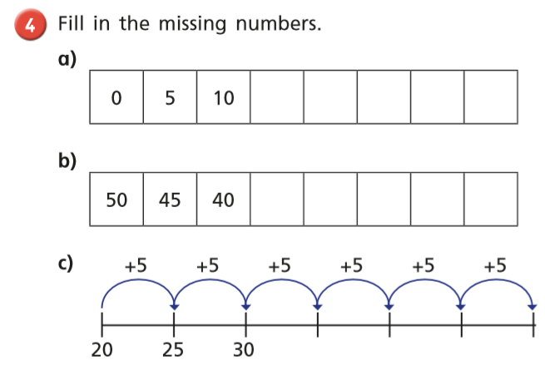

EXTENSION

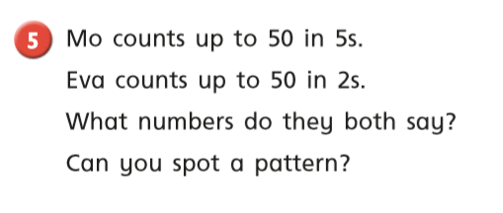

Wednesday
Warm up – Play x10 on Top Marks – Hit the Button
https://www.topmarks.co.uk/maths-games/hit-the-button
White Rose Lesson 3 – Count in 10s
Watch the video and then answer these questions
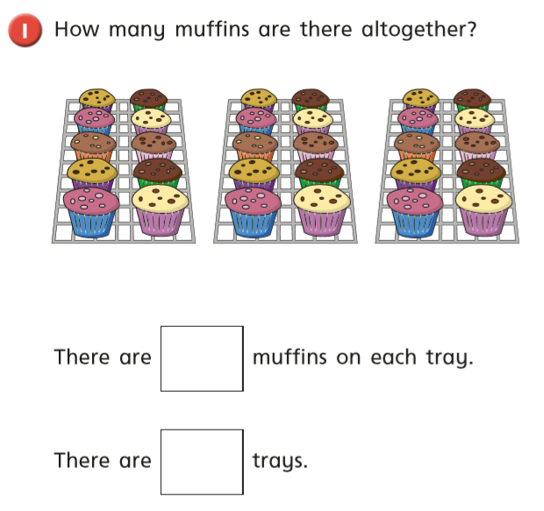

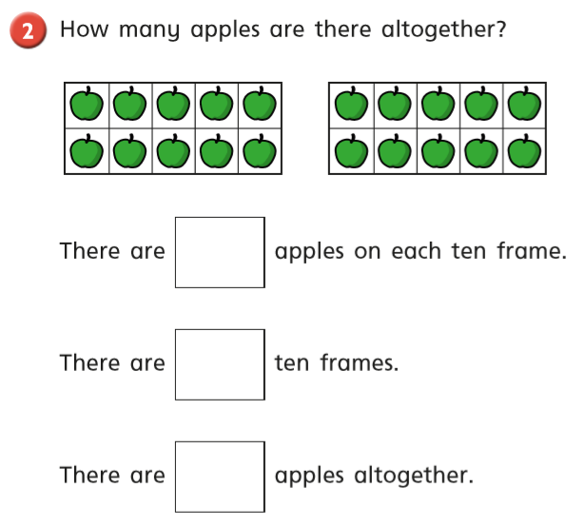
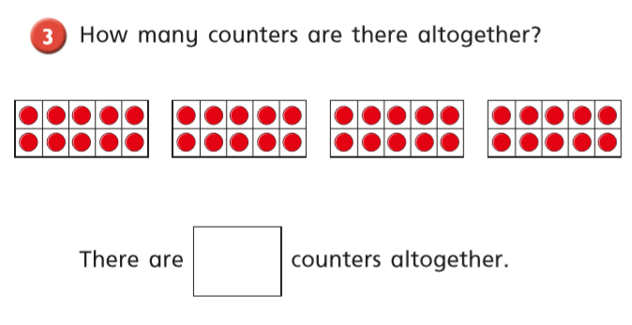

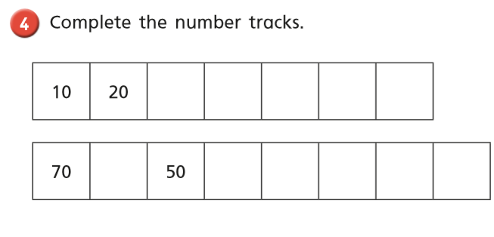
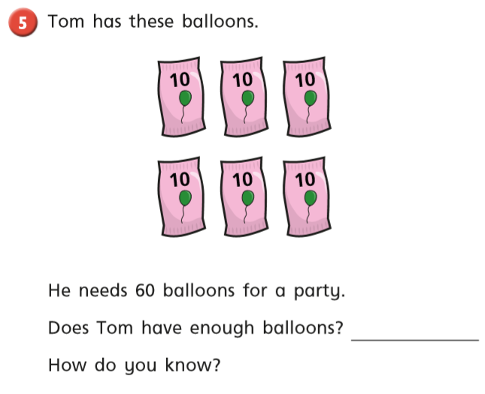

Thursday Warm up – Play ‘Balloon Pop Count in 2s’ on Abacus
White Rose Lesson 4 – Add Equal Groups
Watch the video and then answer these questions
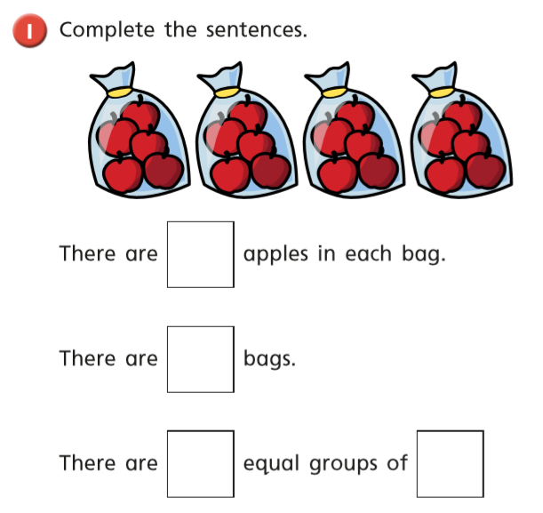
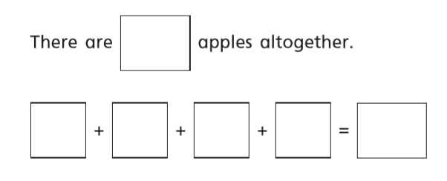
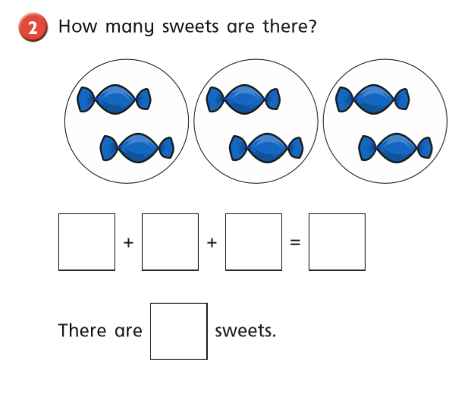
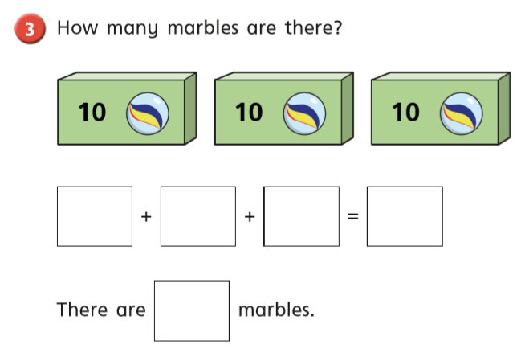
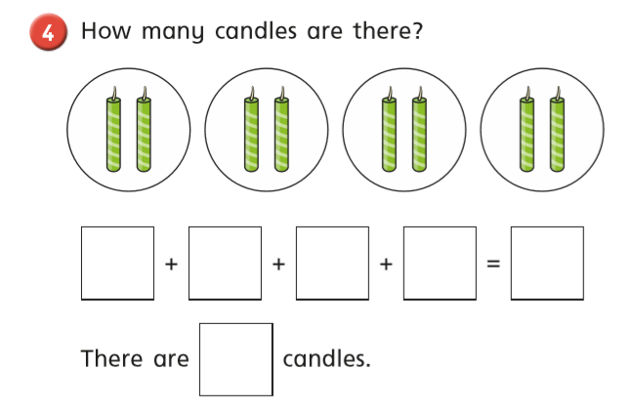
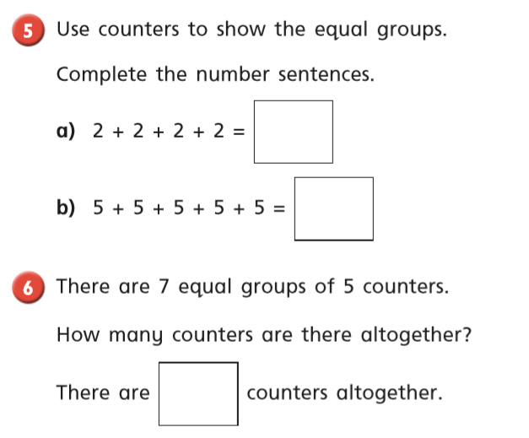

Friday – Warm up – play ‘Halves 10 to 20’ on Topmarks
https://www.topmarks.co.uk/maths-games/hit-the-button

Complete the maths activity mat on page 15 and the telling the time activity on page 16.

Happy Learning!
Miss Ryder

