Year 1 Home Learning for WC 1-6-20

Maths – White Rose Maths Home Learning – Summer term week 5 tasks
https://whiterosemaths.com/homelearning/year-1/
Monday - Lesson 1 – Compare length and height
Watch the video and answer these questions
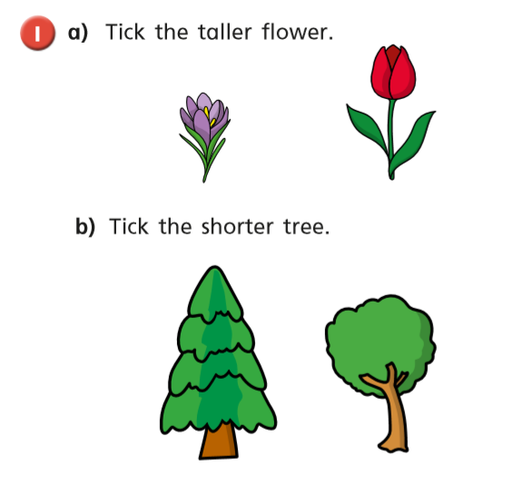

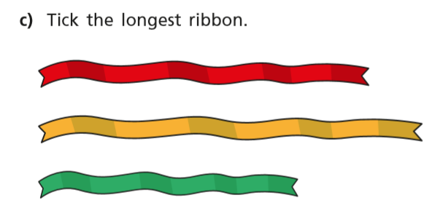

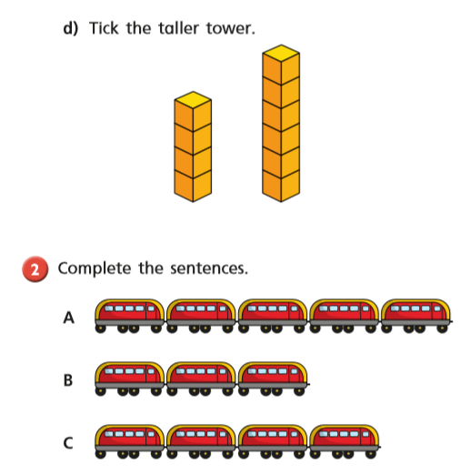

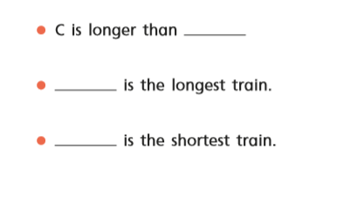

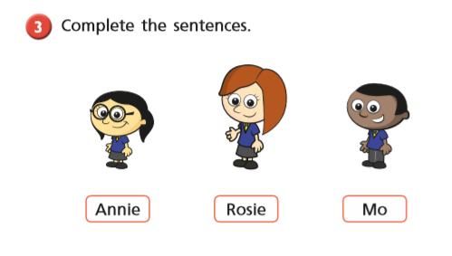
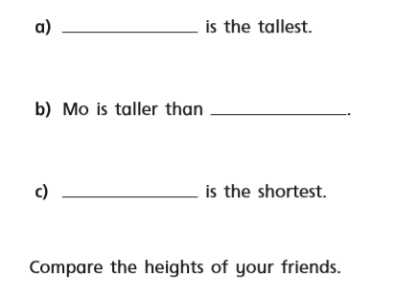

Tuesday
Warm up – Play sequencing caterpillar on Top Marks
https://www.topmarks.co.uk/ordering-and-sequencing/caterpillar-ordering
White Rose Lesson 2 – Measure Length 1 Watch the video and then answer these questions
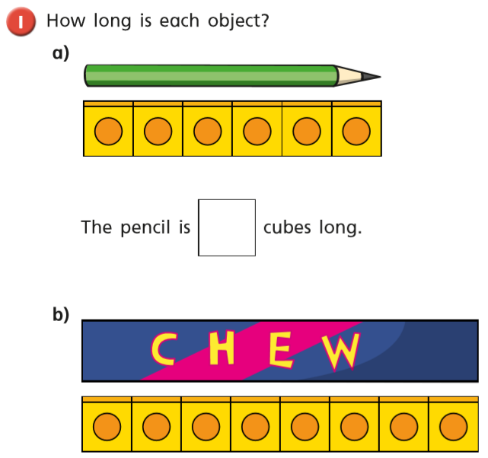

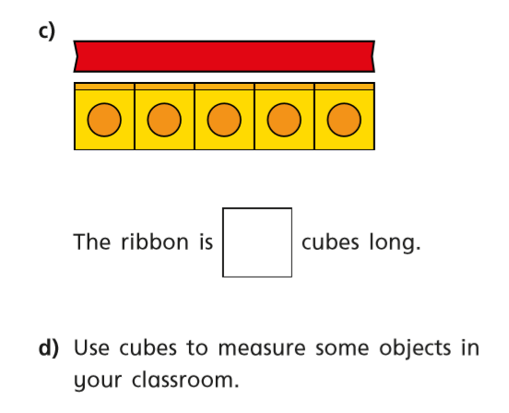

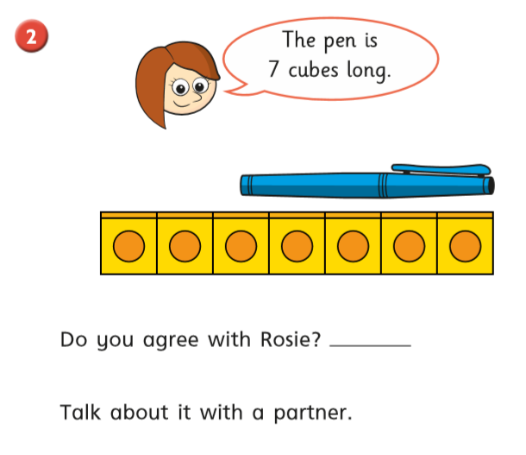

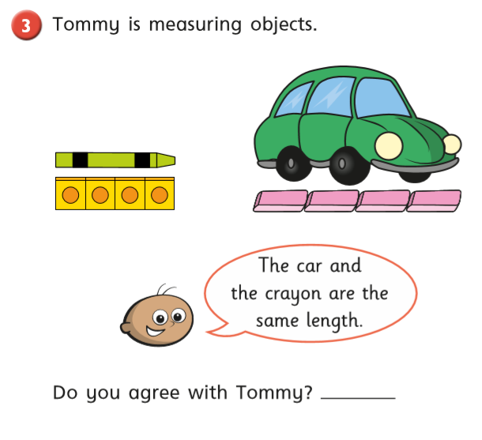
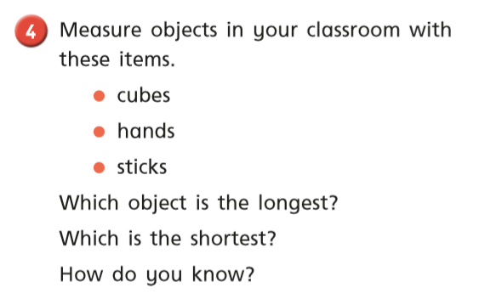
Wednesday
Warm up – Play sequencing caterpillar on Top Marks
https://www.topmarks.co.uk/ordering-and-sequencing/caterpillar-ordering
White Rose Lesson 3 – Measure length 2
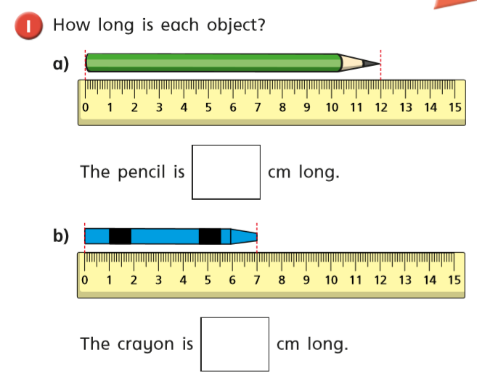
Watch the video and then answer these questions

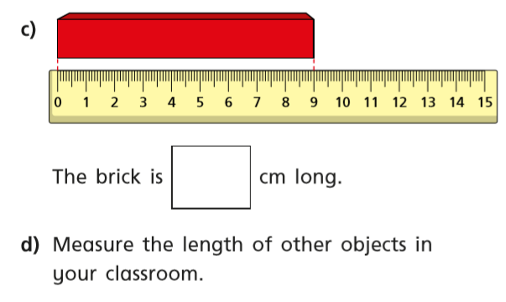

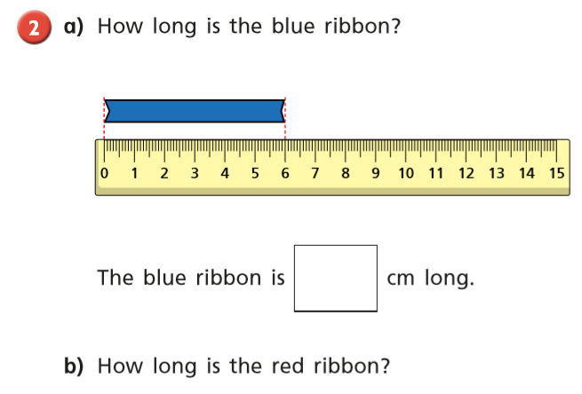

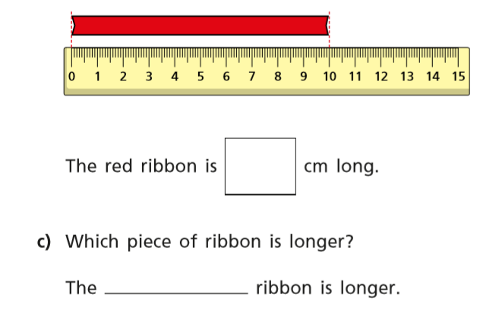

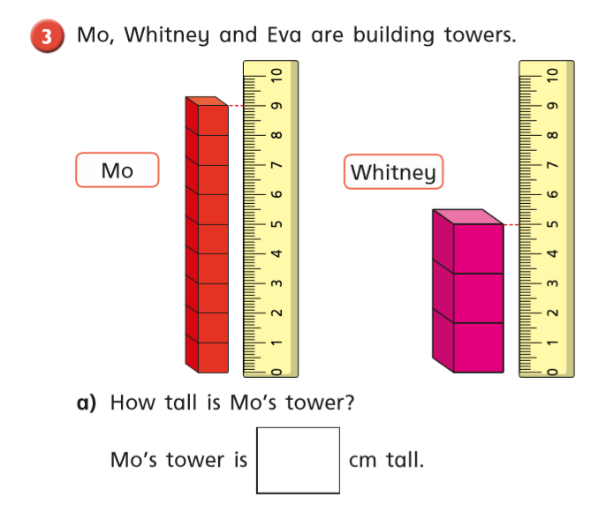
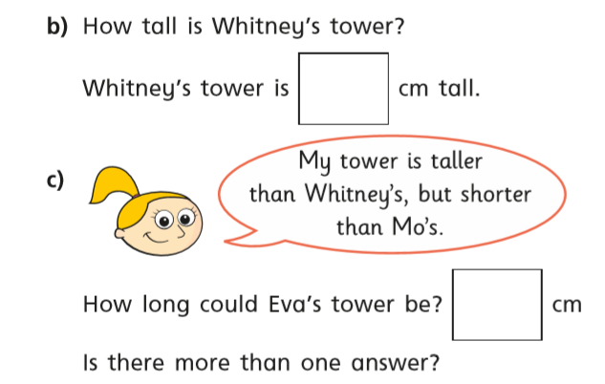
Thursday Warm up – Play ‘Balloon Pop’ on Abacus
White Rose Lesson 4 – Introduce Weight and Mass
Watch the video and then answer these questions
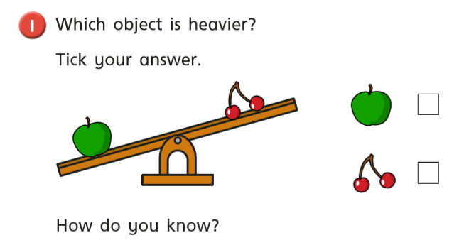
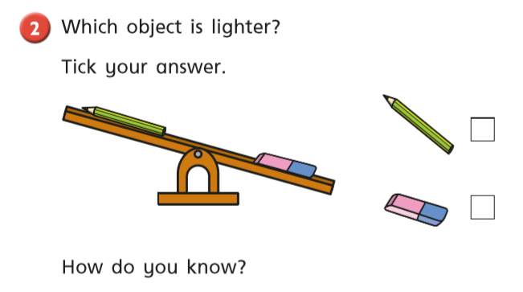

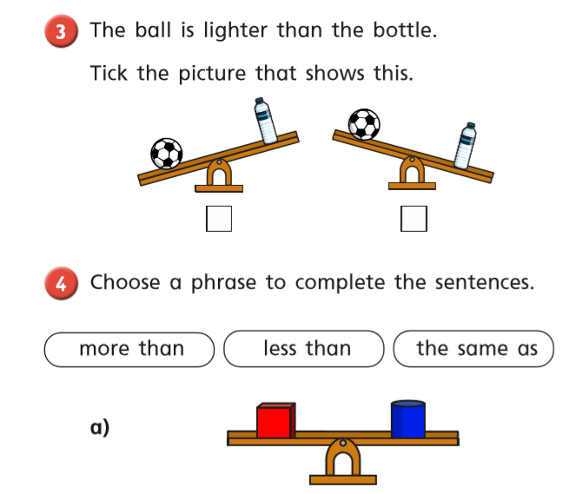
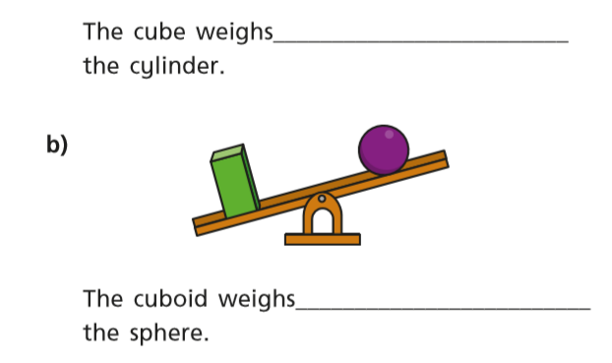

Friday – Warm up – play Doubles on Topmarks
https://www.topmarks.co.uk/maths-games/hit-the-button

Play Classroom Secrets Maths Game - ‘Measuring Lengths using Centimetres’
https://kids.classroomsecrets.co.uk/resource/year-1-compare-number-sentences-game/

Complete the maths activity mat on page 13 and the 3D shape task on page 14.

Happy Learning!
Miss Ryder

