Year 1 and 2 Home Learning Challenges WC 15.6.20
Refugee Week – How might it feel to leave home?
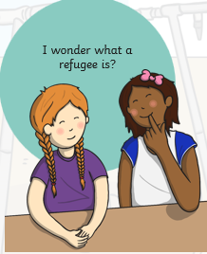  What is a refugee?  A refugee is a person who has been forced to leave their country.  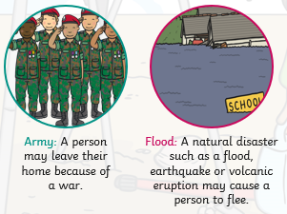  They might have to leave for different reasons. | What would you take with you?  Paddington Bear left his home in Peru and travelled to England to find a home in London.  What do you think he might have packed in his suitcase?  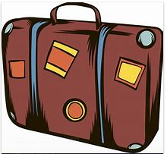  Draw and write some of the essential and treasured items that you would want to take with you if you left home. (Use the empty suitcase on page 2.) | How might Paddington feel about leaving his home?  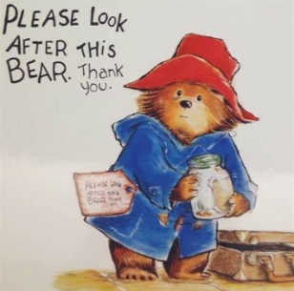  Think about some feelings that Paddington might have about leaving his home and write them around the picture.  (Page 3)
How can we make people feel welcome?  If Paddington came to stay at your house, how would you make him feel welcome?  Think of 5 things that you might do to make Paddington feel at home.  Record your ideas on page 4. | What is great about living in Ripon?  Imagine that Paddington came to live in Ripon.  What are the best things about living in Ripon?  Are there any places that you would take him to visit?  Record your ideas on page 5. | Paddington at Moorside!  When refugee children come to England, they will have to start at a new school.  Imagine that Paddington was going to start coming to Moorside Primary School. What would you tell him about our school?  Use the template on page 6 to write a fact file about school.

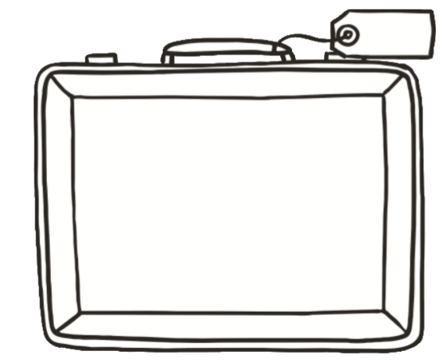

Write some words to describe how Paddington might feel about having to leave his home.

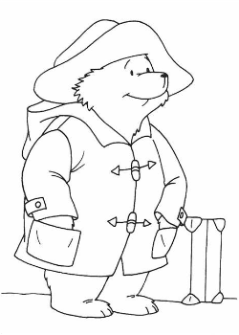

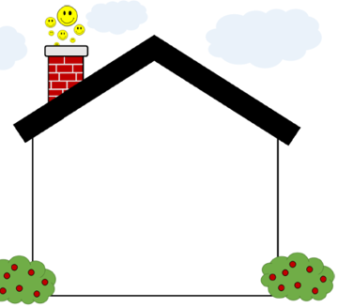

Welcome to Ripon
Places to visit and things to do.

