Year 1 and 2 Home Learning Challenges WC 29.6.20
Geography – Where in the world do I live?
The 7 continents  A continent is a large, solid area of land. The earth has 7 continents.  Watch this You Tube clip to help you learn the names of the 7 continents:  https://www.youtube.com/watch?v=K6DSMZ8b3LE  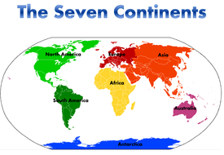  Can you label the map on page 2 with the 7 continents?  Cut out the names and continents on pages 4 and 5 and see if you can match them. Stick them in your home learning book. | The earth from space  Look at some of the photos from the NASA Space Station. They show different parts of the earth. It is hard to believe these photos were taken from space!  https://visibleearth.nasa.gov/  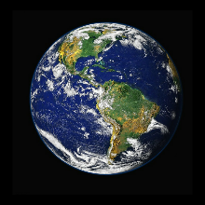  Try to spot some photos which show:  - Mountains  - Seas, rivers  - Snow  - Deserts  - Fields  - Clouds  You can also look on Google Earth too. | What is it like to live here?  Would you like to live in Antarctica? Why? Look at the following clip called ‘Teachers in the Freezer’ to help you learn what life is like in Antarctica:  https://www.youtube.com/watch?v=pJdykZRFuqs  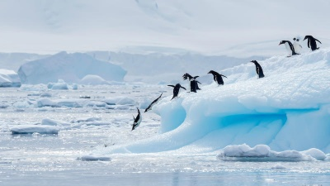  The teachers in this clip have been to Antarctica but Miss Ryder and Mrs Burland haven’t!!  What would Miss Ryder and Mrs Burland need to know if they were to travel to Antarctica?  Using facts from the clip, fill in the grid on page 6.
Where in the United Kingdom?  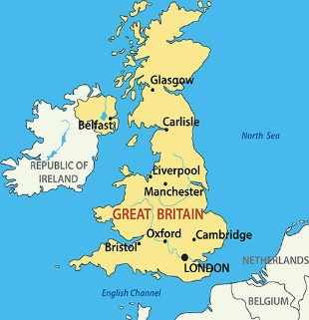  1 Find out the names of the 4 countries which make up the United Kingdom.  2. Label the map on page 7 | Introducing Ripon  Think about the area you live in.  Make a list of the important physical and human features on page 8. You could spot some of these features on a walk around your area. Use the table on page 8 to help you.  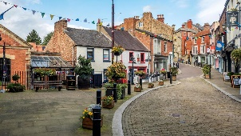  Design a poster to advertise Ripon. Why should people visit our city? What are the important features? You might want to use the paper on page 9. | 5 Finger Facts  See if you can learn these top 5 facts as part of the topic.  - I can name the seven continents  - I can ask questions about what it is like to live in different parts of the world.  - I can identify physical and human features of Antarctica  - I can name the countries of the United Kingdom  - I can name physical and human feature of Ripon.

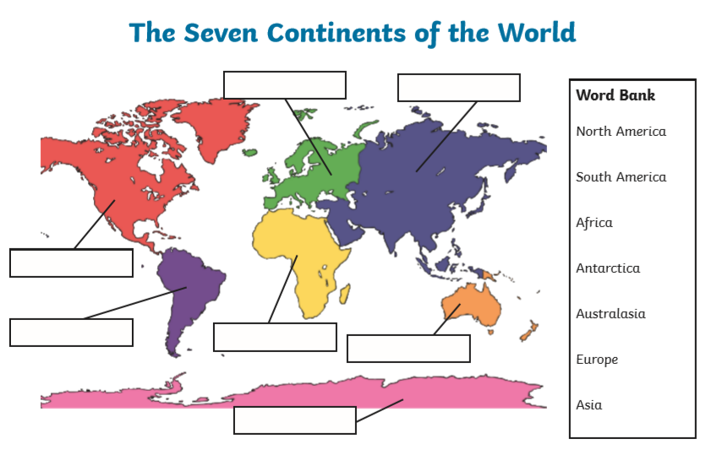

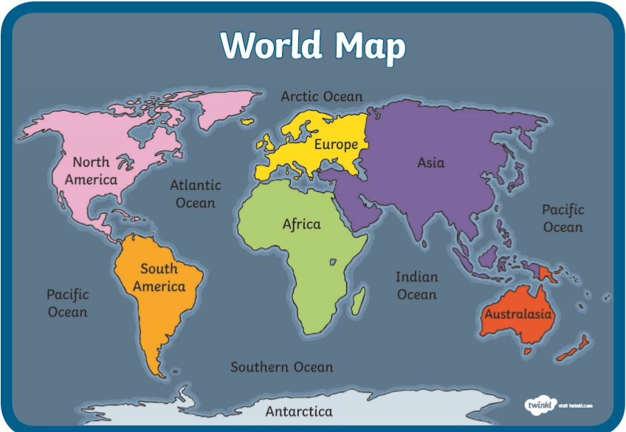

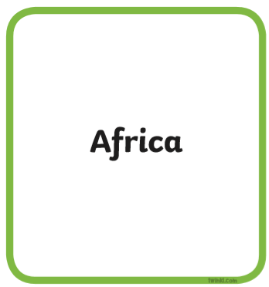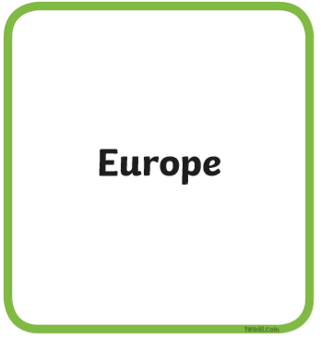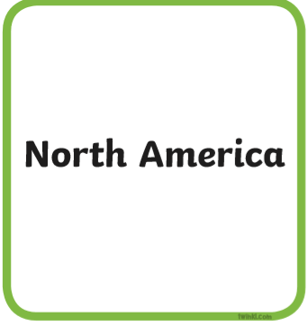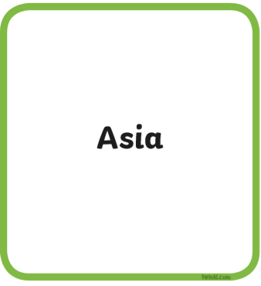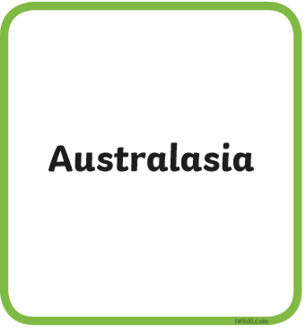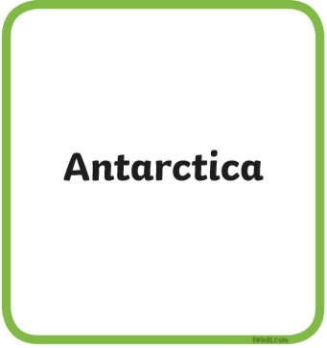

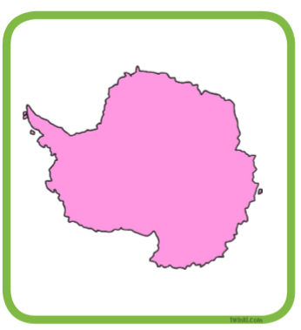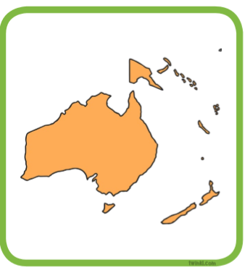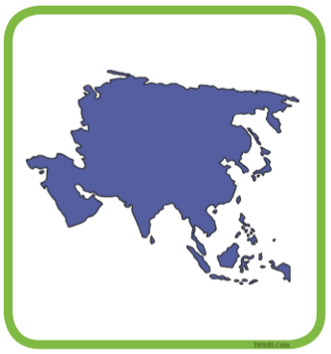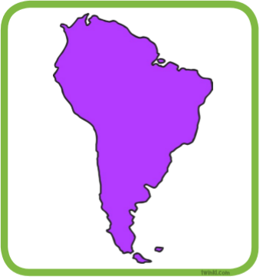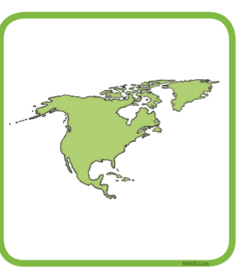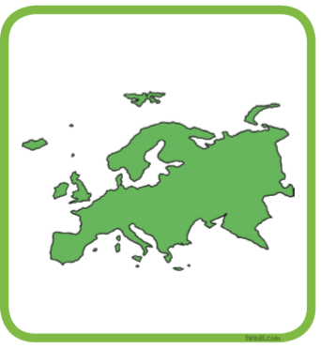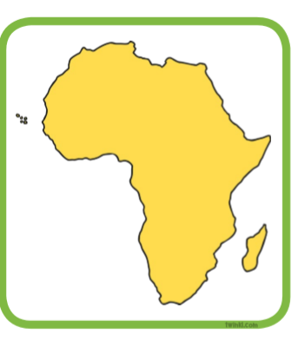

Preparing Miss Ryder and Mrs Burland for a trip to Antarctica!
What clothes do we need to take?

What food do we need to take?

Where will we stay?

What will the weather be like?

What else might Miss Ryder and Mrs Burland need?

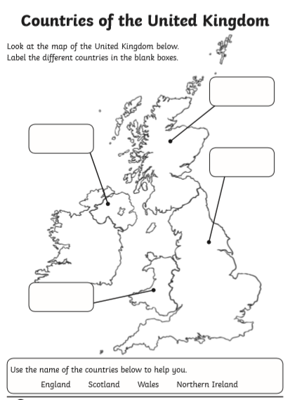

The physical and human features of Ripon
Physical features are formed naturally like water, rivers and mountains
Human features are things which are built such as bridges, houses and parks

Physical features in Ripon | Human features in Ripon

