Year 3 and 4 Geography Week Home Learning Challenges
Task 1  Create a poster or finger snapper using the 5 Finger facts below:  - I know physical and human features of a locality (Rivers)  - I know human features of UK regions, cities and /or counties.  - I know why there are similarities and differences between places.  - I can identify where counties are within the UK and the key topographical features.  - I can recognise the different shapes of continents. | Task 2. Rivers of Britain. (pages 2 and 3)  Using an atlas and online maps to help you, identify each of these rivers marked on the map above. The first one is done for you.  Use the sheet on page 2 and fill on the missing rivers. The answer sheet is on page 3 but don’t peak and see how many you can find!  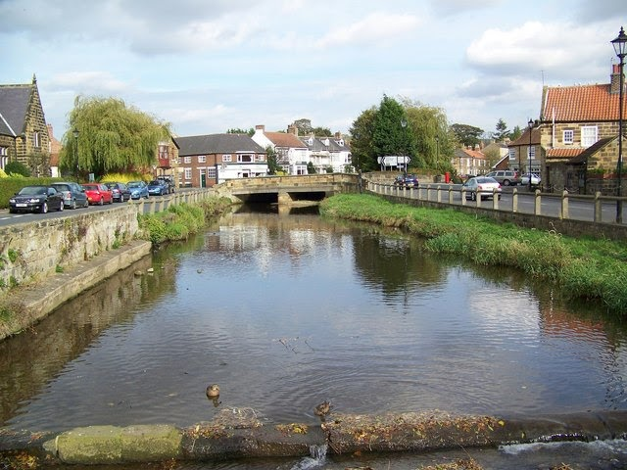 | Task 3. Rivers of the world. (pages 4 and 5).  Now you have amazing knowledge of British Rivers, now try these Rivers of The World on page 4 with the answers on page 5. Again, don’t peep and see how many you can name.  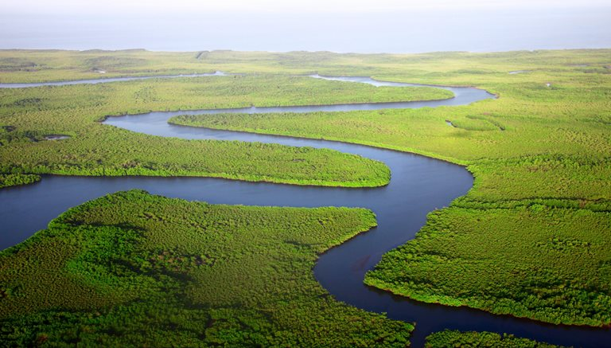
 | Task 3. Puddle Investigation.  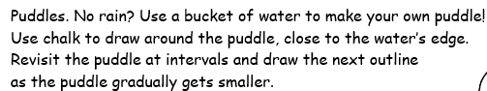  Take photos and draw diagrams as to what is happening to your puddle.  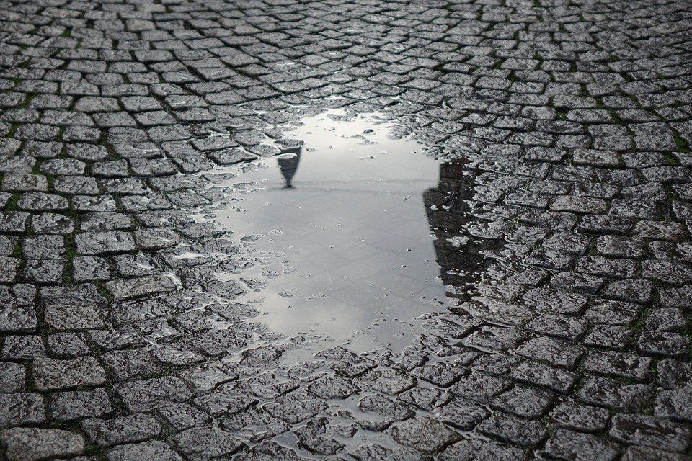 | Key Vocabulary  River: a large natural stream of water flowing in a channel to the sea, a lake, or another river.  Human features: Human geography relates only to the human environment; something that is built by humans and would not have existed in nature without humans.  Physical features: The features that are man-made or naturally-created are known as geographical features.
Rivers.
Task 2 Rivers of Britain.
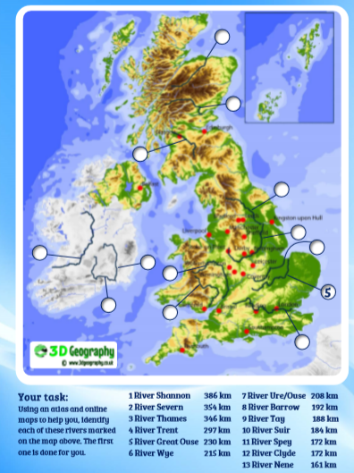
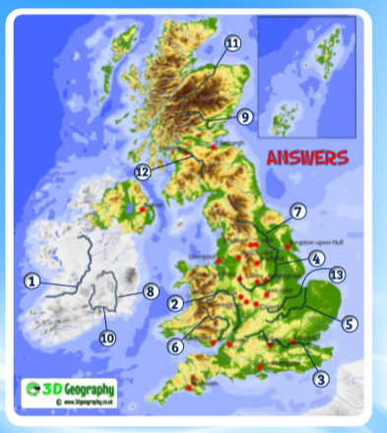
Task 3 Rivers of the World.
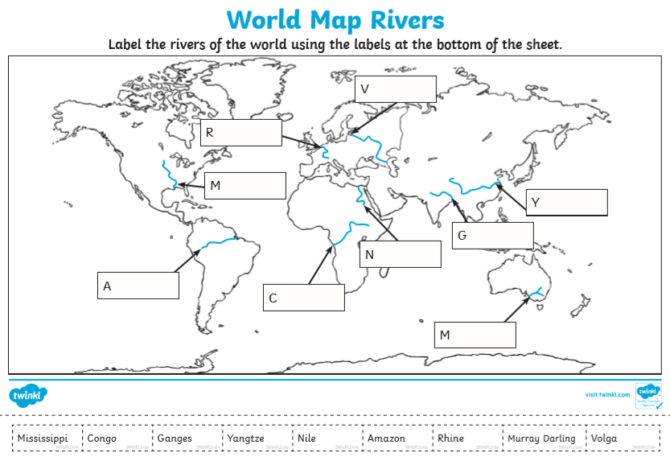
Task 3 Rivers of the World Answers.
