Maths Year 4
w/c 29.06.20
The objective we are working on in detail this week is:
♣ recognise and show, using diagrams, families of common equivalent fractions
This week on Monday, you will start by understanding what a fraction is. On Tuesday, you will be starting to recall and understand equivalent fractions and what they are. On Wednesday, you will be developing your understanding of equivalent fractions further. On Thursday, you will be finding out all about factions which are greater than 1 and on Friday, you have maths challenges to complete!
Lesson 1 – Monday – use this link to watch the correct video for ‘What is Fraction?’ https://vimeo.com/418154269 (it is still a White Rose link).
Then for Lesson 2 onwards, use the Summer Term Week 5 link and click select lesson 2, which you will complete on Tuesday. Lesson 3 – Wednesday, Lesson 4 – Thursday and Lesson 5 – Friday.
As usual all of your worksheets are in the pack for you.
https://whiterosemaths.com/homelearning/year-4/

Have a go at this classroom secrets games to practise your skills!

https://kids.classroomsecrets.co.uk/resource/year-4-equivalent-fractions-interactive-animation/

https://kids.classroomsecrets.co.uk/resource/year-4-equivalent-fractions-game/

Monday
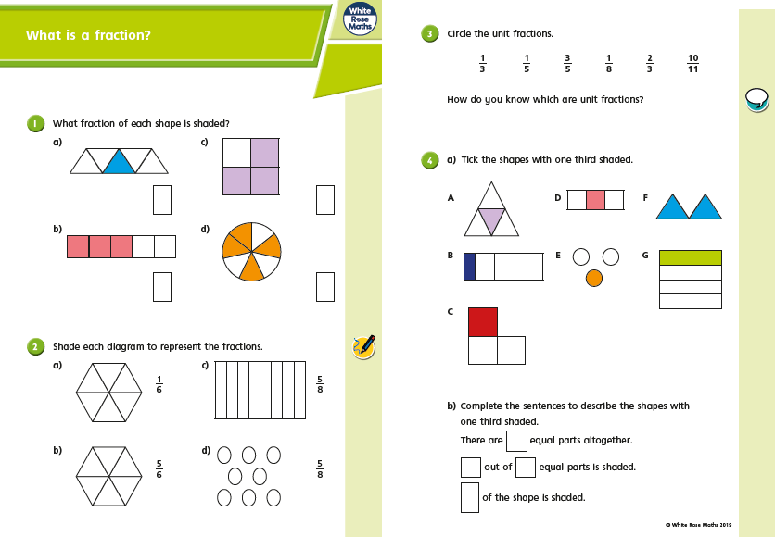

Monday
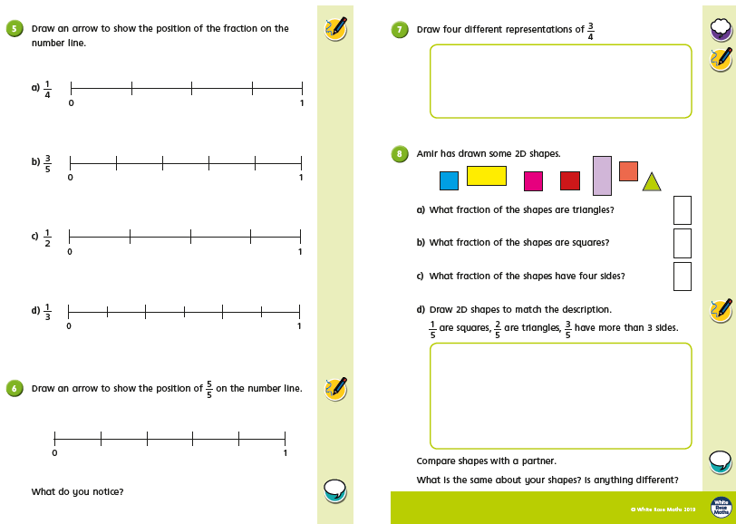
Tuesday
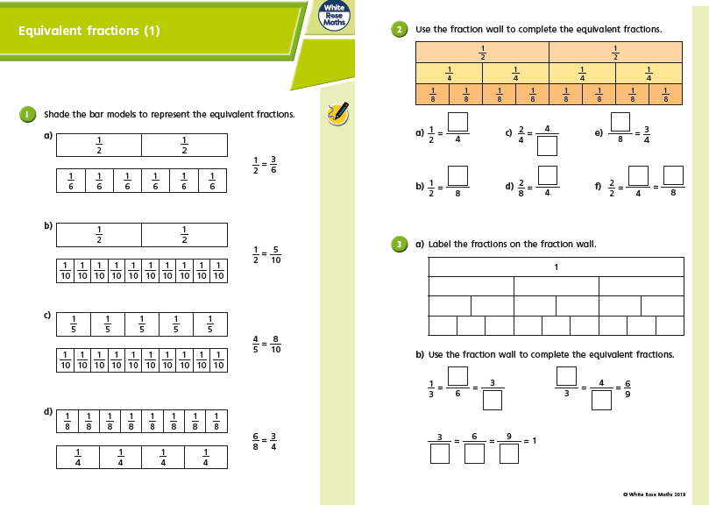
Tuesday
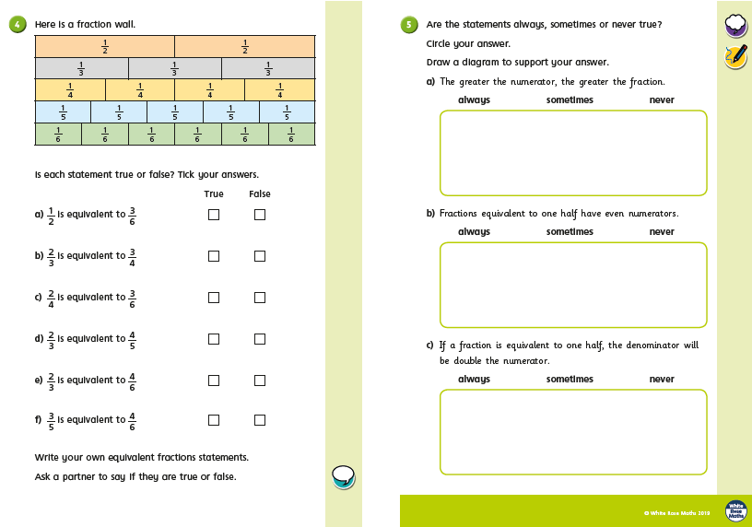
Wednesday
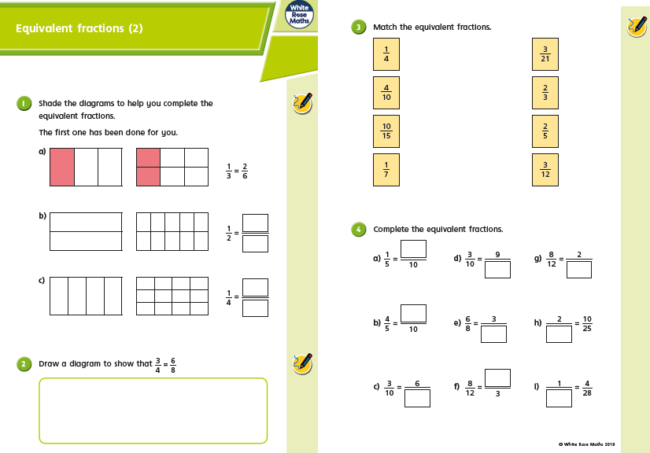
Wednesday
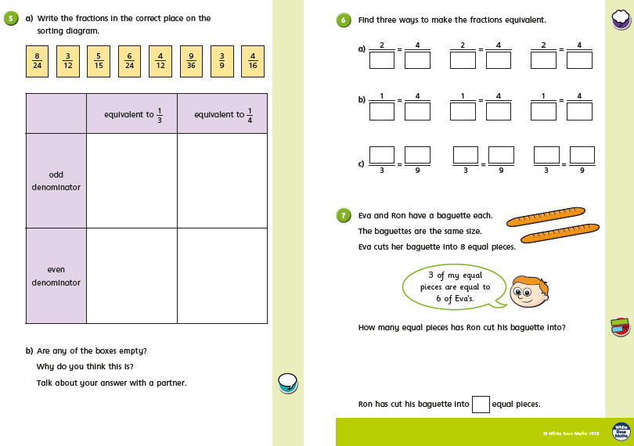
Thursday
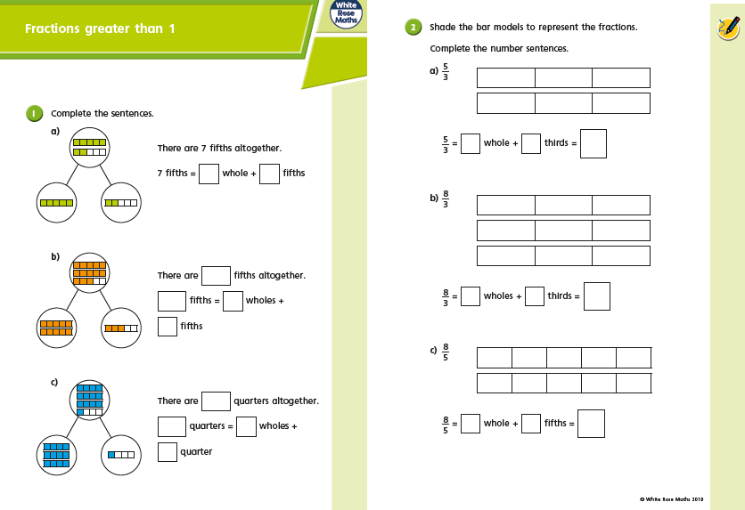
Thursday
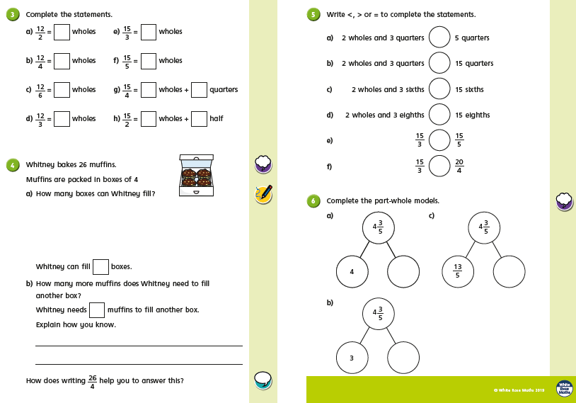
Friday Challenges
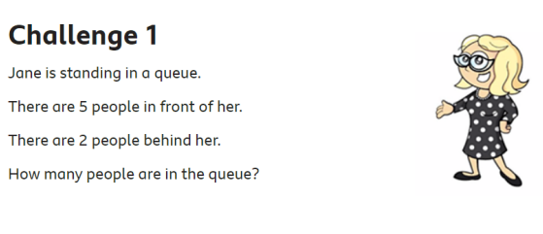
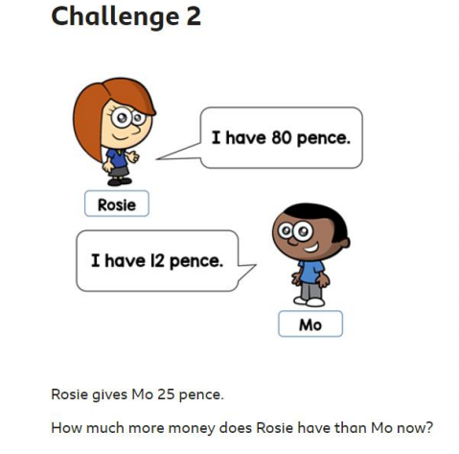

Friday Challenges
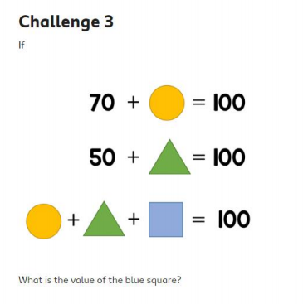
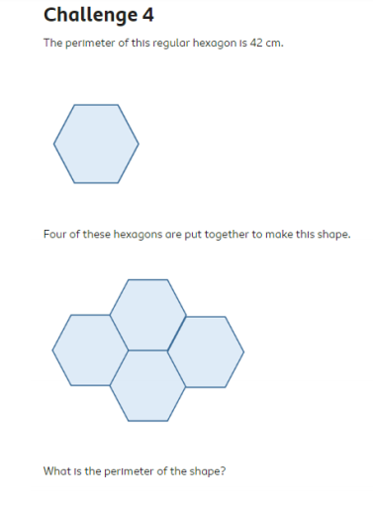
Friday Challenges
