Maths Year 4
w/c 22.06.20
The objectives we are working on in detail this week are:
- To solve problems involving multiplying and adding, including using the distributive law to multiply a two-digit number by a 1-digit number, integer scaling problems and harder correspondence problems such as n objects are connected to m objects.
- To measure and calculate the perimeter of a rectilinear figure (including squares) in centimetres and metres
- To find the area of rectilinear shapes by counting squares

This week on Monday, you will start by completing multiplication and division problems. On Tuesday, you will be finding the perimeter of rectangles. On Wednesday, you will be finding the perimeter of rectilinear shapes (shapes made up of more than 1 rectangle). On Thursday, you will be finding the area of shapes by counting squares and on Friday, you have maths challenges to complete!

Using the link below, click on Summer Term Week 4 and each day watch the video and complete the accompanying task (these are printed in your pack), recording the answers in your book. Lesson 1 – Monday, Lesson 2 – Tuesday, Lesson 3 – Wednesday, Lesson 4 – Thursday and Lesson 5 – Friday.
https://whiterosemaths.com/homelearning/year-4/

Have a go at these Classroom Secrets games to practise your skills!

https://kids.classroomsecrets.co.uk/resource/year-4-perimeter-of-a-rectangle/

https://kids.classroomsecrets.co.uk/resource/year-4-counting-squares-interactive-animation/

Monday
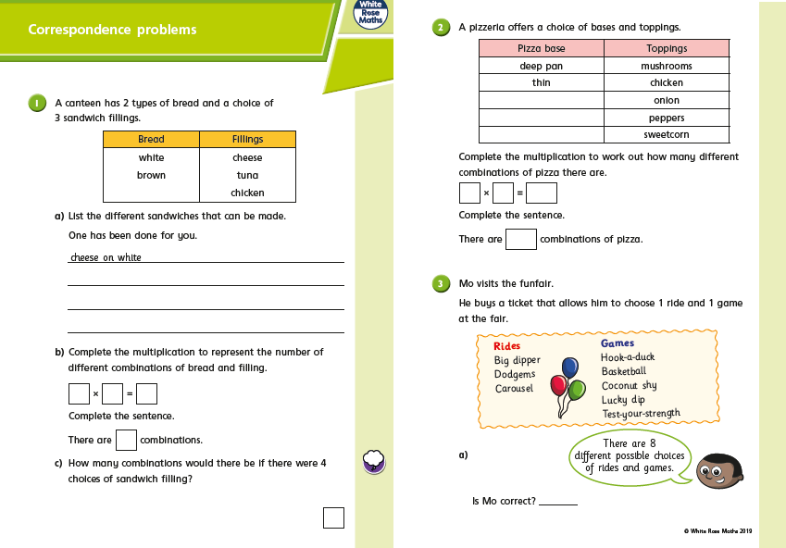

Monday
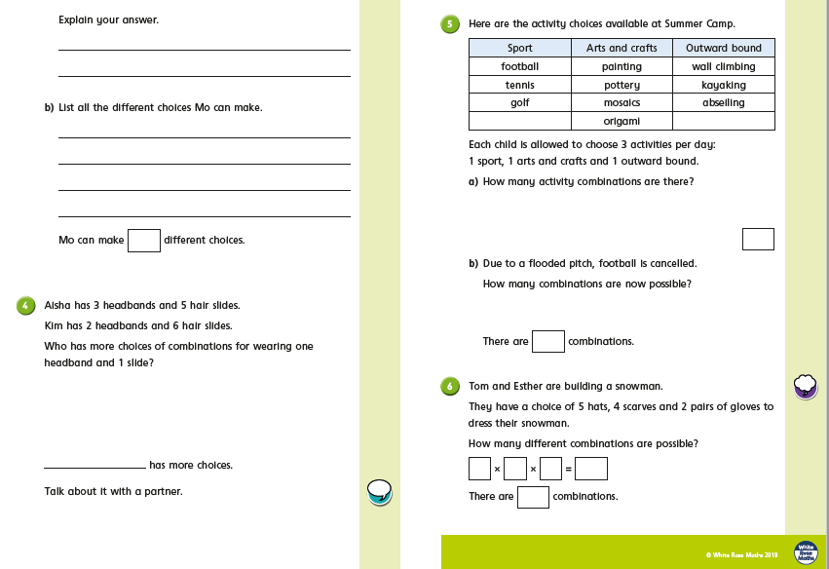
Tuesday
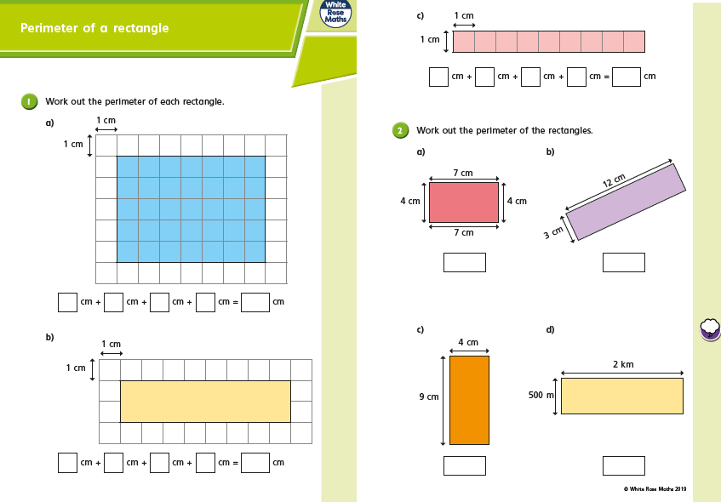
Tuesday
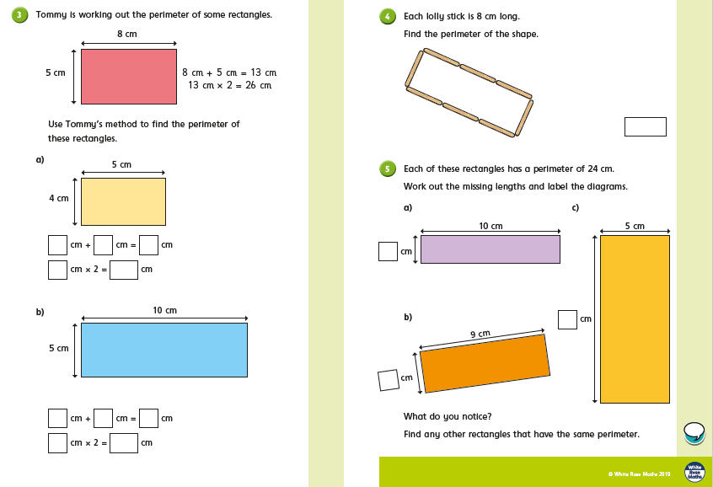
Wednesday
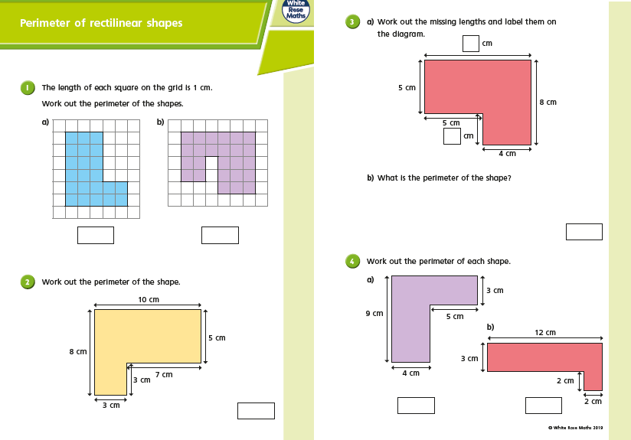

Wednesday
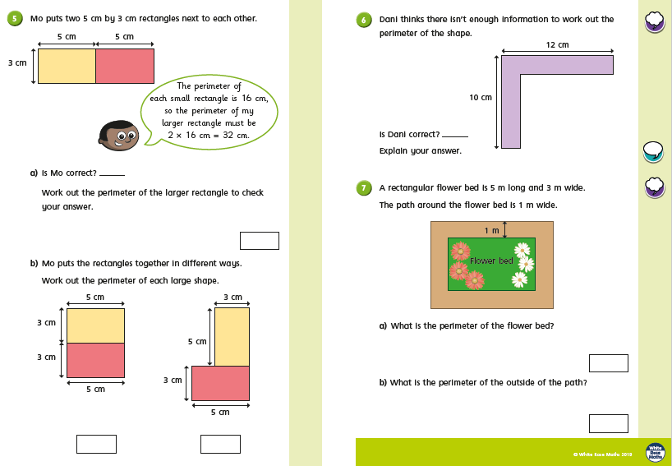
Thursday
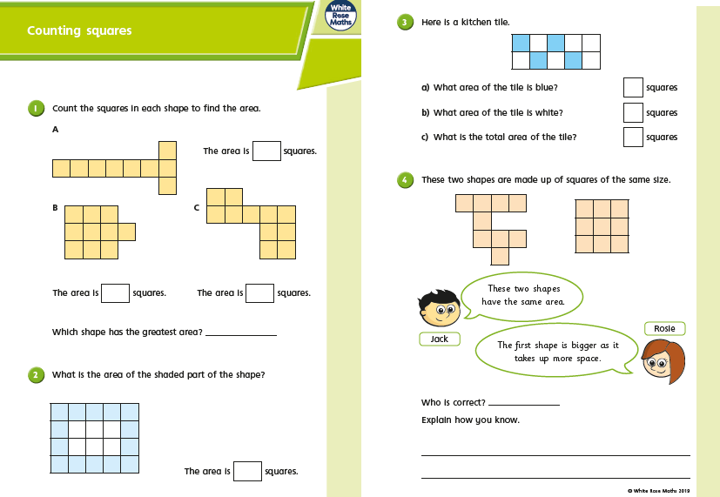
Thursday
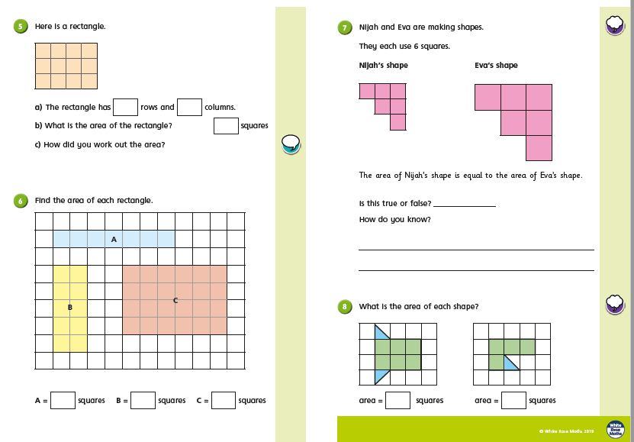
Friday Challenges
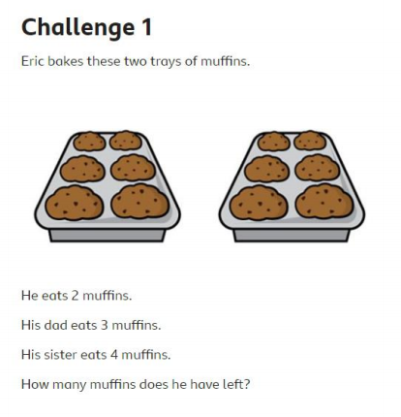
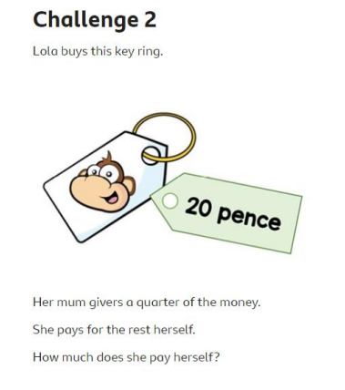
Friday Challenges
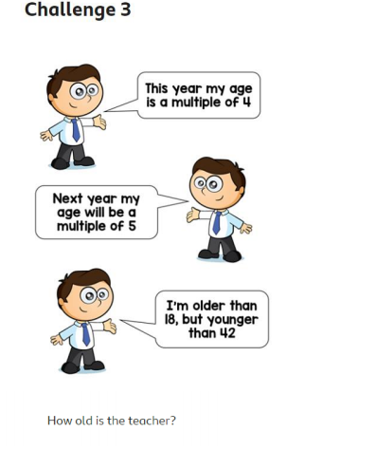
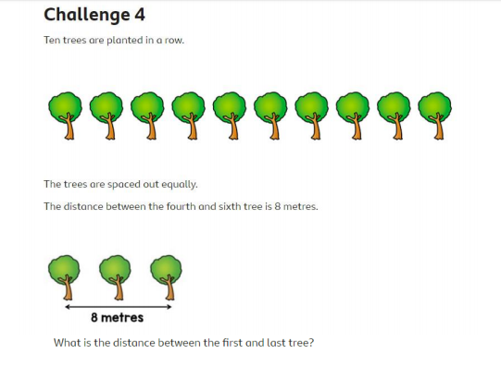

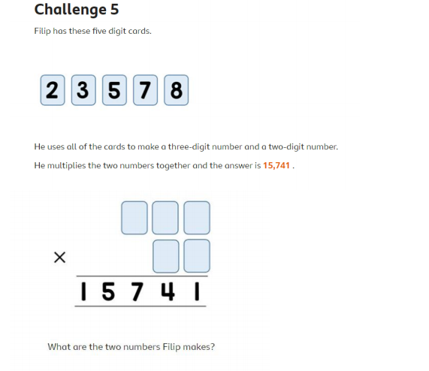
Friday Challenges

