Maths Year 4
w/c 15.06.20
The objective we are working on in detail this week is:
To multiply two-digit and three-digit numbers by a one-digit number using a formal written method
Recall multiplication and division facts for multiplication tables up to 12 × 12
This week on Monday, you will start by multiplying a 2-digit number by a 1-digit number. On Tuesday, you will be multiplying a 3-digit number by a 1-digit number. On Wednesday, you will be dividing a 2-digit number by a 1-digit number. On Thursday, you will be dividing a 3-digit number by a 1-digit number, and on Friday, you have a maths challenge!

Using the link below, click on Summer Term Week 3 and each day watch the video and complete the accompanying task (these are printed in your pack), recording the answers in your book. Lesson 1 – Monday, Lesson 2 – Tuesday, Lesson 3 – Wednesday, Lesson 4 – Thursday and lesson 5 – Friday.
https://whiterosemaths.com/homelearning/year-4/

Have a go at the following Classroom Secrets games to practise your skills!

https://kids.classroomsecrets.co.uk/resource/year-4-multiply-2-digits-by-1-digit-game/

https://kids.classroomsecrets.co.uk/resource/year-4-divide-2-digits-by-1-digit-2-reasoning-practice/

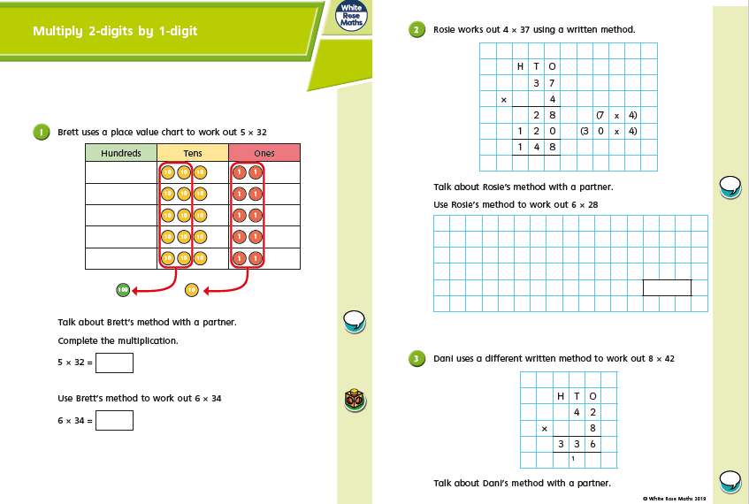
Monday
Monday
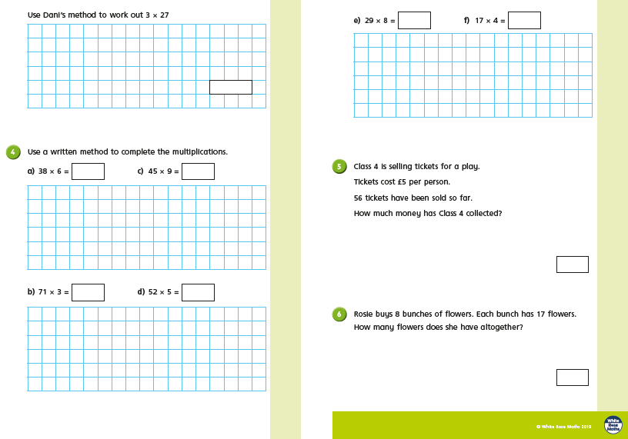

Tuesday
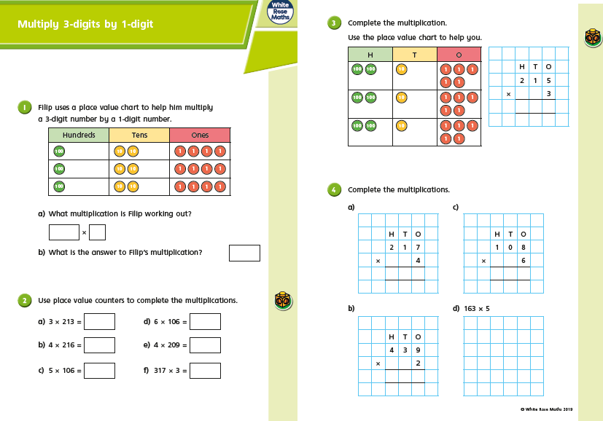
Tuesday
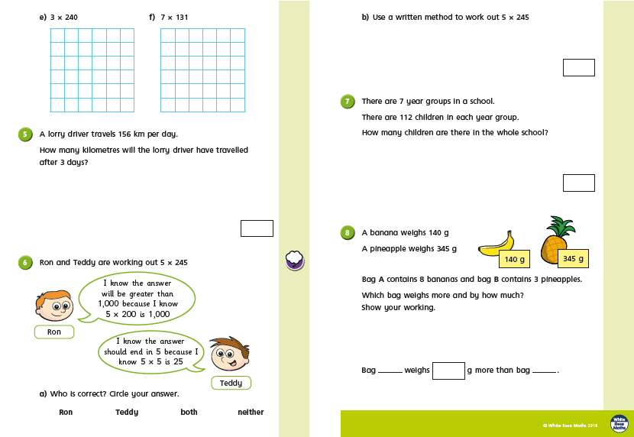
Wednesday
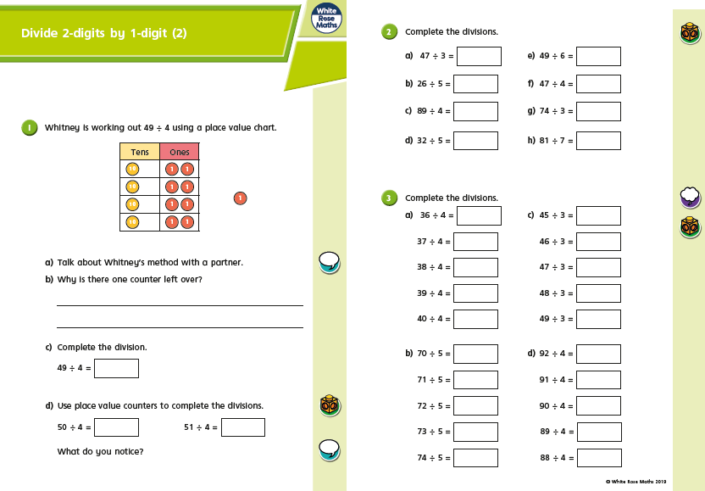

Wednesday
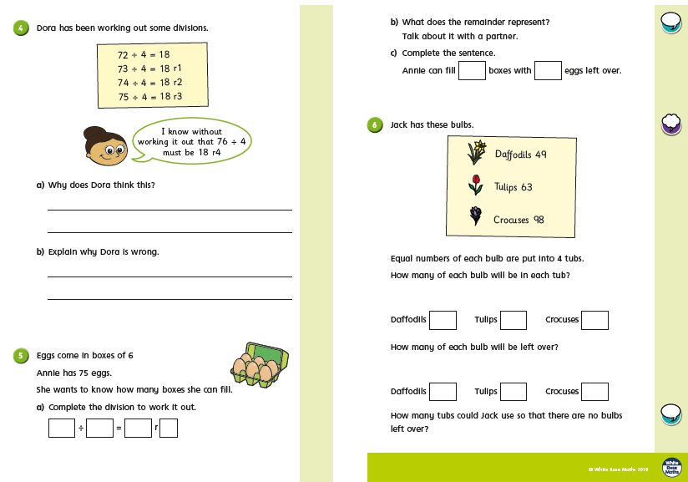
Thursday
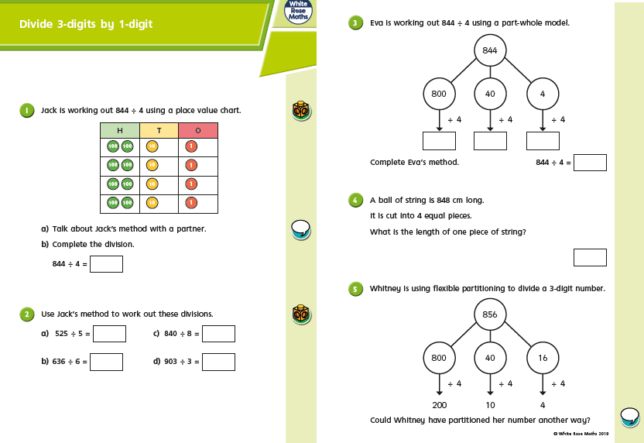
Thursday
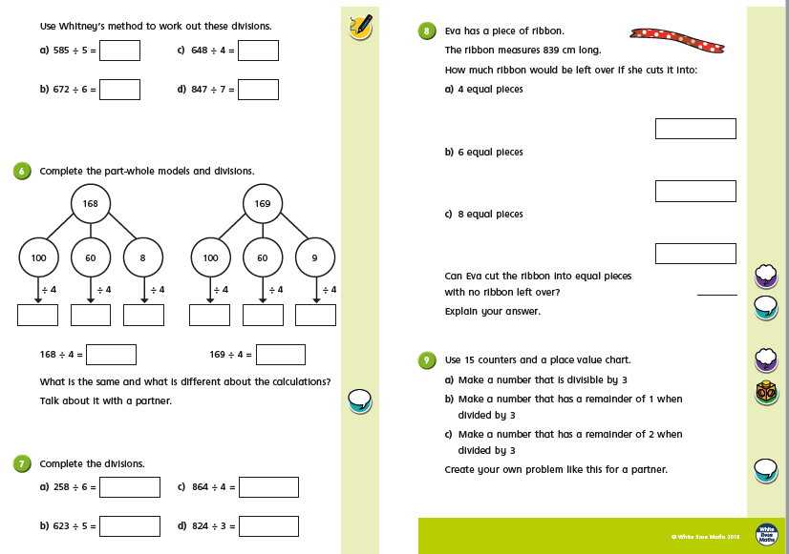
Friday Challenges
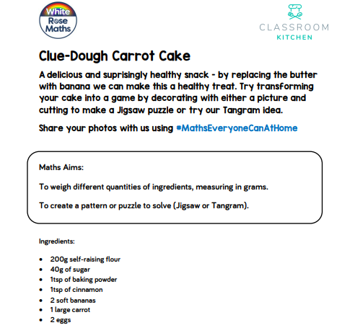

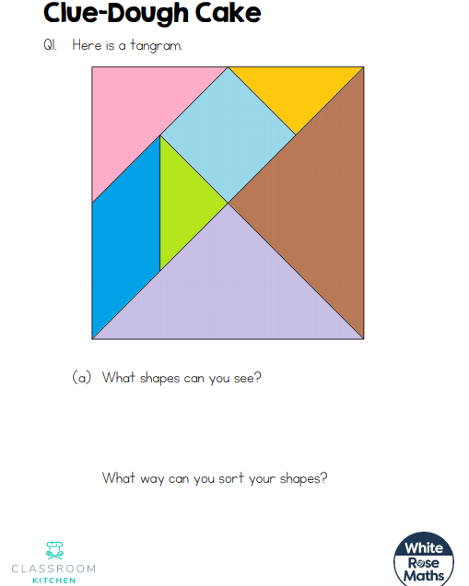
If you are not able to bake, you can complete these challenges!

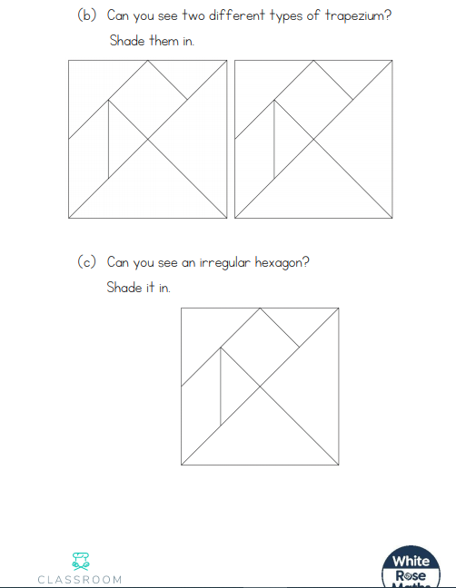

Friday Challenges
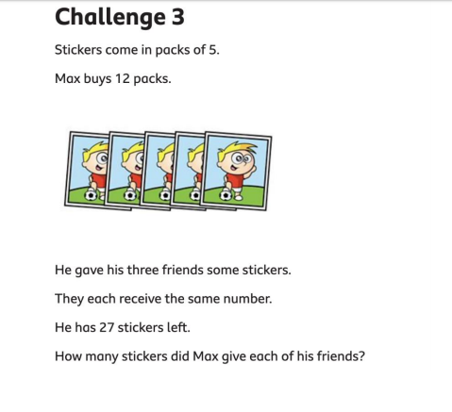
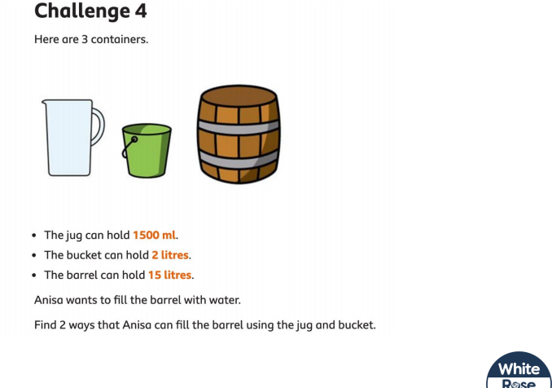
Friday Challenges
