Maths Year 4
w/c 08.06.20
The objectives we are working on in detail this week are:
To recognise and write decimal equivalents to ¼ , ½ , ¾
To estimate, compare and calculate different measures, including money in pounds and pence
This week on Monday, you will start by rounding decimals. On Tuesday, you will be using halves and quarters and their equivalent fractions. On Wednesday, you will be using money and solving problems involving money. On Thursday, you will be ordering money, and on Friday, you have some maths challenges to try to complete!

Using the link below, click on Summer Term Week 2 and each day watch the video and complete the accompanying task (these are printed in your pack), recording the answers in your book. Lesson 1 – Monday, Lesson 2 – Tuesday, Lesson 3 – Wednesday, Lesson 4 – Thursday and lesson 5 – Friday.
https://whiterosemaths.com/homelearning/year-4/

Have a go at this Classroom Secrets Kids games all about decimals! Enjoy!

https://kids.classroomsecrets.co.uk/resource/year-4-hundredths-as-decimals/

https://kids.classroomsecrets.co.uk/resource/year-4-order-decimals/

Monday
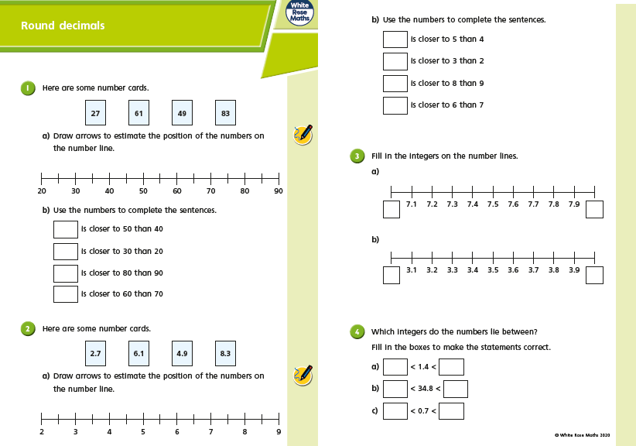

Monday
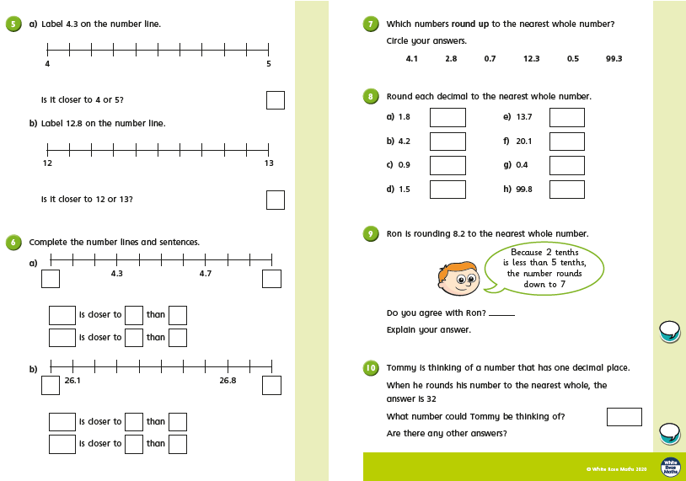

Tuesday
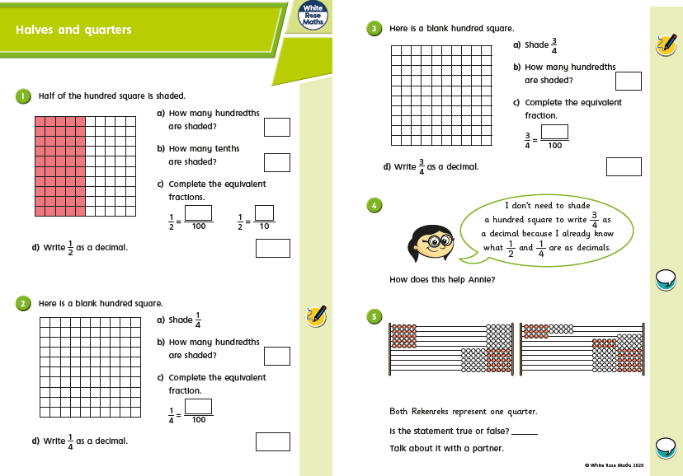

Tuesday
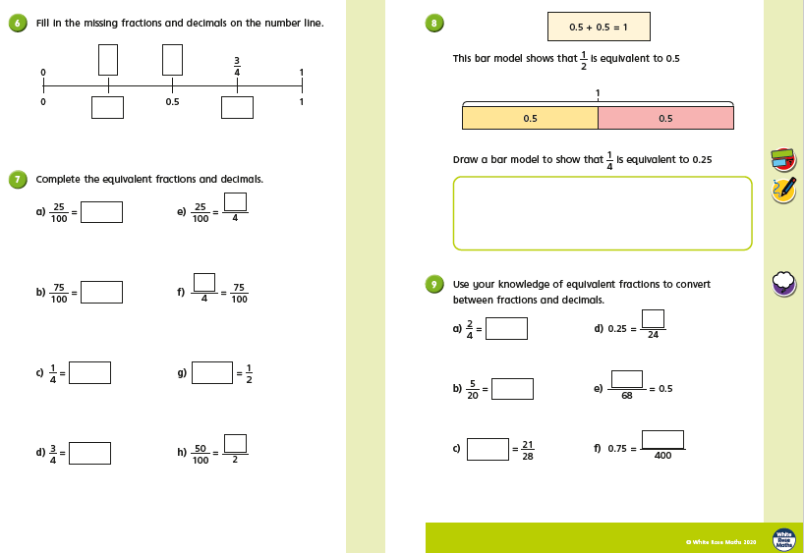

Wednesday
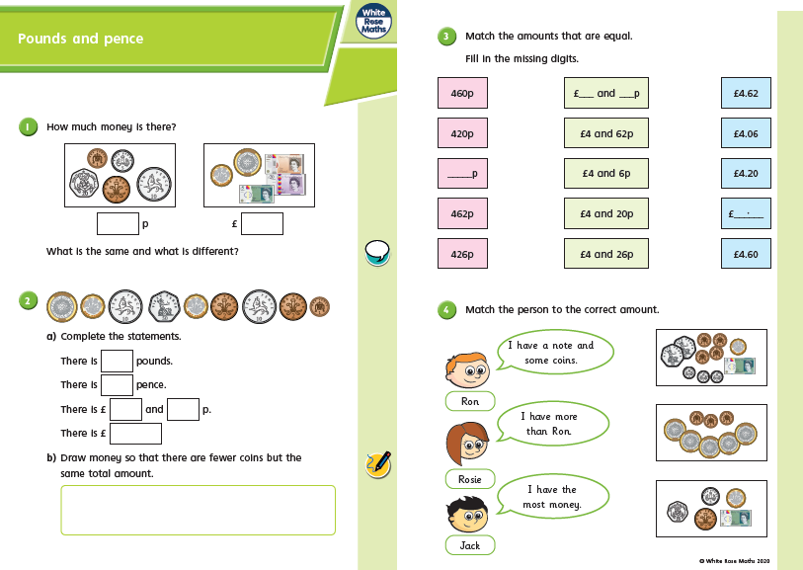

Wednesday
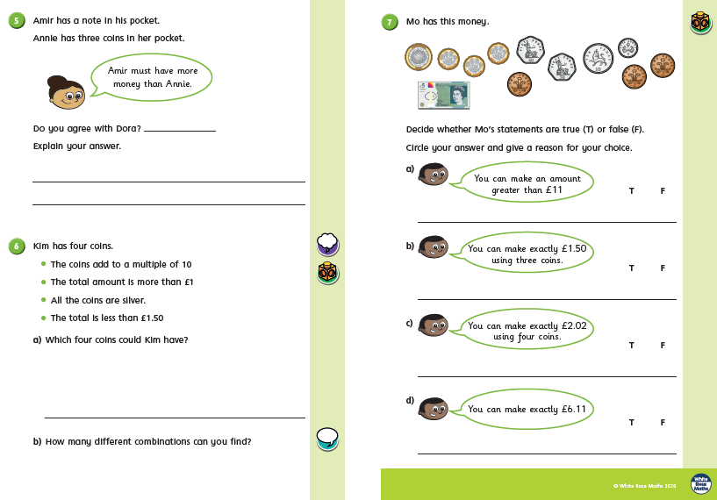
Thursday
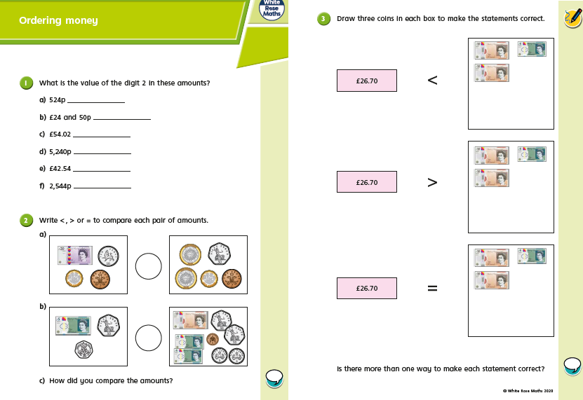
Thursday
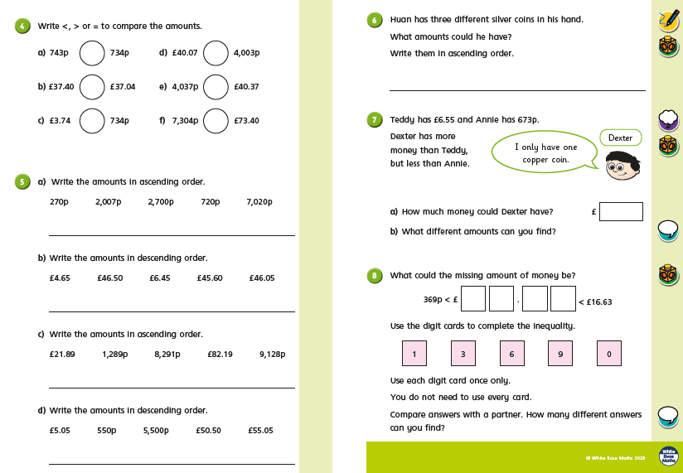

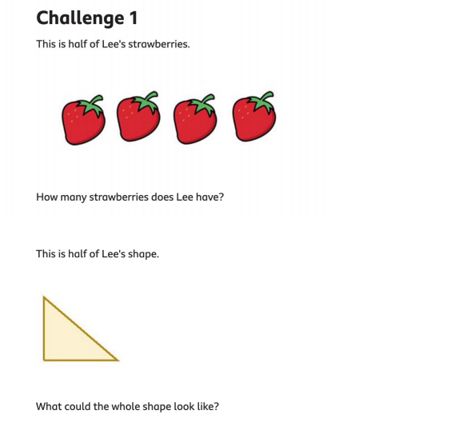
Friday Challenges

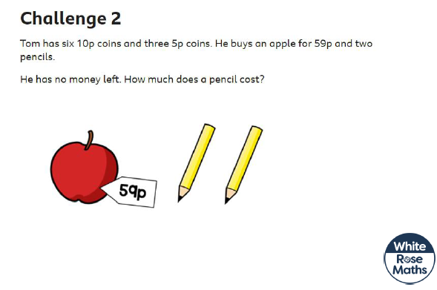

Friday Challenges
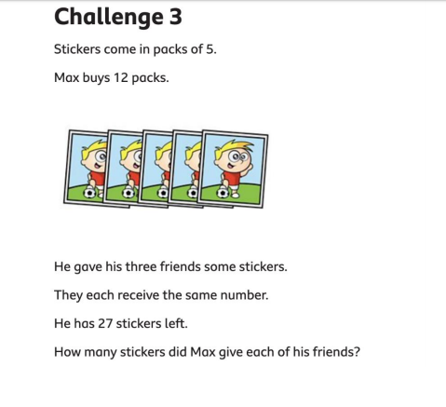
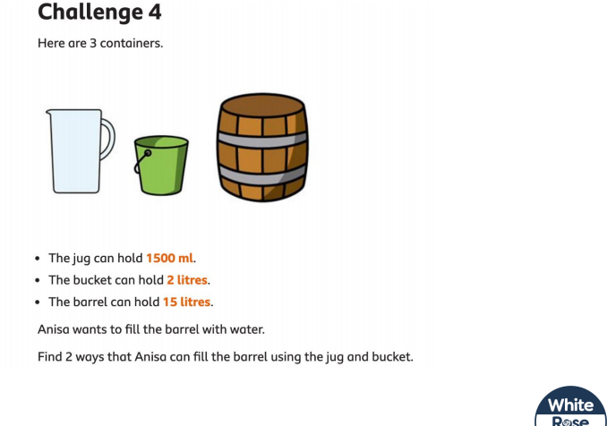
Friday Challenges
