Maths Year 4
w/c 01.06.20
The objectives we are working on in detail this week are:
To compare numbers with the same number of decimal places up to two decimal places
To recognise and write decimal equivalents to ¼ , ½ , ¾

This week on Monday, you will start by making a whole by adding fractions and decimals together. On Tuesday, you will be learning how to write decimals and understanding their place value. On Wednesday, you will be comparing decimals. On Thursday, you will be ordering decimals, and on Friday, you have some maths challenges to try and complete!
Using the link below, click on Summer Term Week 1 and each day watch the video and complete the accompanying task (these are printed in your pack), recording the answers in your book. Lesson 1 – Monday, Lesson 2 – Tuesday, Lesson 3 – Wednesday, Lesson 4 – Thursday and lesson 5 – Friday.
https://whiterosemaths.com/homelearning/year-4/

Have a go at this classroom secrets games too all about decimals! Enjoy!

https://kids.classroomsecrets.co.uk/resource/year-4-recognise-tenths-and-hundredths-game/

https://kids.classroomsecrets.co.uk/resource/year-4-compare-decimals/

Place value grid

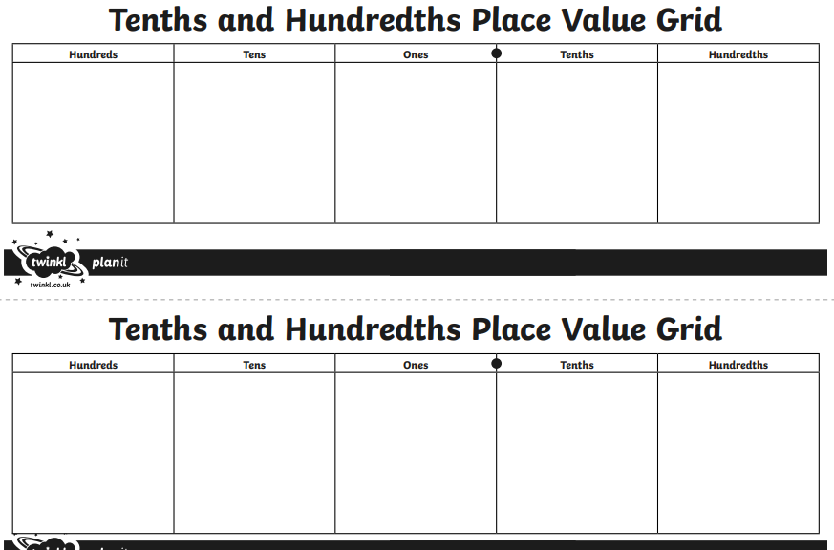
Monday

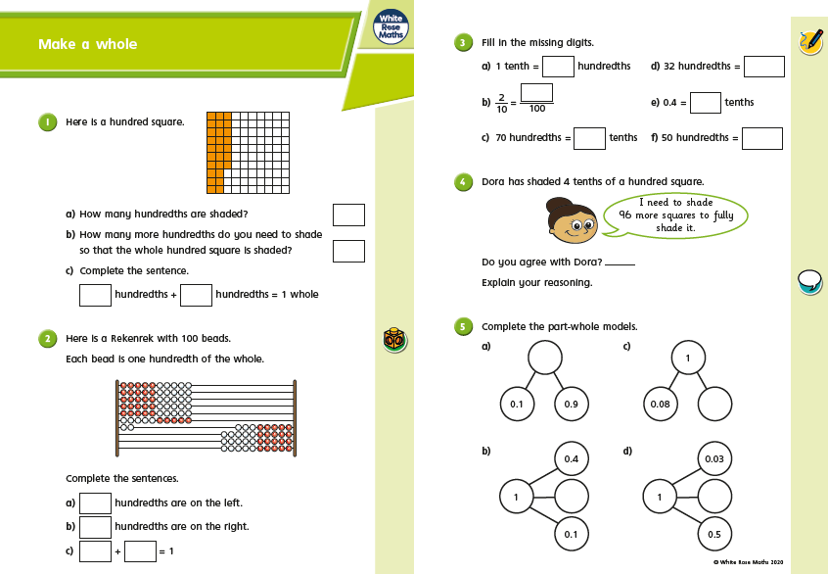

Monday
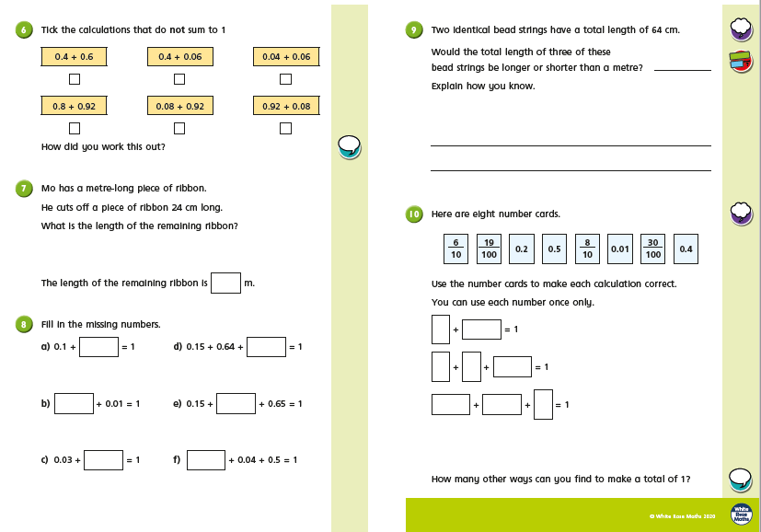
Tuesday
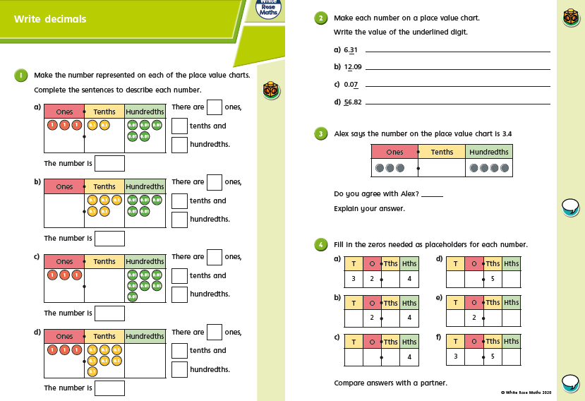
Tuesday
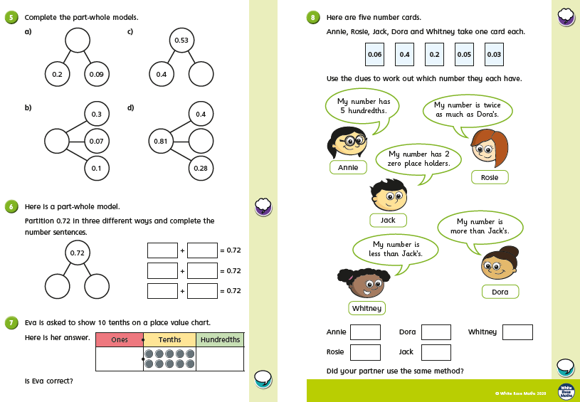

Wednesday
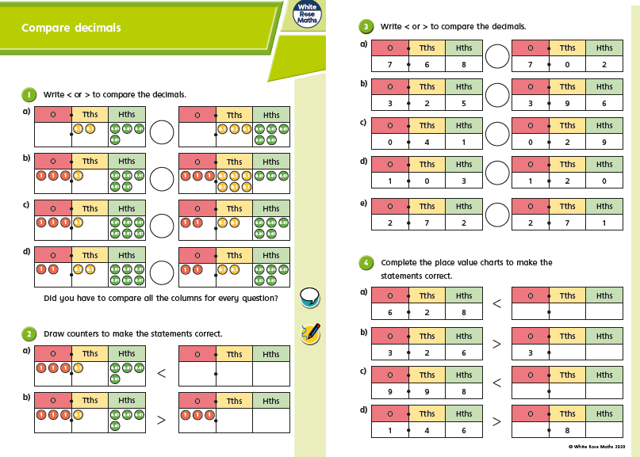

Wednesday
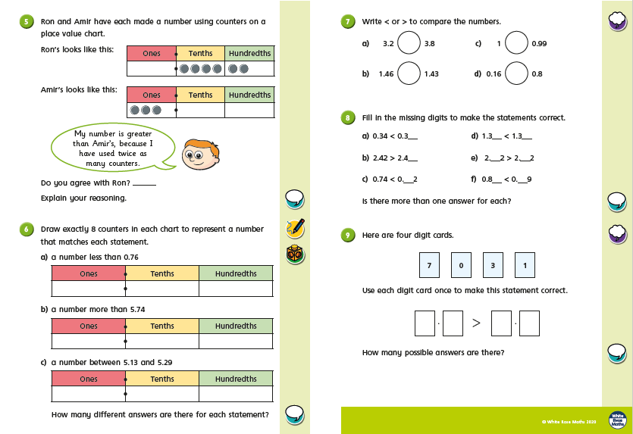
Thursday

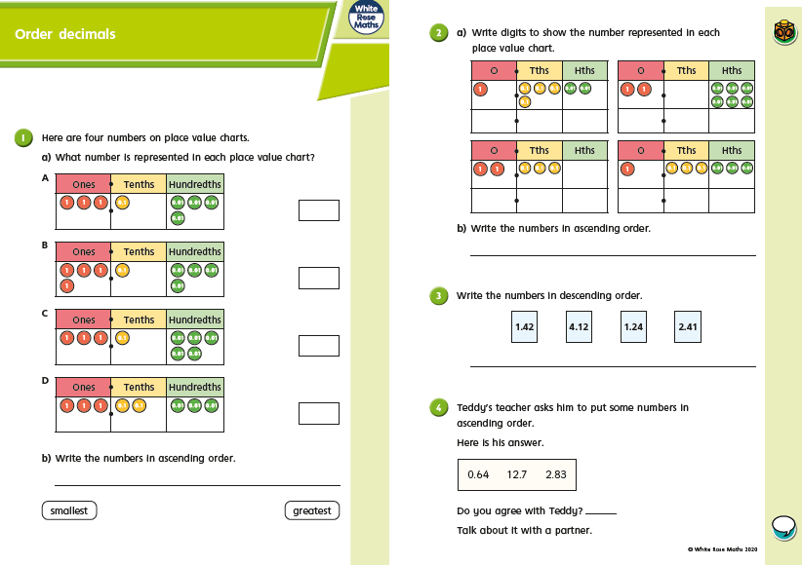
Thursday
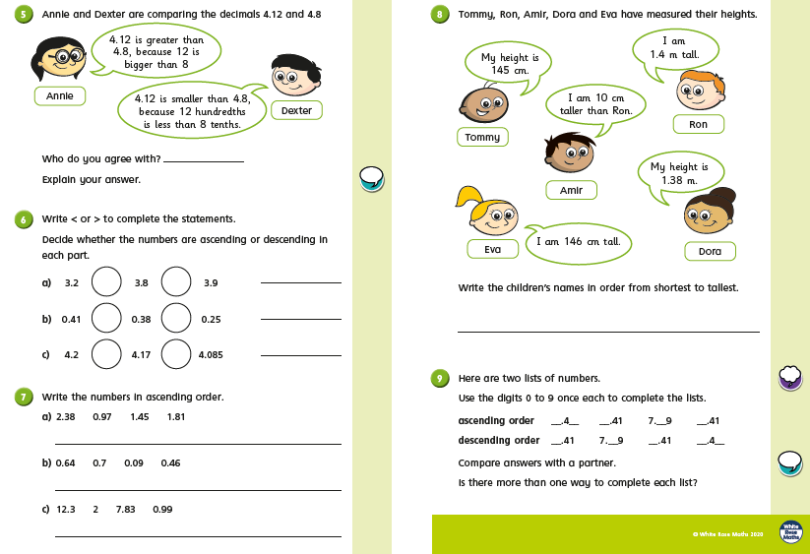

Friday Challenges
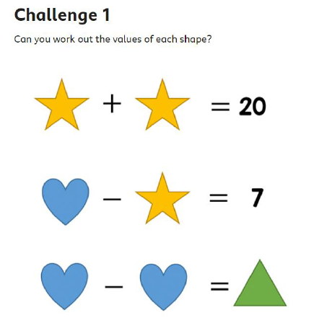
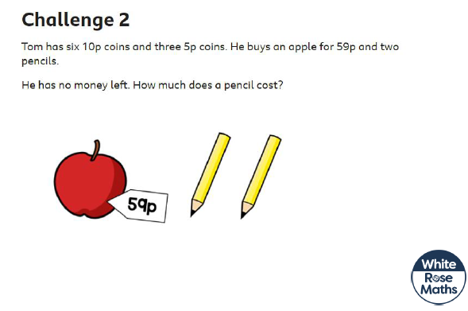

Friday Challenges
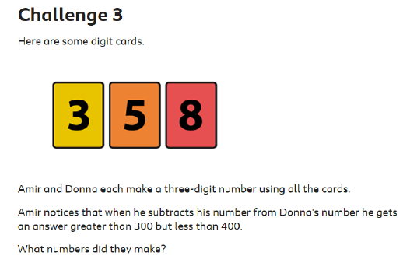
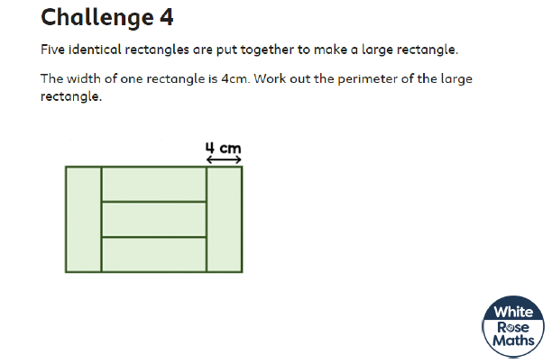

Friday Challenges
