Maths Year 4
Shape w/c 04/05/2020
The objectives we are working on this week are:
To identify lines of symmetry in 2-D shapes presented in different orientations
To complete a simple symmetric figure with respect to a specific line of symmetry
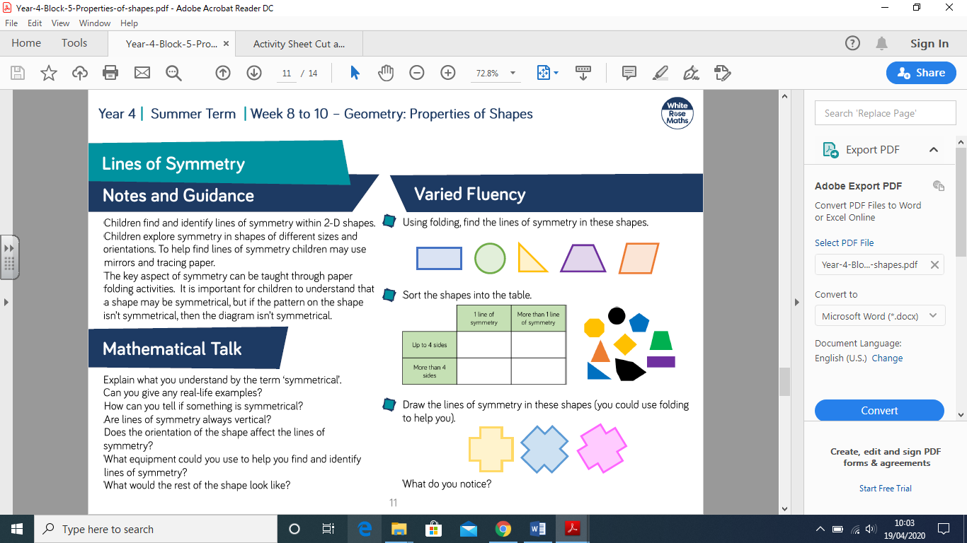

This week, we are learning all about lines of symmetry. We will be finding lines of symmetry, completing patterns and finally creating a symmetrical Second World War medal for soldiers who fought for Britain!

Have a go at watching the clip:
https://www.bbc.co.uk/bitesize/topics/zvmxsbk/articles/zggsfrd
You can complete the tasks on the clip if you would like, but your first mission will be:
- Cut out the 2D shapes, by folding the shapes. Can you work out how many lines of symmetry each shape has? (Page 2)

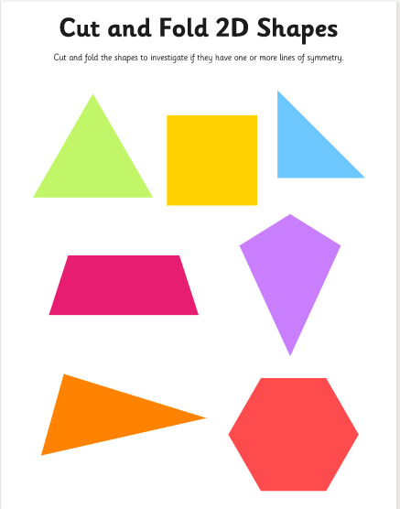

- Challenge 1: have a go at seeing how many symmetrical shapes you can make by colouring in a maximum of 6 squares. (page 3, 4 and 5)
Lines of Symmetry – Challenge 1!
How many symmetrical shapes you can make by colouring in a maximum of 6 squares?
Example

Sheet 2

Symmetrical patterns and shapes

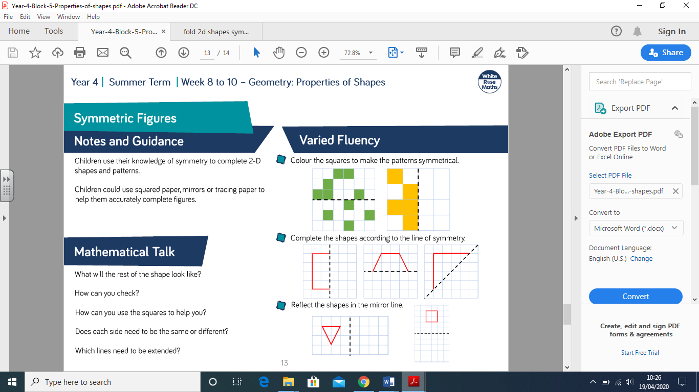

- Try completing the patterns on page 7, making sure you take note of where the line of symmetry is! Remember, the pattern needs to be exactly the same on each side. Example:

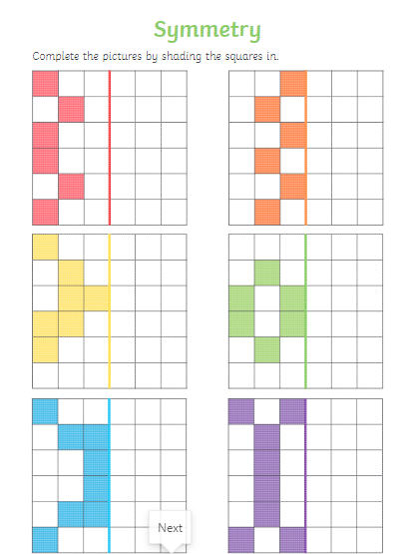

- Work your way through the reflecting figures information on page 8 and 9, remembering to look carefully at where the mirror lines are and how the shape has been reflected! Complete the challenge on page 10.
Reflecting each point of the shape makes it easier to ensure the shape is symmetrical – good luck!
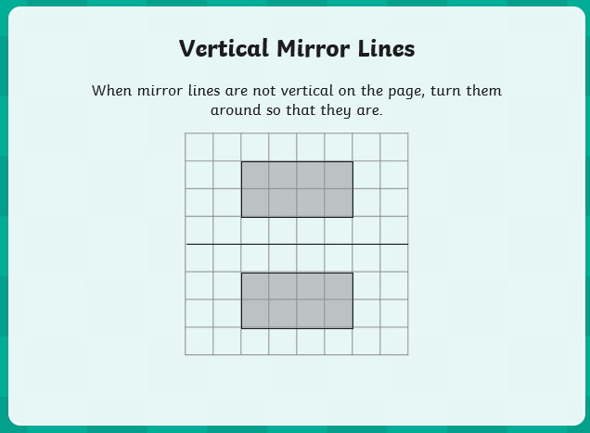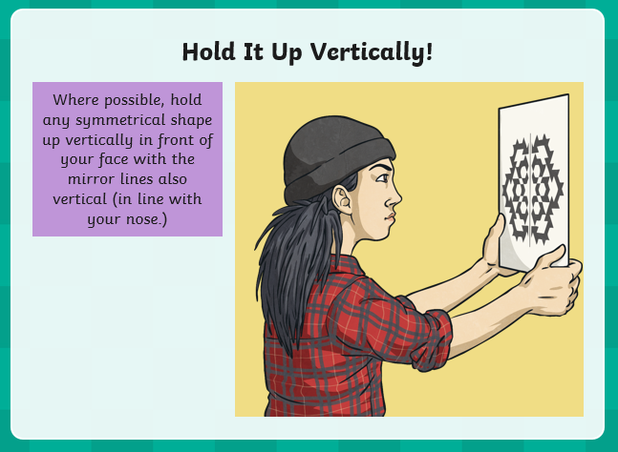
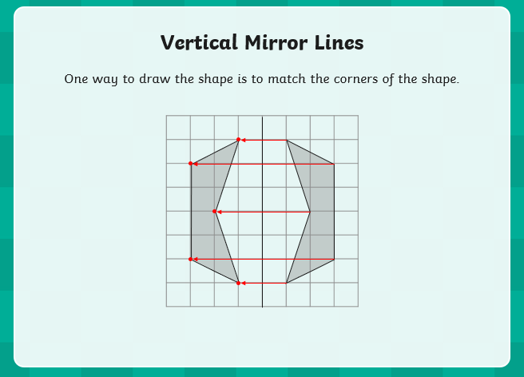

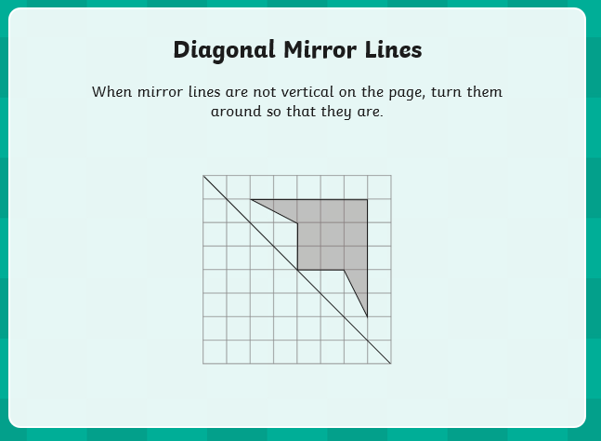

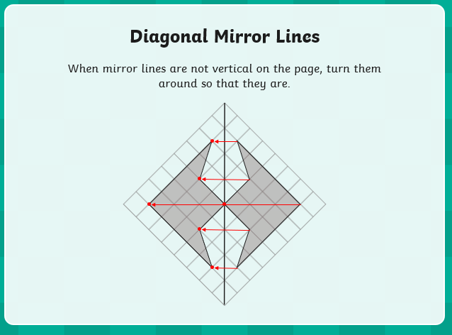

I can use mirror lines to reflect shapes
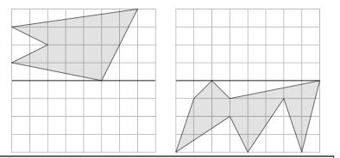
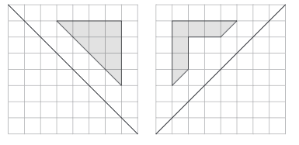

- Final Mission
As we have been learning about symmetry, I would like you to create a symmetrical medal for the soldiers from the Second World War. You can use different shapes and patterns and you can either draw on page 12 or use the computer!
This is a very simple one I created; can you make a more detailed one?

This is the mirror line for my medal creation!

Have fun year 4!
Mrs Taylor

P.S. I have included some symmetry mastery challenges for you – if you are finding symmetry easy, have a go at the challenges on page 13.

Create a symmetrical war time medal!

Mastery Questions – Symmetry

