Maths Year 6
w/c 18.5.2020
The objectives we are working on in this week are:
- To use common factors to simplify fractions
- To compare and order fractions
- To add and subtract fractions with different denominators
This week’s learning will be a recap of learning we carried out in school during the Spring term. On Monday, you will start by revisiting how to simplify fractions; then on Tuesday, you will revisit comparing and ordering fractions; on Wednesday and Thursday, you will be revisiting how to add and subtract fractions; and finally, on Friday, you will be revisiting previous learning on the order of operations (BIDMAS) using Classroom Secrets Kids.
Using the link below, click on Summer Term – Week 3 and each day (Monday – Thursday) watch the video and complete the accompanying task (these are printed in your pack). Lesson 1 – Monday, Lesson 2 – Tuesday, Lesson 3 – Wednesday, Lesson 4 – Thursday.
https://whiterosemaths.com/homelearning/year-6/
On Friday, use the following links to revisit learning on the order of operations using BIDMAS to help you:

B-brackets
I-indices
D-division
M-multiplication
A-addition
S-subtraction

https://kids.classroomsecrets.co.uk/resource/year-6-order-of-operations-game/

https://kids.classroomsecrets.co.uk/resource/year-6-order-of-operations-matching-game/

Play the games to practise your skills and recap learning.

Monday (part 1)

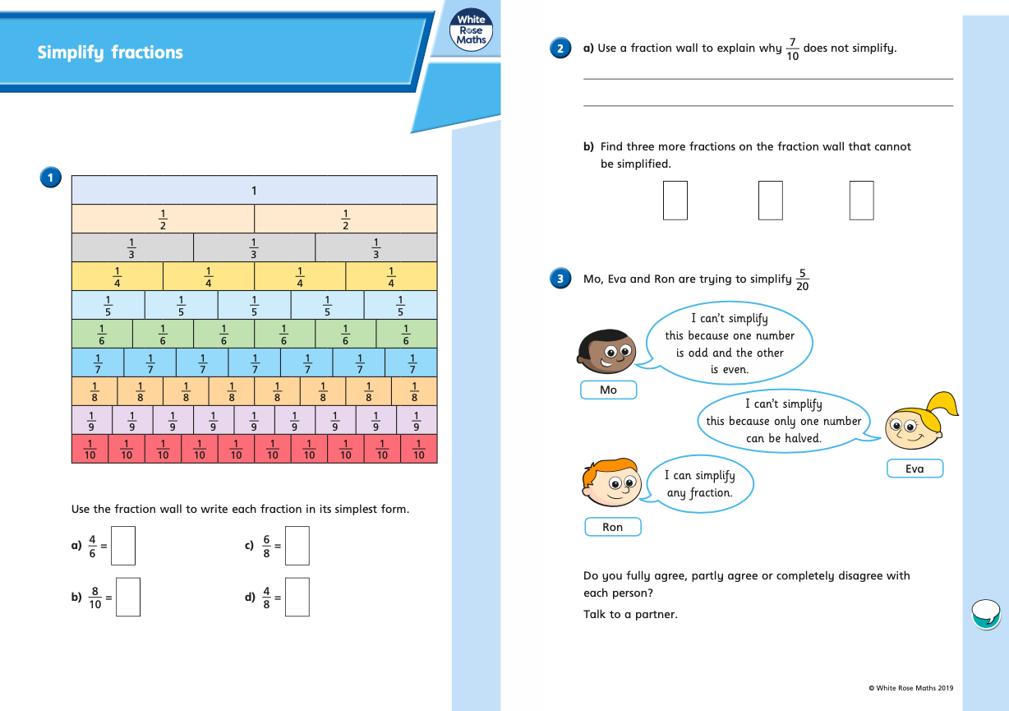
Monday (part 2)
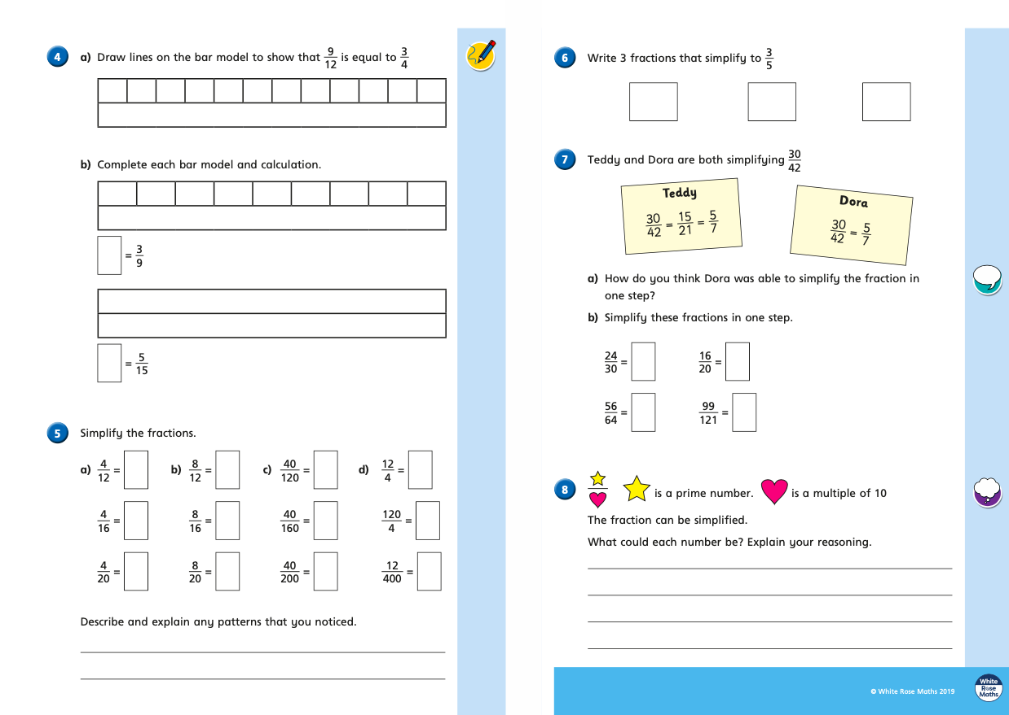
Tuesday (part 1)
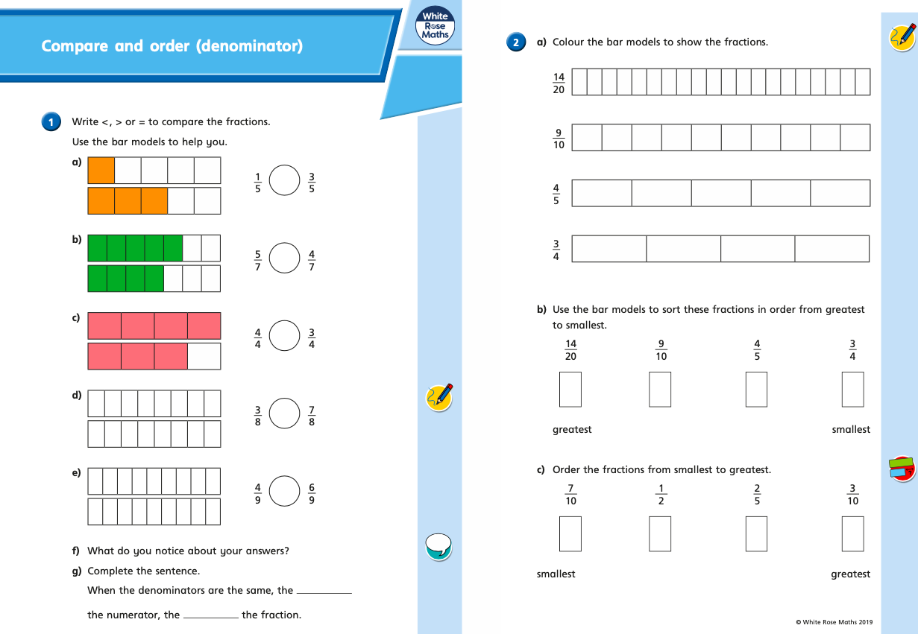

Tuesday (part 2)
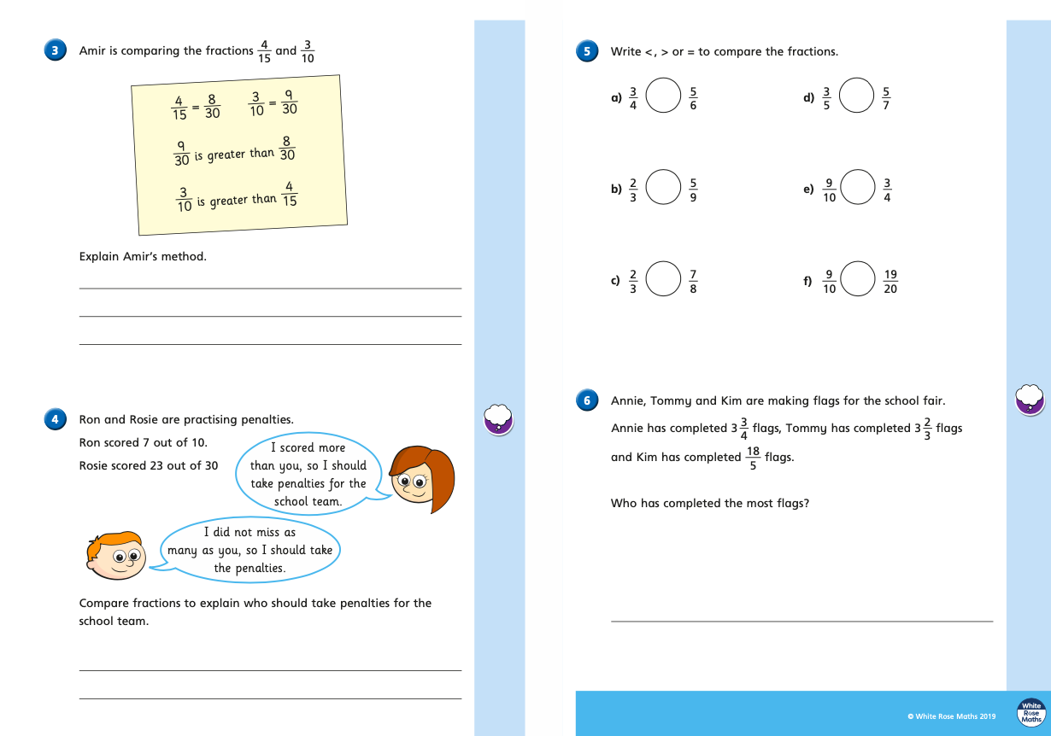
Wednesday (part 1)
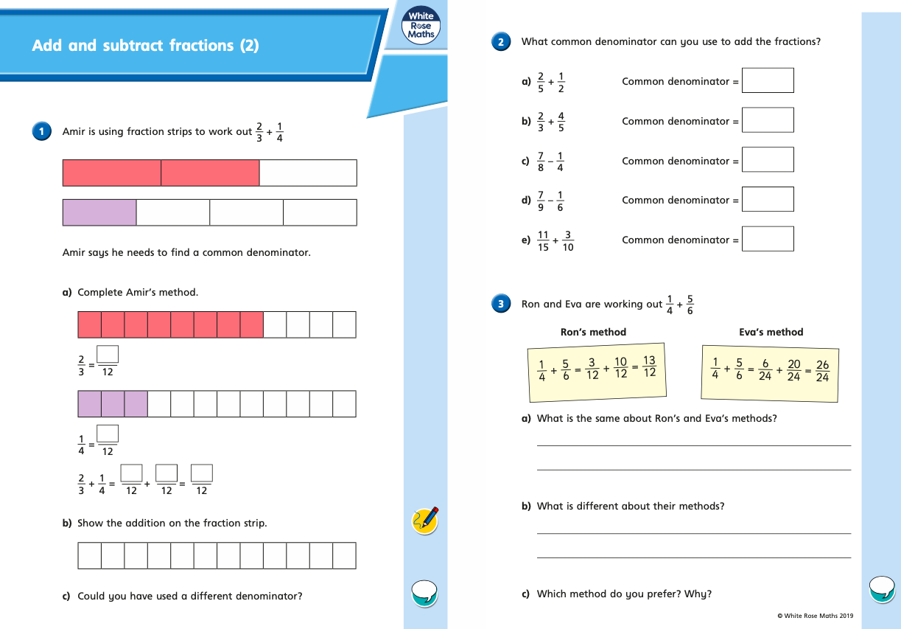

Wednesday (part 2)
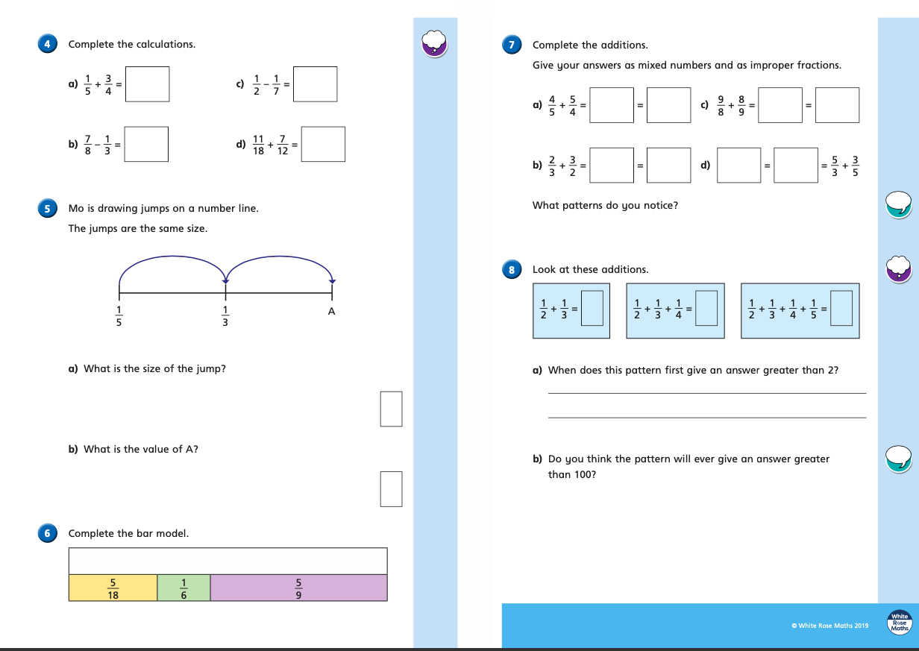

Thursday (part 1)
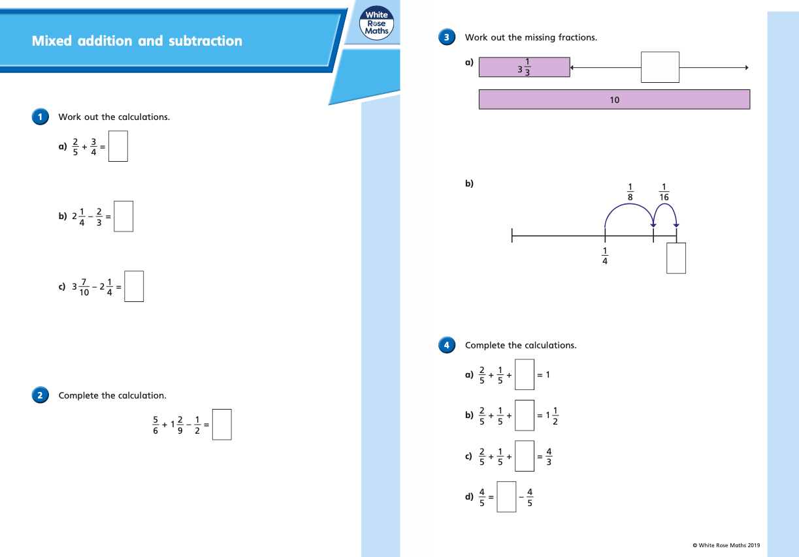

Thursday (part 2)
