Maths Year 6
w/c 11.5.2020
The objective we are working on in detail this week is:
- To compare and classify geometric shapes based on their properties and sizes and find unknown angles in any triangles, quadrilaterals, and regular polygons
This week on Monday, you will start by learning about angles in special quadrilaterals; then on Tuesday, you will learn about angles in regular polygons; on Wednesday and Thursday, you will be developing your problem-solving skills and finally on Friday, you will be revisiting previous learning on adding fractions using Classroom Secrets Kids.
Using the link below, click on Summer Term – Week 2 and each day (Monday – Thursday) watch the video and complete the accompanying task (these are printed in your pack), recording the answers in your book. Lesson 1 – Monday, Lesson 2 – Tuesday, Lesson 3 – Wednesday, Lesson 4 – Thursday.

https://whiterosemaths.com/homelearning/year-6/
On Friday, use the following links to revisit learning on adding fractions and to practise your skills.

https://kids.classroomsecrets.co.uk/resource/adding-fractions-video-tutorial-2/ - video to watch to recap learning

https://kids.classroomsecrets.co.uk/resource/year-6-adding-fractions-game/

Play game to practise skills

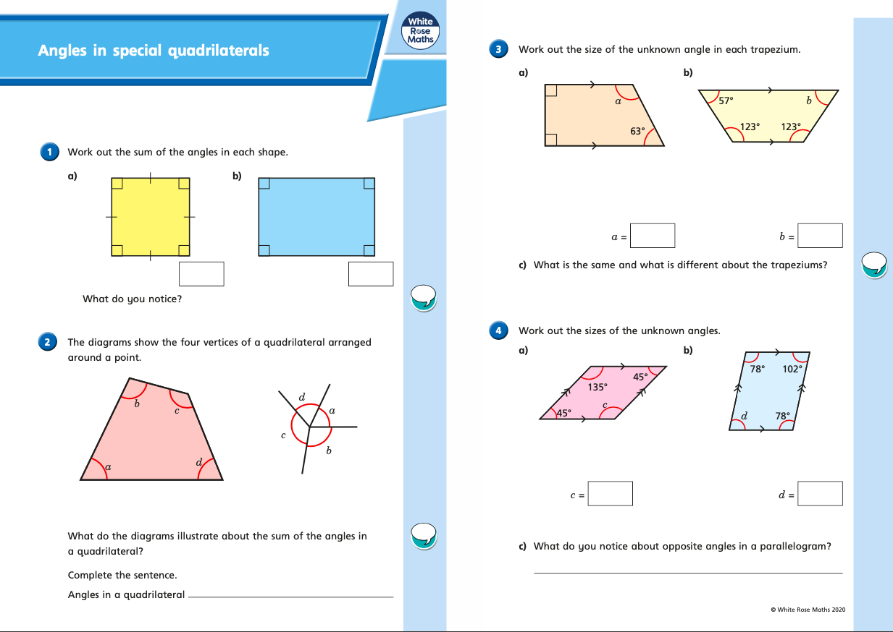
Monday (part 1)
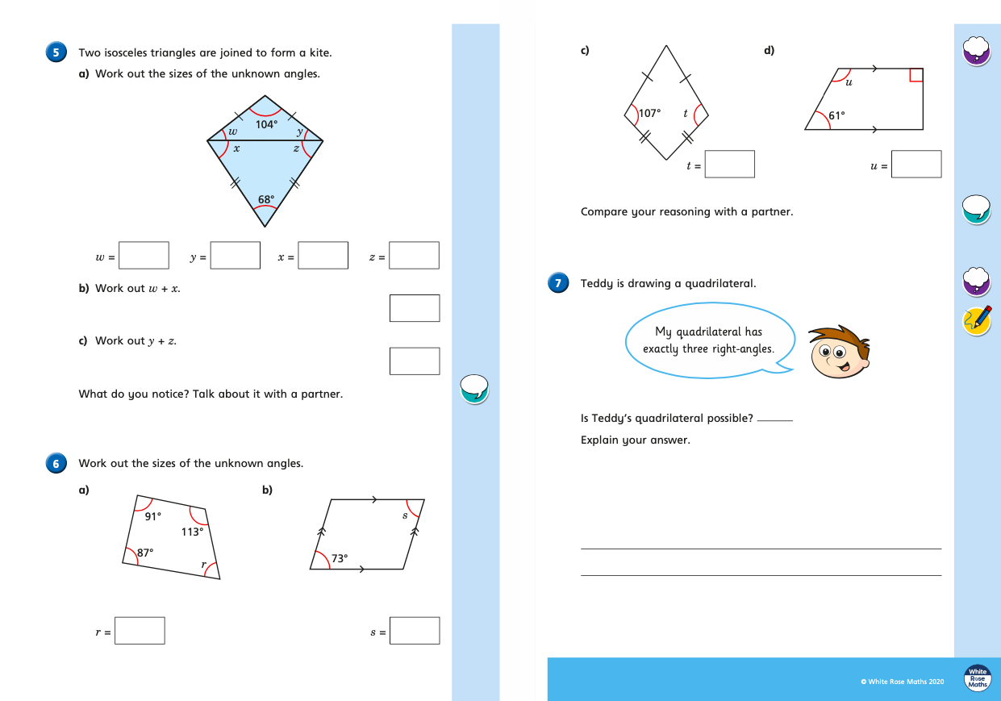
Monday (part 2)
Tuesday (part 1)
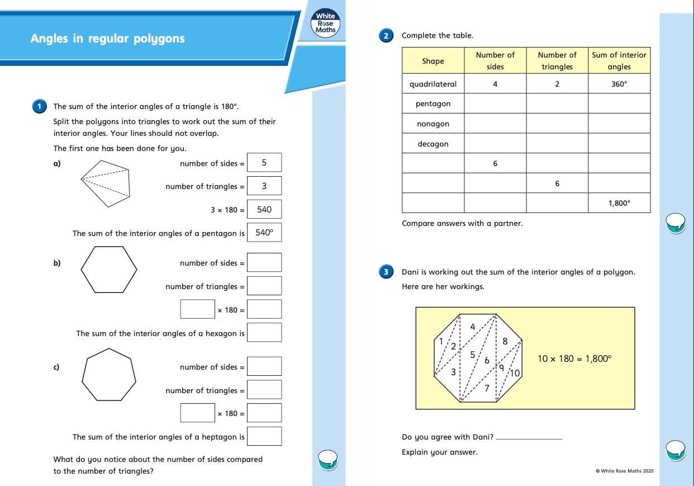
Tuesday (part 2)

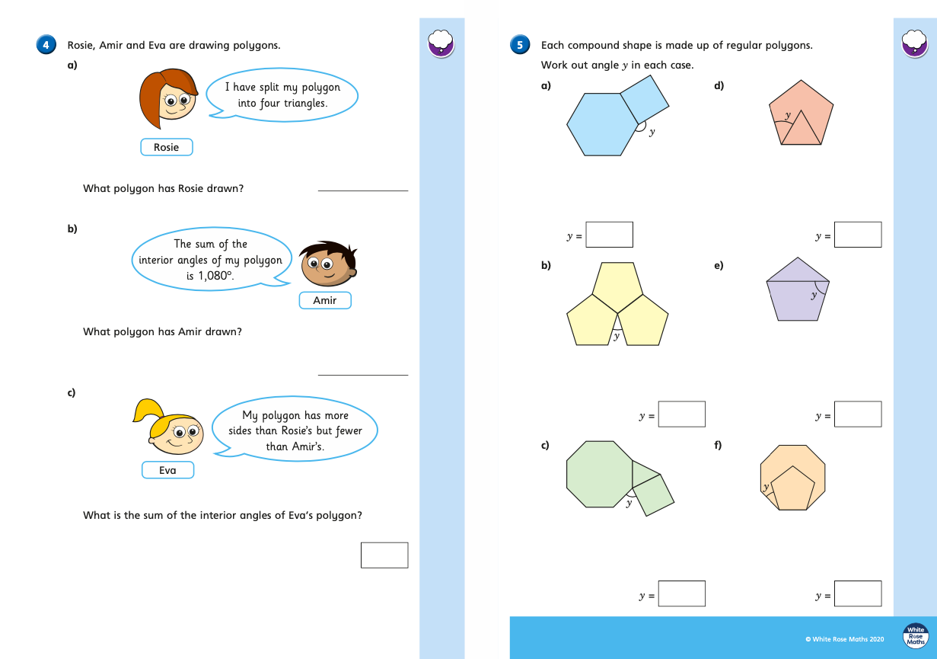
Wednesday (part 1)
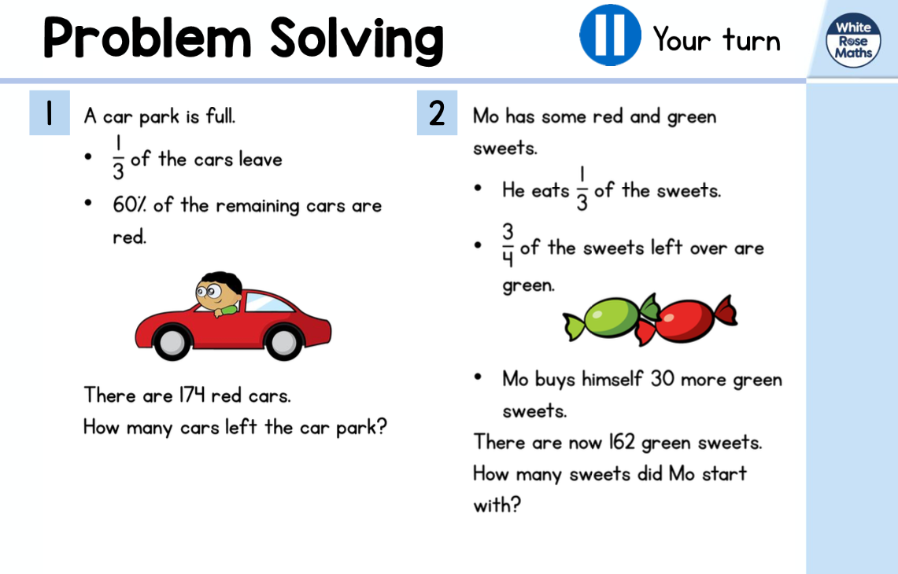
Wednesday (part 2)
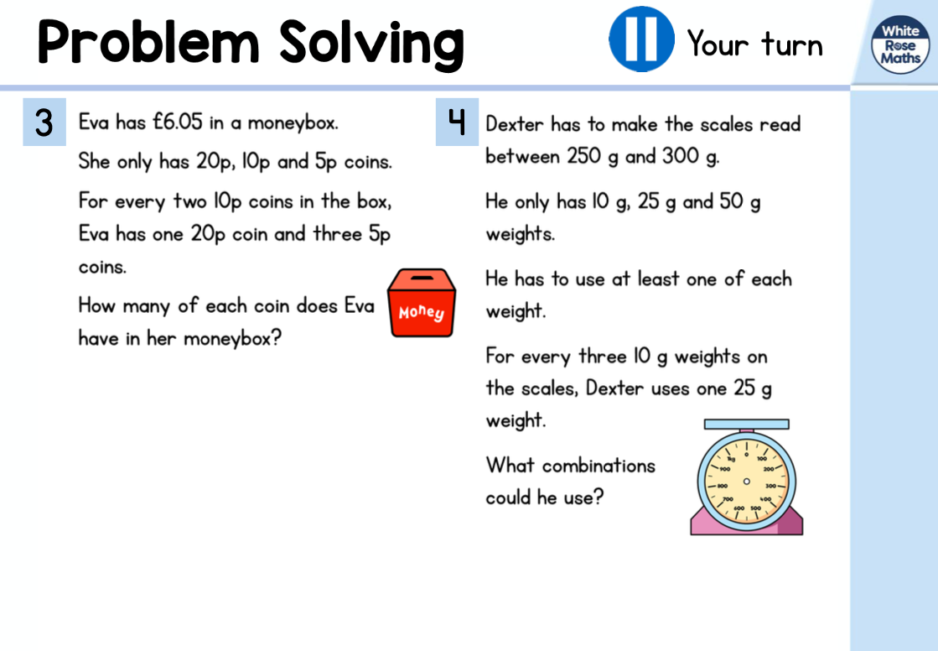
Thursday (part 1)
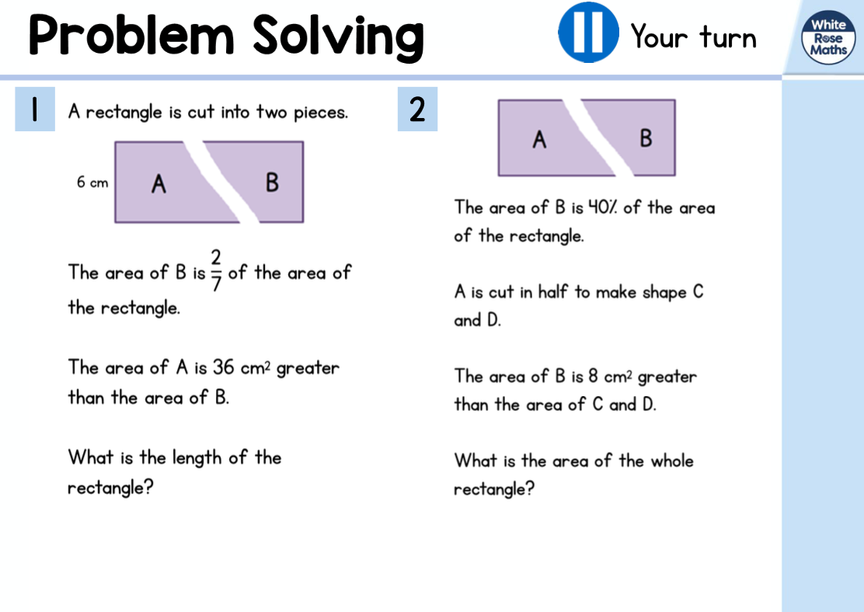
Thursday (part 2)
