Year 4 Writing
You are going to write a letter to a friend to explain how you have celebrated Eid.
Monday
SPAG – subject verb agreement
Work your way through the information below about subject/verb agreement. One thing which quite a lot of you do in writing is write ‘we was’, instead of ‘we were’!
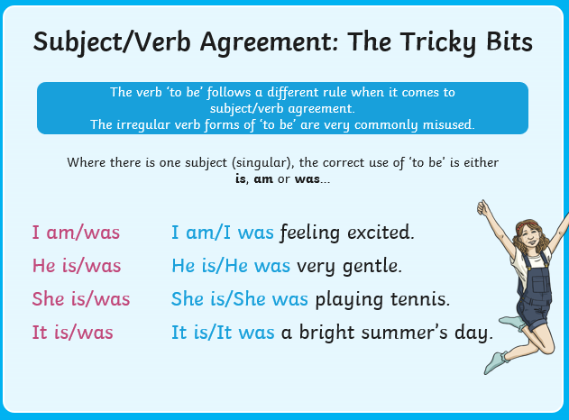
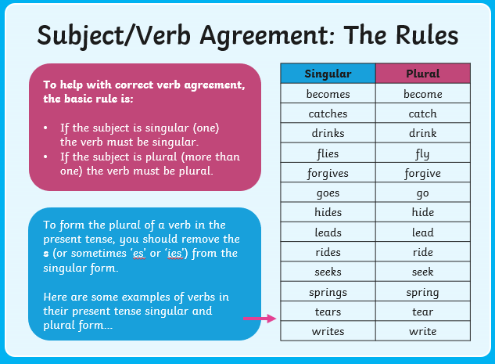
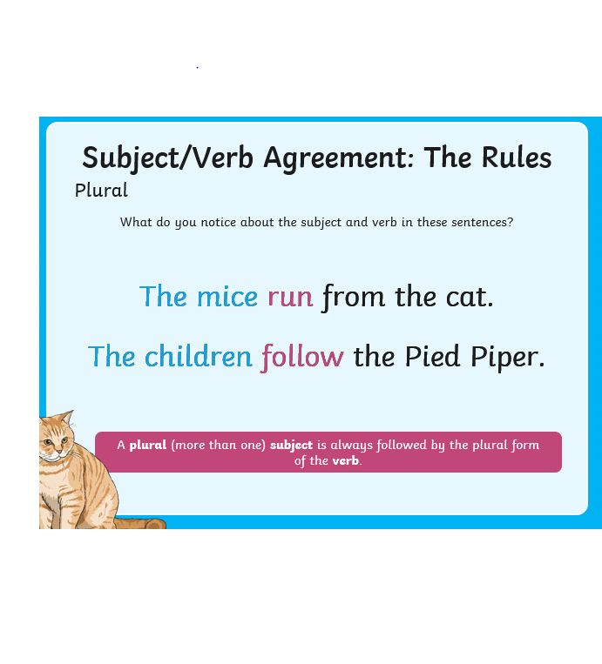
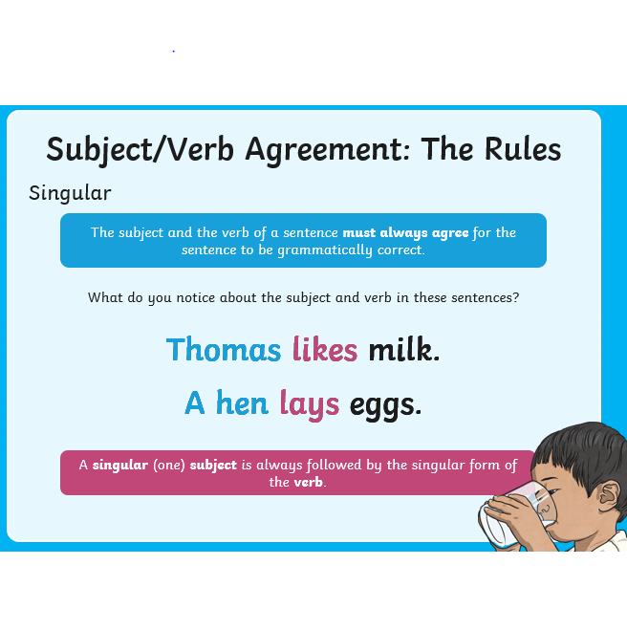
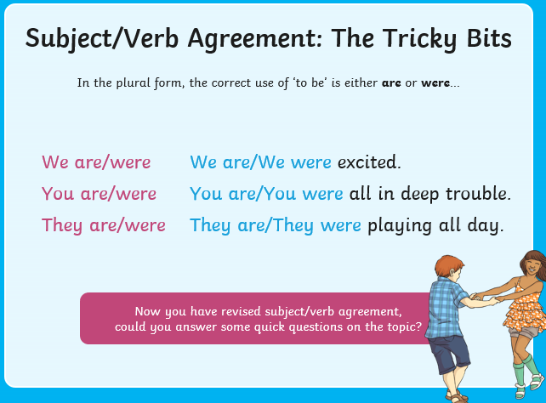

Now have a go at copying and completing the sentences on page 3 in your book with the correct subject/verb agreement:

Was or Were Subject-Verb Agreement
The basic rule is that a singular subject takes a singular verb, while a plural subject takes a plural verb.
- Read the sentence.
- Decide whether the subject is singular or plural.
- Circle the correct verb.
was = singular were = plural
- He (was/were) prepared for school.
- We (was/were) scared of thunder.
- I (was/were) excited about my new book.
- We (was/were) playing together as a team.
- She (was/were) my best friend.
- We (was/were) excited about the championship game.
- They (was/were) walking around the lake.
- He (was/were) a very sensible member of the class.
- Can you tell if they (was/were) prepared?
- Who (was/were) with us at the birthday party?

Write four of your own sentences, like the examples above, which use the verbs was and were correctly.
1.
2.
3.
4.

Tuesday
Tuesday
Research
Use this video clip to find out about Ramadan and Eid:
https://www.bbc.co.uk/teach/class-clips-video/religious-education-ks2-my-life-my-religion-ramadan-and-eid-ul-fitr/zdv7pg8
Make notes in your book about the important pieces of information this clip gives you.
Now, have a go at reading through the text about how Eid is celebrated by Muslims on page 5 and then answer the questions from page 5 in your book using full sentences.

Sheet 2
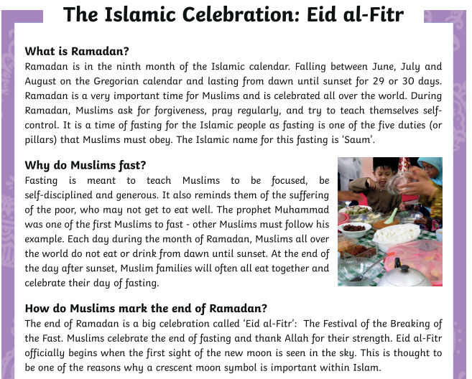
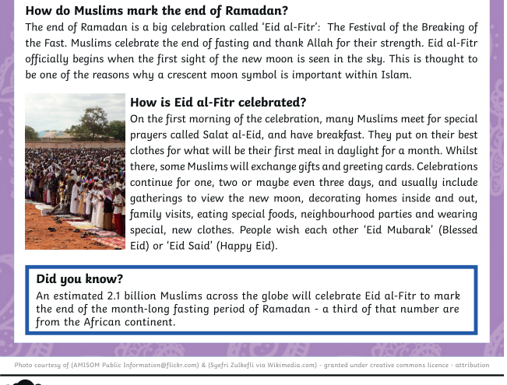
Sheet 2
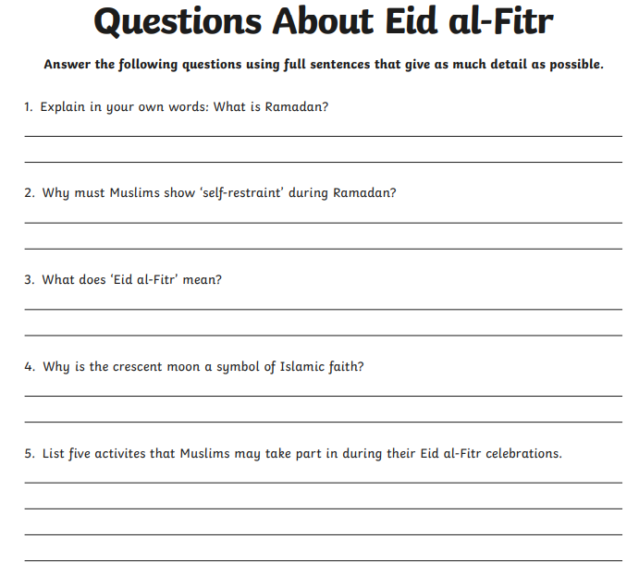
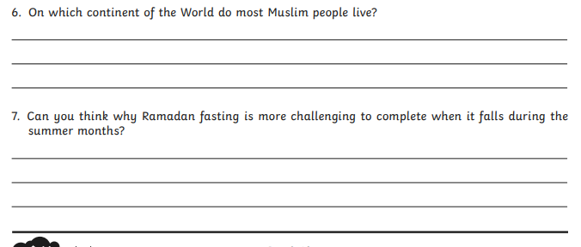

Wednesday
Planning
From the notes and comprehension activity you completed yesterday, you are now going to start thinking about writing a letter to a friend explaining what Ramadan is and what you have been doing to celebrate Eid.
Complete the planning frame on page 9, with notes you made yesterday about Eid, making sure the relevant information is in the right box!

Sheet 3 - I can plan letter about how Eid is celebrated

Introduction – why are you writing the letter?

Ramadan – what is it? Why and when does fasting take place?

Eid – what is it? How is it celebrated? Did you enjoy the celebrations?

Conclusion – explain you hope the reader enjoyed reading the letter

Thursday and Friday
Have a look at my example of a letter below, written to my friend about celebrating Eid. Have a go at highlighting:
The subject / verb agreement
The conjunctions I have used
I can write a letter about celebrating Eid
Moorside Primary School and Nursery,
Harrogate Road,
Ripon
HG4 1SU

Dear Mandy,
I am writing to you to tell you all about our celebration for Eid! It was so much fun and amazing, definitely what we all needed after Ramadan.

Over the past few weeks, my family and I have been completing Ramadan. When Muslims are in Ramadan, they are not allowed to eat or drink during the hours of daylight. As children, you don’t have to do Ramadan, but once you are older, you are expected to. I decided to give it a try. It was so difficult and tiring! We would be eating our tea at about 9pm and then eating our breakfast at about 3:30am, it was so exhausting, but thankfully it is over now!

Yesterday, we celebrated Eid, it was so much fun! Eid officially starts when you see the new moon for the first time in the sky. At the start of the day, we said special prayers, and had breakfast. Then we put on our best clothes and gave each other cards and presents, I really enjoyed myself. After that, Mum and Dad, took all of us to a big party! There was lots of food there and even fairground rides, which were so much fun. It was so amazing having lots of people altogether celebrating Eid, I can’t wait for it to come around again next year!

I really hope you enjoyed reading this letter and finding out all about Ramadan and Eid. It really is a brilliant celebration!

I hope you are OK and I’ll see you soon.
Love from
Emma

Once you have done this, try and write your own letter about celebrating Eid. You could also have a go at designing a Happy Eid card (using the example on page 11 to help you!)

Have fun year 4!

Mrs Taylor

