Year 2 Home Learning for 4.5.20
Maths
For Monday, Tuesday and Wednesday look at the activities on the White Rose Maths website. Summer term Week 2 (w/c 27th April). It’s all about length. Watch the videos for Monday, Tuesday and Wednesday and complete the attached questions in this pack. Record the answers to the questions in your home learning book.
There are also some ‘Flashbacks’ on there too!
https://whiterosemaths.com/homelearning/year-2/

Monday – Comparing Lengths
Tuesday – Ordering Lengths
Wednesday – Four Operations with lengths

Your maths on Thursday and Friday is all about counting and making different amounts of money!

Monday part 1
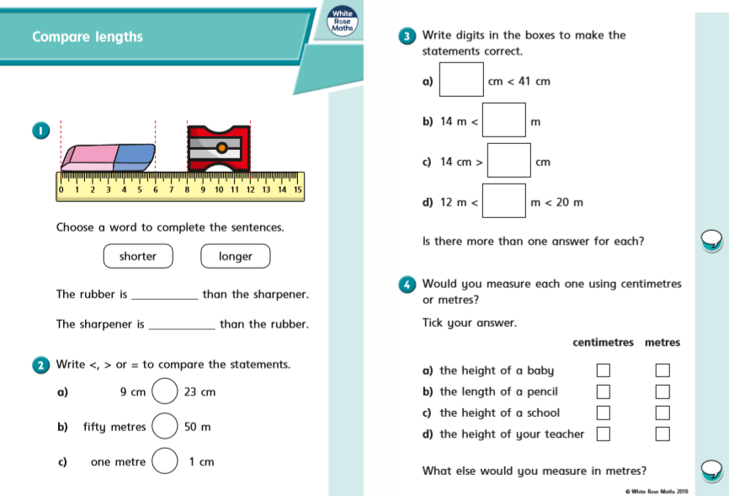

Monday part 2
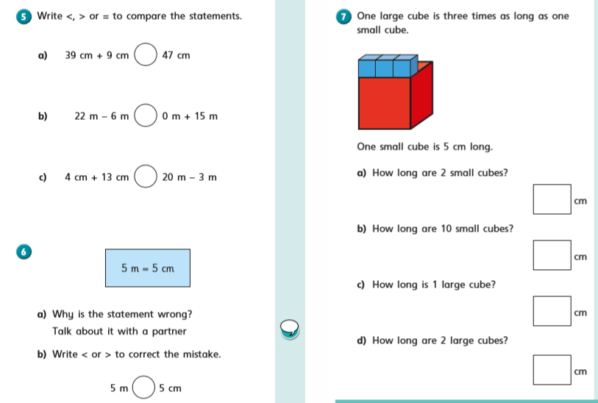

Tuesday part 1
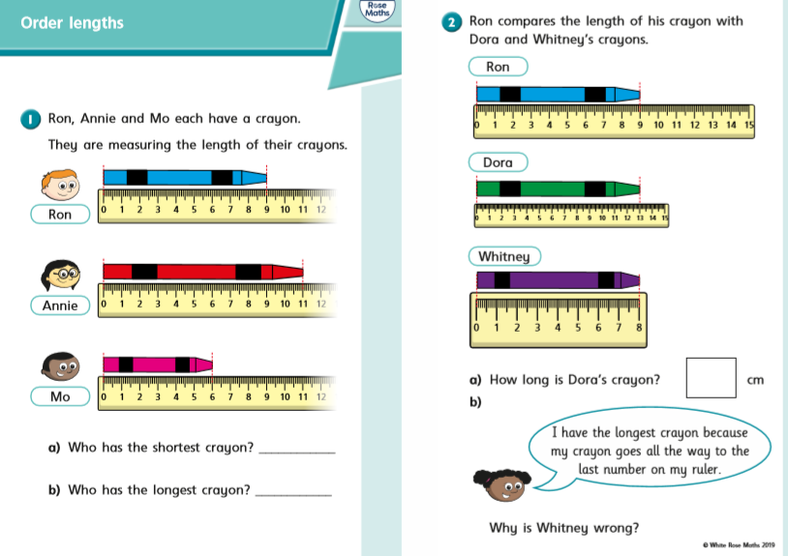

On Thursday and Friday, we are going to look at counting amounts of money in £ and p. In Year 2 we are brilliant at counting in 1s, 2s, 5s and 10s and this is going to help us.
Remember the coins and notes we use are:
1p, 2p, 5p, 10p, 20p, 50p, £1, £2, £5, £10, £20
Tuesday part 2
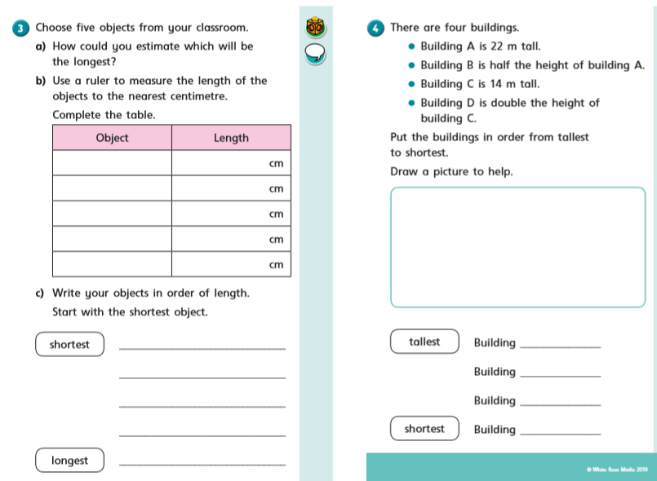

Wednesday part 1
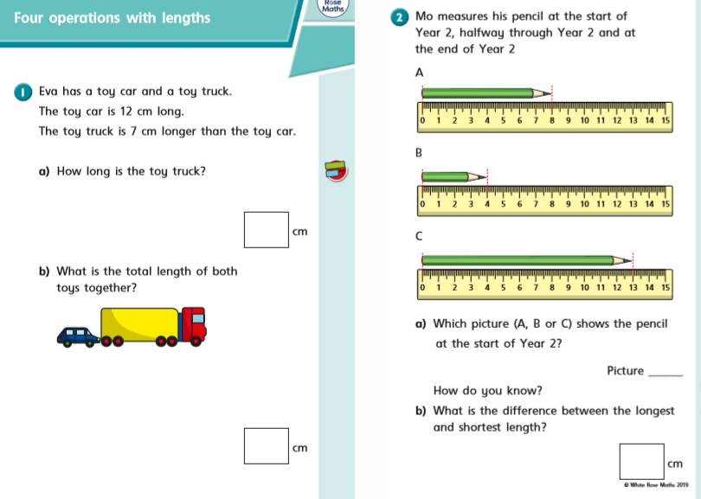

Wednesday part 2
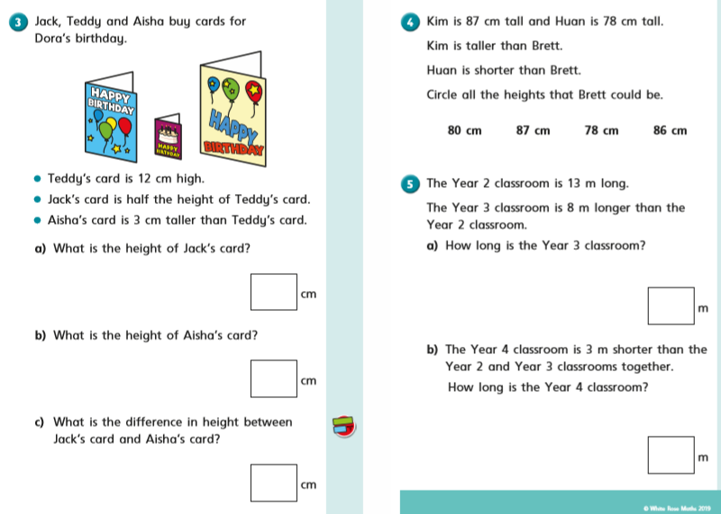

Thursday – If you have access to some real money, have a go at trying to sort it and count it! I have also included some sheets to help you.

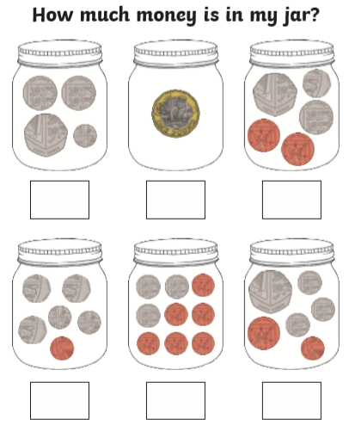

Thursday
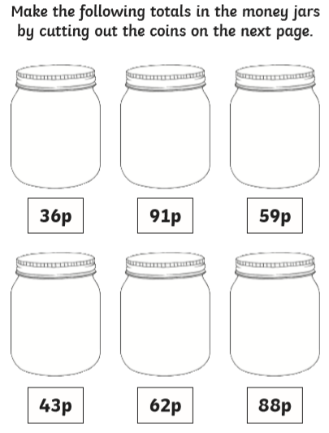

Thursday
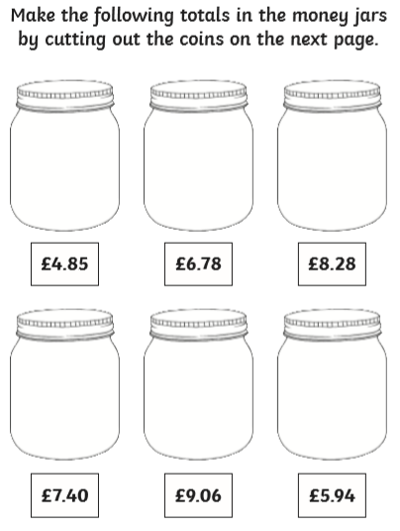

Thursday
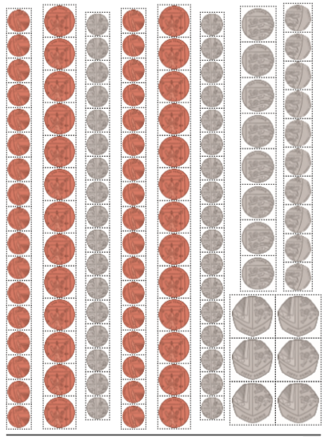

Thursday
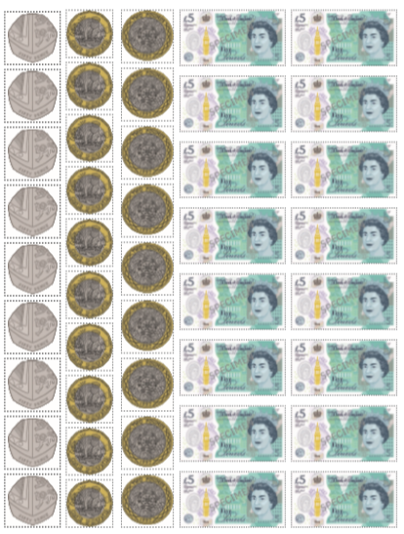

Friday – Problem Solving day!
Get a grown up to choose an amount of money for you. It might be 10p or 20p, 70p or even £1! Your task is to find as many different ways of making that amount of money using the coins we have.
For example, I am going to show you different ways of making 10p.
- 1p + 1p + 1p + 1p + 1p + 1p + 1p + 1p + 1p +1p = 10p
- 2p + 2p + 2p + 2p + 2p = 10p
- 5p + 5p = 10p
- 5p + 2p +2p + 1p = 10p
- 5p + 2p + 1p + 1p + 1p = 10p
I think there are some more ways too!

Could I use 7p + 3p = 10p? Why not? Is there such a thing as a 7p coin?

In your home learning book how many different ways can you find?

I am looking forward to seeing all your exciting learning!
Take Care,
Mrs Burland

