Year 2 Home Learning for 18.5.20
Maths
Your maths this week is all about addition and subtraction. We will begin with multiples of ten and move towards number bonds to 100.
Start each day by watching the videos on the White Rose website (Summer Term Week 4, 11th May). Then complete the sheets in your pack.
https://whiterosemaths.com/homelearning/year-2/
I have included a link to the BBC Bitesize, which matches the lessons you are looking at:
https://www.bbc.co.uk/bitesize/articles/zbypscw
I have also included a hundred square for you to practise with.

Monday – Adding and Subtracting tens. Play this game to help you:
https://kids.classroomsecrets.co.uk/resource/year-2-add-and-subtract-10s-game/

Tuesday – Adding 2-digit numbers. Play this game to help you:
https://kids.classroomsecrets.co.uk/resource/year-2-tens-and-ones-addition-game/

Wednesday – Subtracting 2-digit numbers
Thursday – Number bonds to 100.
Play this game on Classroom Secret Kids to help you:
https://kids.classroomsecrets.co.uk/resource/year-2-bonds-to-100-interactive-animation/
Friday – Play the addition and subtraction game in your pack. You can make it trickier by changing the number of flowers Red Riding Hood has.

Monday part 1
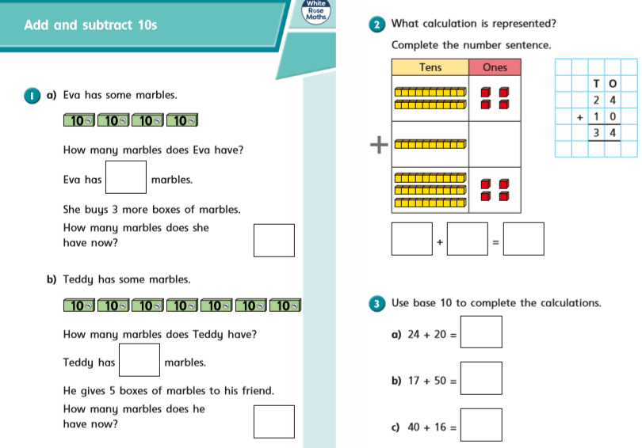

Monday part 2
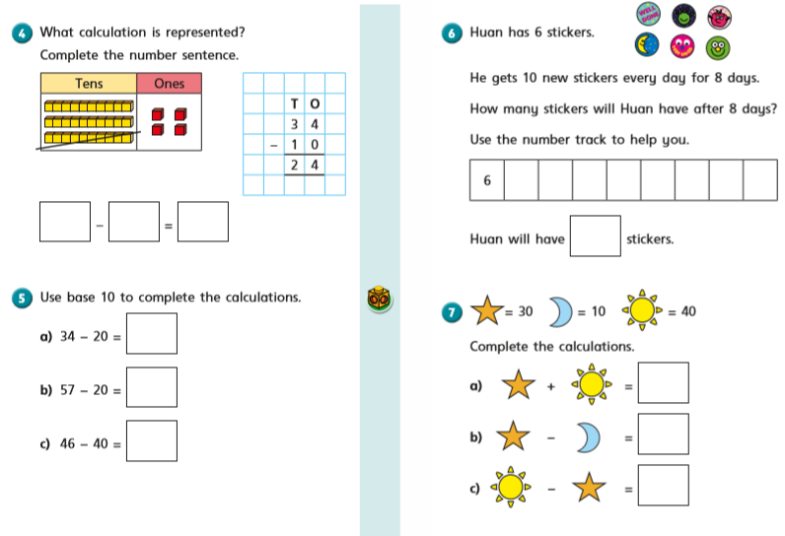

Tuesday part 1

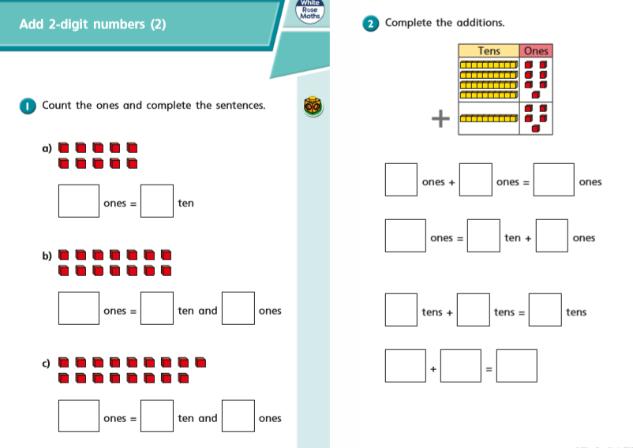

On Thursday and Friday, we are going to look at counting amounts of money in £ and p. In Year 2 we are brilliant at counting in 1s, 2s, 5s and 10s and this is going to help us.
Remember the coins and notes we use are:
1p, 2p, 5p, 10p, 20p, 50p, £1, £2, £5, £10, £20
Tuesday part 2
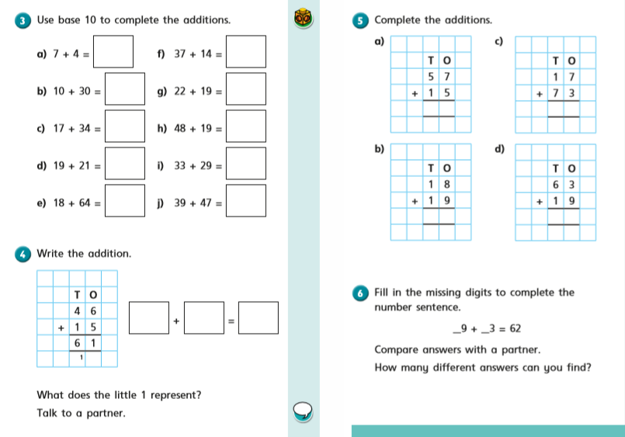

Wednesday part 1
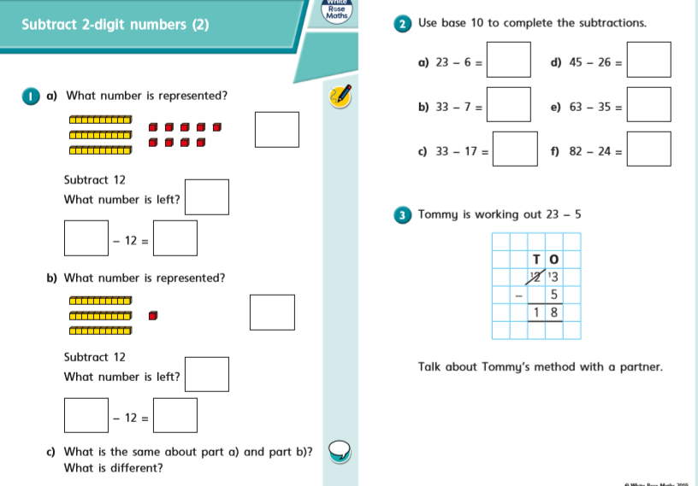

Wednesday part 2
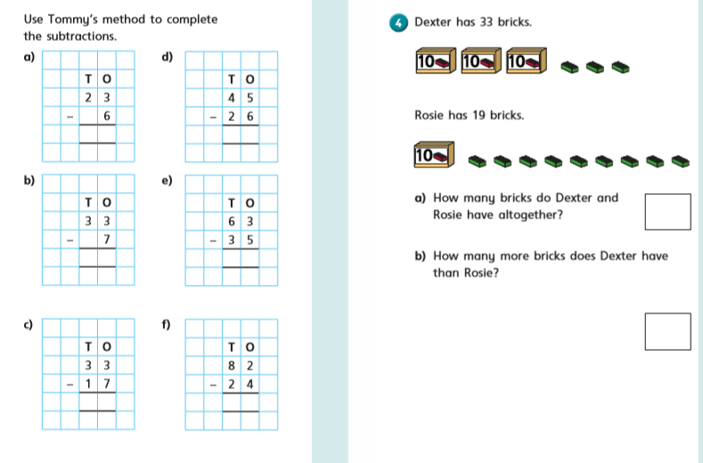

Thursday part 1
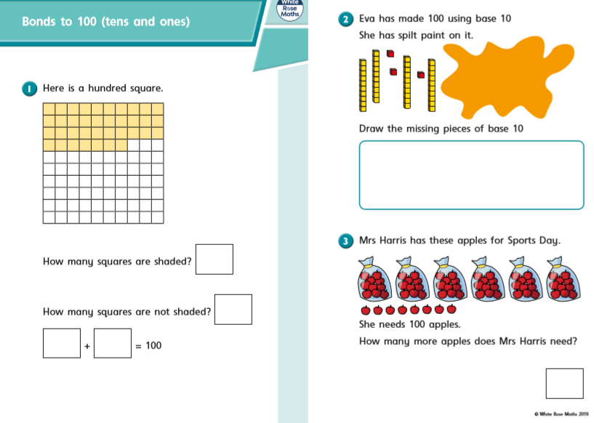

Thursday part 2
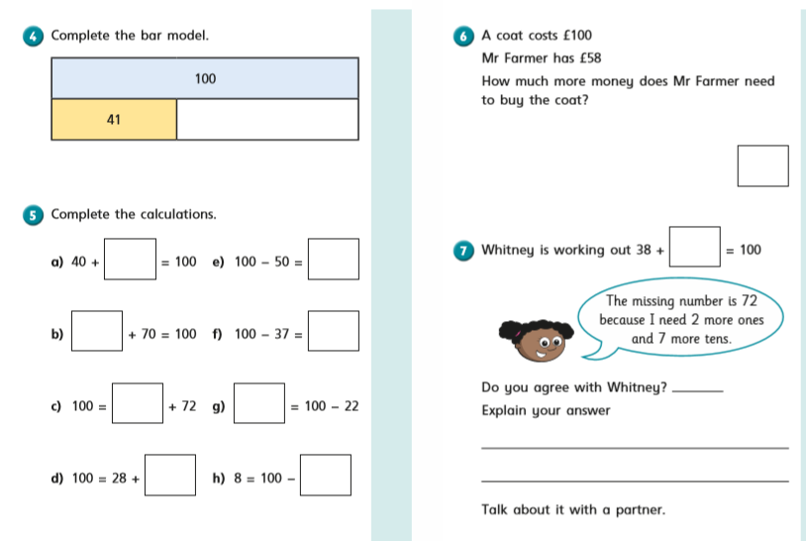

Friday
Friday
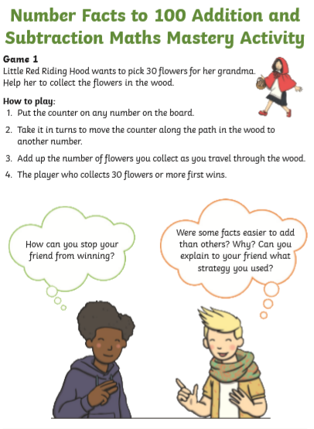

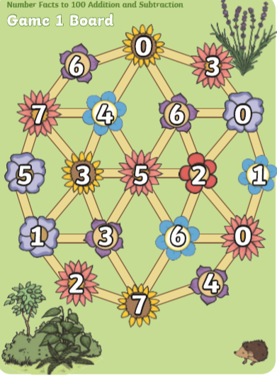

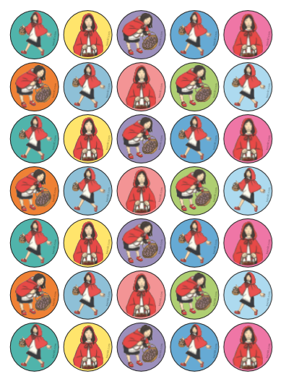

Hundred square
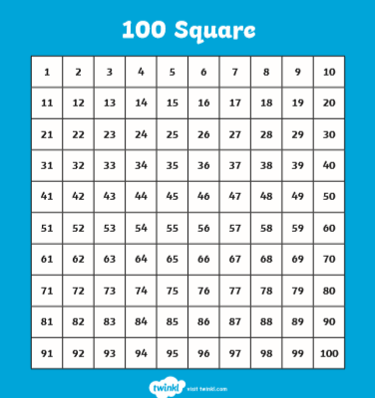

Counters for 10s Fr

I am looking forward to seeing all your exciting learning!
Take Care,
Mrs Burland

