Maths Year 5
Equivalent Fractions w/c 11.05.20

The objective we are working on this week is:
- To identify, name and write equivalent fractions of a given fraction, represented visually, including tenths and hundredths.
Use the following link to find out about equivalent fractions and then have a go at completing the challenges on pages 3 and 4.
https://www.theschoolrun.com/what-are-equivalent-fractions-and-simplifying-fractions
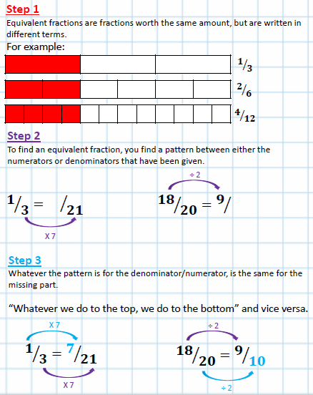
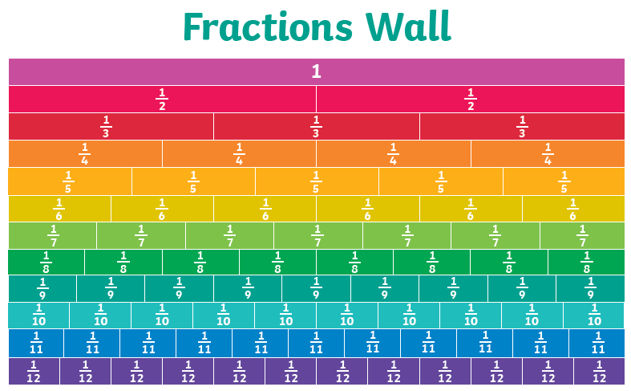
The fraction wall can help you see the equivalent fractions. As you can see ½ is the same as 2/4.
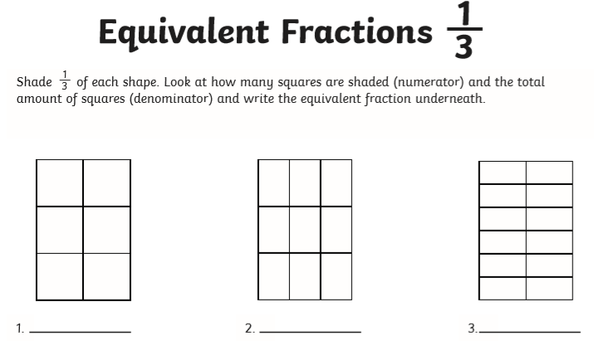
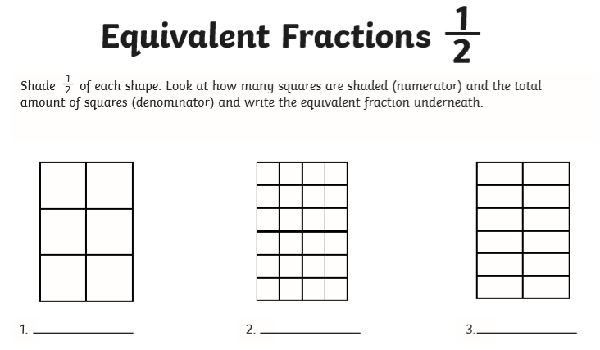
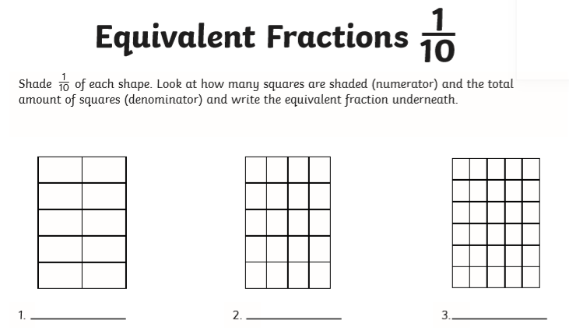
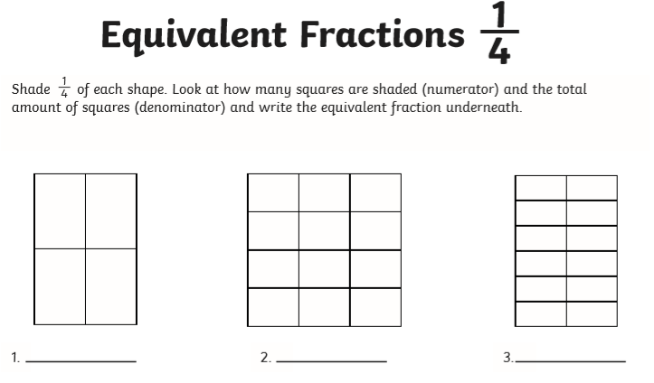

Use the fraction wall to help you work out the equivalent fractions
