Year 2 Writing

Task 1
SPAG – Can you remember when to use a capital letter and full stop? Or what an adjective is? To help you, look on Classroom Secrets Kids – Year 2 revision https://kids.classroomsecrets.co.uk/resource/year-2-autumn-revision-set-1/

Full Stops and Capital Letters
Remember • Sentences start with a capital letter. • Sentences end with a full stop. • Names start with a capital letter. Read these sentences. Write each one yourself with a full stop and capital letters in the right places.

- mark and carl got wet in the rain
- the man gets up at six in the morning
- jill has fair hair but jack has dark hair
- jim has six big coins
- i can hear an owl hoot at night

Read the sentences below. Can you spot the full stops and capital letters that are in the wrong places? Write the sentences out yourself with capital letters and full stops in the right places

- liv has A dog and. a cat
- ben The dog. runS to THE Woods
- he is Looking for rabbits But sees. a fox
- the fox Sees him. and Rushes off to its den
- ben dashes after. It But Cannot see it

Read the piece of writing below. Think about when a sentence ends and when a new one begins. Write the sentences out yourself, adding in any full stops and capital letters. Can you add your own sentences about something else that is happening at the river?
I will soon visit my nan at her farm nell and her sister may join me she will let us feed the hens she has goats and cows as well as hens it is fun on the farm

Task 2
Here are some wartime recipes. Have a look at how they are set out with the list of ingredients at the top and the instructions of how to make it set out in order below.
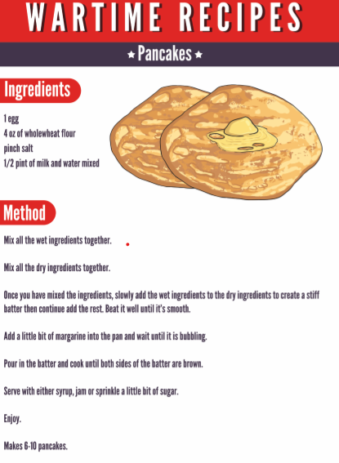
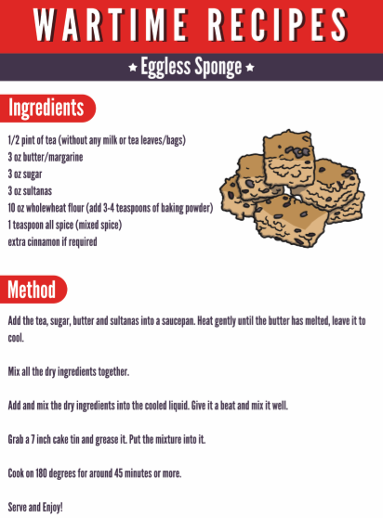

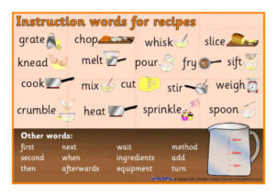
Do you notice on the recipes that the first word of the instruction is a bossy word (like ‘chop, mix, cook, add bake)? These are called ‘Imperative verbs.’ How many can you find?

Task 3

- Your task is to make something yummy to eat. It could be some pancakes, biscuits, buns or sandwiches!
- When you have made your tasty goodies write the instructions out on the guide I have included. Use the word mat to help you.
- Can you take a photograph or draw a picture of what you have made?
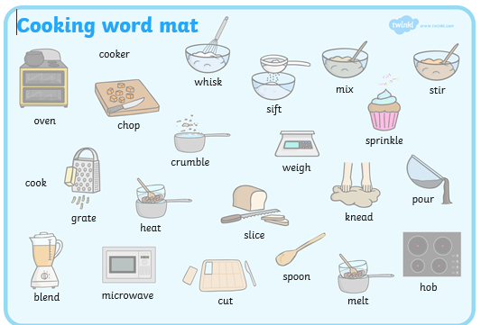

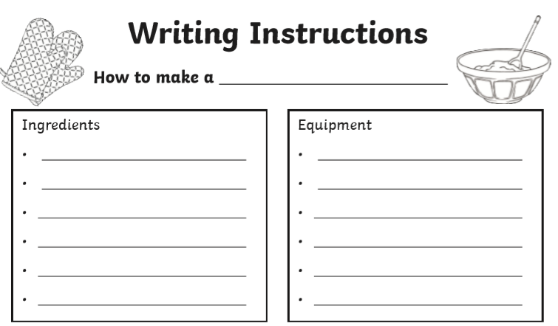

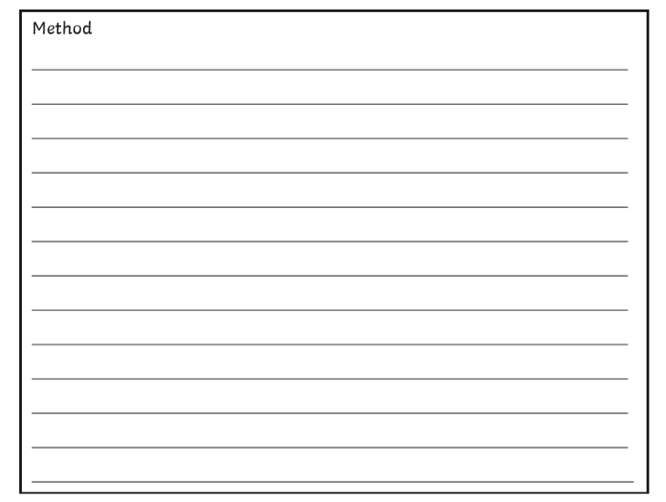

Task 4
The last task is to eat them! I hope they are yummy!!

Please Remember:

Reading – Complete a Reading Eggs lesson. Read your reading book to someone at home and share your thoughts. Complete a book review for one of the books you have read.

Phonics – How many words can you make using the alternative pronunciation for a and y? Can you create some silly sentences or stories using these words? Read the following comics linking to the sounds we are looking at. http://www.phonicsplaycomics.co.uk/comics.html

Please complete a comprehension about VE Day and a ‘Common Exception Word’ word search., which are included in your pack.

Happy Learning,

Mrs Burland

