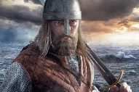
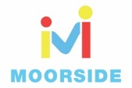
Year 3 History Home Learning Challenges
Learn these facts and then tell someone in your family them!  1)I know that the Vikings came from countries Sweden, Denmark and Norway (Scandinavia)  2)I know that the Vikings sailed in Longboats and would take over lands that weren’t theirs.  3)I know that King Alfred the Great did a lot of great things for England including defeating the Vikings in several battles and keeping part of England under Anglo-Saxon rule.  4)I know that around the year AD 790 Vikings first started to raid Britain. They started out as short trips to steal treasure and take slaves.  5)I know that The Saxon King, King Alfred of Wessex, fought them in a great battle but he could not stop them at first so had to let them have part of the country in a treaty known as Danelaw. | Viking Longboat  Your first mission for the Vikings is to create a Viking Longboat.  I have attached some photos of Longboats for you to have a look at (sheet 1) and also a Viking Longboat template (Sheet 2) if you would like to use it.  Viking artefacts:  I have found a link to the Jorvik Centre in York which shows some of the Viking artefacts which have been discovered, take a look:  https://www.jorvikvikingcentre.co.uk/education/education-projects/shaking-hands-with-the-past/ | Viking Timeline  I have jumbled up some of the key events from during the Viking era and I’ve been struggling to put them into chronological order.  Please can you help me?  Remember, chronological means time order and make sure you check BC and AD!  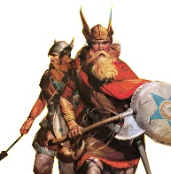
 | 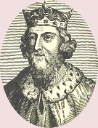  Alfred the Great  Watch this video clip:  https://www.bbc.co.uk/bitesize/clips/zthb4j6  In the clip, it explains who Alfred the Great was and how he was an important figure when the Vikings invaded.  Using the clip, can you create a poster about Alfred the Great, showing the great things and not so great things about him. | Key Vocabulary  Anglo-Saxons - The main group of people living in Britain when the Vikings invaded.  Danelaw – The area in Britain that the Danish Vikings ruled over.  Long ship / longboat – A Viking ship used for fighting and carrying out raids.  Monastery - A place where people who have dedicated their lives to religion, such as monks or nuns live.
Our topic Viking Invasions

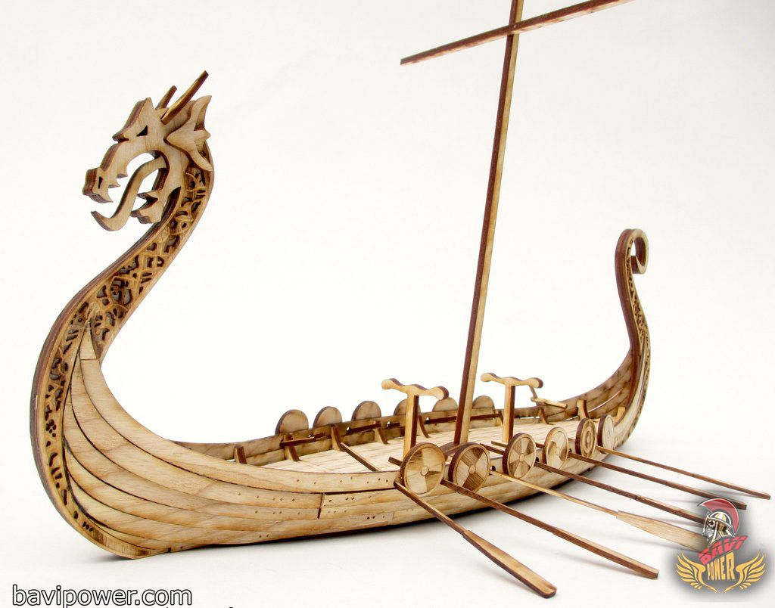
Sheet 1 – Viking Longboat
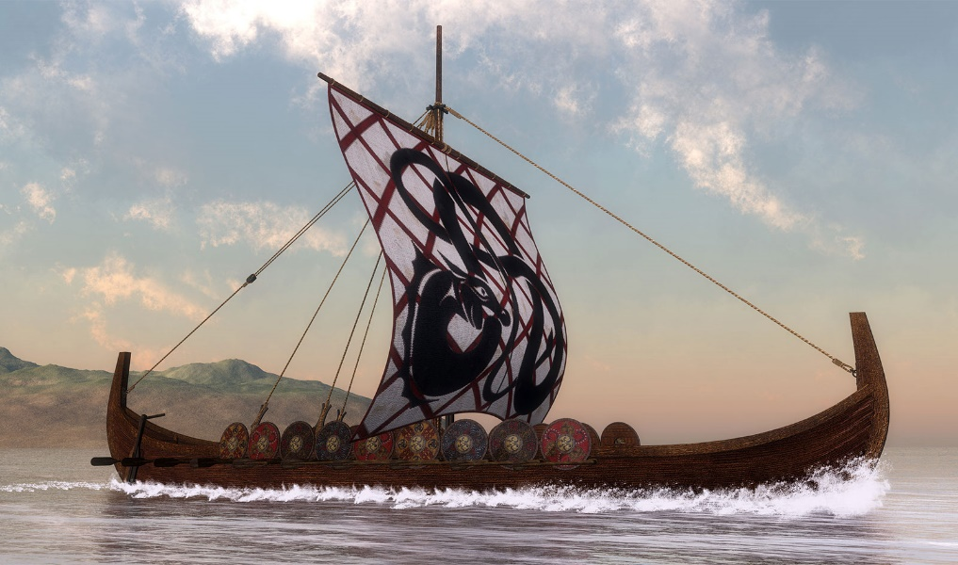

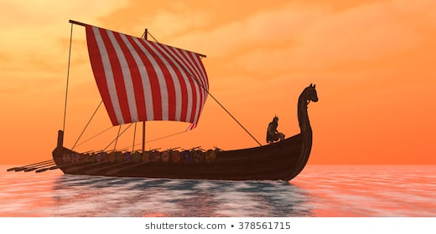
Sheet 2 – Viking Longboat template
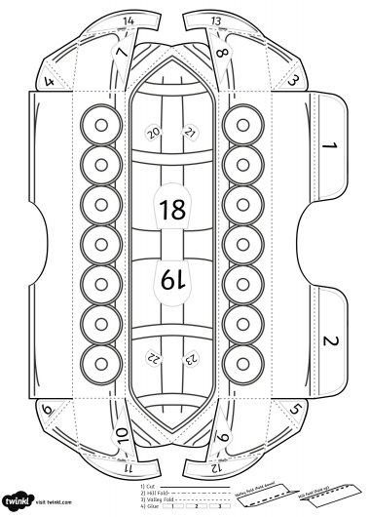
Sheet 2 - Viking Longboat template
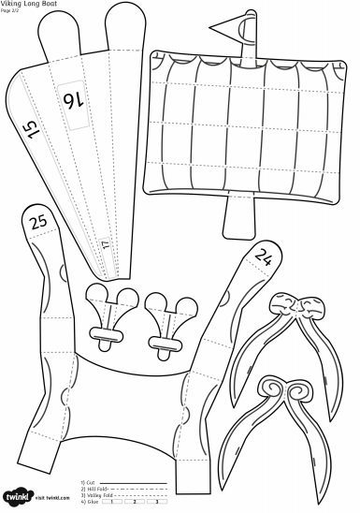
Sheet 2 - Viking Longboat instructions
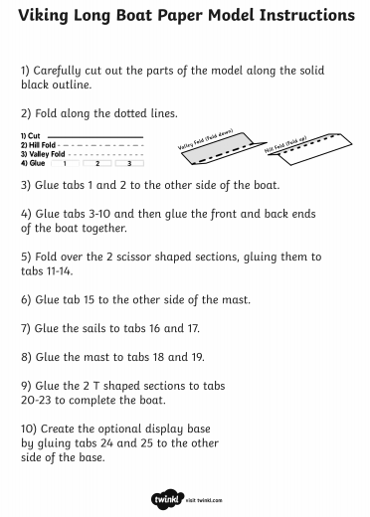
Sheet 3 – Viking Timeline cards
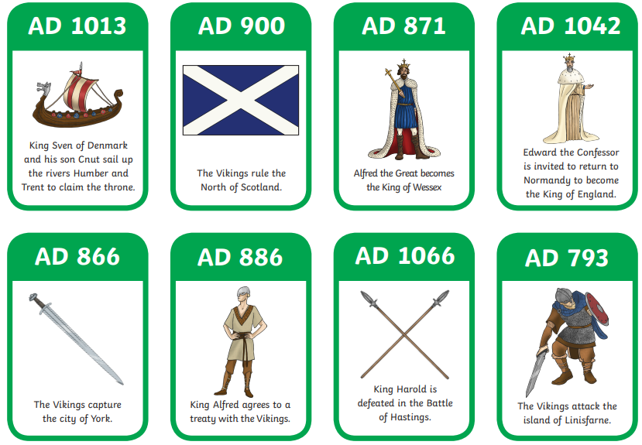
Sheet 3 – Viking Timeline
