Year 5 and 6 Victorians (Crime and Punishment) Home Learning Challenges
How did the Victorians shape Britain today?
5 Finger Facts  Think of a fun game or activity to help you memorise the 5 Finger Facts this week. It might be a song/a matching game…etc. Get creative!  - I know there were 35 monarchs in Britain after Anglo-Saxons and before Queen Victoria and I know that Queen Victoria is the longest reigning monarch in British history (1837-1901) after our current Queen, Queen Elizabeth.  - Theft was the most common crime in the Victorian era.  - It became illegal not to send your children to school in 1870.  - Hangings started taking place in prisons instead of publicly because it was believed that public hangings were too harsh.  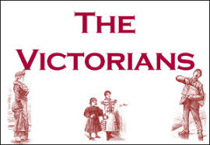  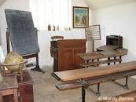  - Highway robbery was less common during the Victorian era because roads were better cared for and more people travelled by car. | Many Monarchs  Research British monarchs throughout history from the Anglo-Saxon era to the Victorian era and create a timeline of at least 10 of these monarchs. Can you include any interesting facts about each one? Check out the information on the school website to help you. (Home learning, Year 6, British monarchs)  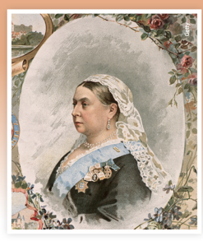  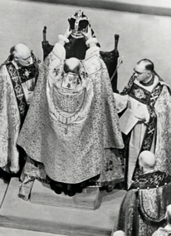 | Quiz Question Time  To help you understand how crime and punishment has changed throughout British history, have a go at the multiple-choice quiz on page 2 (you might like to do this as a family) then mark it using the answers on the school’s website to see how well you did. Discuss your answers with someone in your family: Which answers surprised you? Which ones were you confident you would get right and why?  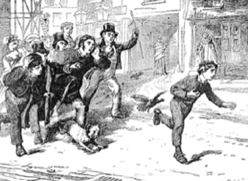
 | Then or Now? How has crime and punishment changed?  Read the statements on page 3 and decide whether they are true for the Victorian era, now or both. Copy the table from page 4 into your book to organise the statements. You could use research to help you. You might want to cut the statements out to help you organise them into groups.  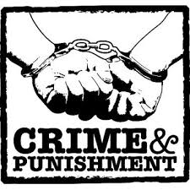 | Key Vocabulary  monarch Called king, queen, emperor, or empress. Generally, reign for life  reign Time king or queen rules a country  shilling Old British coin equal to ¹/₂₀ pound  justice The upholding of what is fair, just, and right.  convict A person found guilty of a criminal offence

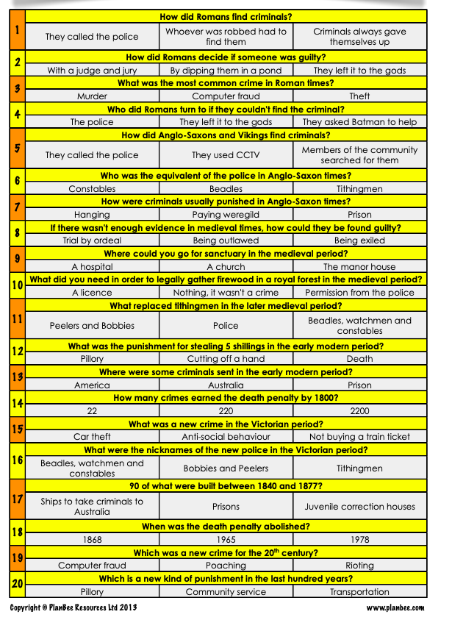

Theft is the most common crime | It is illegal not to send your children to school | Having railways creates crimes such as not having a ticket or damaging railway property | Sir Robert Peel started the police force | Policemen called Bobbies | Hangings take place in prisons
Convicts transported to Australia | Criminals are put in prison | The police force fight crime | Criminals brought to justice in a court of law | Hard labour used as a type of punishment | Fines used as a type of punishment

