Reception Home Learning WC 11-5-20

Reading
Read a book with your grown up every day – the more the better!
We will also be putting a story on YouTube and Facebook every day for you to enjoy at home.
Keep logging onto Reading Eggs – everyday if you can!
Try the Scavenger hunt on page 2 – there are lots of ideas on the North Yorkshire library facebook page – well worth a look!

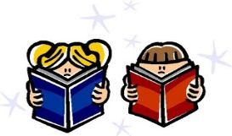
This Photo by Unknown Author is licensed under CC BY-SA
Writing
We have included the handwriting letter family ‘ladder letters’ this week (page 3). Please watch the handwriting video on https://www.youtube.com/watch?v=1U-oQ78Xdc8 -this should help with questions about how to form the letters. See the attached sheets for advice on pencil grip (pages 4 & 5).
If your child is still learning to write their name, remember to practice writing their name every day. Start with the first letter and practice that until they can do it beautifully! Then move onto the second letter etc. We have included a name writing sheet in this pack, so your child can practice writing their name in the cursive style.
Phonics

I HAVE LEFT PAGE 4 FOR PHONICS STUFF – FEEL FREE TO JIG AROUND IF THAT’S NOT ENOUGH SPACE ETC.
Watch the phonics videos
https://www.youtube.com/channel/UCP_FbjYUP_UtldV2K_-niWw/videos?app=desktop
If your child is still learning to blend sounds together (can’t hear ‘cat’ if you say c-a-t), the ‘learning to blend’ videos are great. If your child is confident with blending, try the ‘Reception’ videos.

.

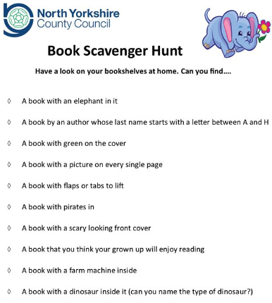

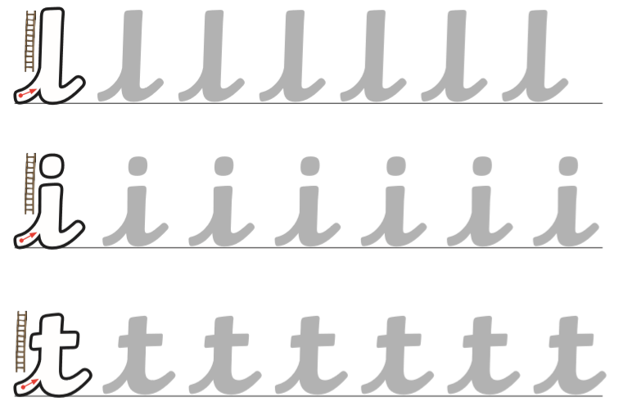
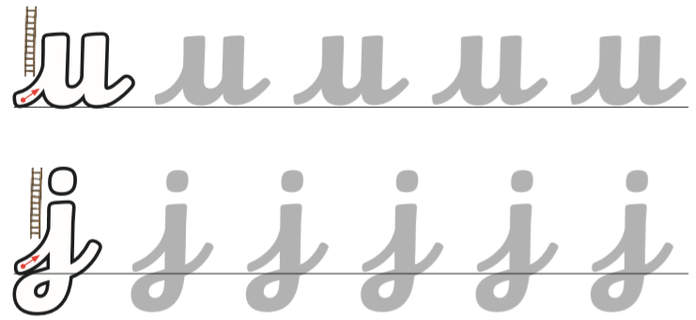

Maths
Try and fill in the missing numbers in the numberlines on page 6. You can use the numberline at the top to help you, or cover it up for more of a challenge.
Have a go at the Representing Numbers 6,7,8 sheet on page 7. Can you think of any other ways to represent these numbers? Can you find something in every room in your house to show the numbers? You could find 7 spoons in the kitchen, 7 shoes by the door, 7 bottles in the bathroom etc.
The ‘Counting and Ordering numbers to 20’ sheet on page 8 will give you some ideas you could try at home to help understand the order of the numbers to 20.

Don’t forget to check on purple mash for more maths activities!

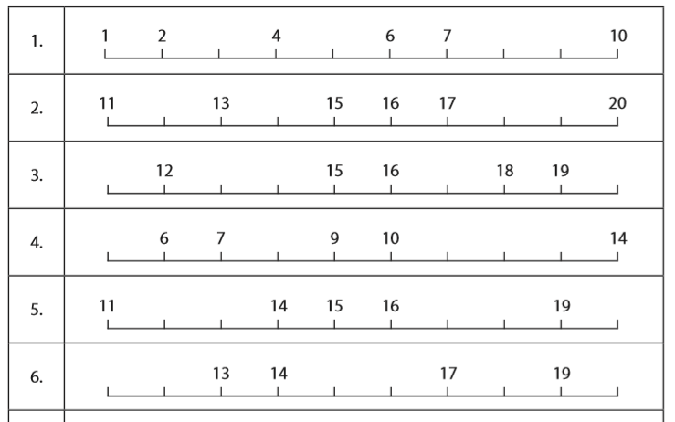
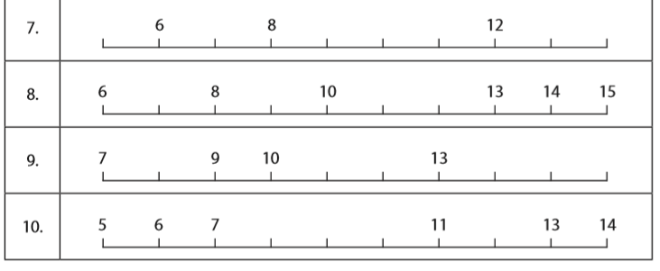

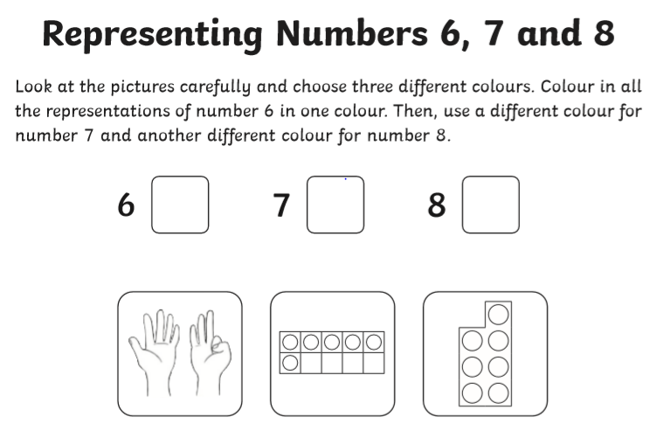
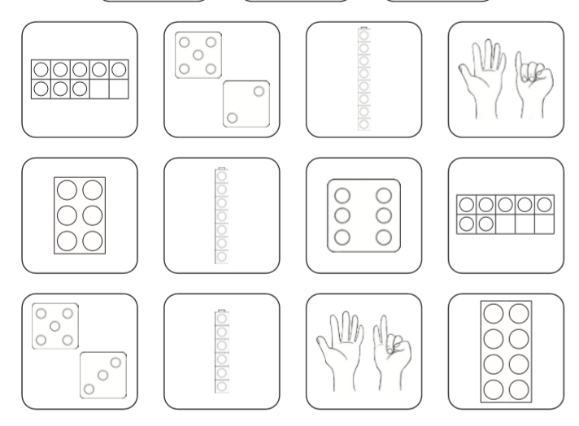

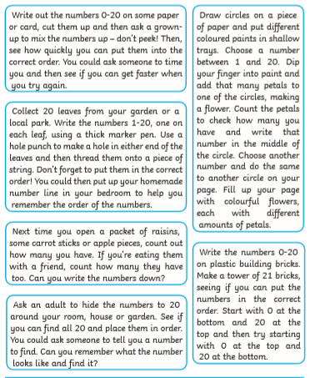

Topic
Visit the website - eyfshome.com
Go to the ‘previous resources’ tab and click on ‘JoJo and GranGran’ – There are lots of opportunities to reflect upon how our relationship with grandparents has changed due to the current lockdown. It is important that children have the opportunity to talk about how they feel and be reassured about any worries they may have.

Babies
Do you know any babies? What do they look like? A few weeks ago, we asked you to find a photo of your grown-ups when they were babies. Now can you find a photo of you as a baby and a photo of what you look like now? Can you tell your grown-up 3 differences between the photos?

Think about what you will be like when you’re a grown-up. Talk to your grown up about what you think you will look like. What job would you like to do? Use page 11 to draw a picture of you doing your job.

