Nursery Home Learning WC 18-5-20

Phonics
Go to phonicsplay.co.uk and choose ‘phase 1’. Then play the ‘super smoothie’ game – can your child find the objects that start with the same sound? Now try some of the activities below to practise hearing and finding things that start with the same sound.

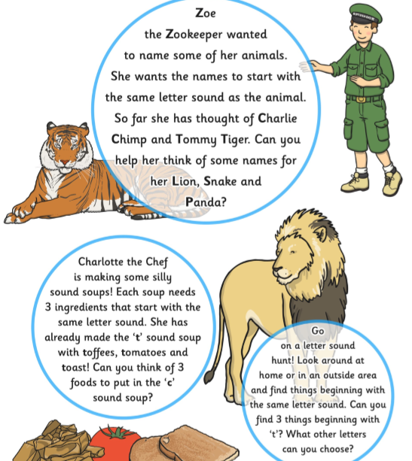

This week’s rhyme is ‘Apples, peaches, pears and plums’ – practise it with the people you live with. This is a chant that children say at Nursery. We say it all together, and the children have to clap when it’s their birthday month. Look up ‘Apples, Peaches, Pears and Plums with Masumi’ on youtube to help!

‘Apples, Peaches, Pears and Plums,
Tell me when your birthday comes?
January, February, March, April,
May, June, July, August,
September, October, November, December.’

Can you find out when your family’s birthdays are? Clap for them, too!

Reading
Read a book with your grown up every day – the more the better!
We will also be putting a story on YouTube and Facebook every day for you to enjoy at home.
Can you complete the Scavenger Hunt below? Have a look at the books you have at home…
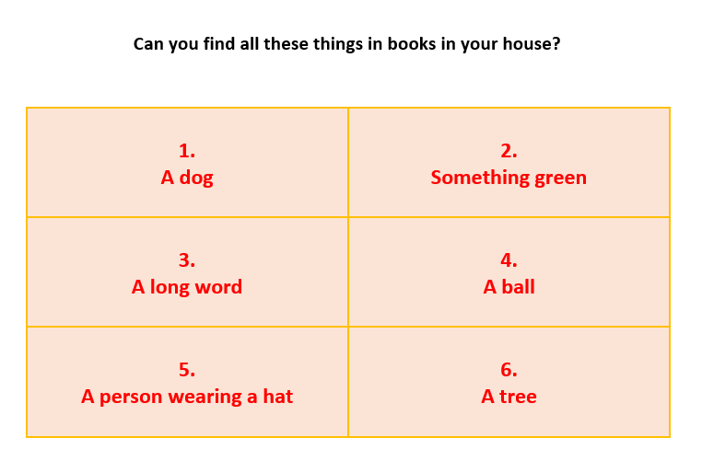

Writing
Remember to practise writing your name every day. Start with the first letter and practise that until you can do it beautifully! Then move onto the second letter etc. We have included a sheet in this week’s pack to help you form your letters in the cursive style – that is the style of handwriting that we teach in school. Please watch the handwriting video on youtube for more information;

https://www.youtube.com/watch?v=1U-oQ78Xdc8&t=295s

Try the pencil control challenges below – remember that you can do this repeatedly using different colours. You could do it in red on Monday, blue on Tuesday etc.

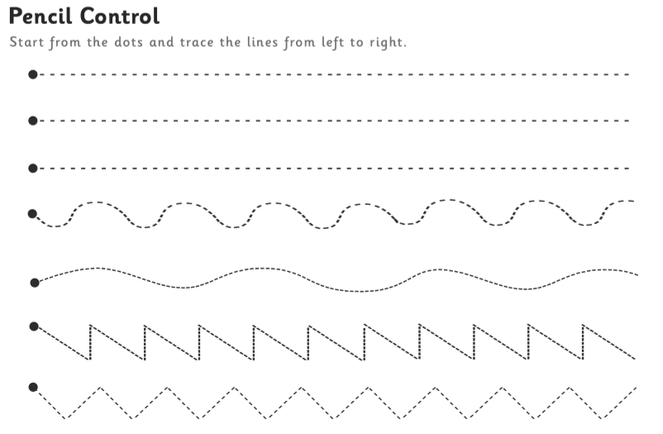
Maths
Hunt some numbers around the house. Ask your child to bring you 3 spoons from the kitchen, 3 socks from the bedroom, 3 books from the living room etc. This will help your child see that groups of 3 things can look very different from each other, but the counting and the label (the number 3) is the same. You could repeat this activity everyday using a different number and asking for different items. It is great to discuss with your child why the groups look different and to talk about how a group of 3 teddies is bigger than a group of 3 spoons, but the number is the same.

During your daily exercise, or in your garden if you have one, can you use leaves, sticks etc. to make some numbers like these ones?
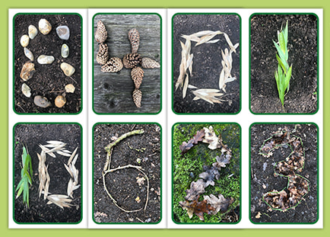

Then try the cutting and sticking sheet on page 6. Count up to find the next number; if you have just stuck down number 5, say ‘what comes next? 1,2,3,4,5….?’

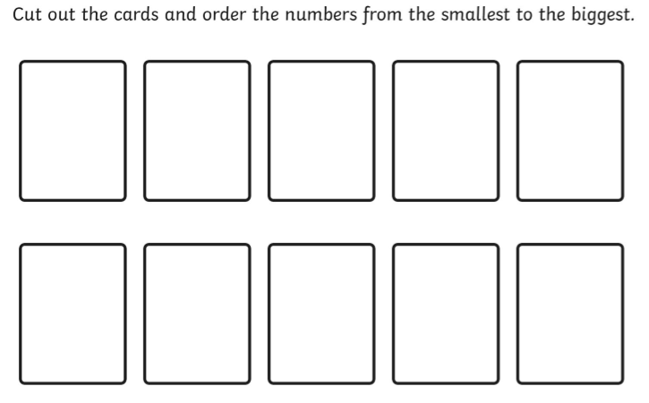

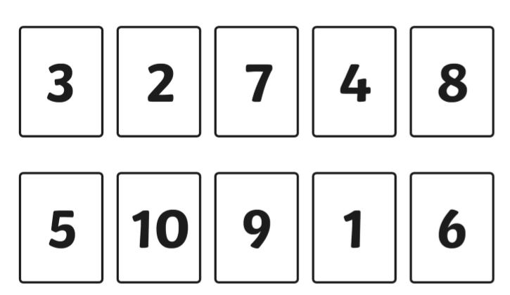

Shapes
We’re thinking about circles this week! Practice singing the circle song with your grown up – draw a big circle in the air as you sing.

Here we go round the Circle
(to the tune of Here we go round the Mulberry Bush)

Here we go round the circle, the circle, the circle,
Here we go round the circle,
Round and round and round.

Use the ‘I spy circles’ (page 8) sheet to trace around the outside of circles, spot circles, colour them in and discuss why some of the shapes are NOT circles.

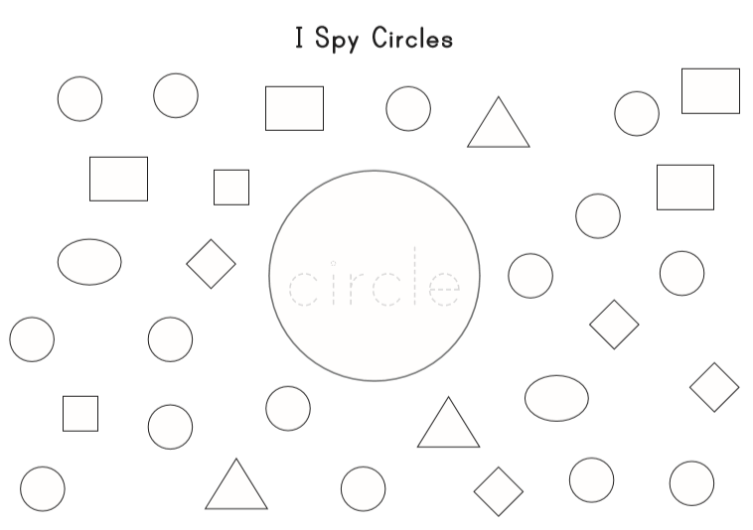
Topic – EID
Watch https://www.bbc.co.uk/cbeebies/puzzles/lets-celebrate-eid to help explain how and why Muslim families celebrate Eid.
Eid al-Fitr
Eid al-Fitr, also known as just Eid, is a Muslim holiday which marks the end of Ramadan, the Islamic month of fasting. Celebrations continue for one, two or three days, and people wish each other Eid Mubarak (Blessed Eid) or Eid Said (Happy Eid). Celebrations vary by country but include gatherings to view the new moon, decorating homes inside and out, family visits, eating special sweet foods, neighbourhood fairs, visits to amusement parks, wearing new clothes and giving and receiving gifts. Eid al-Fitr is next celebrated on 23rd May 2020.

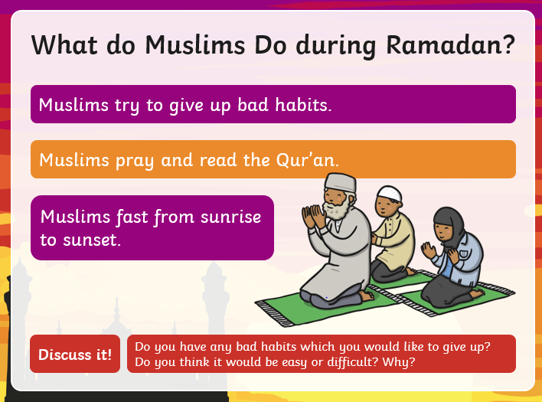

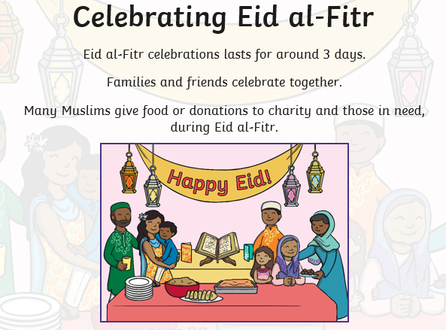
During Eid, Muslim people celebrate with their families. They exchange gifts, eat special meals and wear new clothes. Talk to your child about things that you celebrate in your family – maybe a birthday, a wedding, Christmas or another celebration.
What did we do? |  | What did we eat?
Who was there? | My Celebration is……
 | What did we wear?

During Ramadan, Muslim people try to think of others and do things to help them. Can you try and do some of these good deeds to help your family?
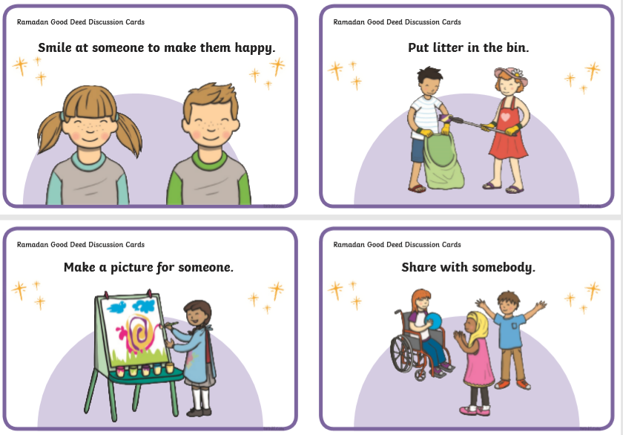
Draw a picture of what you did to help…

