Nursery Home Learning WC 11-5-20

Phonics
Go to phonicsplay.co.uk and choose ‘phase 1’. Then play the ‘zoo’ game – what noises can your child identify? Can you use the animal pictures on page 2 to practice making animal noises? Cut them out and see how quickly your child can make the noise, or see if your child can spot the animal if you make the noise. Have you got any animal teddies in your house? What noises would they make?
This week’s rhyme is ‘Pat a cake, pat a cake, Bakers man’’ (page 3) – practice it with the people you live with. Search ‘patacake The Baby Club’ on YouTube.
Finally, colour in the picture – can you tell your grown up what colours you are using?

Reading
Read a book with your grown up every day – the more the better!
We will also be putting a story on YouTube and Facebook every day for you to enjoy at home.
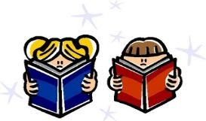
This Photo by Unknown Author is licensed under CC BY-SA

Writing
Remember to practice writing your name every day. Start with the first letter and practice that until you can do it beautifully! Then move onto the second letter etc.
Use the handwriting sheet on page 4 to practice controlling a pencil. Try and stay on the dotty lines! You could use lots of different coloured pencils to make some rainbow lines; start with a red pencil, then go over it in a different colour and then a different colour etc.

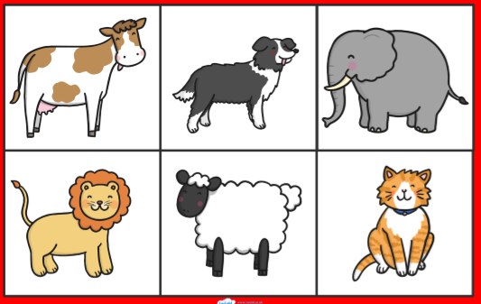
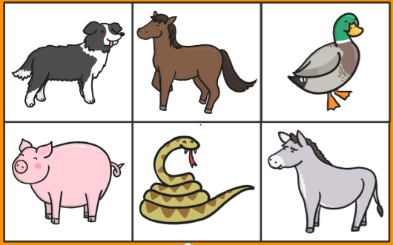

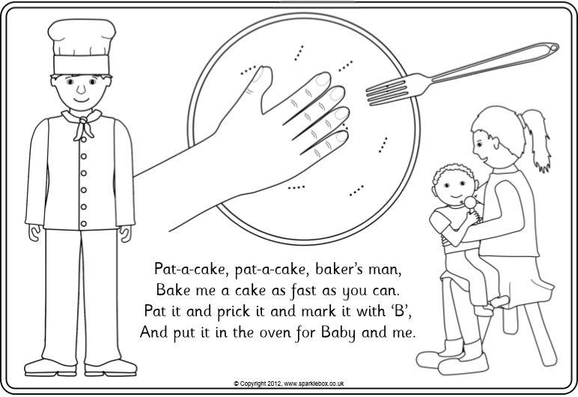
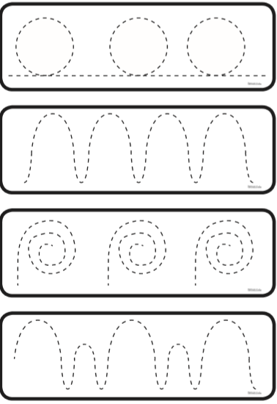Maths
Use the caterpillar on page 6 to cut out and match the numbers.
Can your child make groups of each object for each number? They might find 1 teddy, 2 cars, 3 beads etc.
Use the spring counting sheet to practice counting groups of objects. Encourage your child to cross off each object as they count it.
How many……
Chicks? Rainclouds? Daffodils?

Tulips? Umbrellas? Suns?

Butterflies? Froglets?

Shapes
Have a go at the triangle sheet on page 8. What can you tell your grown up about triangles? Go on a hunt around your house and see if you can find any? In my house, I have got triangle windows on my front door, there are triangle shapes in the back of my dining chairs and triangles on my bed sheets.

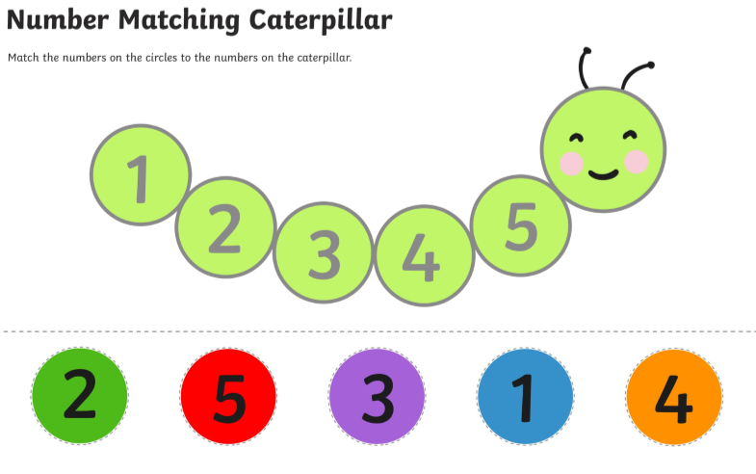
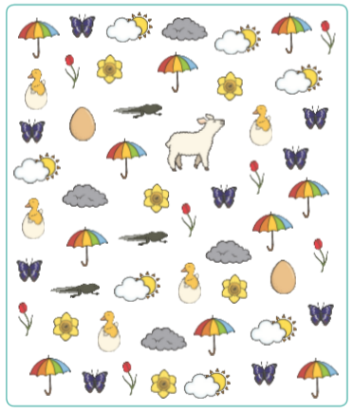

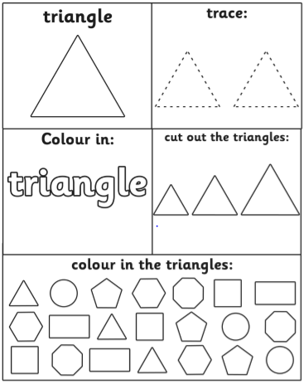

Topic
Visit the website - eyfshome.com
Go to the ‘previous resources’ tab and click on ‘JoJo and GranGran’ – There are lots of opportunities to reflect upon how our relationship with grandparents has changed due to the current lockdown. It is important that children have the opportunity to talk about how they feel and be reassured about any worries they may have.

Babies
Do you know any babies? What do they look like? A few weeks ago, we asked you to find a photo of your grown ups when they were babies. Now can you find a photo of you as a baby and a photo of what you look like now? Talk to your grown up about the differences between the photos.

