Year 5 Mindfulness

I hope you enjoyed your mindfulness colouring from last week. This week I thought it would be nice to do some mindfulness challenges
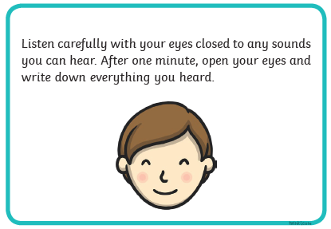
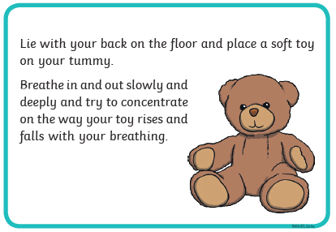
Don’t forget to send us pictures and updates to admin@moorside-pri.n-yorks.sch.uk or headteacher@moorside-pri.n-yorks.sch.uk

Hope you enjoy these challenges

