Year 3 Maths
The objectives we are working on are:
- add and subtract amounts of money to give change, using both £ and p in practical contexts
- recall and use multiplication and division facts for the 3, 4 and 8 multiplication tables.
This week is Adding and Subtracting Money week. On Thursday and Friday there are a range of different challenges to try, to revisit some different areas of learning too!

All the lessons can be found on https://whiterosemaths.com/homelearning/year-3/
This week’s learning is dated 4th May.
Monday Converting Pounds and pence.
Use the link above to watch the video for today. It is lesson 1 is Converting Pounds to Pence. You can use this link all week to watch the videos for each lesson.

Monday Task 1 Converting Pounds and Pence..
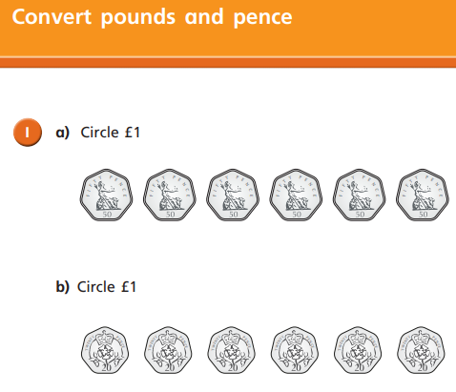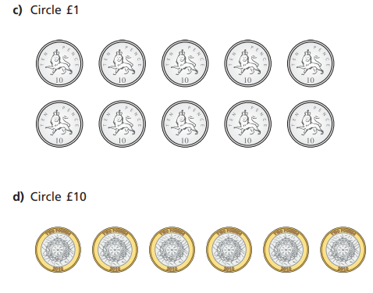
Monday Task 2 Converting Pounds and Pence.
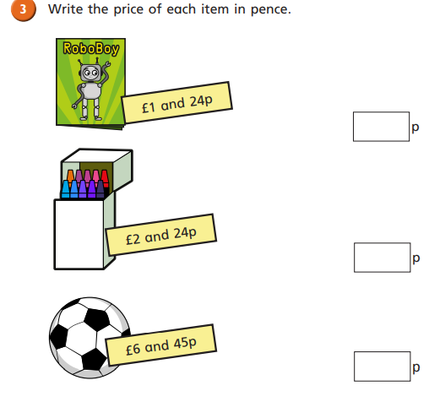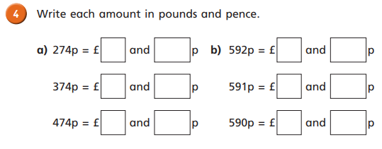

Monday Task 3 Converting Pounds and Pence.
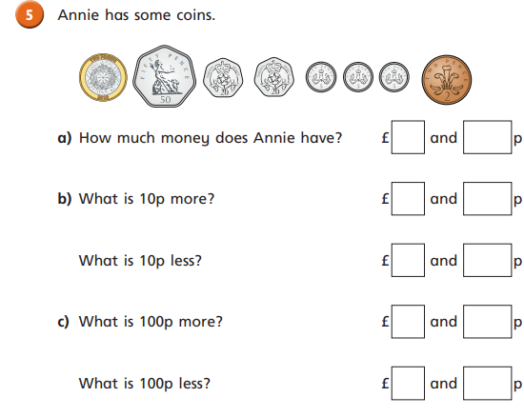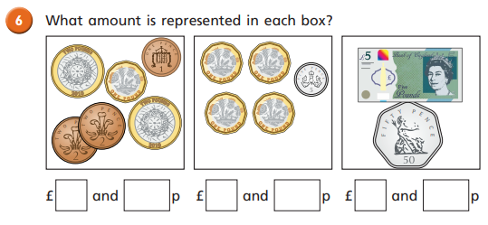

Monday Task 4 Converting Pounds and Pence.
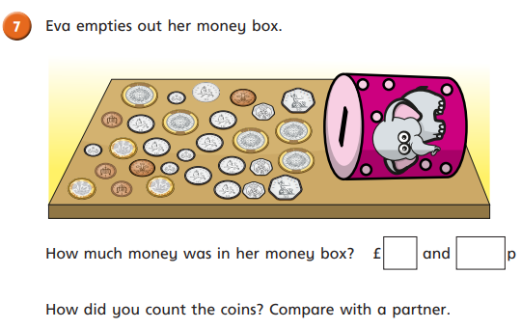

Monday Task 4.
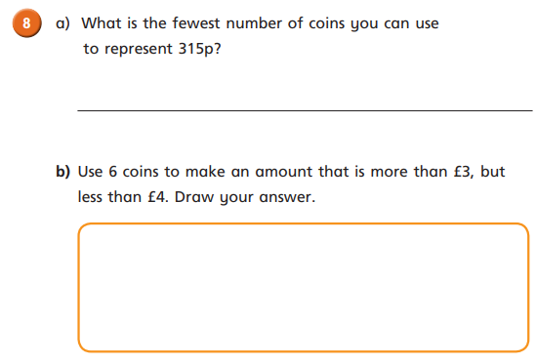
Tuesday Task 1.Adding Money. Watch the video first https://whiterosemaths.com/homelearning/year-3/
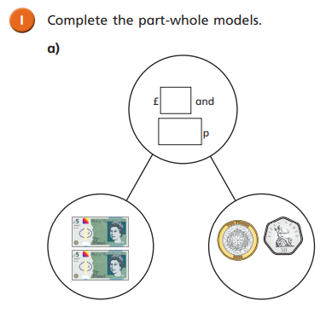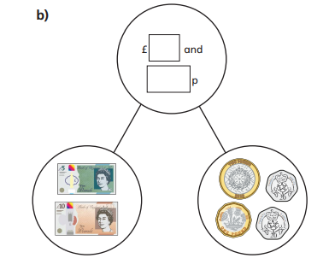

Tuesday Task 2.Adding Money.
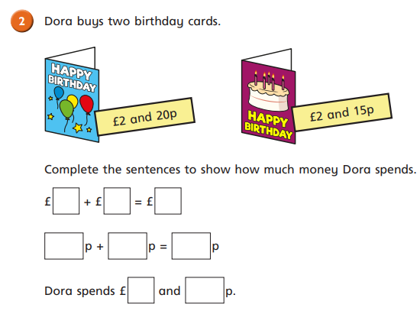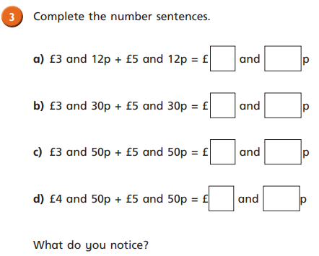

Tuesday Task 3.
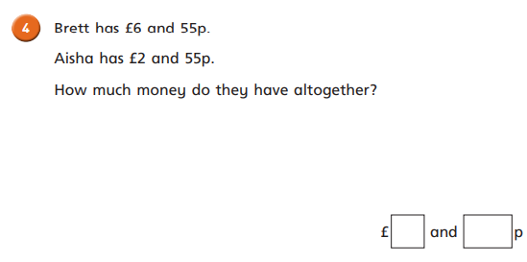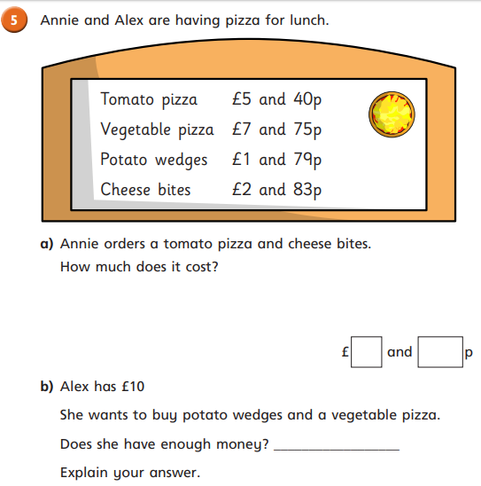

Tuesday Task 4.
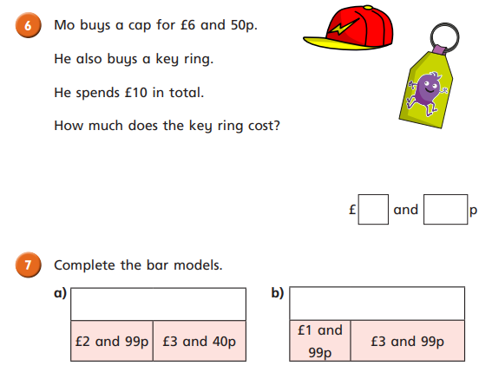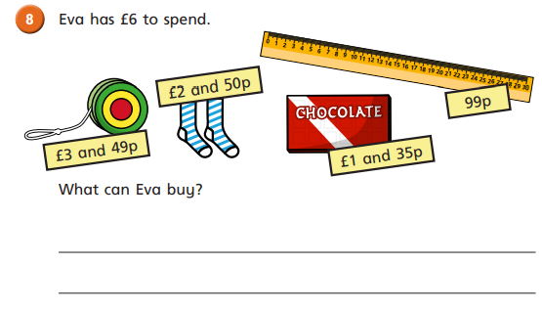

Wednesday Task 1. Subtract Money. Watch the video first https://whiterosemaths.com/homelearning/year-3/
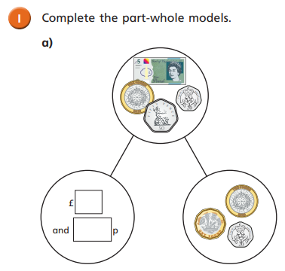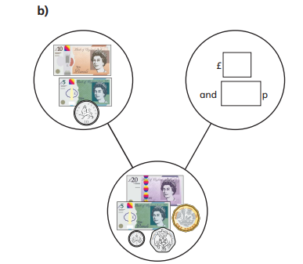

Wednesday Task 2 Subtract Money. Watch the video first https://whiterosemaths.com/homelearning/year-3/
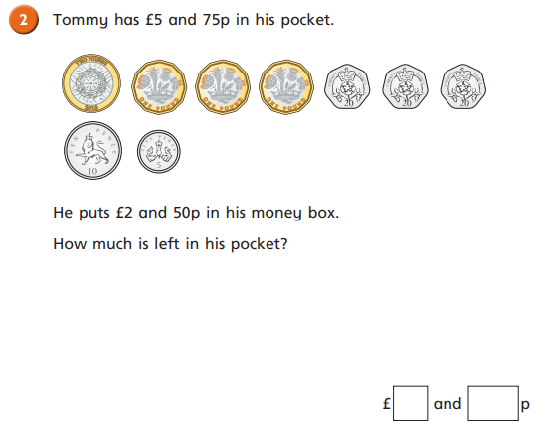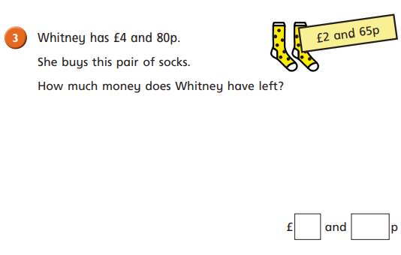

Wednesday Task 3 Subtract Money.
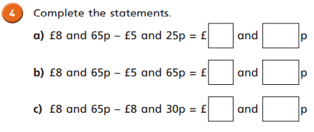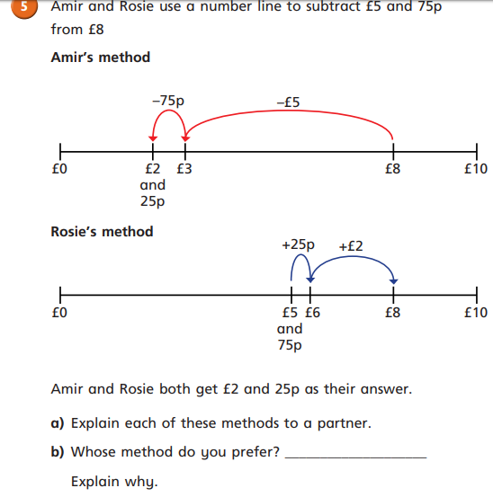

Wednesday Task 4.
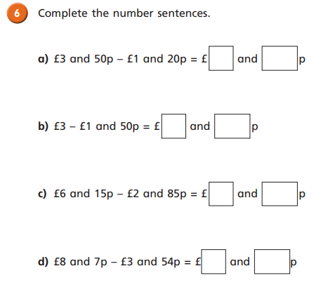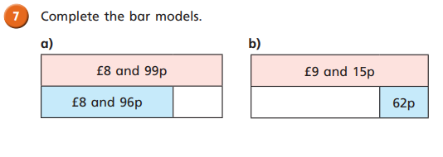
Thursday: Task 1. Three Times Table. Watch the video first https://whiterosemaths.com/homelearning/year-3/
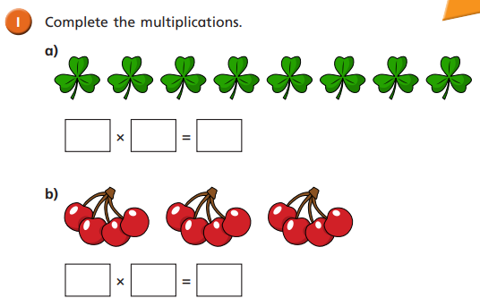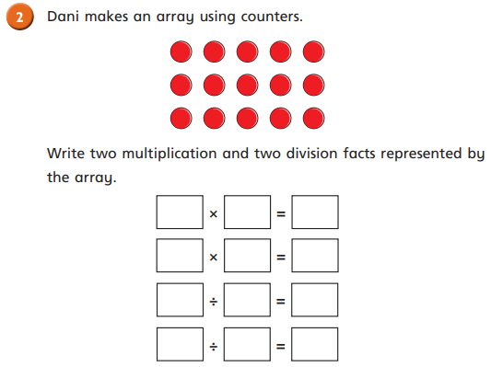

Thursday Task 2. Three Times Table.
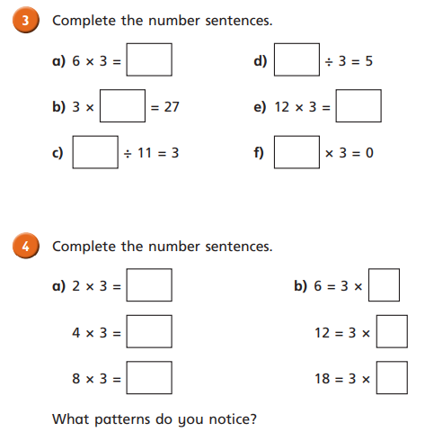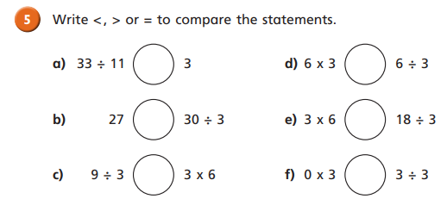

Thursday Task 3.
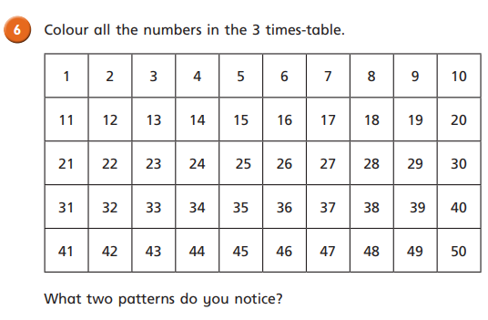
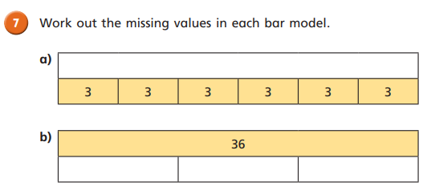
Thursday Task 4.
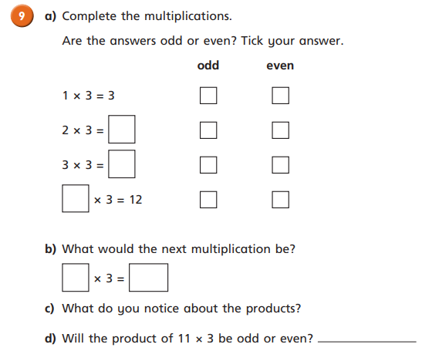

Friday Task 1. Watch the video first https://whiterosemaths.com/homelearning/year-3/
Use this to help you, especially the Trapezium bit!
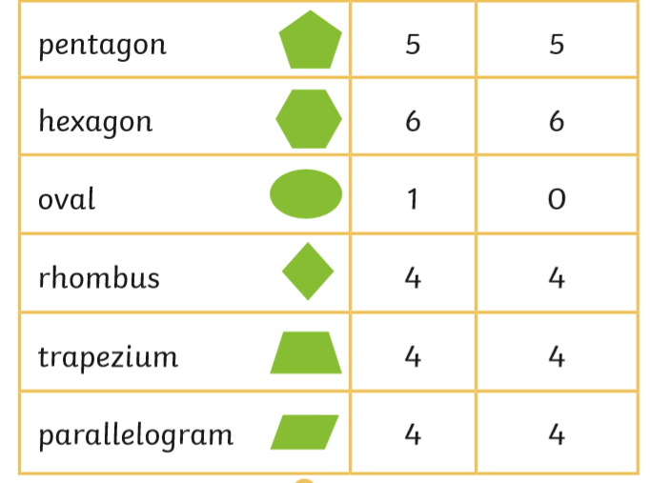

Friday Task 1.
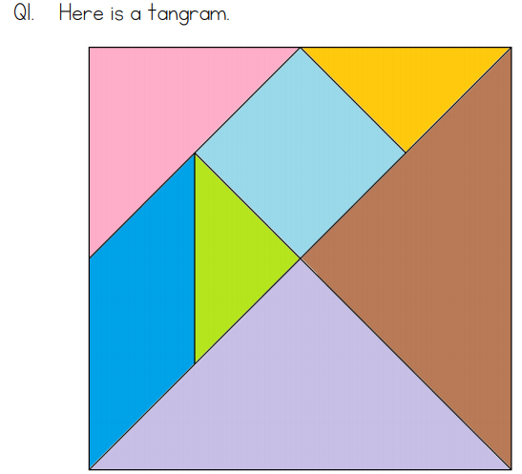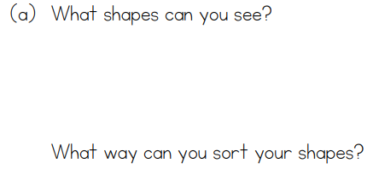

Friday Task 2.
