

Year 3 Maths

The objectives we are working on are:

* Pupils should practise adding and subtracting fractions with the same denominator through a variety of increasingly complex problems to improve fluency.

This week is Adding and Subtracting Fractions week. We haven’t covered this in class and it is easy to get confused BUT if you follow the rules, then you will have no problems! On Thursday and Friday there are a range of different challenges to try, to revisit some different areas of learning too!

1. Keep it simple! When adding or subtracting you are just adding or subtracting the top number (the numerator).
2. The denominator (number on the bottom, stays the same. Don’t change it!
3. When problem solving, use pictures/diagrams to help.
4. Take the problem one step at a time.
5. Use what you know. You are awesome... Just use your brain! You’ve got this!

All the lessons can be found on <https://whiterosemaths.com/homelearning/year-3/>

This week’s learning is dated 27th April.

**Monday Adding Fractions.**

Use the link above to watch the video for today. It is lesson 1 Adding Fractions. You can use this link all week to watch the videos for each lesson.

Monday Task 1 Adding Fractions.

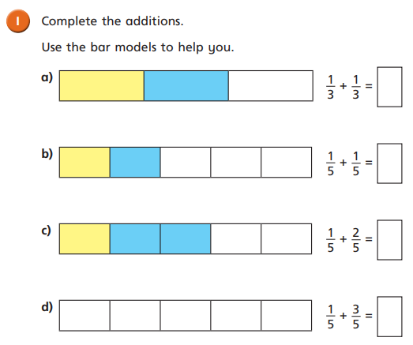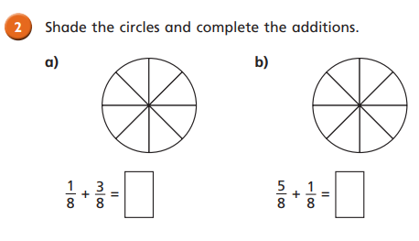

Monday Task 2 Adding Fractions.

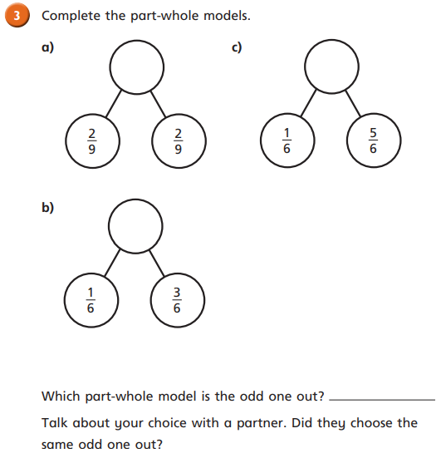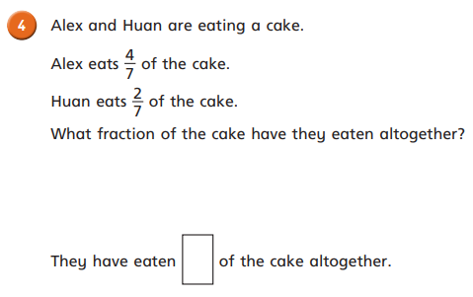

Monday Task 3 Adding Fractions.

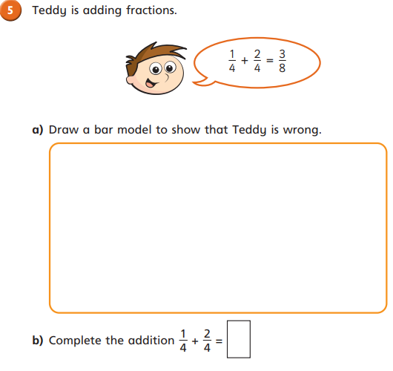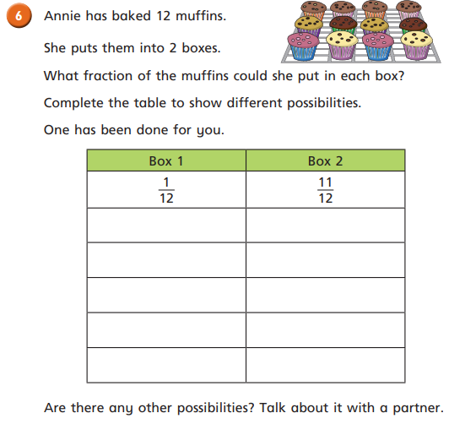

Monday Task 4. Adding Fractions.

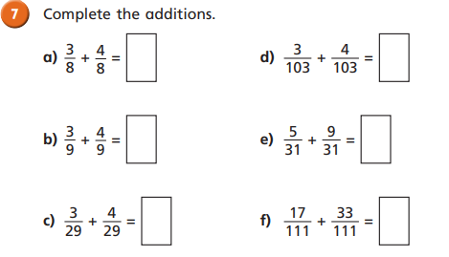**Tuesday Task 1. Subtracting Fractions. Watch the video first https://whiterosemaths.com/homelearning/year-3/**

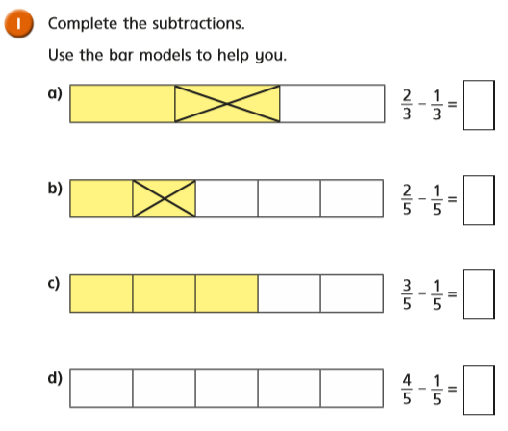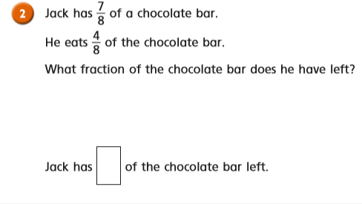

**Monday Task 2. Subtracting Fractions.**

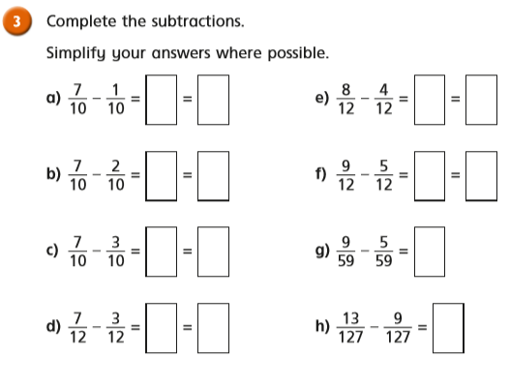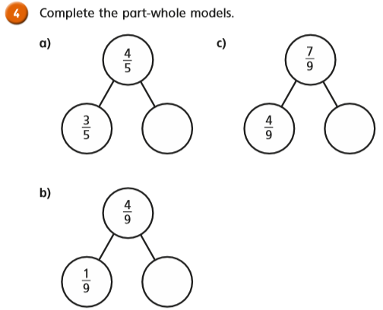

Tuesday Task 3.

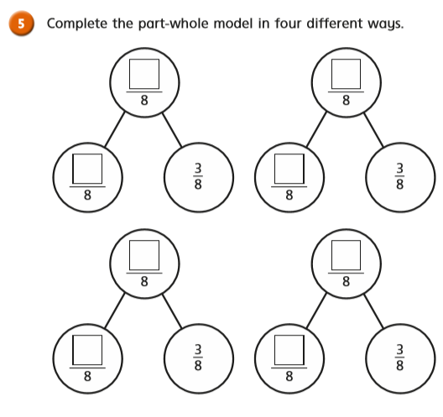

Tuesday Task 4.

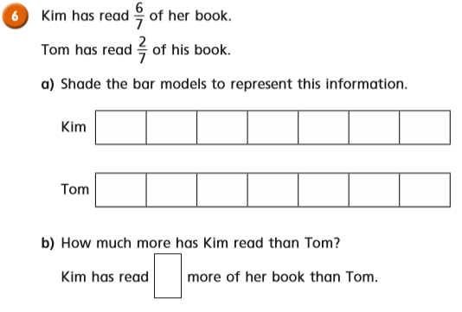

Tuesday Task 5.

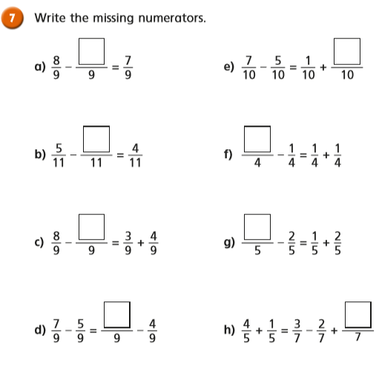

Wednesday Task 2. Watch the video first https://whiterosemaths.com/homelearning/year-3/

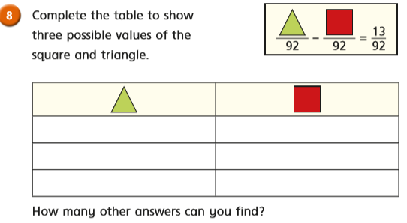

Wednesday Task 1. Watch the video first https://whiterosemaths.com/homelearning/year-3/

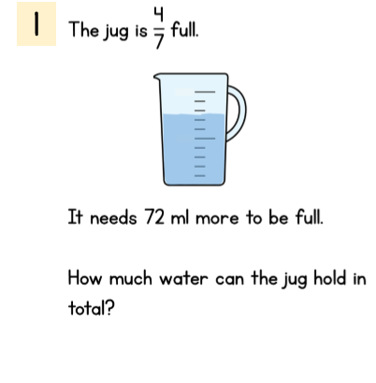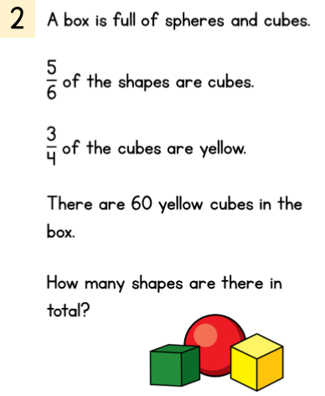

Wednesday Task 2.

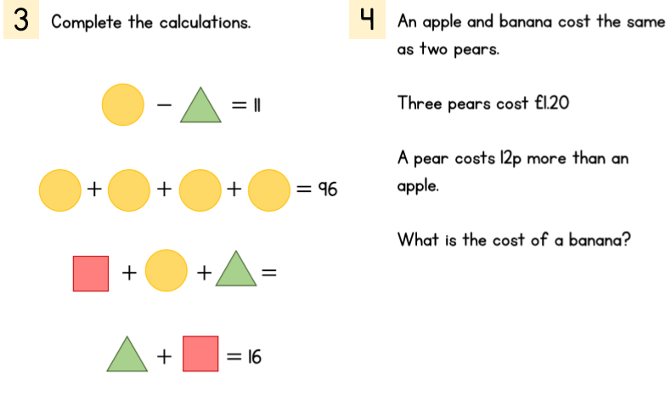

Thursday: Challenges 1 and 2. Watch the video first https://whiterosemaths.com/homelearning/year-3/

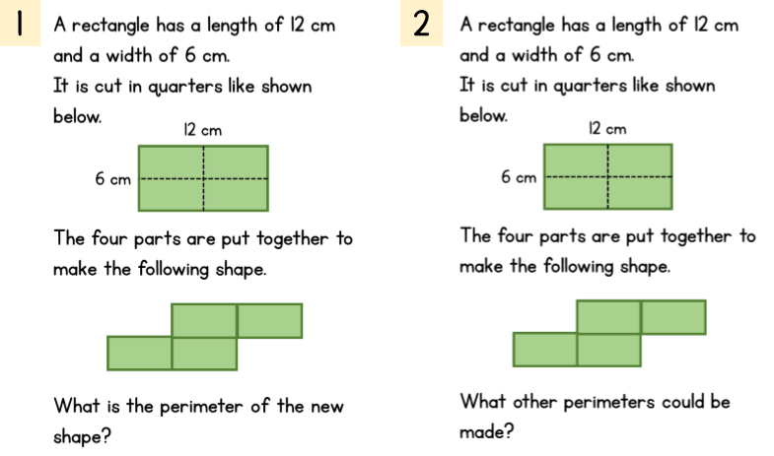

Thursday. Challenges 3 and 4.

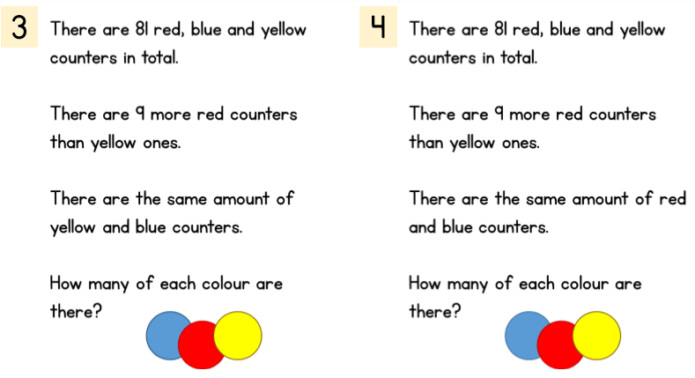

Friday Task 1. Watch the video first https://whiterosemaths.com/homelearning/year-3/



Friday Task 2.

