Year 3 Maths
The objectives we are working on are:
- Recognise and show, using diagrams, equivalent fractions with small denominators.
- Compare and order unit fractions, and fractions with the same denominators

This week is a revision week as we have learned about Fractions previously. Can you recall your knowledge? Let’s find out! There are some videos to help you and these have Flashbacks on them too. Use these videos to help you with your learning. Use the fraction wall that is in amongst the questions.
Just remember, the larger the number on the bottom (denominator) the more pieces the cake is cut up into. Which means, you get a smaller piece. The smaller the denominator means that the cake is cut up into bigger slices.

Monday Equivalent Fractions
Use this link to watch the video for today. It is lesson 1 Equivalent Fractions. You can use this link all week to watch the videos for each lesson.
https://whiterosemaths.com/homelearning/year-3/4

Monday Task 1
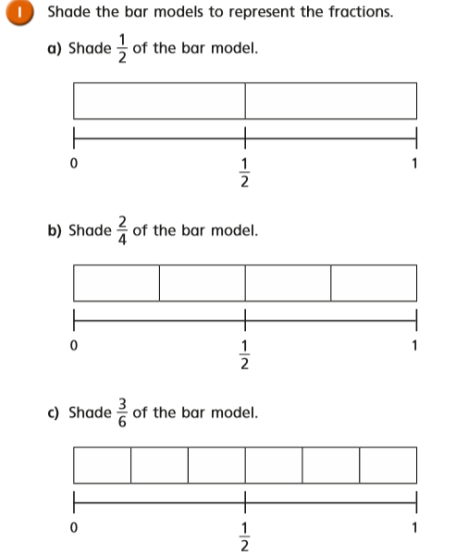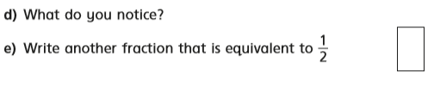
Monday Task 2
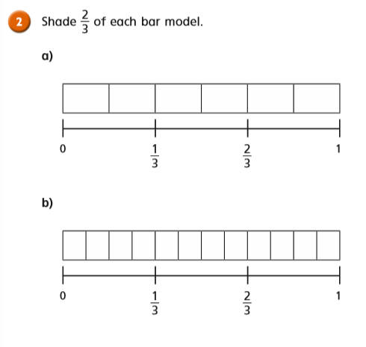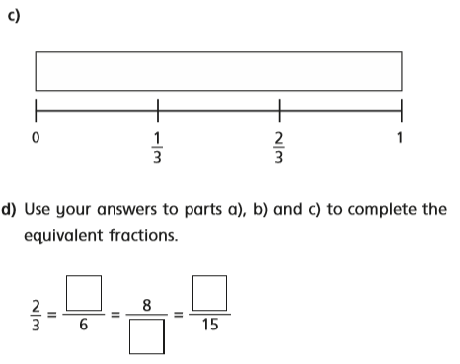

Monday Task 3
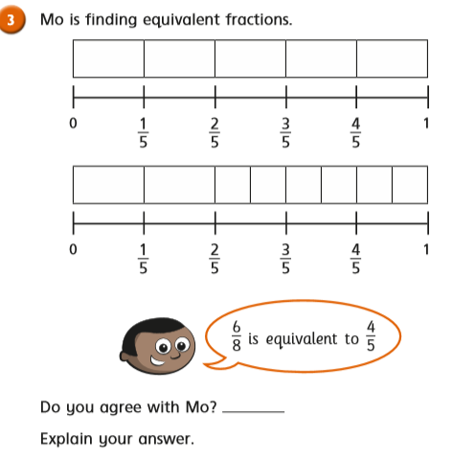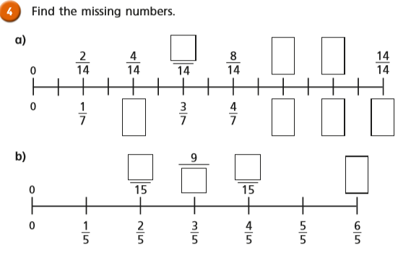

Monday Task 4
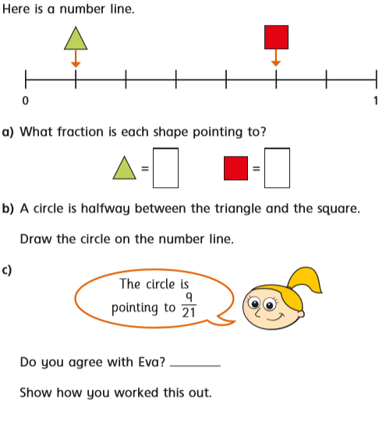

Tuesday Task 1. Use this link https://whiterosemaths.com/homelearning/year-3/4 and watch the video for lesson 2.
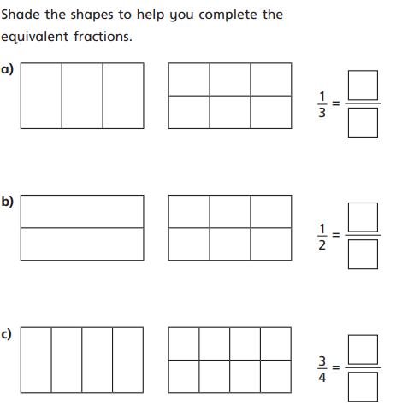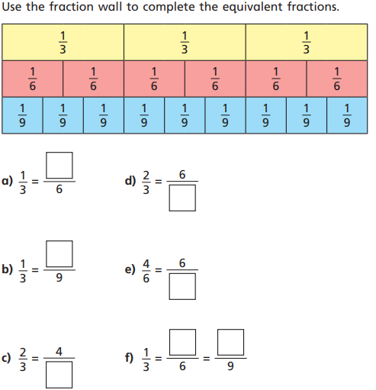

Tuesday Task 2.
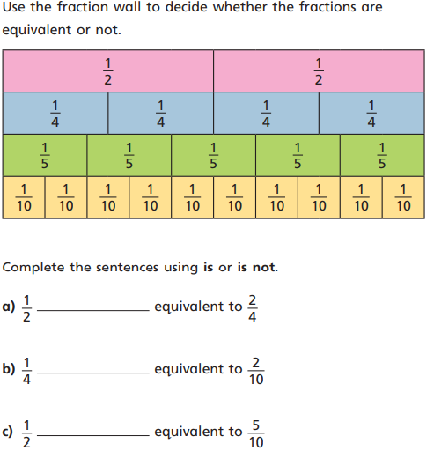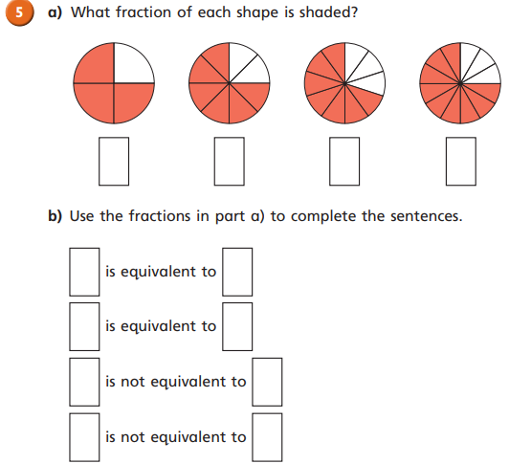

Wednesday Compare Fractions. Watch the video on this link: https://whiterosemaths.com/homelearning/year-3/4
Task 1
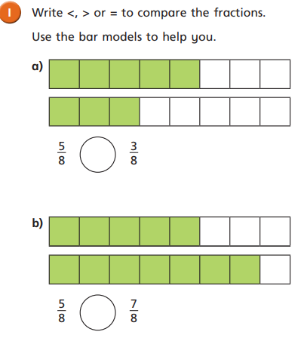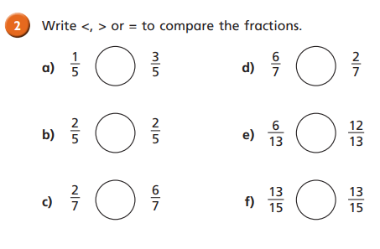

Wednesday Task 2. Compare Fractions. Watch the video to help you. https://whiterosemaths.com/homelearning/year-3/

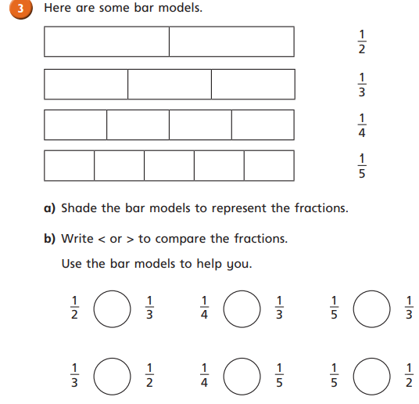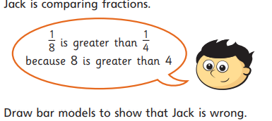

Wednesday Task 3. Comparing Fractions.
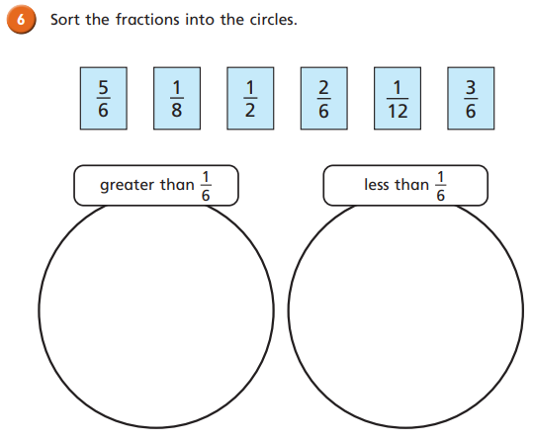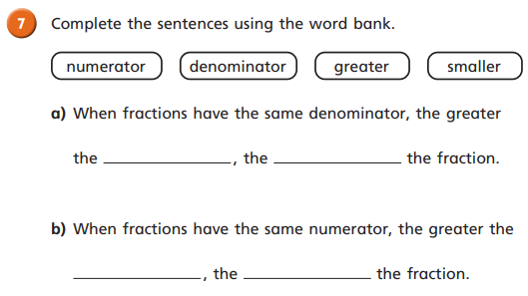

Thursday: Ordering Fractions. Task 1. Watch the video to help you. https://whiterosemaths.com/homelearning/year-3/
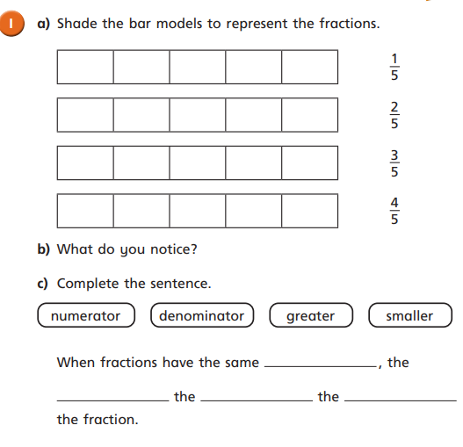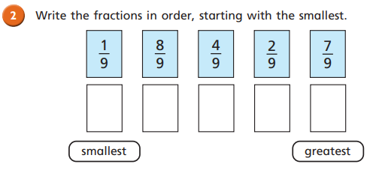

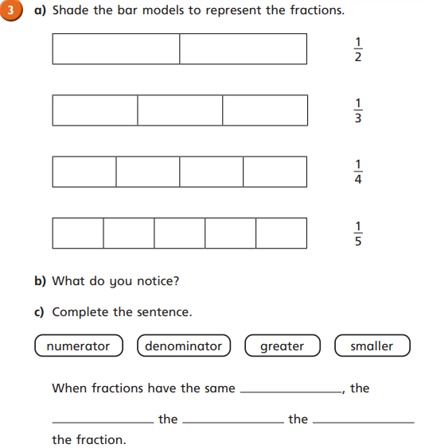
Thursday Task 2.
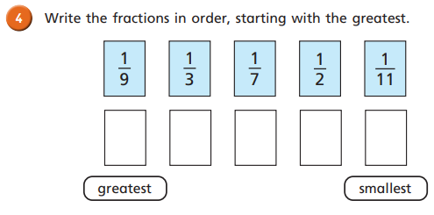

Thursday Task 3.
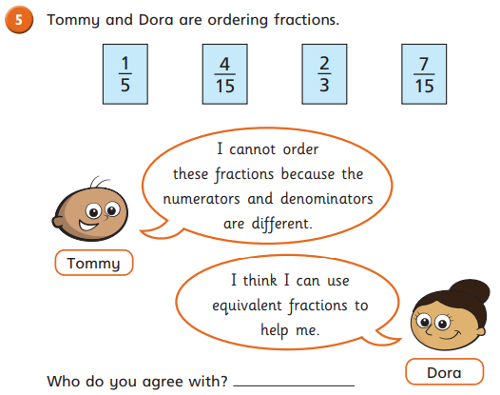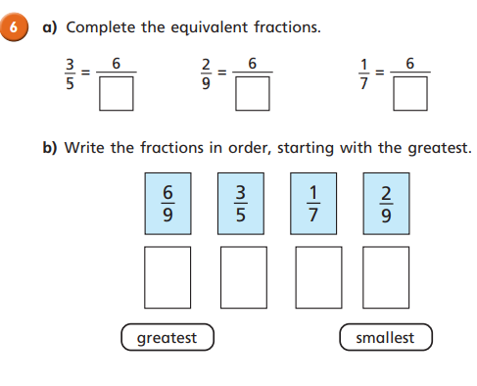
Thursday Task 4.
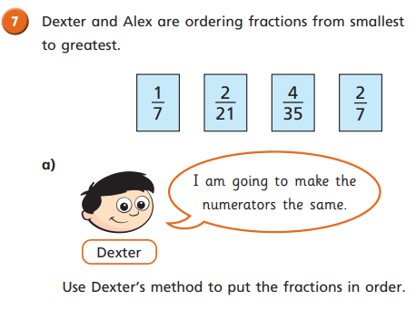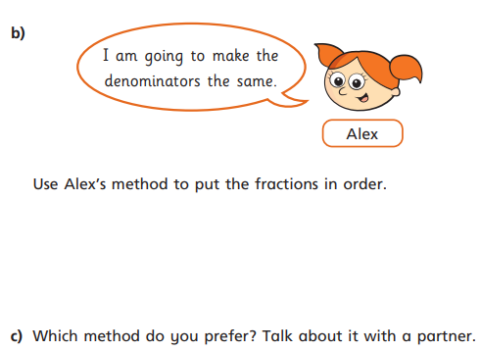

Friday: Challenges 1 and 2.
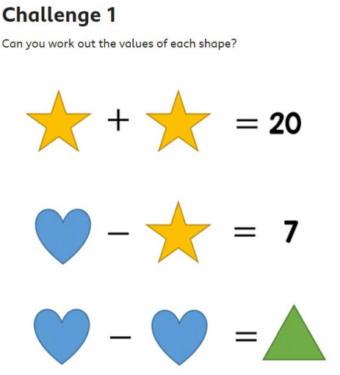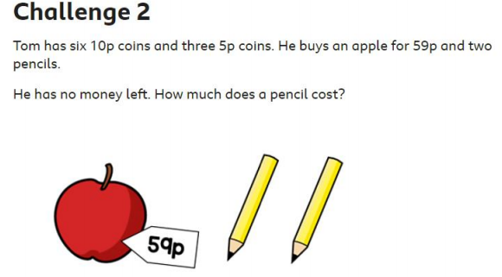

Friday. Challenges 3 and 4.
