Year 1 Home Learning for WC 18-5-20

Maths – White Rose Maths Home Learning – Summer term week 4 tasks
https://whiterosemaths.com/homelearning/year-1/
Monday - Lesson 1 – Add by making 10
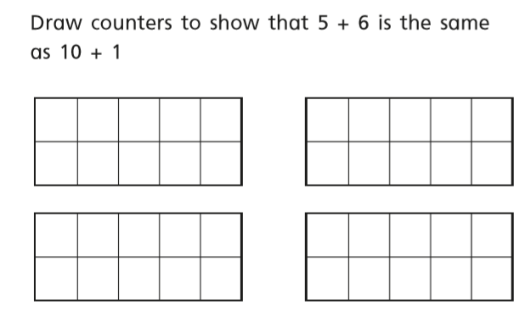
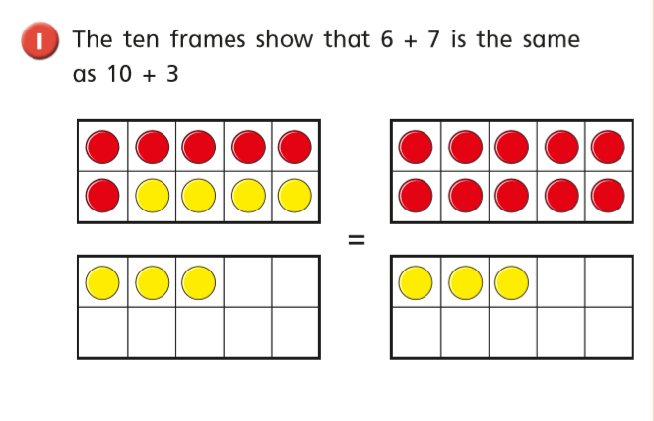
Watch the video and answer these questions

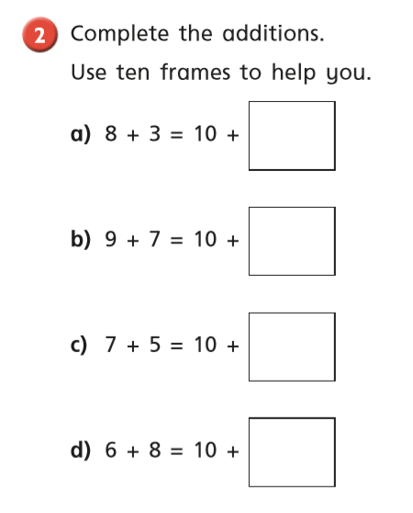

Tuesday
Warm up – Play x 2 on Topmarks Hit The Button
https://www.topmarks.co.uk/maths-games/hit-the-button
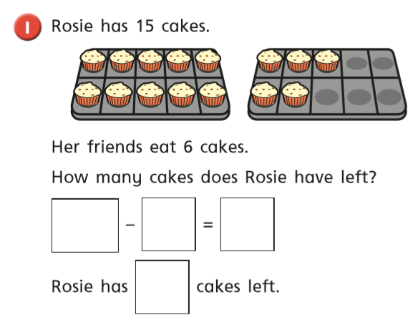
White Rose Lesson 2 – Subtract within 20 Watch the video and then answer these questions

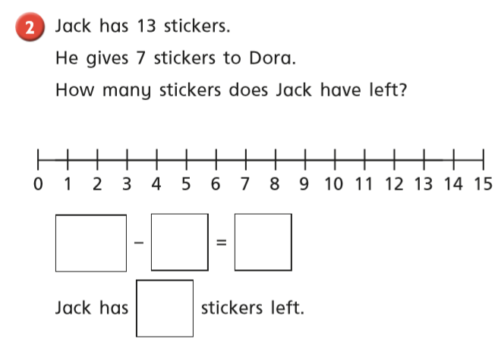

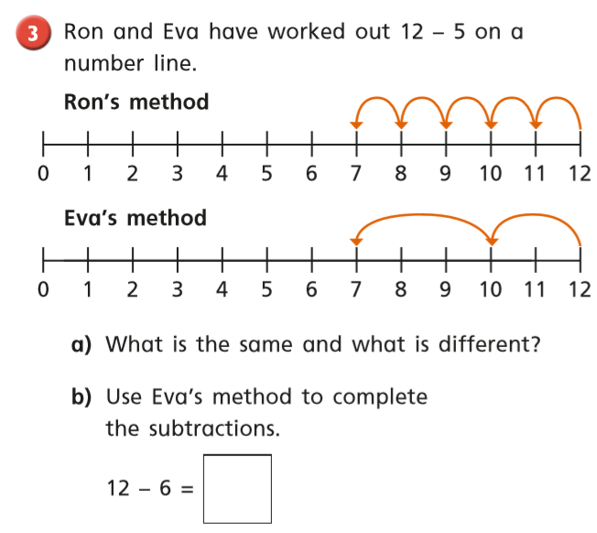

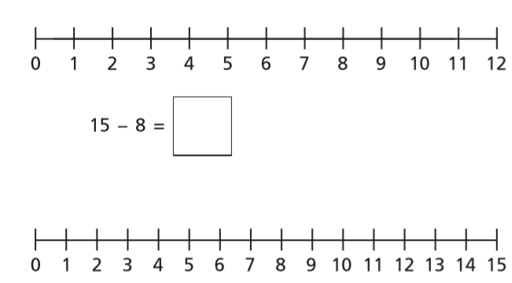

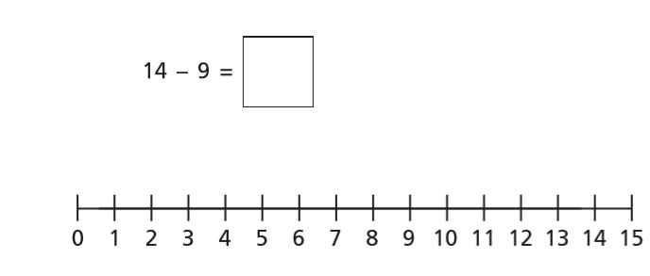
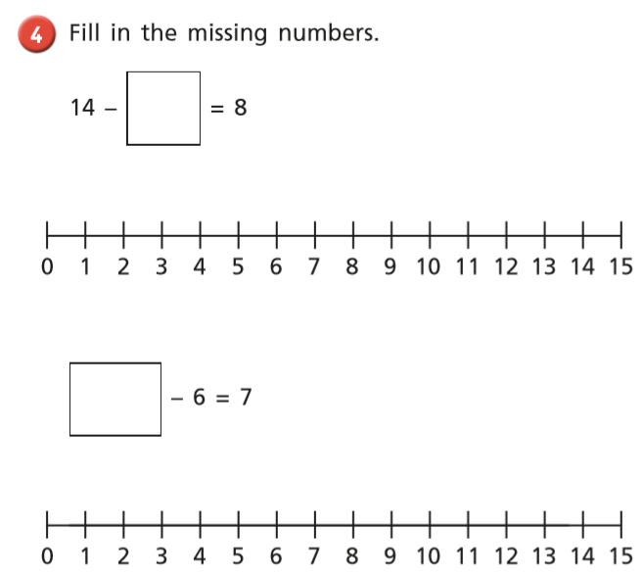

Wednesday Warm up – Play Doubles to 20 on Topmarks Hit The Button
https://www.topmarks.co.uk/maths-games/hit-the-button
White Rose Lesson 3 – Add and Subtract Worded Problems
Watch the video and then answer these questions
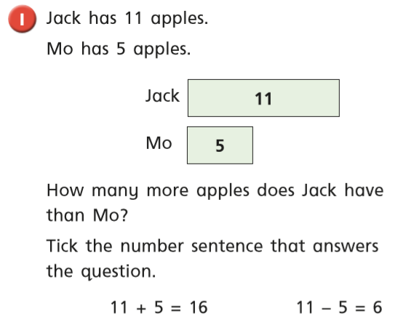

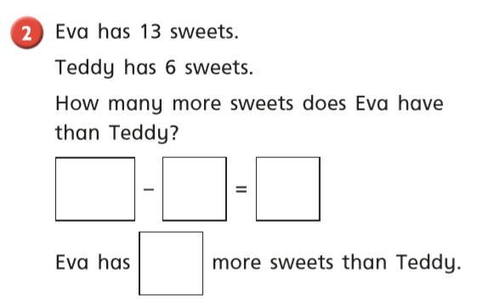

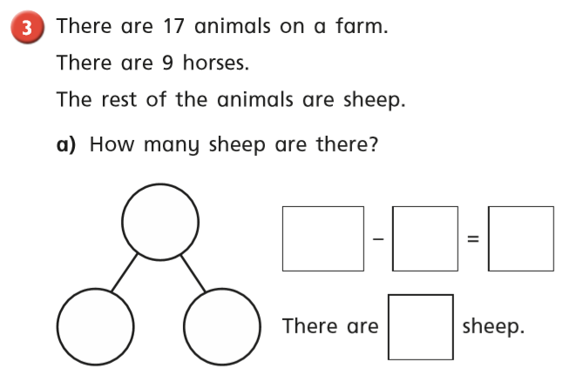

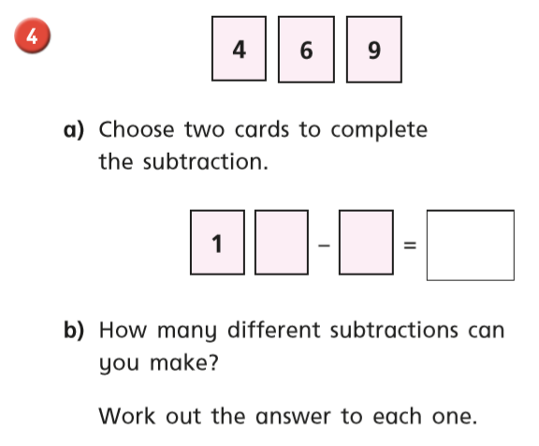
Thursday Warm up – Play ‘Starfish Strike’ on Abacus
White Rose Lesson 4 – Compare Number Sentences
Watch the video and then answer these questions
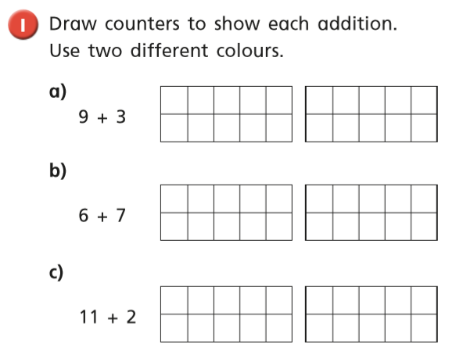
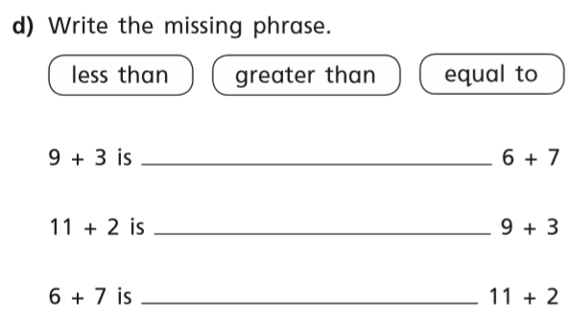

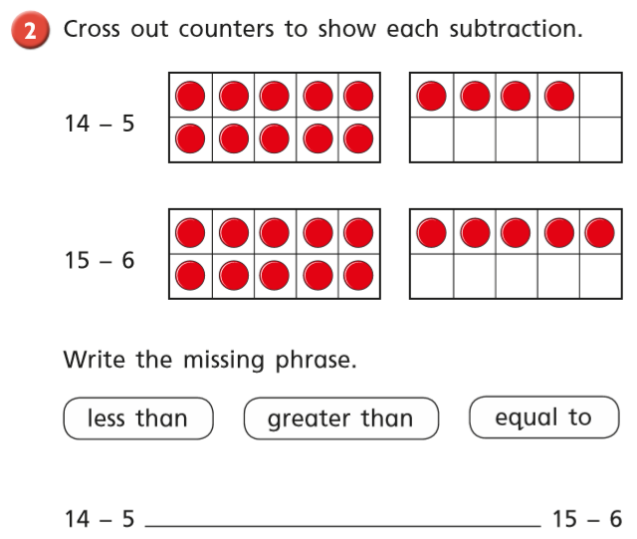
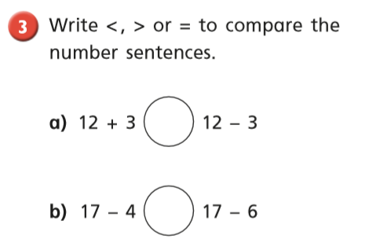

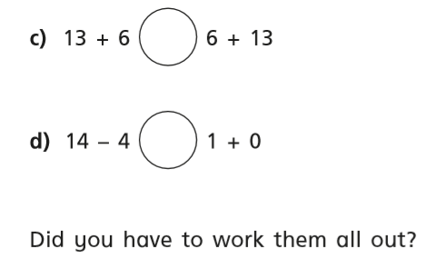

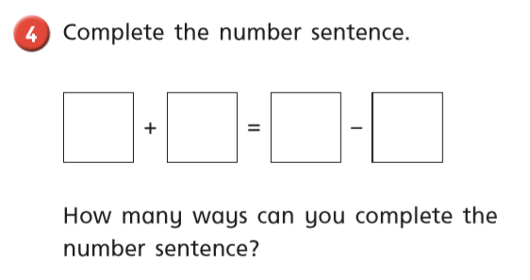

Friday – Warm up – play Halves to 10 and 10-20 on Topmarks
https://www.topmarks.co.uk/maths-games/hit-the-button

Play Classroom Secrets Maths Game - ‘Compare Number Sentences’
https://kids.classroomsecrets.co.uk/resource/year-1-compare-number-sentences-game/

Complete the maths activity mat on page 12.

Happy Learning!
Miss Ryder

