Year 1 Home Learning for WC 11-5-20

Maths – White Rose Maths Home Learning – Summer term week 3 tasks
https://whiterosemaths.com/homelearning/year-1/
Monday - Lesson 1 – Part-Whole relationships number bonds
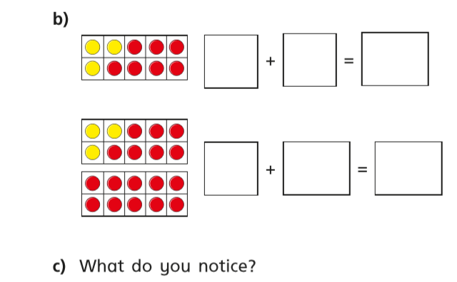
Watch the video and answer these questions
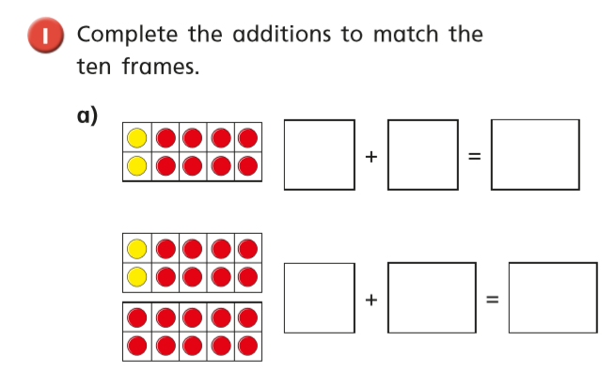

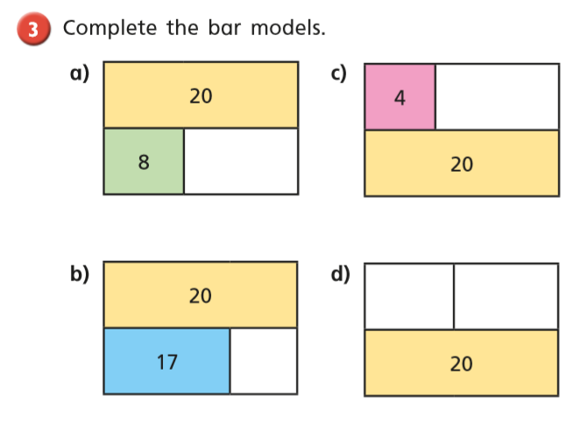
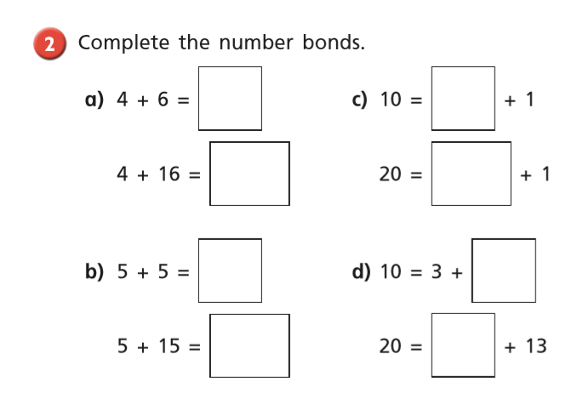

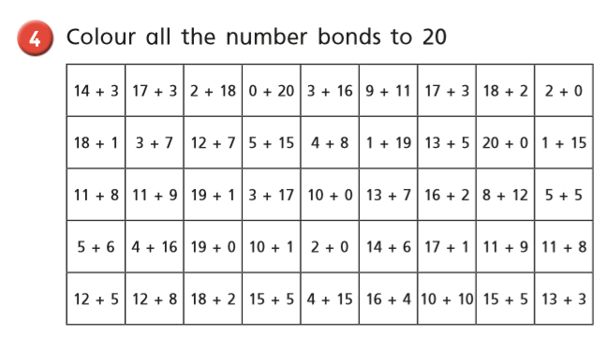

Tuesday
Warm up – Play x10 on Topmarks Hit The Button
https://www.topmarks.co.uk/maths-games/hit-the-button
Lesson 2 – Fact families. Watch the video and then answer these questions

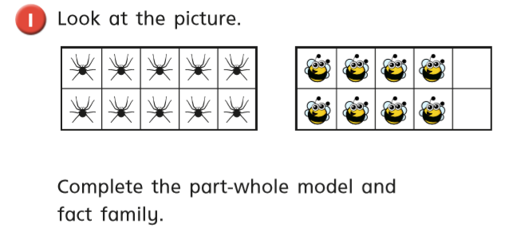

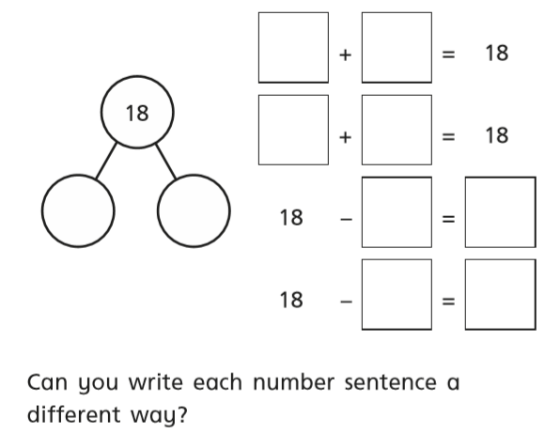

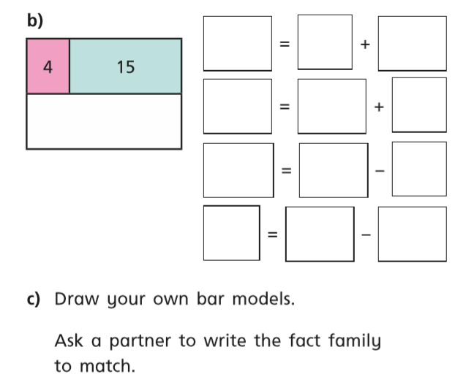
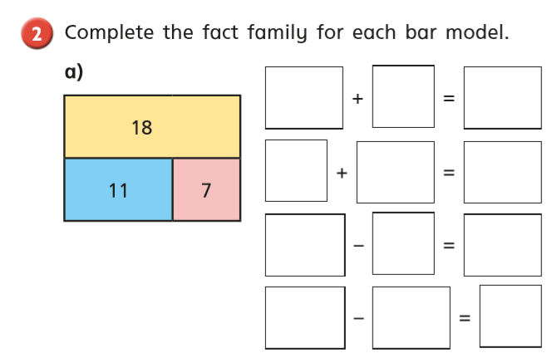

Wednesday Warm up – Play x2 on Topmarks Hit The Button
https://www.topmarks.co.uk/maths-games/hit-the-button
White Rose Lesson 3 – Add together and find a part
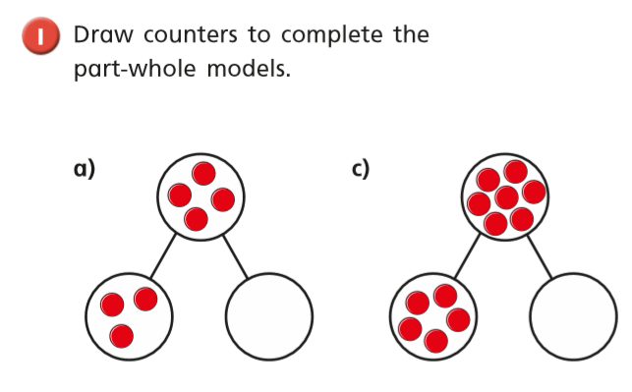

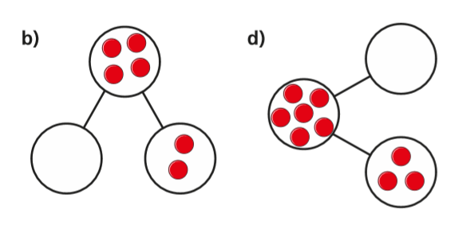

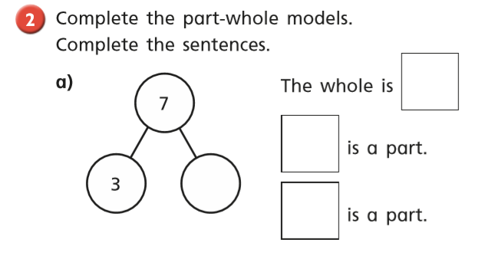

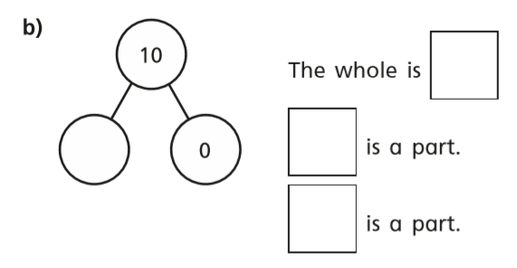

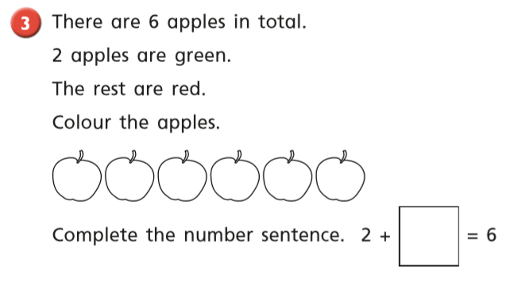

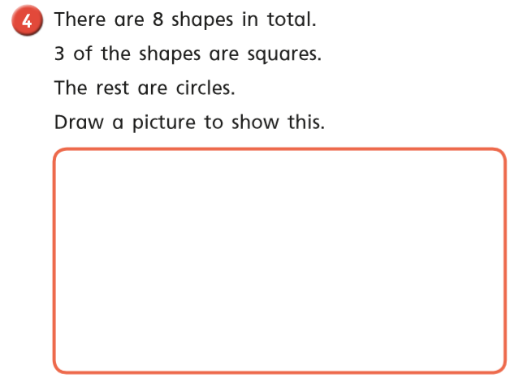

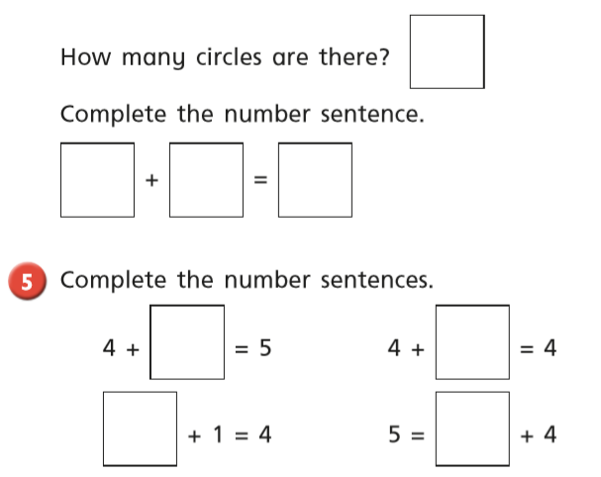
Thursday Warm up – Play ‘Bop a Bird’ on Abacus
White Rose Lesson 4 – Add more and count on within 20. Watch the video and then answer these questions
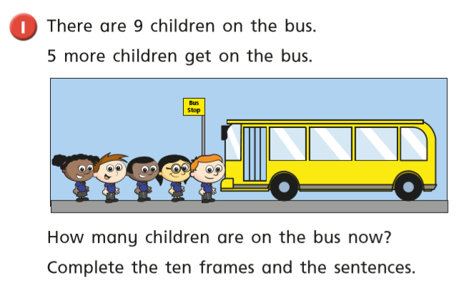

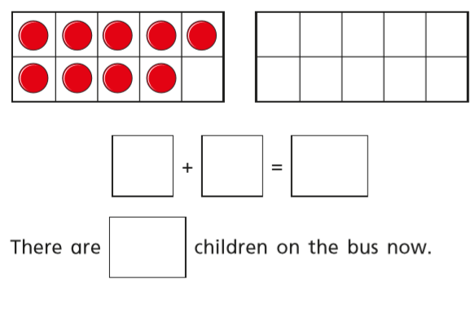

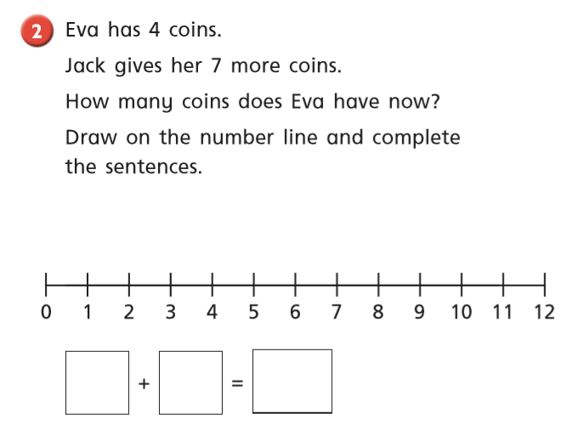
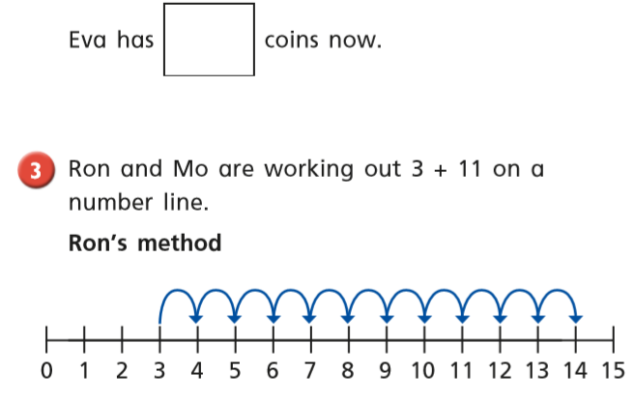

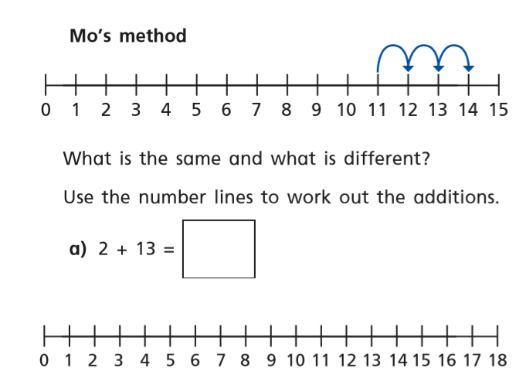

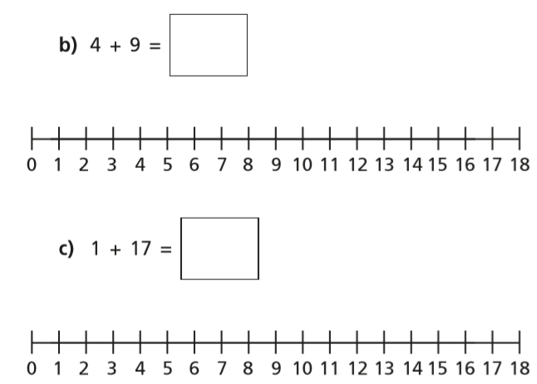
Friday – Warm up – play Counting / sequencing caterpillar on Topmarks
https://www.topmarks.co.uk/ordering-and-sequencing/caterpillar-ordering

Play Classroom Secrets Maths Game - ‘Add by counting on’
https://kids.classroomsecrets.co.uk/resource/year-1-add-by-counting-on-game/

Complete the maths activity mat on page 13.

Happy Learning!
Miss Ryder

