Year 1 and 2 Home Learning Challenges WC 18.5.20
RE – Ramadan and Eid
Investigating Ramadan and Eid  - Watch the following clip all about Ramadan and Eid:  https://www.bbc.co.uk/bitesize/clips/z434wmn  - Look at the powerpoint slides which are in this pack.  - Can you answer the questions in your pack?  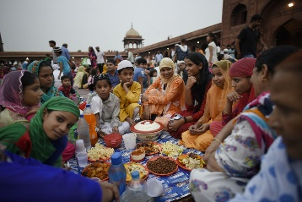 | Crescent moon and star  - The crescent moon and star is recognised as a symbol of Islam and for that reason, it appears on the flag of many countries where Islam is a state religion or which has a largely Muslim population.  - Can you decorate the Moon and Star symbol in your pack? | Giving and Caring  - Muslims believe Ramadan is a month of giving and caring.  - What could you do to be generous and caring?  We have included some ‘kindness cards’ in your pack.  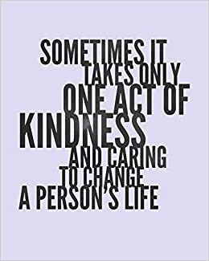  - Either choose a card (or your own idea) and carry out that kindness.  - Can you keep this up for a whole month, like they do at Ramadan?
Prayer Mat  During Ramadan, Muslims spend a lot of time praying.  What would you pray for and why?  Write your own prayer on the prayer mat in your pack. | Ramadan Recipes  Lots of tasty foods are eaten to celebrate the end of Ramadan in the festival of Eid.  - Look on the Internet and find a tasty looking Eid recipe or follow the one we have included in your pack  - Follow the instructions to make your tasty treat!  - Don’t forget to take photos of your treats and send them to school! | 5 Finger Facts  See if you can learn these top 5 facts as part of the topic.  - I know that Eid is celebrated in the Islamic religion.  - I know that Eid is a celebration at the end of Ramadan.  - I know that during Ramadan, Muslims fast between daylight hours.  - I know that if Muslims cannot fast during Ramadan, they should give money to charity.  - I know that Ramadan lasts 29 or 30 days.

Investigating Ramadan and Eid

1 2
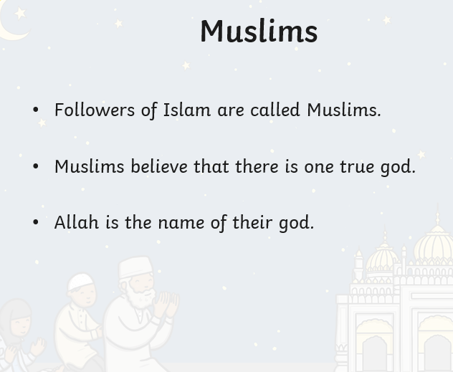
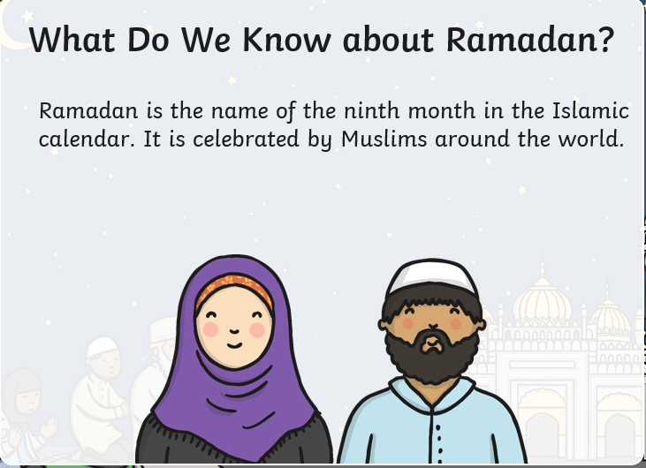

3 4
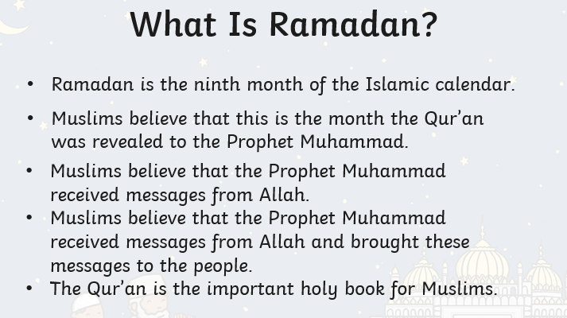
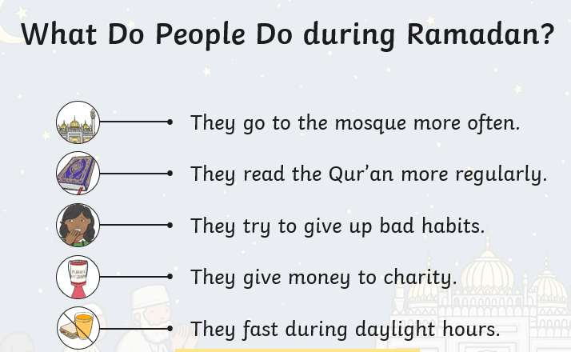

5 6.
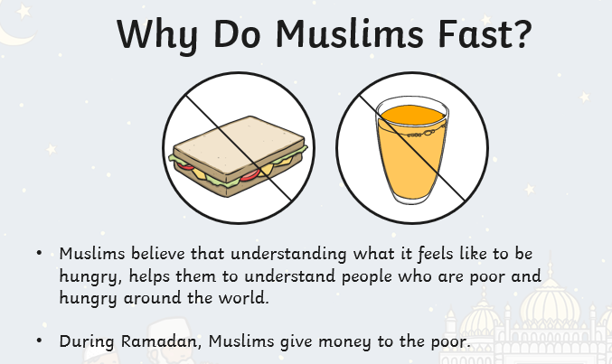
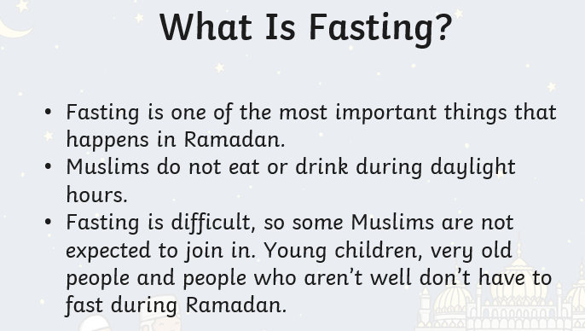

7 8
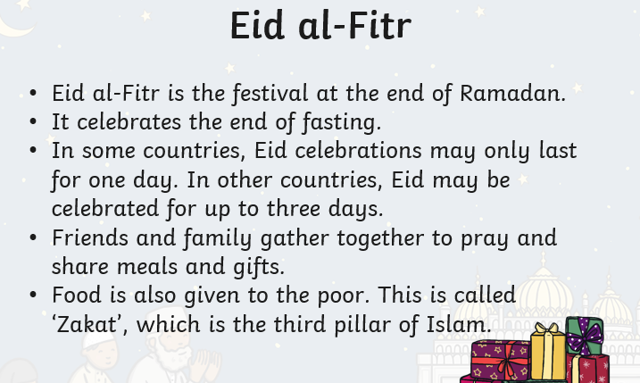
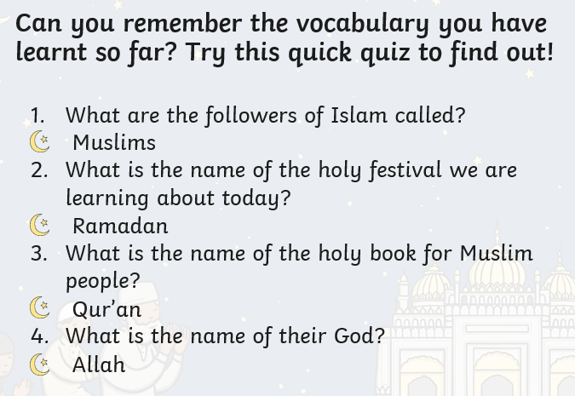

Ramadan and Eid questions

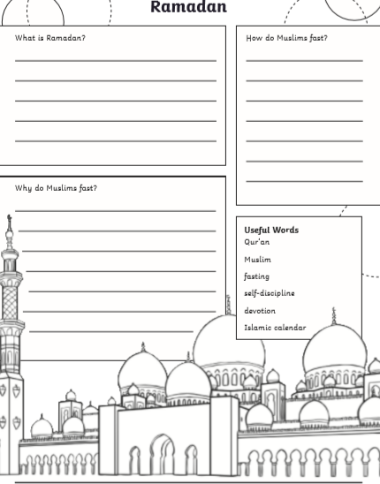

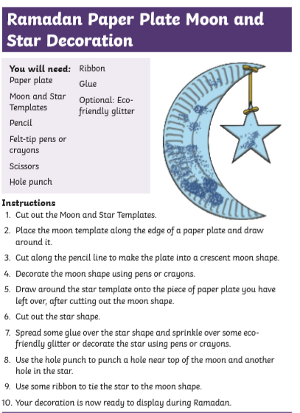

Kindness Cards
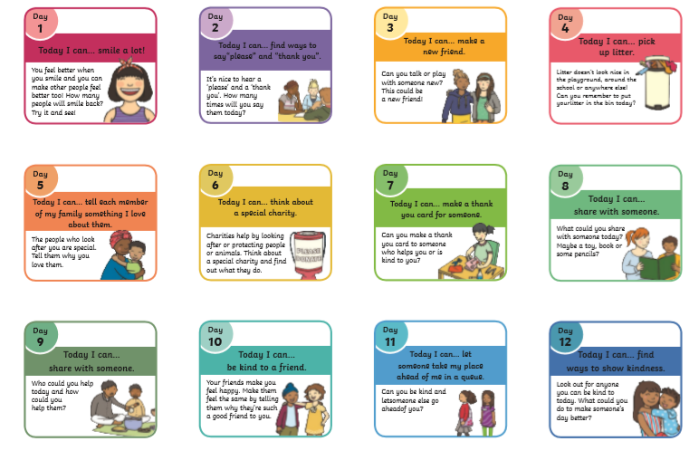

Kindness Cards
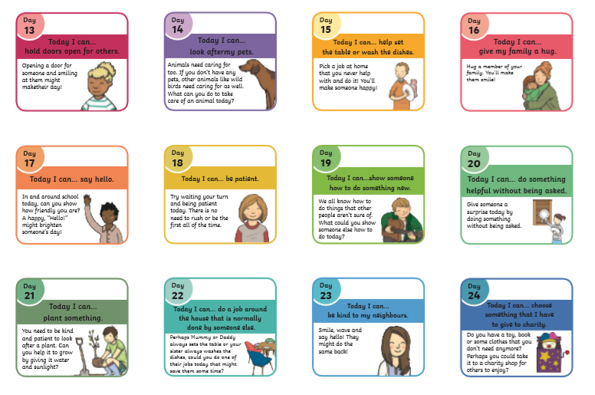

Prayer Mat
