Year 1 and 2 Home Learning Challenges WC 11.5.20
History - Ripon
Go on a detective walk  Go on a walk in your local area.  Take a photograph of any building that you think looks old (you might want to ask an adult to help you out here).  Look at the photographs you have taken. Why do you think they are old? Could you put the photographs in order from the oldest to the youngest? Why have you chosen this order?  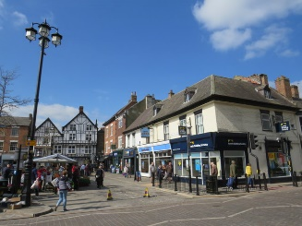 | Comparing Ripon then and now  - In your pack are two photographs of Ripon marketplace. One was taken around 1950 and the other is a modern photo.  - Look at both photographs.  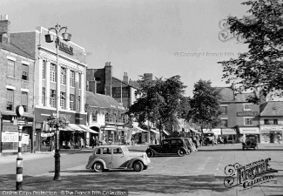  - What is the same about the photographs?  - What is different?  - How do you think Ripon has changed? | Interviewing  Did your parents or grandparents live in Ripon when they were your age?  You have the important job of becoming a reporter!  In order to find out about how life in Ripon has changed can you interview a parent or grandparent (by phone if necessary)?  - The first thing you need to do is think of 5 questions. They might be questions about school, the shops, jobs or transport.  - Write your questions down and carry out your interview.  - Can you work out how Ripon has changed over the years?
Why does Ripon have a Hornblower?  1 Look at this website to see if you can work out why Ripon has a Hornblower:  http://www.bbc.co.uk/northyorkshire/content/articles  /2008/07/10/ripon_hornblower_history_feature.shtm  2. On the attached sheet are some facts which tell the story of the Hornblower. Cut them out and stick them in order.  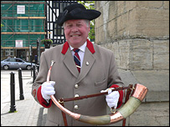  3. Can you find out how many Hornblowers are there today? | Ripon Hornblower  Can you draw and label a picture of the horn which is used in the market square each night? You might need to look on the Internet to find a photo to help you.  If you didn’t want to draw a picture, maybe you could make one. What materials could you use? Our science activities from 2 weeks ago might help with this activity!  What materials can you use to show the horn? | 5 Finger Facts  See if you can learn these top 5 facts as part of the topic.  - human features – means anything created by people eg buildings.  - physical features – something that is formed naturally eg river, cliff  - I can identify how Ripon has changed over the years.  - I know what a Wakeman is.  - I can say why Ripon has a Hornblower.

Detective Walk
Try to put the photographs you have taken in order of how old they are
2.
1.

4.
3.

Ripon in the 1950s

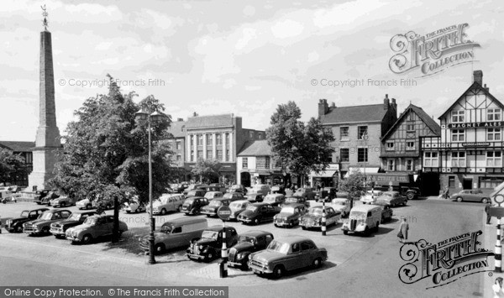

Ripon today

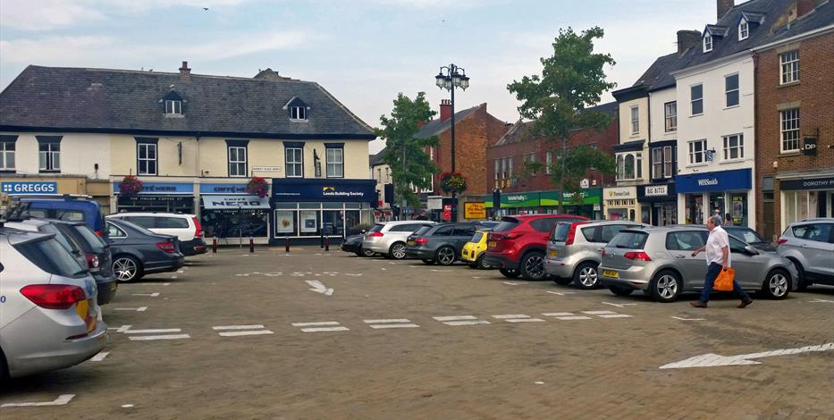

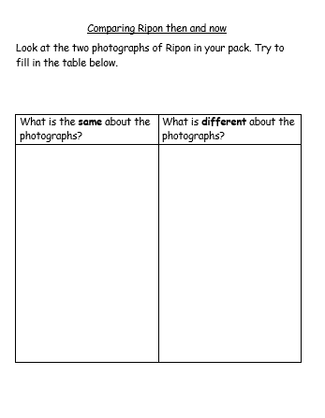

My Interview
Who did you interview?______________________
Question 1 | Answer
Question 2 | Answer
Question 3 | Answer
Question 4 | Answer
Question 5 | Answer

Why does Ripon have a Hornblower?

King Alfred the Great wanted the people of Ripon to be alert to the dangers from the Vikings.
The Wakeman began by sounding his horn at the 4 corners of the market place to let people know he was on duty.
This tradition still goes on today.
A Wakeman was appointed to stay awake all night and protect Ripon.
King Alfred the Great wanted to make the country safe again.
The Vikings were raiding England.

