Year 4 RE Home Learning Challenges
Create a finger snapper to memorise the 5 finger facts for this topic  - I know that Eid is celebrated in the Islamic religion.  - I know that Eid is a celebration at the end of Ramadan.  - I know that during Ramadan, Muslims fast between daylight hours.  - I know that if Muslims cannot fast during Ramadan, they should give money to charity.  - I know that Ramadan lasts 29 or 30 days. | Ramadan and Eid  https://www.bbc.co.uk/bitesize/clips/z434wmn  Watch this clip about Ramadan and Eid and then look through the powerpoint slides on pages 2 and 3 all about Ramadan.  Once you have done this, make notes on the ‘What Happens during Ramadan’ sheet on page 4.  One you’ve done this, create an information poster to inform people why Muslims take part in Ramadan and celebrate Eid. | Eid Biscuits  Using the recipe on page 6, have a go at making biscuits which are eaten by Muslims when they are celebrating Eid.  If you do not want to make biscuits, have a try at making a Ramadan lantern instead! (Pages 8 and 9)
 | Quiz time!  To show a real understanding of Ramadan and Eid, can you create a quiz for your families to answer?  If you’d prefer, you could always make a different game (such as a board game or a card game) for people to play to see how much they know about Ramadan and Eid.  I’ve included some example questions on page 5 to help you! | Key Vocabulary  Ramadan – the ninth month of the Muslim year, where Muslims are expected to fast.  Eid al-Fitr – the celebration which takes place to mark the end of Ramadan.  Muslim – a person who follows the Islamic faith.  Allah – is the name for God in the Islamic faith.
Our topic is Ramadan and Eid

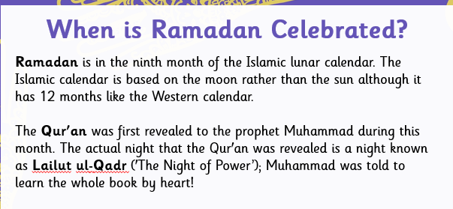
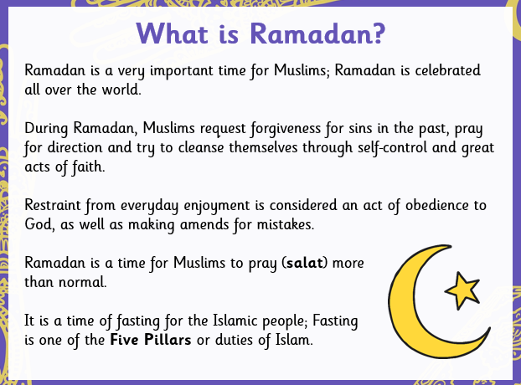
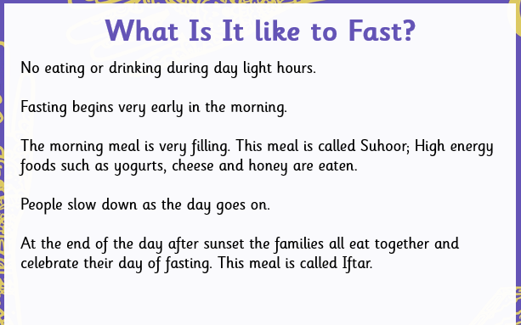
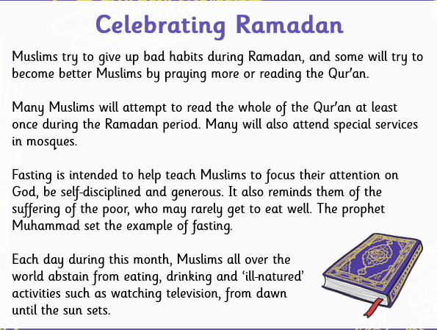

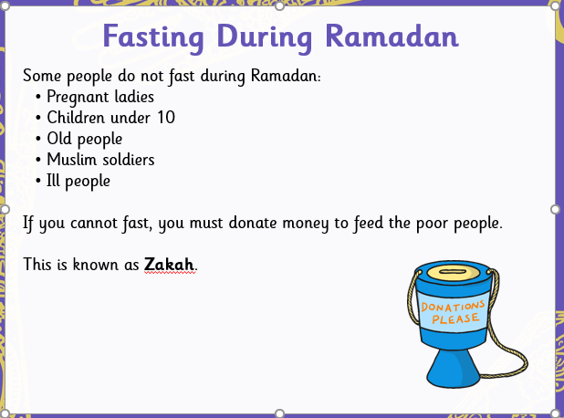
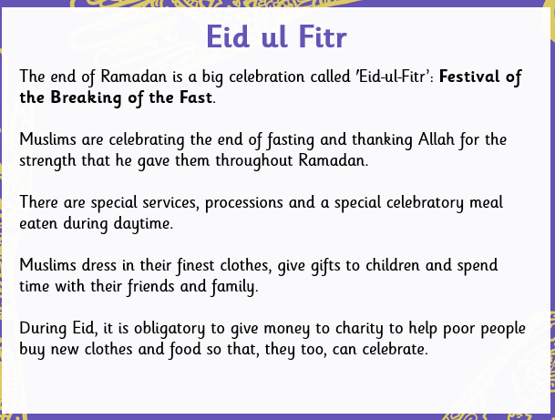

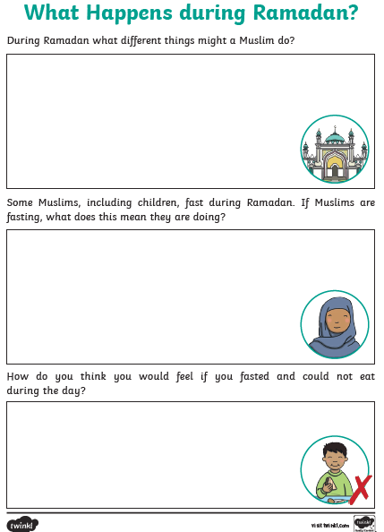
Example quiz questions (and answers!)
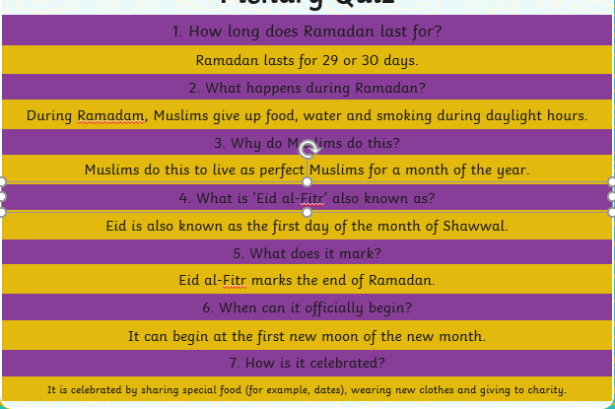
Recipe
