Maths Year 4
w/c 11.5.20
The objective we are working on in detail this week is:
To recognise and write decimal equivalents of any number of tenths or hundredths

This week on Monday, you will start by recognising tenths and hundredths. On Tuesday, you will learn how to recognise tenths as decimals. On Wednesday, you will be using place value grids to develop your understanding of tenths as decimals. On Thursday, you will be putting tenths onto numberlines and finally on Friday, you will be dividing one digit by 10 to get decimal answers.
Remember ... When you divide by 10, you move each digit one place to the right on the place value chart!
Using the link below, click on Week 1 and each day watch the video and complete the accompanying task (these are printed in your pack), recording the answers in your book. Lesson 1 – Monday, Lesson 2 – Tuesday, Lesson 3 – Wednesday, Lesson 4 – Thursday and lesson 5 – Friday.
https://whiterosemaths.com/homelearning/year-4/

Have a go at this timestables activity from Classroom Secrets – thought it would make a change from TTRockstars and Abacus!

https://kids.classroomsecrets.co.uk/resource/year-4-mixed-multiplication-memory-card-game/

Place Value Chart
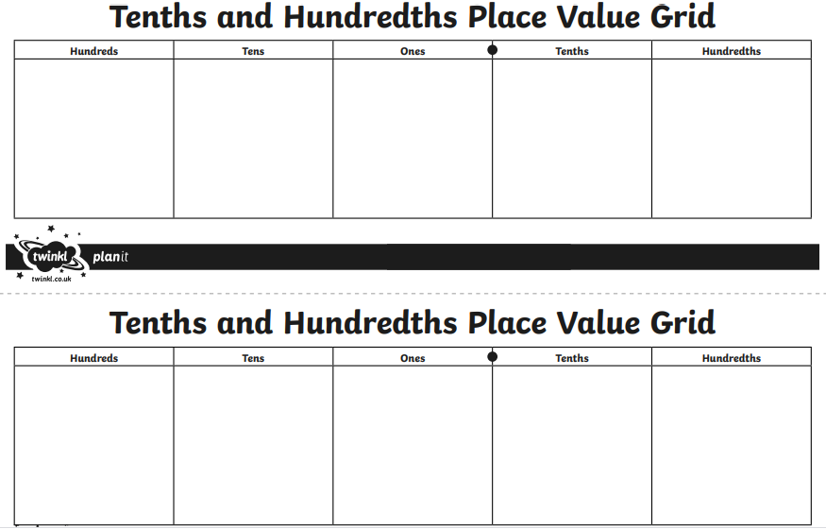
Sheet 1 - Monday
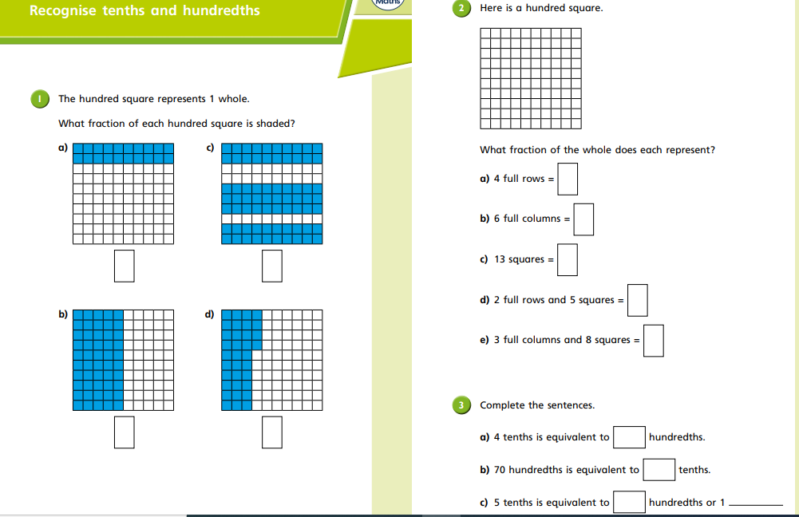Sheet 1

Sheet 1 - Monday
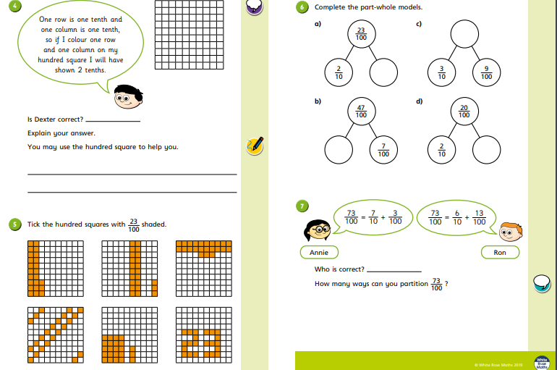

Sheet 2 - Tuesday
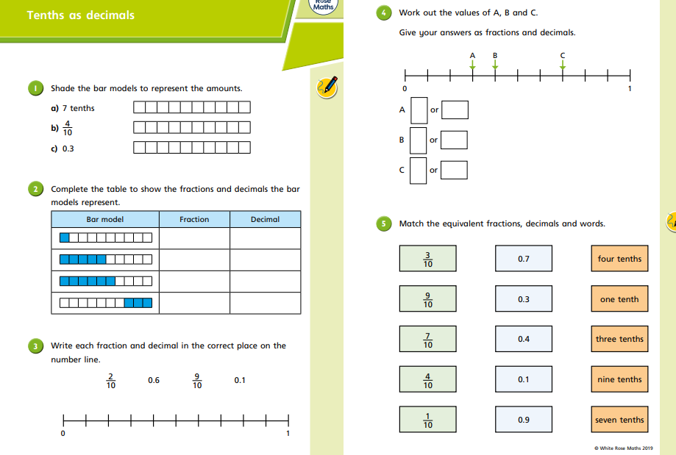

Sheet 2 - Tuesday
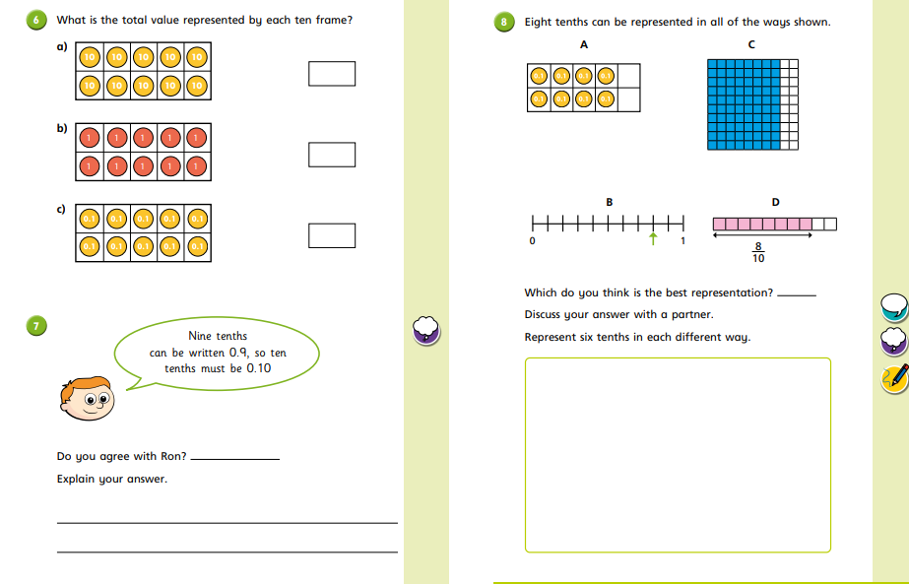

Sheet 3 - Wednesday
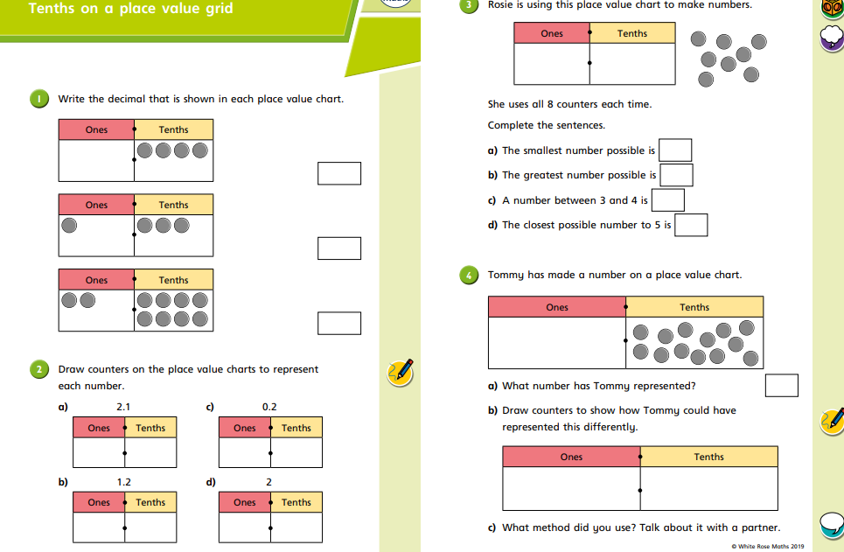

Sheet 3 - Wednesday
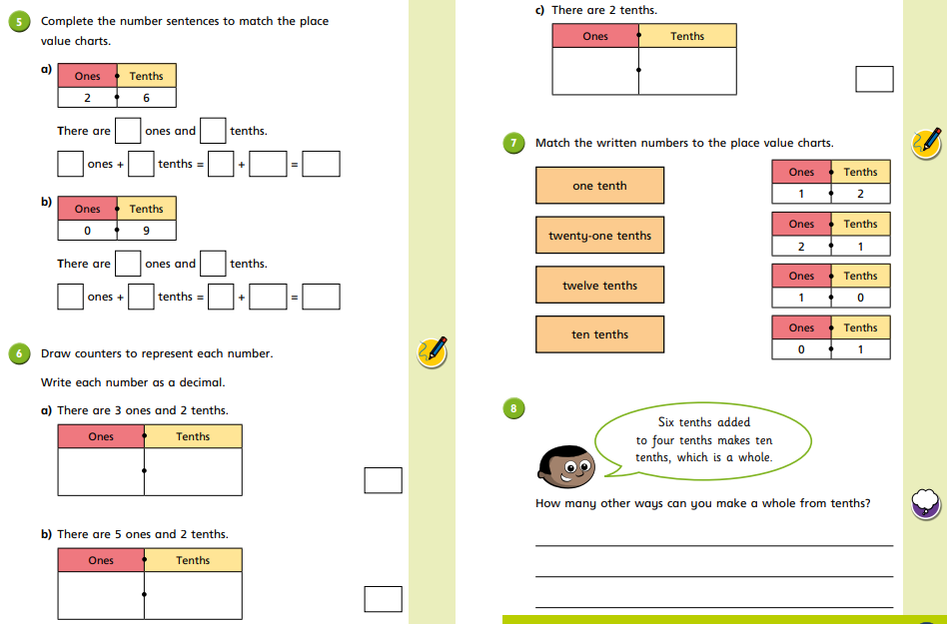

Sheet 4 – Thursday
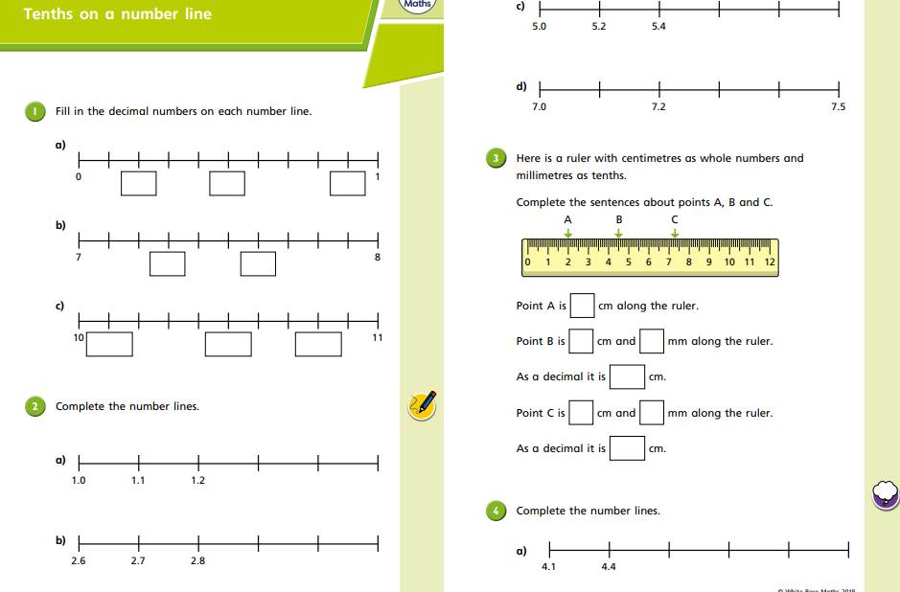

Sheet 4 - Thursday
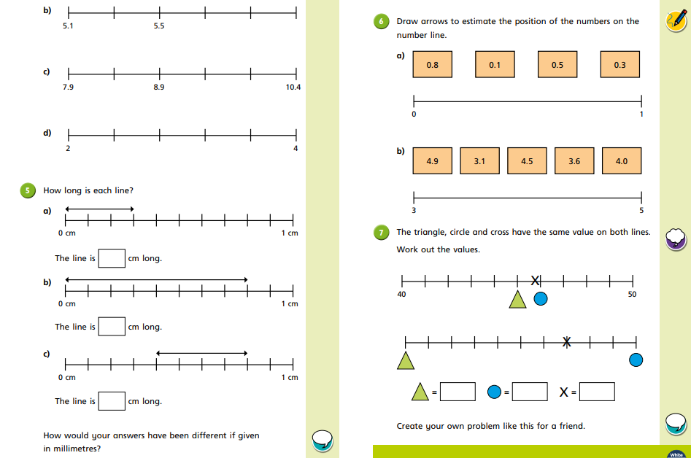
Sheet 5 - Friday
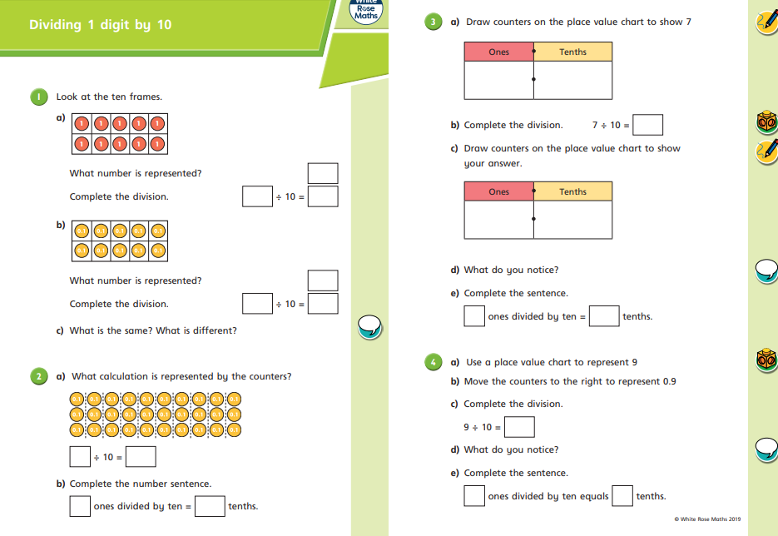
Sheet 5 - Friday
