Year 4 Writing
You are going to write a non-chronological report about the Vikings and their invasion of Britain for the children in years 5 and 6.
Monday
SPAG – Fronted Adverbials
Watch this clip:
https://www.bbc.co.uk/bitesize/topics/zwwp8mn/articles/zp937p3
Using what you have found out about fronted adverbials, have a go at the activity sheet ‘A Day at the Zoo.’ First underline the verb and then the adverbial. After, have a go at putting the adverbial at the start of the sentence – then you have used a fronted adverbial!

Sheet 1 –
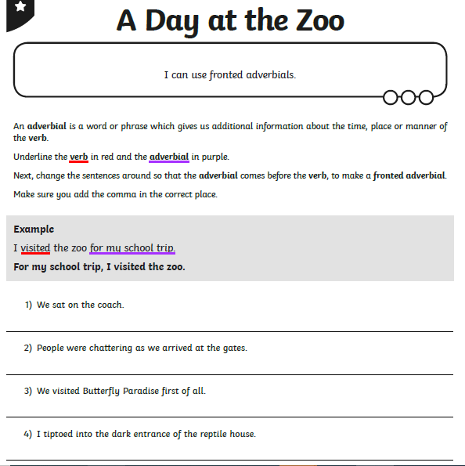
Then have a go at writing two of you own sentences using include fronted adverbials!

Tuesday
Research
Use this video clip to find out about the Vikings
https://www.bbc.co.uk/teach/class-clips-video/history-ks2-the-vikings-animation/zhrygwx
Make notes about the important pieces of information this clip gives you.
Then, read through the Victorious Vikings fact sheet and answer the questions.
Sheet 2
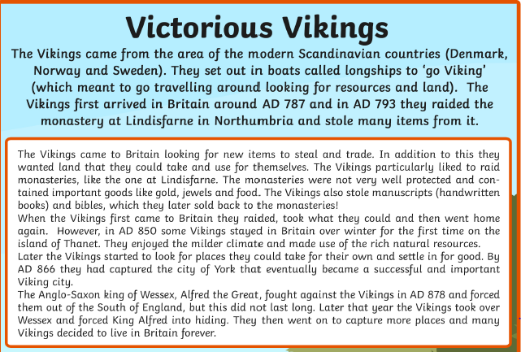

Sheet 2

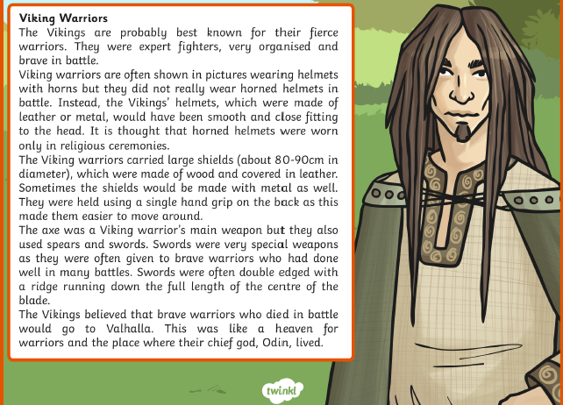

Sheet 2
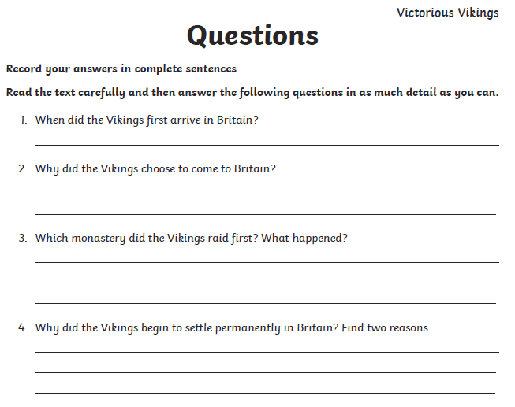
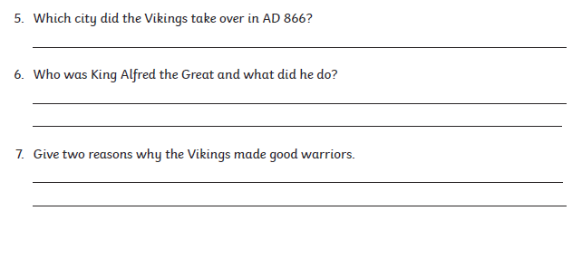

If you need some more information, I have also included some slides from a powerpoint.
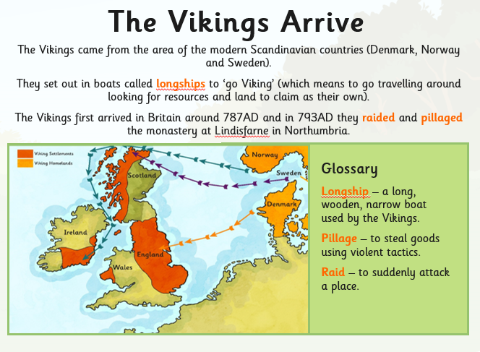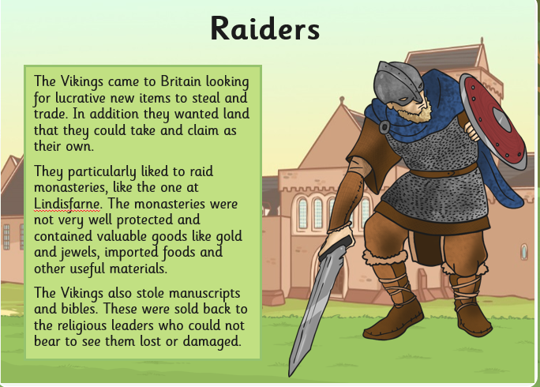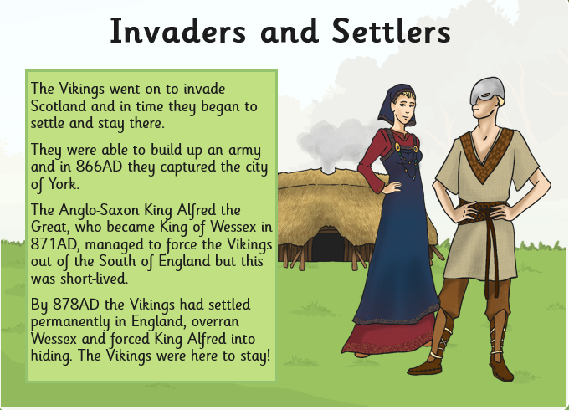

Wednesday
Planning
From the notes and comprehension you complete yesterday, you are now going to start thinking about writing a non-chronological report about the Vikings.
Complete the planning frame, with notes you made yesterday about the Vikings, make sure the relevant information is in the right box!
To help your writing further, with a different coloured pencil, write down the fronted adverbials you could use in your writing. There is a fronted adverbials word mat in your pack.

Sheet 3 - I can plan a non-chronological report about the Viking invasion

Who were the Vikings and where were they from?

Why did the Vikings choose to come to Britain?

Viking Raids

Viking Warriors

Sheet 4 – Fronted Adverbials word mat
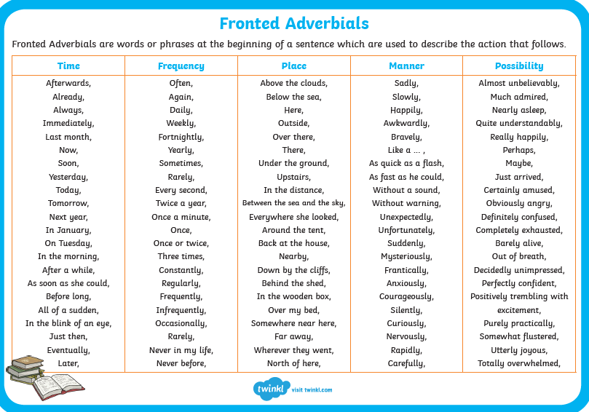

Thursday and Friday
Have a look at my model of a non-chronological report about the Vikings.
Have a go at highlighting:
The fronted adverbials
The sub-headings
The adjectives (decsribing words)

Sheet 5 – Model non-chronological report

I can write a non-chronological report about the Viking Invasion
What do you already know about the Vikings? The report aims to fill you with information about the Vikings and their invasion of Britain.
Who were the Viking and where were they from?
From the distant lands of Scandinavia, came a group of people called Vikings. They sailed across the North Sea towards Britain first arriving in 787AD. In order to arrive safely, the Vikings used their longships, which were long, wooden boats.

Why did they choose to come to Britain?
Surprisingly, one of the main reasons the Vikings came to Britain was because our land was more fertile than theirs in Scandinavia. The Vikings wanted to grow the own crops successfully and in milder weather, so this was one of the main reasons they sailed over to Britain.
Unfortunately, there was another reason that some Vikings made the dangerous journey to Britain, so that they could steal valuable items and then sell them, helping them to become richer and richer.

Viking Raids
Violently, the Vikings would raid different buildings, mainly monasteries. A raid was a surprise attack, and the Vikings were merciless in their raiding, determined to get their hands on as many valuable things as they could. Often, a raid would be brutal, resulting in many deaths of unarmed people.

Viking Warriors
Viking warriors were brave, daring and amazing fighters and this is a reason why they were so successful in both raids and battles. Bravely, the warriors would storm into battle carrying a wooden shield, covered in leather and an axe. If a Viking warrior had been extremely brave, he would be rewarded with a sword, this was something which needed to be treasured.

To conclude, the Vikings were brave warriors and not afraid to fight until death. They were also clever as they knew invading Britain would allow them to grow more crops and become richer.

Once you have done this, try and write your own non-chronological report about the Viking invasion. You could also include some pictures in your report as well!

Have fun year 4!

Mrs Taylor

