Year 4 History Home Learning Challenges
Create a finger snapper to memorise the 5 finger facts for this topic  - I know that the Second World War was from 1939 - 1945.  - I know that the Second World War ended on 8th May 1945.  - I know that an evacuee was a child who moved to the countryside from a city to be safe.  - I know that rationing meant that people could not have all the food they wanted.  - I know that Winston Churchill was the British Prime Minister during the Second World War. | VE Day in London  https://www.bbc.co.uk/teach/class-clips-video/history-ks2-ve-day/z7xtmfr  Watch the video clip and then read through the information (pages 2 and 3)  Imagine you are Alan and you are writing a postcard telling your best friend how you celebrated VE day in London. Remember to include how you felt during the celebrations, what you did and who you were with.  Postcard template – Page 4  VE Day word mat – Page 5 | Winston Churchill  You are going to find out all about Winston Churchill and why he was so important during the Second World War.  Use this link to help you!  https://www.bbc.co.uk/bitesize/topics/zkrkscw/articles/zfq9pg8  There is also a Factfile sheet about Winston Churchill in your pack to help. (pages 10 and 11)  Your challenge is to create a poster or PowerPoint presentation all about Winston Churchill.  This is what I’d like to know:  When and where was he born? What was his job before he went into politics? How did Winston Churchill help people during the war? Why do you think he is famous?
 | Let’s Celebrate!  Plan a VE day “stay safe at home” garden party to celebrate the 75th Anniversary of VE day with your family! Some photos of your event would be brilliant!  Have a go at creating some Union Jack bunting for your party. (Pages 6 and 7)  Why not try to make something from the war time recipes? (Pages 8 and 9) | Key Vocabulary  Evacuee – a person moved from a place of danger  Rationing – the controlling of the handing out of different goods  Prime Minister – the head of an elected government  Victory – an act of defeating the enemy
Our topic is Victory

Sheet 1 – VE Day powerpoint
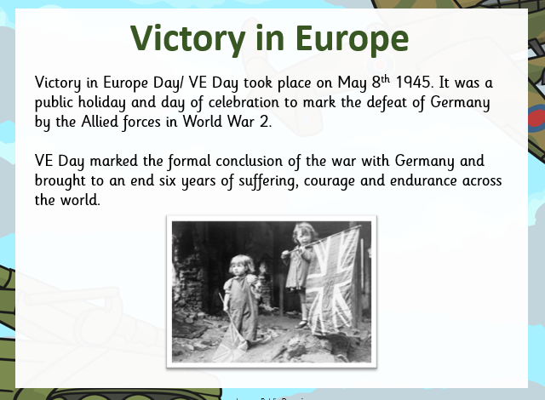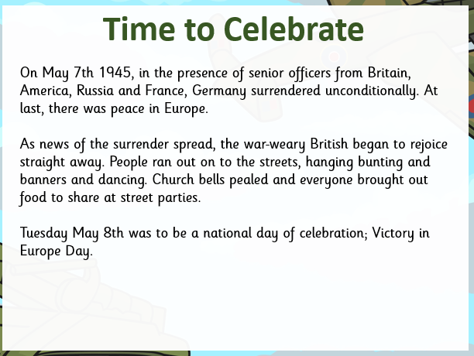
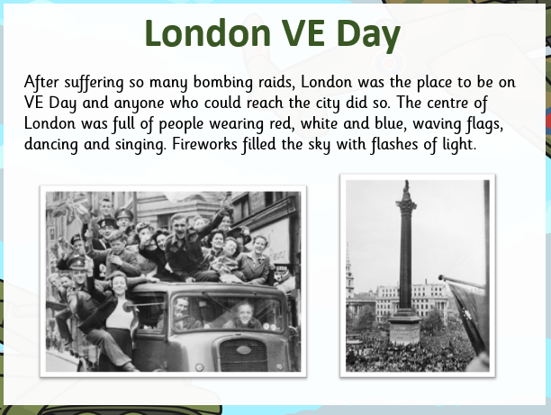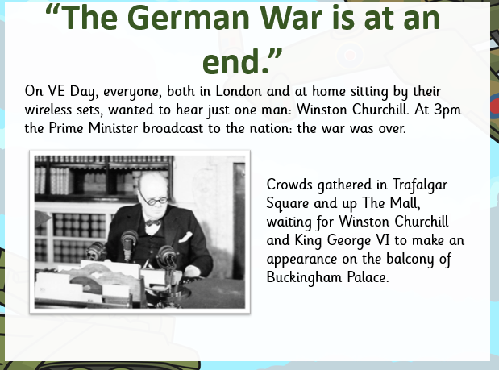

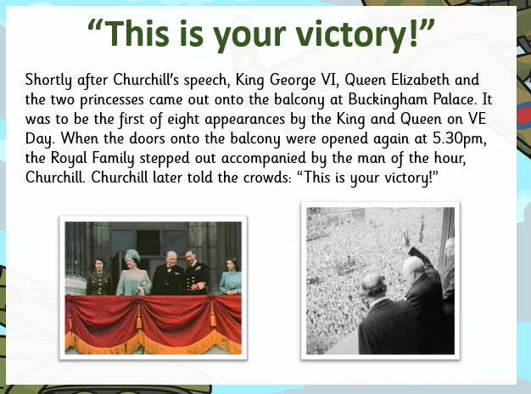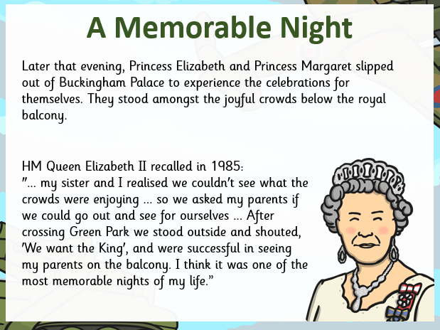

Sheet 2 – Postcard template

Sheet 3 – Word Mat
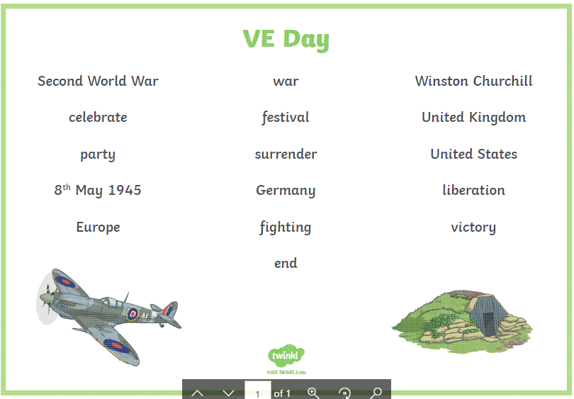

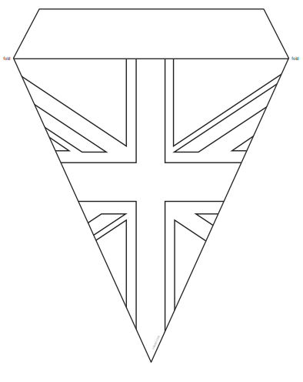
Sheet 4 – VE Day Bunting

Sheet 4- Bunting

Sheet 5 – War time Recipes

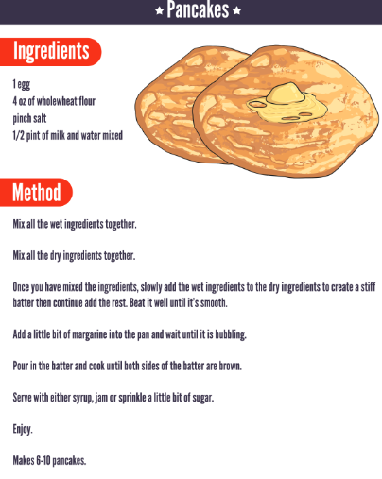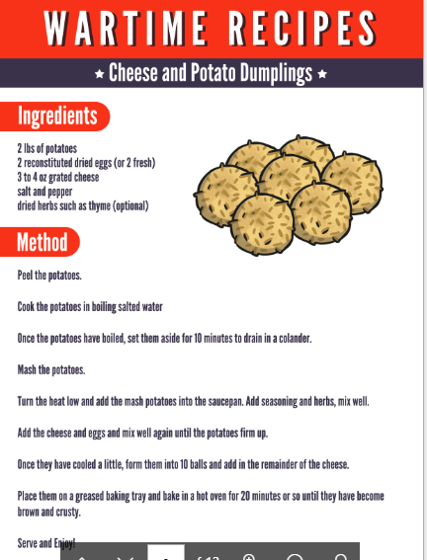

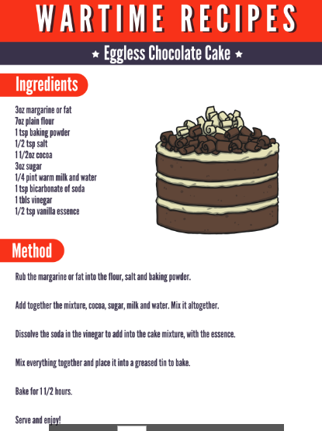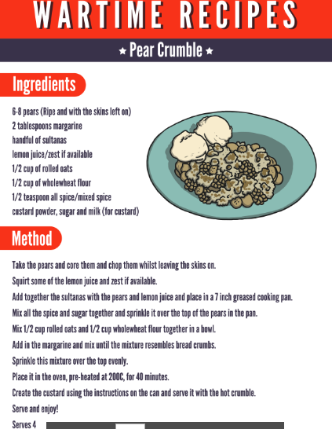

Sheet 6 – Winston Churchill Fact File
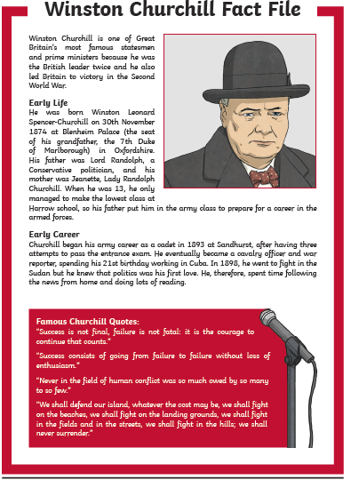

Sheet 6
