Maths Year 4
w/c 18.5.20
The objective we are working on in detail this week is:
To recognise and write decimal equivalents of any number of tenths or hundredths

This week on Monday, you will start by dividing a 2-digit numbers by 10 – remembering to use a place value chart! On Tuesday, you will start to learn all about hundredths. On Wednesday, you will be writing and using hundredths as decimals. On Thursday, you will be using hundredths on a place value grid and finally on Friday, you will be dividing 1 and 2-digit numbers by 100!
Remember...When you are dividing by 100, you move each digit 2 places to the right!

Using the link below, click on Week 2 and each day watch the video and complete the accompanying task (these are printed in your pack). Lesson 1 – Monday, Lesson 2 – Tuesday, Lesson 3 – Wednesday, Lesson 4 – Thursday and lesson 5 – Friday.
https://whiterosemaths.com/homelearning/year-4/

Have a go at this Classroom Secrets games for dividing 1 and 2-digit numbers by 100 and placing hundredths on a place value grid.

https://kids.classroomsecrets.co.uk/resource/year-4-hundredths-on-a-place-value-grid/

https://kids.classroomsecrets.co.uk/resource/year-4-divide-1-or-2-digits-by-100/

Place value grid

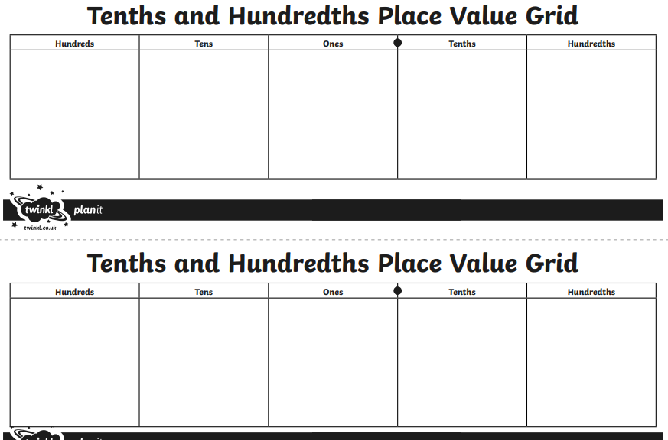
Monday

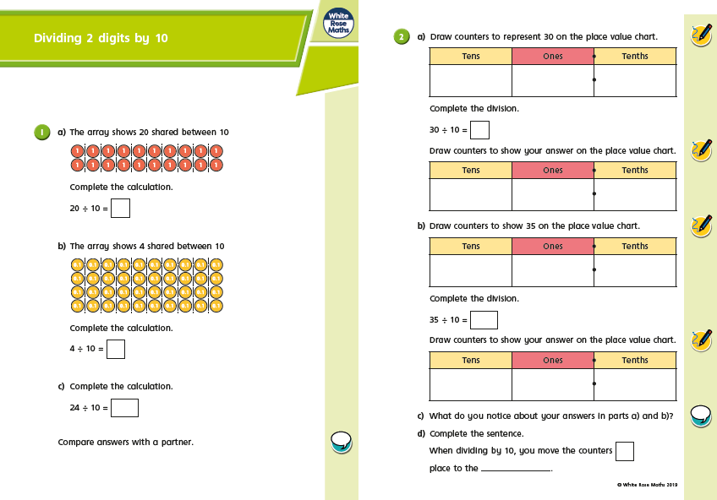

Monday

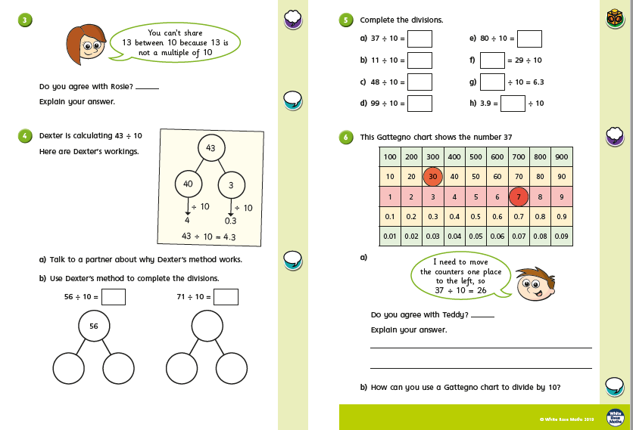
Tuesday
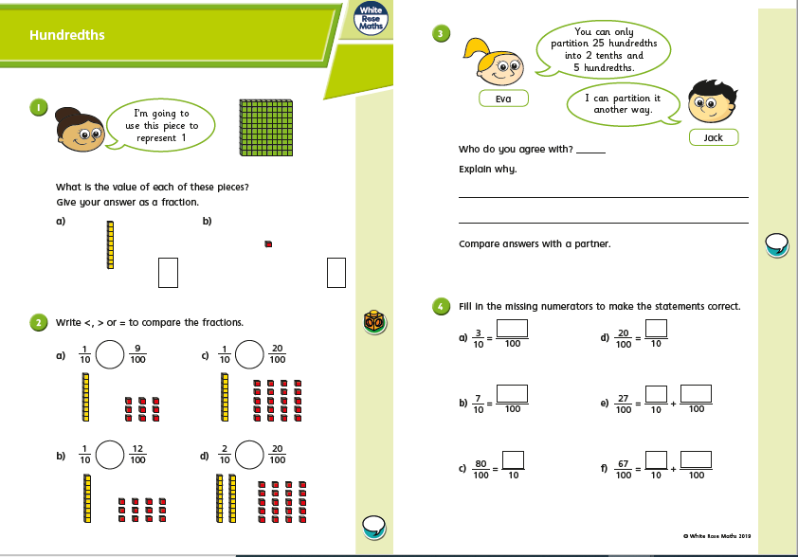
Tuesday

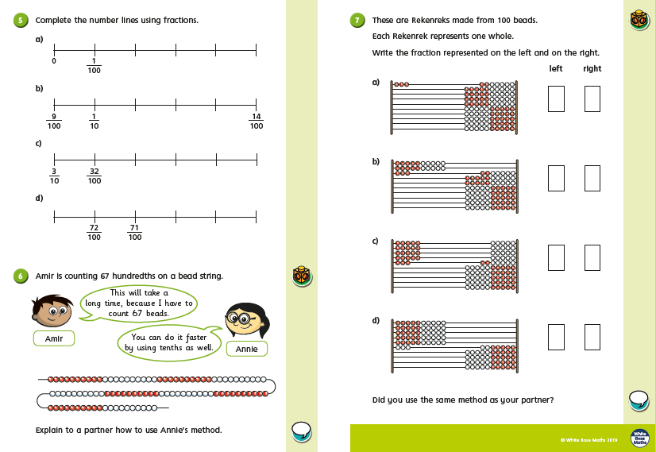
Wednesday
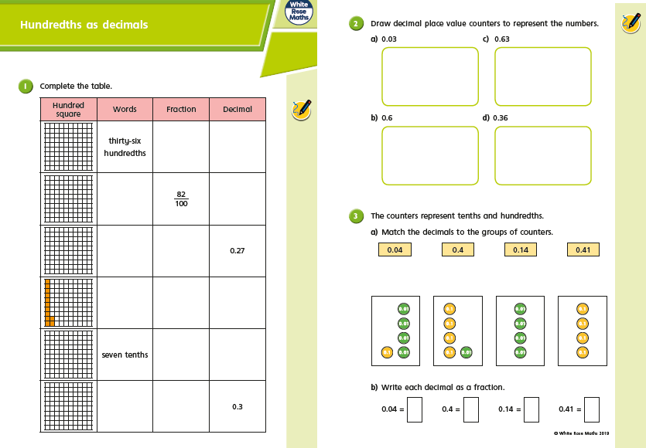

Wednesday

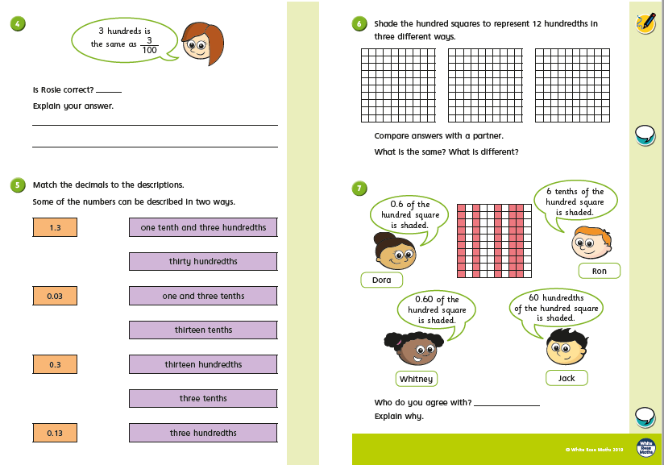

Thursday

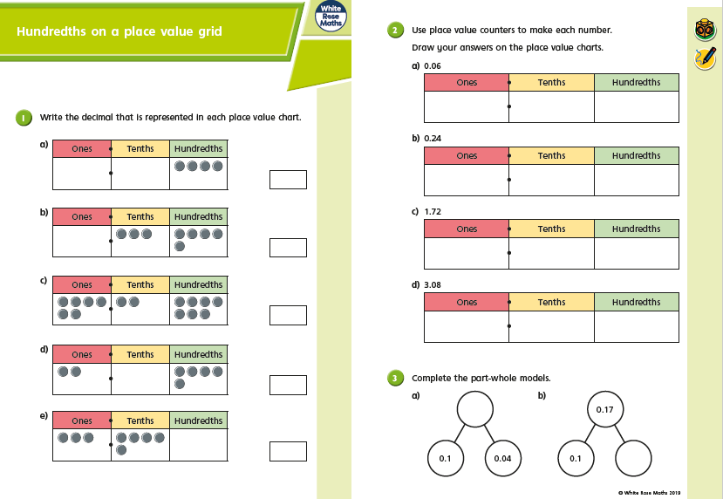

Thursday
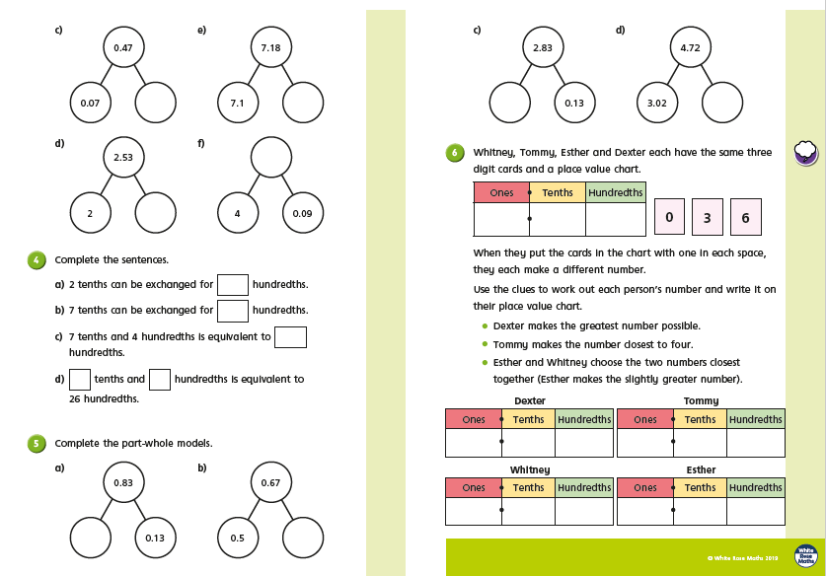

Friday
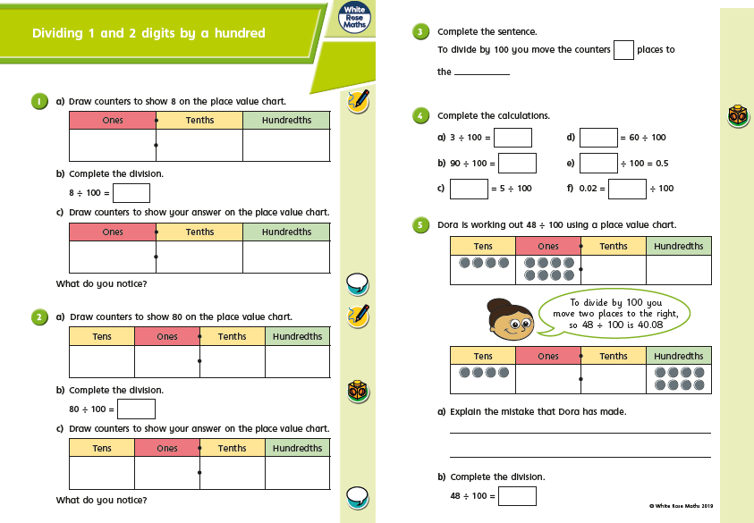

Friday
