Mrs Taylor’s Recommended Reads!
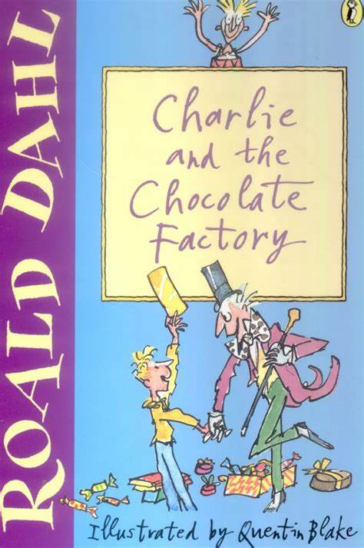
Working at expected standard
Bills’ New Frock by Anne Fine
Charlie and the Chocolate Factory by Roald Dahl
Matilda by Roald Dahl
Desirable by Frank Cottrell Boyce
Stig of the Dump by Clive King
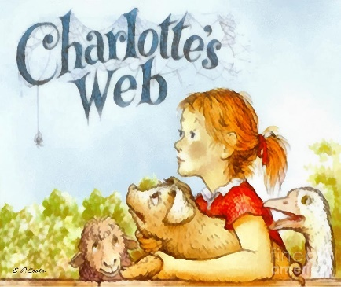
The BFG by Roald Dahl
Charlotte’s Web by E.B. White
How to Train Your Dragon by Cressida Cowell
The Suitcase Kid by Jacqueline Wilson
Cliffhanger by Jacqueline Wilson

Greater Depth
The Water Horse by Dick King Smith
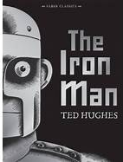
The Firework Maker’s Daughter by Phillip Pullman
Why the Whales Came by Michael Morpurgo
The Butterfly Lion by Michael Morpurgo
The Iron Man by Ted Hughes

