Maths Year 4
Shape w/c 27/04/2020
The objectives we are working on this week are:
Compare and classify geometric shapes, including quadrilaterals and triangles, based on their properties and sizes
Identify lines of symmetry in 2-D shapes presented in different orientations
Complete a simple symmetric figure with respect to a specific line of symmetry.
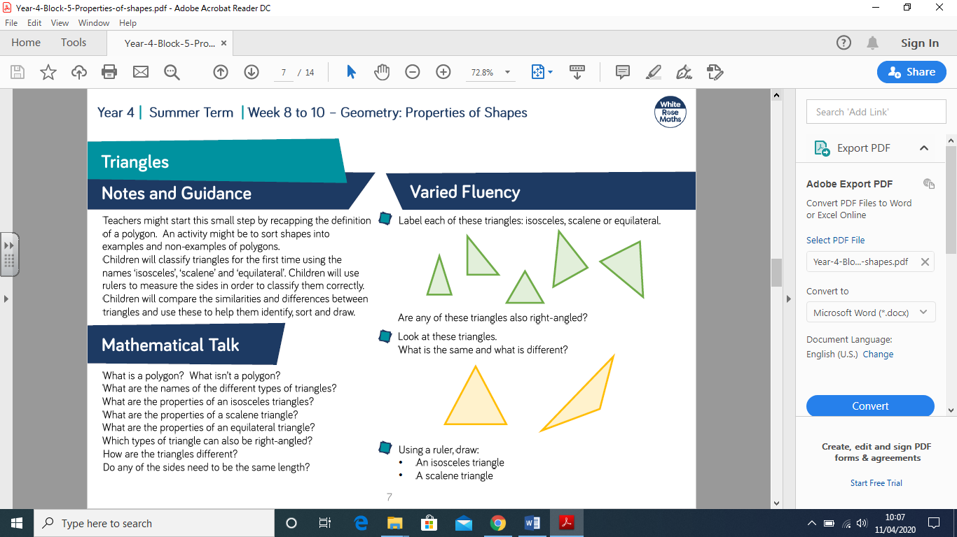
Properties of the different types of triangles:
There are 4 types of triangle. They all have 3 sides and are polygons.

1. Equilateral
Equilateral triangles have 3 equal sides and 3 equal angles of 60°

2. Isosceles
Isosceles triangles have 2 equal sides and 2 equal angles.

3. Right-angled
1 of the angles is a right angle (90°) in right-angled triangles.

4. Scalene
Scalene triangles have no equal sides and no equal angles.

Now watch the clip:
https://www.bbc.co.uk/bitesize/topics/zvmxsbk/articles/zggsfrd
- Practical maths! Cut out the different types of triangle. Can you sort them into the different categories provided? Give it a whirl! (Sheet 1)
- Challenge – look at the triangle challenge sheet I have given you, can you complete it and explain how you came to the answer? (Sheet 2)
Quadrilaterals
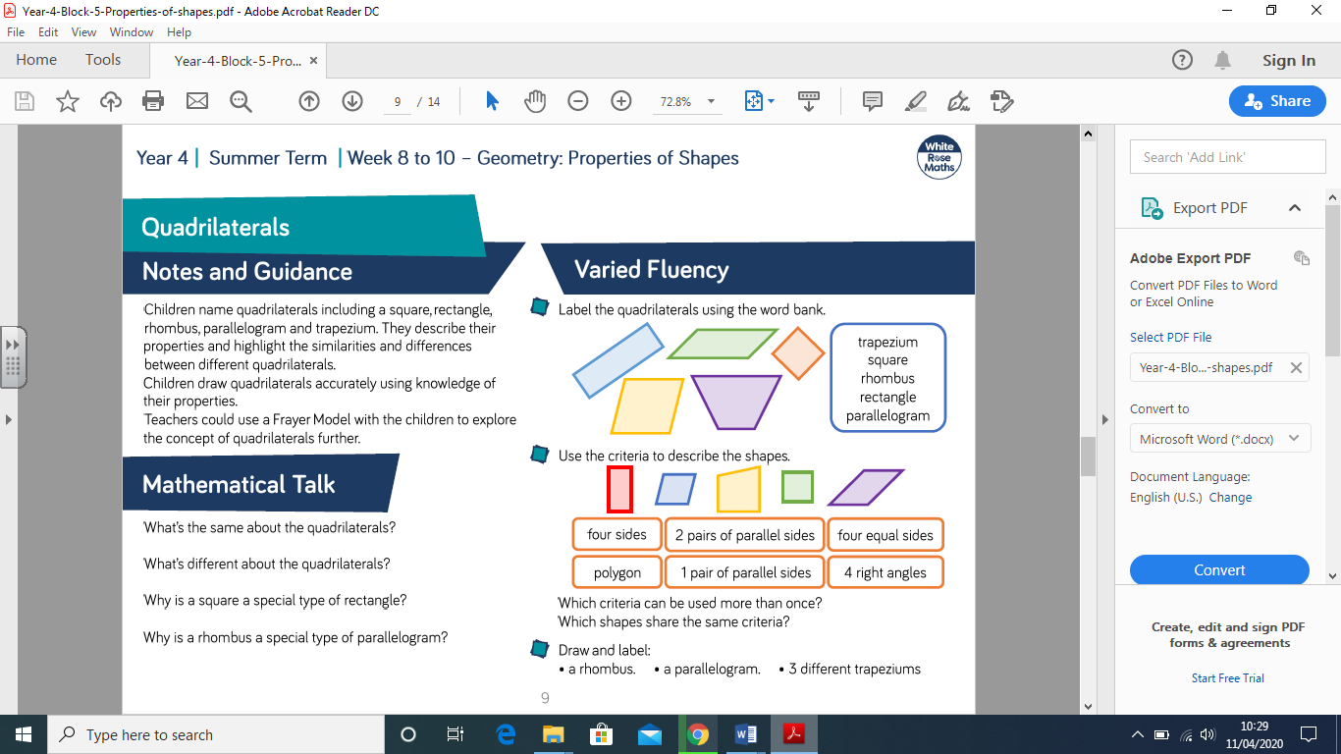
From the screen shot the children are going to be sorting different types of quadrilaterals. There is some key vocabulary which the children need to know:
Parallel lines – straight lines the same distance apart, which never meet
Quadrilateral – 4-sided shape
There is also a quadrilateral poster in the pack, to give you the properties of different quadrilaterals.
- Have a go at drawing the different types of quadrilaterals based on your poster and noting down their key properties, then sort the different quadrilaterals into a venn diagram. (Sheet 3, 4,
- Have a go at completing the quadrilaterals challenge! (Sheet 6)
Enjoy Year 4!
Mrs Taylor.

