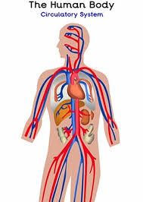
Year 5 and 6 Science Home Learning Challenges
Our topic is Animals including Humans

Create a finger snapper to memorise the 5 finger facts for this topic (you could also test members of your family) sheet 5  - I know that the circulatory system is made up of three parts: the heart, blood vessels and the blood itself.  - I know the main parts of the human circulatory system are the right atrium, left atrium, right ventricle, left ventricle, pulmonic valve, pulmonary artery (left), left pulmonary veins, aortic valve and aorta.  - I know that the heart pumps blood to the lungs to get oxygen, the blood vessels move blood to and from your heart and blood carries oxygen and nutrients, removes waste and protects against infection.  - I know that it’s important to keep my heart healthy with a well-balanced diet and exercise and by avoiding things that can damage it, like smoking.  - Nutrients and water pass through the villi in the small intestine and are absorbed into the blood vessels. | Who? What? When? Human Lifecycle Challenge (sheets 1, 2 and 3)  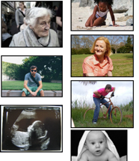  Match the picture with what might be happening and the age. Now see if you can think of other things that might happen during that stage of life and write down any questions you would like answering, or to explore about humans and their development and lifecycle. Research the answers to some of your questions and present your findings in any way you like: recording in writing/ creating a poster/ creating a PPT? | What is the circulatory system and what does our heart do?  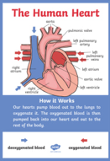  Create an information poster (look at the sound poster sheet 4 to help you consider what it may look like) to explain what the circulatory system is and what our heart’s job is. Watch the clip and have a go at the short ‘fill in the missing words’ challenge on this website first to help you.  https://www.bbc.co.uk/bitesize/topics/zwdr6yc/articles/zs8f8mn  You may even like to do some more of your own research to help you. Remember to try and include some pictures on your poster.
 | 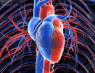  Main parts of the circulatory system Watch the first video clip here:  https://www.bbc.co.uk/teach/class-clips-video/science-ks2-how-our-circulatory-system-keeps-us-alive/zhf76v4 Then have a go at the ‘labelling the heart’ activity sheet 6. You may wish to draw the heart yourself. Re-watching and pausing the video to help you, have a go at writing a short explanation of how each part works. | Key Vocabulary  